Precalculus

Systems of Equations and Inequalities Guided Notes
This tool is designed to work alongside your Study Plan and class sessions. Before class, you'll use it with the assigned readings by filling in key terms, noting examples, and writing down questions that arise. During class, you'll add to your notes as you deepen your understanding and instructors highlight important concepts. You'll find a mix of fill-in-the-blank sections, reflection spaces, and areas to record real-world examples.

9.1 Systems of Linear Equations: Two Variables

Solutions of Systems Overview
A system of linear equations consists of two or more linear equations made up of two or more variables such that all equations in the system are considered simultaneously. To find the unique solution, we must find a numerical value for each variable that satisfies all equations at the same time.

Key Takeaway: System of Linear Equations
A system of linear equations consists of two or more linear equations made up of two or more variables such that all equations in the system are considered simultaneously.

Example

Consider the following system of linear equations in two variables.
$$2x + y = 15 \\ 3x - y = 5$$
The solution to a system of linear equations in two variables is any ordered pair that satisfies each equation independently. In this example, the ordered pair (4, 7) is the solution to the system.
Verification:
$2(4) + (7) = 15$True
$3(4) - (7) = 5$ True

Key Takeaway: Types of Linear Systems
There are three types of systems of linear equations in two variables, and three types of solutions.
- An independent system has exactly one solution pair (x, y). The point where the two lines intersect is the only solution.
- An inconsistent system has no solution. The two lines are parallel and will never intersect.
- A dependent system has infinitely many solutions. The lines are coincident — they are the same line, so every coordinate pair on the line is a solution to both equations.
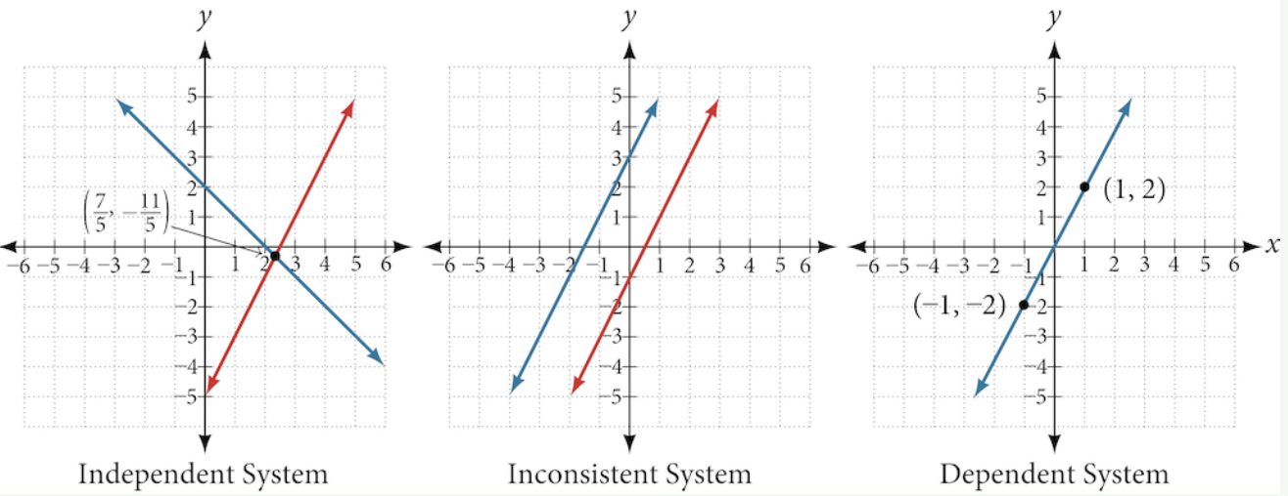

Question Help

Given a system of linear equations and an ordered pair, determine whether the ordered pair is a solution.
- Substitute the ordered pair into each equation in the system.
- Determine whether true statements result from the substitution in both equations; if so, the ordered pair is a solution.

Example

Determine whether the ordered pair $(5, 1)$ is a solution to the given system of equations.
$$x + 3y = 8$$
$$2x - 9 = y$$

Try It
Determine whether (7,3) is a solution to the system
$$\begin{matrix}6x+y=45 \\ 2x+7y=42\end{matrix}$$

Solving Systems of Equations by Graphing

Question Help: Solve a system of linear equations by graphing
- Graph the first equation.
- Graph the second equation on the same rectangular coordinate system.
- Determine whether the lines intersect, are parallel, or are the same line.
- Identify the solution to the system.
- Check the solution in both equations.
Pro Tip
Making a quick sketch of any mathematical situation is often a good idea to help you visualize it. Recall the techniques for graphing linear equations include using the y-intercept and slope to plot two points as well as using the intercepts. With practice, you'll get a feel for which technique to use in a given situation.

Example

Solve the following system of equations by graphing. Identify the type of system.
$$2x + y = -8$$
$$x - y = -1$$

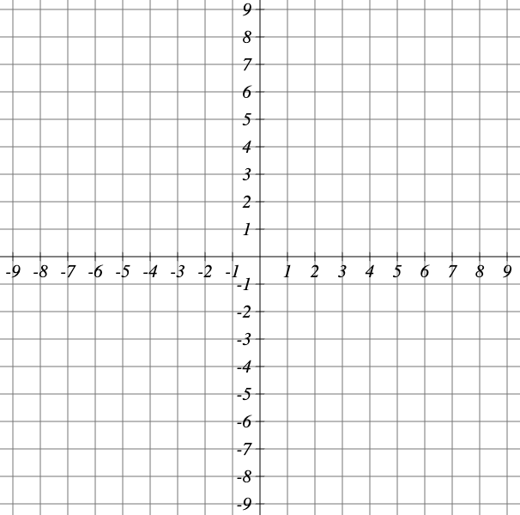

Try It
Solve the system of equations by graphing
$$y = -2x+1$$
$$2x+4y=-8$$

Question Help

Can graphing be used if the system is inconsistent or dependent?
Yes, in both cases we can still graph the system to determine the type of system and solution.
- If the two lines are parallel, the system has no solution and is inconsistent.
- If the two lines are identical, the system has infinite solutions and is a dependent system.
Situation | Outcome
Lines intersect | One solution | 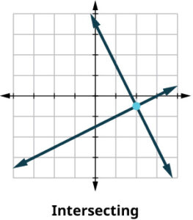
Lines are parallel | No solution | 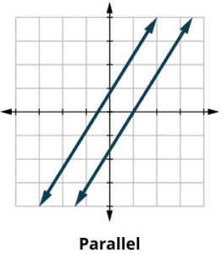
Lines are the same | Infinite solutions | 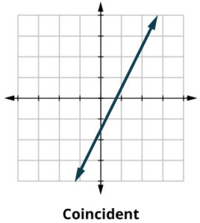

Try It
Graph each set of equations. Then describe the solution set.
$$-8x+6y=-24$$  $$-12x+9y=-36$$ | $$8x-4y=-16$$  $$4x-2y=-10$$
(circle one)  - Infinite solutions  - No solution  - One solution | (circle one)  - Infinite solutions  - No solution  - One solution

Example

Plot the three different systems with an online graphing calculator. Categorize each solution as either consistent or inconsistent. If the system is consistent determine whether it is dependent or independent.
- $5x - 3y = -19$ and $x = 2y - 1$
- $4x + y = 11$ and $-2y = -25 + 8x$
- $y = -3x + 6$and $-\frac{1}{3}y + 2 = x$

Solving Systems of Equations by Substitution
Solving by graphing works well when the solution consists of integer values, but if our solution contains decimals or fractions, it is not the most precise method. One alternative is solving by the substitution method, in which we solve one of the equations for one variable and then substitute the result into the second equation.

Question Help:

Given a system of two equations in two variables, solve using the substitution method.
- Solve one of the two equations for one of the variables in terms of the other.
- Substitute the expression for this variable into the second equation, then solve for the remaining variable.
- Substitute that solution into either of the original equations to find the value of the first variable. If possible, write the solution as an ordered pair.
- Check the solution in both equations.

Example

Solve the following system of equations by substitution.
$$-x + y = -5$$
$$2x - 5y = 1$$

Example:

Solve the following system of equations.
$$x = 9 - 2y$$
$$x + 2y = 13$$

Try It
Solve the linear system of equations
$$7x+6y=-1$$
$$x=4y-5$$

Try It
Solve the system of linear equations
$$3x+y=13$$
$$2y=23-6x$$

Solving Systems of Equations by the Elimination Method
A third method of solving systems of linear equations is the elimination method, also called the addition method. In this method, we add two terms with the same variable but opposite coefficients so that the sum is zero. Often, we must adjust one or both equations by multiplication so that one variable will be eliminated by addition.

Question Help

Given a system of equations, solve using the addition method.
- Write both equations with x- and y-variables on the left side of the equal sign and constants on the right.
- Write one equation above the other, lining up corresponding variables.
  - If one of the variables in the top equation has the opposite coefficient of the same variable in the bottom equation, add the equations together, eliminating one variable.
  - If not, use multiplication by a nonzero number so that one of the variables in the top equation has the opposite coefficient of the same variable in the bottom equation, then add the equations to eliminate the variable.
- Solve the resulting equation for the remaining variable.
- Substitute that value into one of the original equations and solve for the second variable.
- Check the solution by substituting the values into the other equation.

Example

Solve the given system of equations by addition.
$$x + 2y = -1$$
$$-x + y = 3$$

Example

Solve the given system of equations by the addition method.
$$3x + 5y = -11$$
$$x - 2y = 11$$

Example

Solve the given system of equations in two variables by addition.
$$2x + 3y = -16$$
$$5x - 10y = 30$$

Example

Solve the given system of equations in two variables by addition.
$$\frac{x}{3} +\frac{y}{6} = 3$$
$$\frac{x}{2} -\frac{y}{4} = 1$$

Try It
Solve the system of equations
$$\begin{matrix}3x+2y=7 \\ 9x-3y=10\end{matrix}$$

Try It
Solve the system of equations
$$\begin{matrix}4x+2y=22 \\ 3x-3y=3\end{matrix}$$

Identifying Inconsistent Systems of Equations Containing Two Variables
Recall that an inconsistent system consists of parallel lines that have the same slope but different y-intercepts. They will never intersect. When searching for a solution to an inconsistent system, we will come up with a false statement, such as 12 = 0.

Example

Solve the following system of equations.
$$x = 9 - 2y$$
$$x + 2y = 13$$
Approach 1 — Substitution:

Approach 2 — Slope-intercept form:

Try It
Solve the system of equations
$$\begin{matrix}8x-8y=-32 \\ 12x-12y=-51\end{matrix}$$

Expressing the Solution of a System of Dependent Equations Containing Two Variables
Recall that a dependent system of equations in two variables is a system in which the two equations represent the same line. Dependent systems have an infinite number of solutions because all of the points on one line are also on the other line. After using substitution or the addition method, the resulting equation will be an identity, such as 0 = 0.
Pro Tip
To write the solution of a dependent system, solve one equation for one variable, such as y = mx + b. The solution is often written in set notation as:
$$(x, y) = (x, mx + b)$$
where x can be any real number.

Example

Solve the system of equations.
$$x + 3y = 2$$
$$3x + 9y = 6$$

After a little algebra, we found that these two equations were exactly the same. The general solution $(x, -\frac{1}{3}x +\frac{2}{3})$tells us that x can be anything, and y depends on x. There are infinitely many (x, y) pairs that will satisfy this system, and they all fall on the line f$\left(x\right)= -\frac{1}{3}x +\frac{2}{3}.$

Try It
Solve the system of equations
$$\begin{matrix}y=-5x-3 \\ 15x+3y=-9\end{matrix}$$

Try It
Show that the system is a dependent system by graphing.
$$\begin{matrix}2x+y=-3 \\ 4x+2y=-6\end{matrix}$$

9.2 Systems of Linear Equations: Three Variables

Systems of Three Equations in Three Variables
A system of three equations in three variables helps us solve problems that involve three unknown quantities. Each equation takes the form $ax + by + cz = d$. When we graph any single equation from this system, it creates a plane in three-dimensional space.

Key Takeaway: Systems of Three Equations in Three Variables
A system of linear equations with three variables is a set of linear equations with three variables.
The primary tool we will use is called Gaussian elimination, named after Karl Friedrich Gauss. The goal is to eliminate one variable at a time to achieve upper triangular form:
$$Ax + By + Cz = D$$
$$Ey + Fz = G$$
$$Hz = K$$
The third equation can be solved for z, and then we back-substitute to find y and x.
To write the system in upper triangular form, we can perform the following operations:
- Interchange the order of any two equations.
- Multiply both sides of an equation by a nonzero constant.
- Add a nonzero multiple of one equation to another equation.
The solution set to a three-by-three system is an ordered triple $(x, y, z)$.

Number of Solutions:
- One solution: The ordered triple defines the point where three planes intersect.
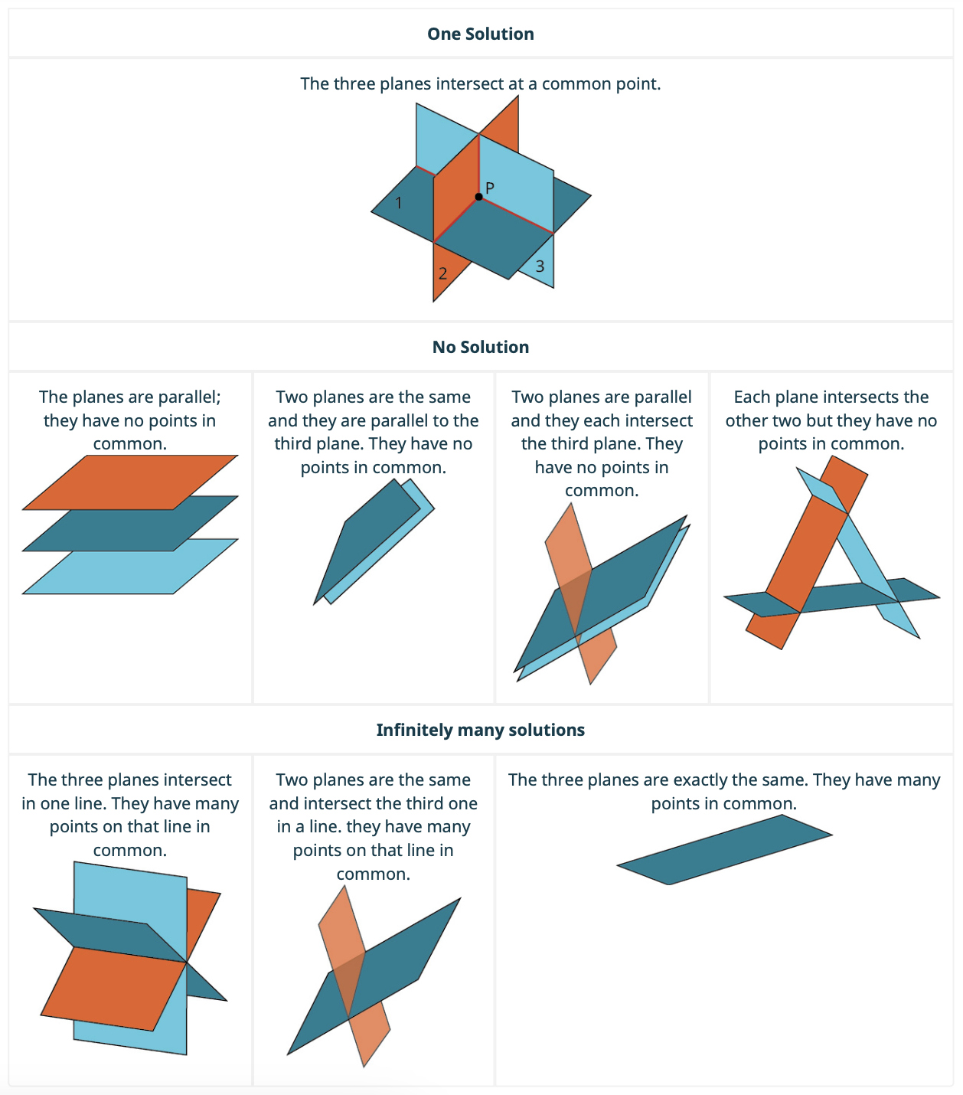
- Infinite solutions: After elimination, the result is an identity such as 0 = 0.
- No solution: After elimination, the result is a contradiction such as 3 = 0.

Recall
Term | Meaning
Consistent | At least one solution exists
Inconsistent | No solution — equations represent parallel planes
Dependent | Infinitely many solutions

Try It
What is the graphical interpretation of a system of linear equations in three variables that is independent? How many solutions are there?

Try It
A system that you are solving is dependent. Select all of the following statements that are true. Select all that apply
- Graphically, none of the planes defined by the system will intersect
- Solving the system algebraically leads to an identity
- Solving the system algebraically leads to a contradiction
- Graphically, the system defines two or three planes whose intersection results in either a line or a plane

Solve Systems of Three Equations in Three Variables

Question Help

Given a linear system of three equations, solve for three unknowns.
- Pick any pair of equations and solve for one variable.
- Pick another pair of equations and solve for the same variable.
- You have created a system of two equations in two unknowns. Solve the resulting two-by-two system.
- Back-substitute known variables into any one of the original equations and solve for the missing variable.

Example

Determine whether the ordered triple $(3, -2, 1)$ is a solution to the system.
$$x + y + z = 2$$
$$6x - 4y + 5z = 31$$
$$5x + 2y + 2z = 13$$

Try It
Is the point $(3,4,3)$ a solution to the given system of equations?
$$y- z = 1$$
$$-x+2y + z = 8$$
$$-x + y + 3z = 10$$

Example

Solve the given system.
$$x - \frac{1}{3}y +\frac{1}{2}z = 1$$
$$y -\frac{1}{2}z = 4 \\ z = -1$$
Back-substitute z = −1 into the second equation:

Back-substitute y and z into the first equation:

Try It

Solve the following system.
$$x+ \frac{1}{6}y +\frac{1}{3}z = -\frac{11}{3}$$
$$y+\frac{1}{3}z = -\frac{1}{3} \\ z = 5$$

Solving a System of Three Equations in Three Variables by Elimination

Question Help

Solve a system of linear equations with three variables by elimination
- Write the equations in standard form. If any coefficients are fractions, clear them.
- Eliminate the same variable from two equations.
  - Decide which variable you will eliminate.
  - Work with a pair of equations to eliminate the chosen variable.
  - Multiply one or both equations so that the coefficients of that variable are opposites.
  - Add the equations to eliminate one variable.
- Repeat Step 2 using two other equations and eliminate the same variable.
- The two new equations form a system of two equations with two variables. Solve this system.
- Use the values of the two variables found in Step 4 to find the third variable.
- Write the solution as an ordered triple.
- Check that the ordered triple is a solution to all three original equations.

Example

Find a solution to the following system.
$$x - y + z = 5 (1)$$
$$-2y + z = 6 (2)$$
$$2y - 2z = -12 (3)$$
Add equations (2) and (3):

Substitute z into equation (2):

Substitute z and y into equation (1):

Example

Find a solution to the following system.
$$x - 2y + 3z = 9 (1)$$
$$-x + 3y - z = -6 (2)$$
$$2x - 5y + 5z = 17 (3)$$
Add equations (1) and (2):

Multiply equation (1) by −2 and add to equation (3):

New two-by-two system. Solve:

Try It

Solve the following system.
$$-6x+ 6y +5z = -7$$
$$-12x-6y+z =49 \\ 24x-6y-2z =-26$$

Try It

Solve the following system.
$$-2x-4z = 18$$
$$2x+6y-6z =14 \\ -2x+5z =0$$

Inconsistent Systems of Equations Containing Three Variables
Just as with systems in two variables, we may come across an inconsistent system in three variables — one that does not have a solution that satisfies all three equations. The process of elimination will result in a false statement, such as 3 = 7.

Example

Solve the system.
$$x - 3y + z = 4 (1)$$
$$-x + 2y - 5z = 3 (2)$$
$$5x - 13y + 13z = 8 (3)$$
Add equations (1) and (2):

Multiply equation (1) by −5 and add to equation (3):

Multiply equation (4) by 2 and add to equation (5):

Dependent Systems of Equations Containing Three Variables
A dependent system of equations in three variables has an infinite number of solutions. The three planes could be the same, or they could all intersect on a line.
We can express the general solution using only one variable:
- If we choose $x: \{(x, y, z)\} = \{(x, y = mx + b, z = nx + c)\}$
- If we choose $z: \{(x, y, z)\} = \{(x = mz + a, y = nz + b, z)\}$

Example

Find the solution to the given system of three equations in three variables.
$$2x + y - 3z = 0 (1)$$
$$4x + 2y - 6z = 0 (2)$$
$$x - y + z = 0 (3)$$
Multiply equation (1) by −2 and add to equation (2):

Add equations (1) and (3) to express z in terms of x:

Back-substitute to find y in terms of x:

Try It

Solve the system of equations. If the system has an infinite number of solutions, express them in terms of the parameter z. If there is no solution write DNE.
$$4x-6y - 34z = 32$$
$$16x±7y - 85z =-60$$
$$4x - 3y-25 z =20$$

Try It

Given the system of equations.
$$x+y+z = 4$$
$$y -3z =-3$$
$$2x+y+5 z =12$$
  - Determine if it is dependent or inconsistent.
  - If it is dependent, find the complete solution. Let z = t and write x, y, and z as functions of t.

9.3 Systems of Nonlinear Equations and Inequalities

Solving a System of Nonlinear Equations Using Substitution
A system of nonlinear equations is a system of two or more equations in two or more variables containing at least one equation that is not linear. Recall that a linear equation can take the form $Ax + By + C = 0$. Any equation that cannot be written in this form is nonlinear.
The substitution method we used for linear systems is the same method we will use for nonlinear systems.

Key Takeaway: Possible Types of Solutions for Points of Intersection of a Parabola and a Line
- No solution. The line will never intersect the parabola.
- One solution. The line is tangent to the parabola and intersects it at exactly one point.
- Two solutions. The line crosses the inside of the parabola and intersects it at two points.
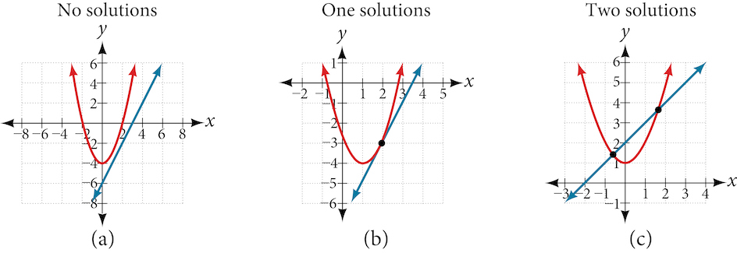

Question Help

Given a system of equations containing a line and a parabola, find the solution.
- Solve the linear equation for one of the variables.
- Substitute the expression obtained in step one into the parabola equation.
- Solve for the remaining variable.
- Check your solutions in both equations.

Example

Solve the system of equations.
$$x - y = -1$$
$$y = x^{2} + 1$$

Try It

Solve the given system of equations by substitution.
$$3x - y = -2$$
$$2x^{2} - y = 0$$

Try It

Find the solutions to the nonlinear system of equations.
$$y = -4x-3$$
$$y = x^{2}-3$$

Interact

Use an online graphing calculator to graph the parabola $y = x^{2} + 2x - 3$. Now graph the line ax + by + c = 0 and adjust the values of a, b, and c to find equations for lines that produce systems with the following types of solutions.
One solution: a = _______ b = _______ c = _______
Two solutions: a = _______ b = _______ c = _______
No solutions: a = _______ b = _______ c = _______

Key Takeaway: Possible Types of Solutions for Points of Intersection of a Circle and a Line
- No solution. The line does not intersect the circle.
- One solution. The line is tangent to the circle and intersects it at exactly one point.
- Two solutions. The line crosses the circle and intersects it at two points.
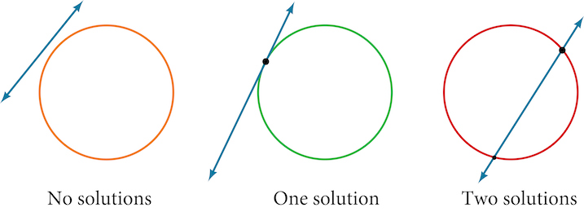

Question Help

Given a system of equations containing a line and a circle, find the solution.
- Solve the linear equation for one of the variables.
- Substitute the expression obtained in step one into the equation for the circle.
- Solve for the remaining variable.
- Check your solutions in both equations.

Example

Find the intersection of the given circle and the given line by substitution.
$$x^{2} + y^{2} = 5$$
$$y = 3x - 5$$

Try It

Solve the system of nonlinear equations.
$$x^{2} + y^{2} = 10$$
$$x - 3y = -10$$

Try It

Find the ordered pair solutions to the system of nonlinear equations.
$$y= x-12$$
$$x^{2}+y^{2}=80$$

Try It

Solve the system of nonlinear equations.
$${(x-2)}^{2} + {(y-4)}^{2} = 50$$
$$x+2y = 5$$

Solving a System of Nonlinear Equations Using Elimination
When both equations in the system have like variables of the second degree, solving by elimination by addition is often easier than substitution.

Key Takeaway: Possible Types of Solutions for Points of Intersection of a Circle and an Ellipse
The figure below illustrates possible solution sets for a system of equations involving a circle and an ellipse.

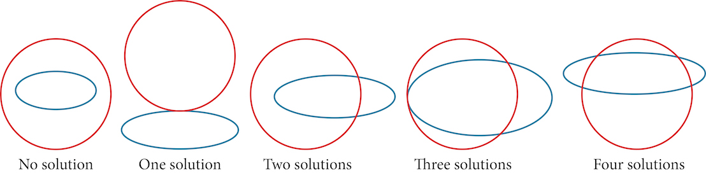

Example

Solve the system of nonlinear equations.
$$x^{2} + y^{2} = 26 (1)$$
$$3x^{2} + 25y^{2} = 100 (2)$$
Multiply equation (1) by −3 and add to equation (2):

Solve for y:

Solve for all values of x:

Try It
Use the elimination method to find all solutions of the system:
$$x^{2}-2y=15$$
$$x^{2}+5y=50$$

Try It
Solve the system of equations below. Give your solutions as points with exact coordinates.
$$x^{2}+y^{2}=6$$
$$x^{2}-y^{2}=4$$

Graphing Nonlinear Inequalities
Steps to graph a nonlinear inequality:
- Convert the inequality to an equation by replacing the inequality sign with an equal sign.
- Plot the equation on a coordinate plane. This line or curve serves as the boundary.
  - Use a solid line/curve if the inequality includes ≥ or ≤.
  - Use a dashed line/curve if the inequality includes > or <.
- Choose a test point not on the line/curve to determine which side satisfies the inequality.
- Shade the region where the inequality is true.

Example

Graph the inequality $x + 4y ≤ 4$.

Question Help

Given an inequality bounded by a parabola, sketch a graph.
- Graph the parabola as if it were an equation. This is the boundary for the solution set.
- If the boundary is included (≤ or ≥), graph the parabola as a solid line. If not included (< or >), graph as a dashed line.
- Test a point in one of the regions. If the statement is true, the solution set is the region including the point. If false, the solution set is the region on the other side.
- Shade the region representing the solution set.
Explain the inequality relationship for each sketch:
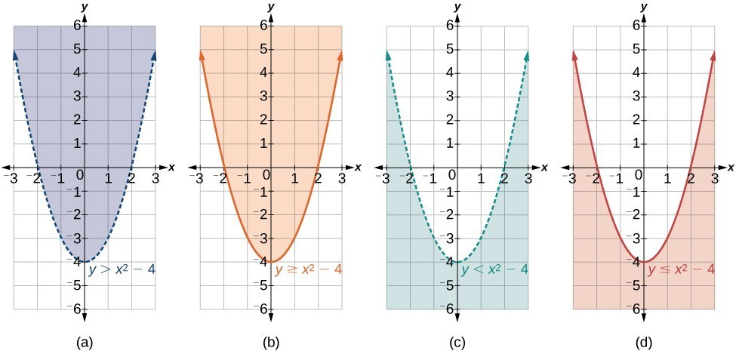

Example

Graph the inequality $y>x^{2}+1$.

Try It

Graph inequality $y≤x^{2}+1$.

Graphing a System of Nonlinear Inequalities
A system of nonlinear inequalities is a system of two or more inequalities in two or more variables containing at least one inequality that is not linear. The solution to a nonlinear system of inequalities is the region of the graph where the shaded regions of each inequality overlap — called the feasible region.

Question Help

Given a system of nonlinear inequalities, sketch a graph.
- Find the intersection points by solving the corresponding system of nonlinear equations.
- Graph the nonlinear equations.
- Find the shaded regions of each inequality.
- Identify the feasible region as the intersection of the shaded regions of each inequality or the set of points common to each inequality.

Example

Graph the given system of inequalities.
$$x² - y ≤ 0$$
$$2x² + y ≤ 12$$

Try It

Graph the given system of inequalities.
$$y>-x^{2}+3$$
$$y ≤ 2x+3$$

Example

Graph the given system of inequalities.
$$y ≥ x² - 1$$
$$x - y ≥ -1$$

9.4 Partial Fractions

Linear Factors
Partial fraction decomposition is the reverse of adding or subtracting rational expressions — it takes a single simplified rational expression and returns it to its original partial fractions.
For example:
$$\frac{x + 7}{x^{2}- x - 6} =\frac{2}{x - 3} +\frac{-1}{x + 2}$$

Key Takeaway: Partial Fraction Decomposition — Nonrepeated Linear Factors
The partial fraction decomposition of P(x)/Q(x) when Q(x) has nonrepeated linear factors and the degree of P(x) is less than the degree of Q(x) is:
$$\frac{P\left(x\right)}{Q\left(x\right)}=\frac{A_{1}}{a_{1}x + b_{1}}+\frac{A_{2}}{a_{2}x + b_{2}}+\frac{A_{3}}{a_{3}x + b_{3}}+ ⋯ +\frac{Aₙ}{aₙx + bₙ}$$

Question Help

Given a rational expression with distinct linear factors in the denominator, decompose it.
- Use a variable for the original numerators (usually A, B, or C), placing each variable over a single factor.
- Multiply both sides of the equation by the common denominator to eliminate fractions.
- Expand the right side of the equation and collect like terms.
- Set coefficients of like terms from the left side equal to those on the right side to create a system of equations to solve for the numerators.

Example

Decompose the given rational expression with nonrepeated linear factors.
$$\frac{3x}{\left(x + 2\right)\left(x - 1\right)}$$
Set up:
$$\frac{3x}{\left(x + 2\right)\left(x - 1\right)}=\frac{A}{x + 2}+\frac{B}{x - 1}$$
Solve:

Try It
Complete the partial fraction decomposition for
$$\frac{18}{\left(x-1\right)\left(x+1\right)}=\frac{A}{x-1}+\frac{B}{x+1}$$

Example

Find the partial fraction decomposition of the following expression.
$$\frac{x}{\left(x - 3\right)\left(x - 2\right)}$$

Try It

Find the partial fraction decomposition of the following expression.
$$\frac{6x-28}{\left(x - 6\right)\left(x - 2\right)}$$

Try It

Give the partial fraction decomposition of
$$\frac{-x+78}{x^{2}-4x-12}$$

Repeated Linear Factors
We account for repeated factors by writing each factor in increasing powers.

Key Takeaway: Partial Fraction Decomposition — Repeated Linear Factors
The partial fraction decomposition of P(x)/Q(x) when Q(x) has a repeated linear factor occurring n times and the degree of P(x) is less than the degree of Q(x) is:
$$\frac{P\left(x\right)}{Q\left(x\right)}=\frac{A_{1}}{ax + b}+\frac{A_{2}}{{\left(ax + b\right)}^{2}}+\frac{A_{3}}{{\left(ax + b\right)}^{3}}+ ⋯ +\frac{Aₙ}{\left(ax + b\right)ⁿ}$$
Write the denominator powers in increasing order.

Question Help

Given a rational expression with repeated linear factors, decompose it.
- Use a variable like A, B, or C for the numerators and account for increasing powers of the denominators.
- Multiply both sides of the equation by the common denominator to eliminate fractions.
- Expand the right side of the equation and collect like terms.
- Set coefficients of like terms from the left side equal to those on the right side to create a system of equations to solve for the numerators.

Example

Decompose the given rational expression with repeated linear factors.
$$\frac{-x^{2}+ 2x + 4}{x^{3}- 4x^{2}+ 4x}$$

Try It

Is the following statement true or false?
The partial fraction decomposition of $\frac{ax^{2}+ bx + c}{x{\left(x+1\right)}^{2}}$ is of the form $\frac{A}{x}+\frac{Bx+C}{{\left(x+1\right)}^{2}}$

Try It
Decompose the following rational expression into partial fractions.
$$\frac{9x^{3}+147x^{2}+495x-324}{x^{2}{\left(x+9\right)}^{2}}$$

Try It

Find the partial fraction decomposition of the expression with repeated linear factors.
$$(6x - 11)/{\left(x - 1\right)}^{2}$$

Nonrepeated Irreducible Quadratic Factor
When one of the factors in the denominator is a quadratic expression that does not factor, this is called an irreducible quadratic factor. In these cases, we use a linear numerator such as $Ax + B$, $Cx + D$, etc.

Key Takeaway: Partial Fraction Decomposition — Nonrepeated Irreducible Quadratic Factor
The partial fraction decomposition of P(x)/Q(x) such that Q(x) has a nonrepeated irreducible quadratic factor and the degree of P(x) is less than the degree of Q(x) is written as:
$$\frac{P\left(x\right)}{Q\left(x\right)}=\frac{A_{1}x + B_{1}}{a_{1}x^{2}+ b_{1}x + c_{1}}+\frac{A_{2}x + B_{2}}{a_{2}x^{2}+ b_{2}x + c_{2}}+ ⋯ +\frac{Aₙx + Bₙ}{aₙx^{2}+ bₙx + cₙ}$$
The decomposition may also contain rational expressions with constant numerators over any linear factors.

Question Help

Given a rational expression where the factors of the denominator are distinct, irreducible quadratic factors, decompose it.
- Use variables such as A, B, or C for the constant numerators over linear factors, and linear expressions such as $A₁x + B$₁, $A₂x + B$₂, etc., for the numerators of each quadratic factor in the denominator.
- Multiply both sides of the equation by the common denominator to eliminate fractions.
- Expand the right side of the equation and collect like terms.
- Set coefficients of like terms from the left side equal to those on the right side to create a system of equations to solve for the numerators.

Example

Find a partial fraction decomposition of the given expression.
$$\frac{8x^{2}+ 12x - 20}{\left(x + 3\right)\left(x^{2}+ x + 2\right)}$$

Try It

The partial fraction decomposition of
$$\frac{3x^{2}-7x - 2}{\left(x-2\right)\left(x^{2}-3x + 3\right)}$$
Can be written in the form of $\frac{f\left(x\right)}{x-2}+\frac{g\left(x\right)}{x^{2}-3x+3}$. Find f(x) and g(x)

Example

Find the partial fraction decomposition of the expression with a nonrepeating irreducible quadratic factor.
$$\frac{5x^{2}- 6x + 7}{\left(x - 1\right)\left(x^{2}+ 1\right)}$$

Try It

The partial fraction decomposition of
$$\frac{10x+4}{x^{3}+3x^{2}+4x+12}$$
Can be written in the form of $\frac{f\left(x\right)}{x+3}+\frac{g\left(x\right)}{x^{2}+4}$. Find f(x) and g(x)

Repeated Irreducible Quadratic Factor
The decomposition will consist of partial fractions with linear numerators over each irreducible quadratic factor represented in increasing powers.

Key Takeaway: Partial Fraction Decomposition — Repeated Irreducible Quadratic Factor
The partial fraction decomposition of $P(x)/(ax² + bx + c)ⁿ$ is:
$$\frac{A_{1}x + B_{1}}{ax^{2}+ bx + c}+\frac{A_{2}x + B_{2}}{{\left(ax^{2}+ bx + c\right)}^{2}}+\frac{A_{3}x + B_{3}}{{\left(ax^{2}+ bx + c\right)}^{3}}+ ⋯ +\frac{Aₙx + Bₙ}{\left(ax^{2}+ bx + c\right)ⁿ}$$
Write the denominators in increasing powers.

Question Help

Given a rational expression that has a repeated irreducible factor, decompose it.
- Use variables like A, B, or C for constant numerators over linear factors, and linear expressions such as $A₁x + B₁,$ $A₂x + B₂$, etc., for the numerators of each quadratic factor in the denominator written in increasing powers.
- Multiply both sides of the equation by the common denominator to eliminate fractions.
- Expand the right side of the equation and collect like terms.
- Set coefficients of like terms from the left side equal to those on the right side to create a system of equations to solve for the numerators.

Example

Decompose the given expression that has a repeated irreducible factor in the denominator.
$$\frac{x^{4}+ x^{3}+ x^{2}- x + 1}{x{\left(x^{2}+ 1\right)}^{2}}$$

Try It

Decompose the given expression that has a repeated irreducible factor in the denominator.
$$\frac{ 4x^{3}+x^{2}+7 x-1}{{\left(x^{2}+ 2\right)}^{2}}$$

Try It

Find the partial fraction decomposition of the expression with a repeated irreducible quadratic factor.
$$\frac{x^{3}- 4x^{2}+ 9x - 5}{{\left(x^{2}- 2x + 3\right)}^{2}}$$

Try It
Write the partial fraction decomposition of
$$\frac{3x^{4}+5x^{3}+7x^{2}+19x-9}{x{\left(x^{2}+ 3\right)}^{2}}$$

