Precalculus

Exponential and Logarithmic Functions Guided Notes
This tool is designed to work alongside your Study Plan and class sessions. Before class, you'll use it with the assigned readings by filling in key terms, noting examples, and writing down questions that arise. During class, you'll add to your notes as you deepen your understanding and instructors highlight important concepts. You'll find a mix of fill-in-the-blank sections, reflection spaces, and areas to record real-world examples.

7.1 Graphs of Exponential Functions

Defining Exponential Functions
- Percent change:

- Exponential growth:

- Exponential decay:

x | $$y=2^{x}$$ | y = 2x
0 | $$y=2^{0}=$$ |  | $$y=2\left(0\right)=$$
1 | $$y=2^{1}=$$ |  | $$y=2\left(1\right)=$$
2 | $$y=2^{2}=$$ |  | $$y=2\left(2\right)=$$
3 | $$y=2^{3}=$$ |  | $$y=2\left(3\right)=$$
4 | $$y=2^{4}=$$ |  | $$y=2\left(4\right)=$$

Try It
For each table below, could the table represent a function that is linear, exponential, or neither?
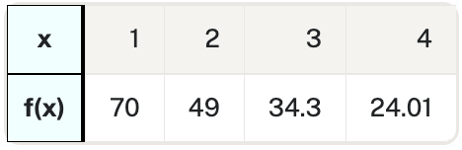
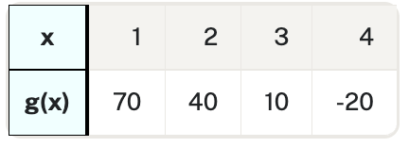
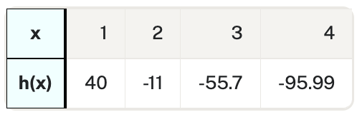

Key Takeaway: Exponential Function
The general form of the exponential formula is $f\left(x\right)=a{\left(b\right)}^{x}$
where $a$ is any nonzero number and $b$ is a positive real number not equal to 1.
- If $b>1$, the function grows at a rate proportional to its size.
- If $0<b<1$, the function decays at a rate proportional to its size.
Why do we limit the base to positive values?

Why do we limit the base to positive values other than 1?

Exponential Growth
To get a sense of the behavior of exponential growth, consider $f\left(x\right)= 2^{x}$.
x | −3 | −2 | −1 | 0 | 1 | 2 | 3
f(x)
The next number is 2 times the previous number — this is the constant ratio.
Characteristics of $f\left(x\right)= 2^{x}$.:
- Domain:
- Range:
- As x → ∞, f(x) →
- As x → −∞, f(x) →
- Horizontal asymptote:

Key Takeaway: Exponential Growth
A function that models exponential growth has the form $f\left(x\right)=a{\left(b\right)}^{x}$ where:
- a is the initial or starting value of the function
- b is the growth factor or growth multiplier per unit x

Example
Company A vs. Company B:
Company A has 100 stores and opens 50 new stores a year: $A\left(x\right)=100+50x$
Company B has 100 stores and increases by 50% each year: $B\left(x\right)=100{\left(1.5\right)}^{x}$
Year, x | Stores, Company A | Stores, Company B
0
1
2
3
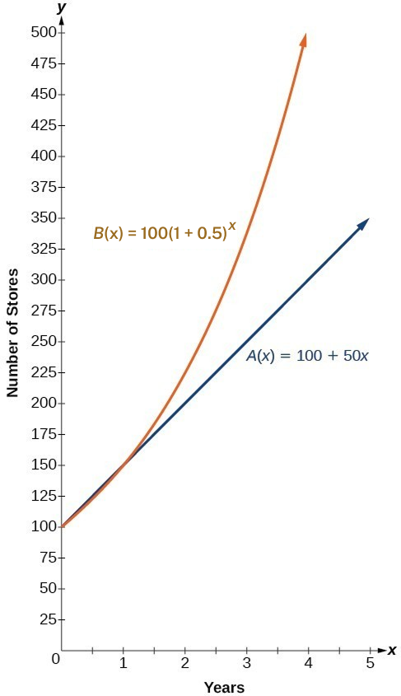
In $B\left(x\right)=100{\left(1.5\right)}^{x}=100{\left(1+0.5\right)}^{x}$
- initial value =
- growth rate =
- growth factor (base) =

Try It
The size of a rat population at the bay area of a certain city grows at a rate of 5% monthly. If there are 270 rats currently, find how many rats (rounded to the nearest whole) should be expected in 18 months.

Exponential Decay
To get a sense of the behavior of exponential decay, consider $g\left(x\right)={\left(\frac{1}{2}\right)}^{x}$.
x | −3 | −2 | −1 | 0 | 1 | 2 | 3
g(x)
Notice:
- Output values are positive for all values of x
- As x increases, output values grow smaller, approaching zero
- As x decreases, output values grow without bound
Characteristics:
- Domain:
- Range:
- x-intercept:
- y-intercept:
- Horizontal asymptote:

Try It
Determine whether the following equation represents exponential growth or exponential decay.
$y=\left(\frac{9}{25}\right){\left(\frac{17}{9}\right)}^{x}$

Try It
Does the graph represent exponential growth or decay?
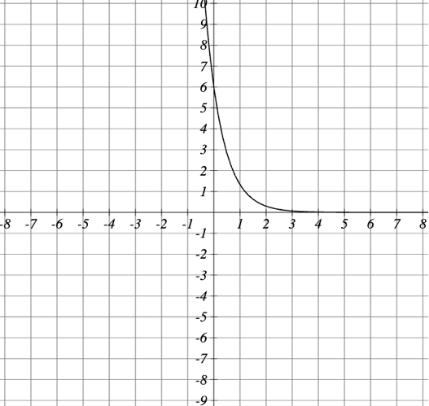

Graph Exponential Functions

Key Takeaway: Characteristics of the Graph of the Parent Function
An exponential function with the form $f\left(x\right)=b^{x}$, b > 0, b ≠ 1, has these characteristics:

Question Help
How to graph an exponential function in the form $f\left(x\right)=b^{x}$
- Create a table of points.
- Plot at least 3 points from the table including the y-intercept (0, 1).
- Draw a smooth curve through the points.
- State the domain (−∞, ∞), the range (0, ∞), and the horizontal asymptote y = 0.
Pro Tip
When sketching by plotting points, use inputs of −3, −2, −1, 0, 1, 2, and 3 to get the idea of the shape of the graph. With few exceptions, this is good practice for most functions.

Try It
Consider the function $f\left(x\right)=5^{x}$
  - The equation of the asymptote is:

  - The coordinates of the intercept are:
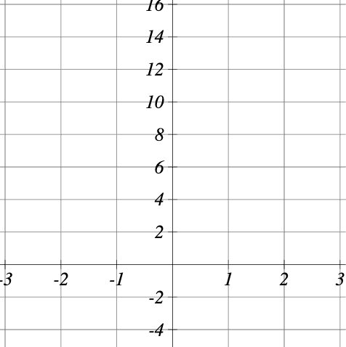
  - Draw the following:

    - Asymptote
    - Y-intercept
    - Function

Exponential Growth vs Decay
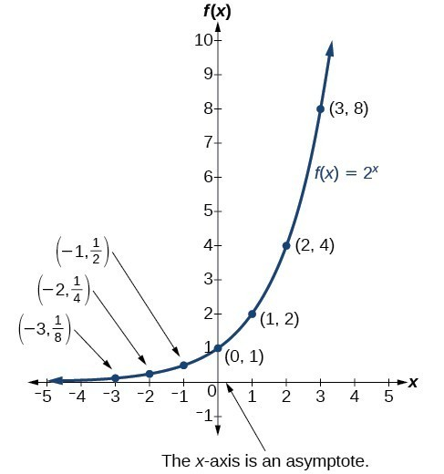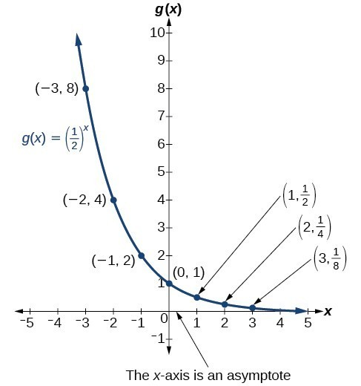
Compare and contrast the two exponential functions

Example
Sketch a graph of $f\left(x\right)={0.25}^{x}$. State the domain, range, and asymptote.

Try It
What function is graphed below?
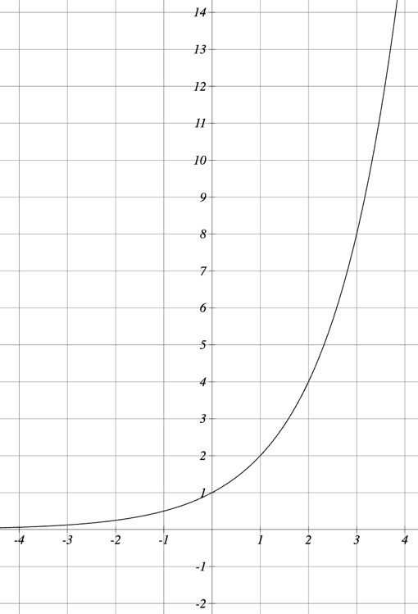

Example
Use a graphing utility to sketch a graph of $f\left(x\right)=\sqrt{2}{\left(\sqrt{2}\right)}^{x}$. State the domain and range.

Transformations of Exponential Graphs

Pro Tip
Translating exponential functions follows the same ideas you’ve used to translate other functions. Add or subtract a value inside the function argument (in the exponent) to shift horizontally, and add or subtract a value outside the function argument to shift vertically.

Graphing a Vertical Shift
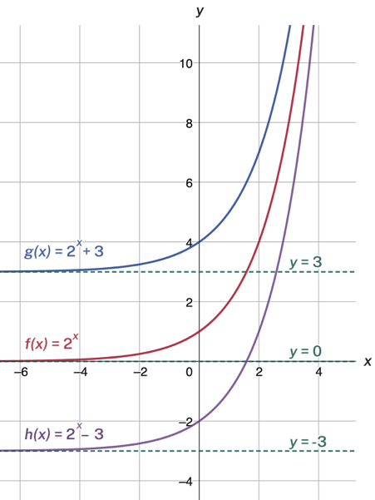
The first transformation occurs when we add a constant d to the parent function $f\left(x\right)=b^{x}$, giving a vertical shift d units in the same direction as the sign.

Example
Compare the graphs of $f\left(x\right)=2^{x}+3$, $f\left(x\right)=2^{x}$, and $f\left(x\right)=2^{x}-3$.

Graphing a Horizontal Shift
The next transformation occurs when we add a constant c to the input of the parent function $f\left(x\right)=b^{x}$, giving a horizontal shift c units in the opposite direction of the sign.
Compare the graphs of $f\left(x\right)=2^{x}$, $f\left(x\right)=2^{x+3}$ and $f\left(x\right)=2^{x-3}$.
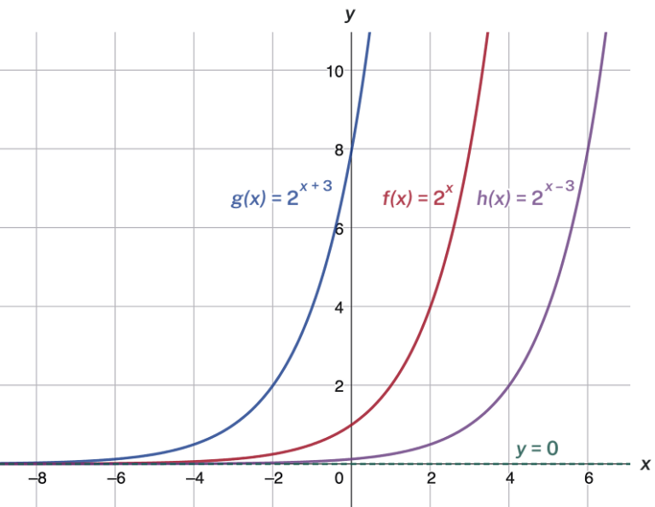

Key Takeaway
Shifts of the Parent Function $f\left(x\right)=b^{x}$
For any constants c and d, the function $f\left(x\right)=b^{x+c}+d$ shifts the parent function:

Question Help
Given an exponential function with the form $f\left(x\right)=b^{x+c}+d$, graph the translation
- Draw the horizontal asymptote y = d.
- Shift the graph of $f\left(x\right)=b^{x}$left c units if c is positive and right c units if c is negative.
- Shift the graph of $f\left(x\right)=b^{x}$up d units if d is positive and down d units if d is negative.
- State the domain (−∞, ∞), the range (d, ∞), and the horizontal asymptote y = d.

Example
Graph $f\left(x\right)=2^{x+1}-3$. State the domain, range, and asymptote.

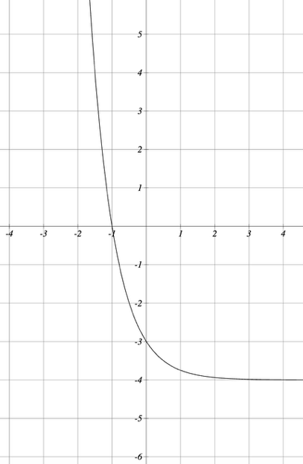
Try It
What is the equation of the function shown on the graph?

Try It
Draw the graph of the function $f\left(x\right)={\left(\frac{1}{3}\right)}^{x-1}$
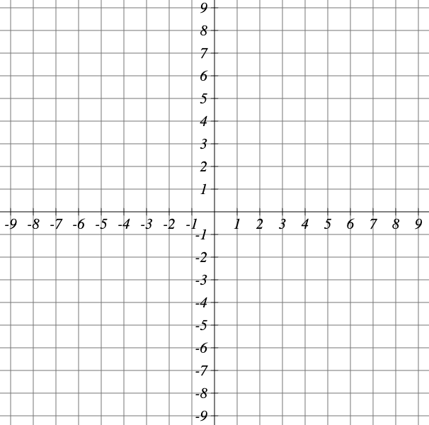

Stretching, Compressing, or Reflecting an Exponential Function
A stretch or compression occurs when we multiply the parent function f(x) = b^x by a constant |a| > 0.

Example
Explain the changes shown in the graphs below
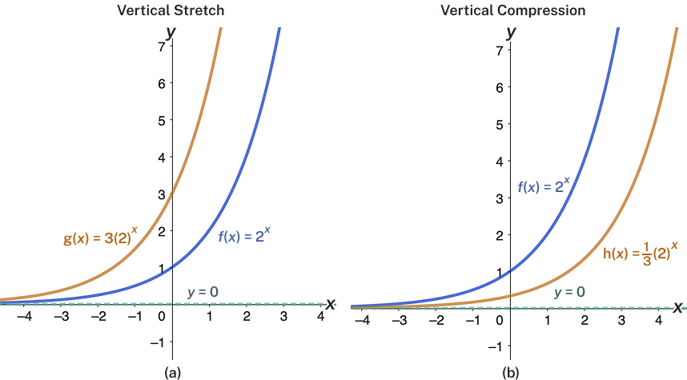

Key Takeaway
Stretches and Compressions of the Parent Function $f\left(x\right)=b^{x}$.
The function $f\left(x\right)=ab^{x}$:
- Is stretched…
- Is compressed…
- Has a y-intercept of
- Has a horizontal asymptote of

Pro Tip
Multipliers or negatives inside the function argument (in the exponent) affect horizontal transformations. Multipliers or negatives outside the function argument affect vertical transformations.

Example
Sketch a graph of $f\left(x\right)=4{\left(\frac{1}{2}\right)}^{x}$. State the domain, range, and asymptote.

Try It
Graph the function, then write the y-intercept as an ordered pair.
$$f\left(x\right)=3{\left(\frac{1}{5}\right)}^{x}$$
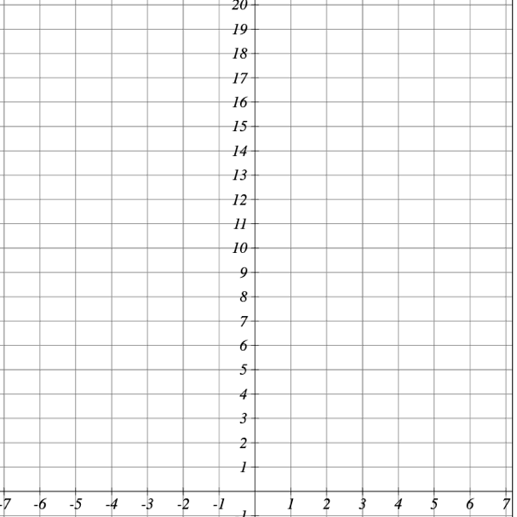

Graphing Reflections
When we multiply the parent function $f\left(x\right)=b^{x}$by −1, we get a reflection about the x-axis. When we multiply the input by −1, we get a reflection about the y-axis.

Example
Describe the differences between the graphs of the two types of reflections
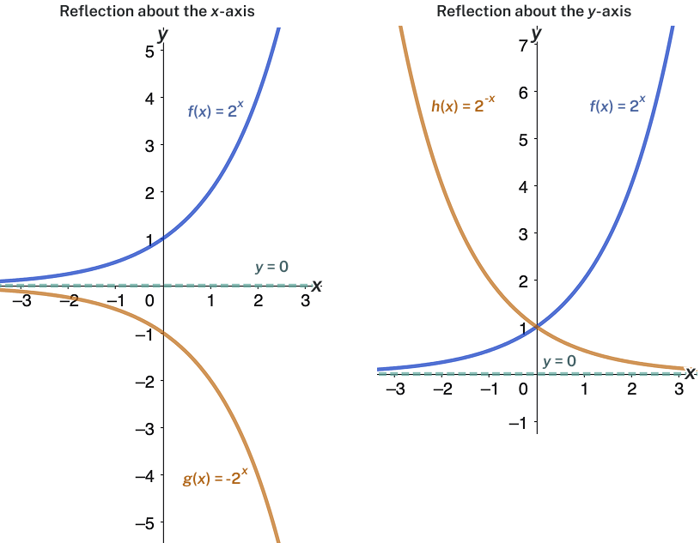

Key Takeaway
Reflecting the Parent Function $f\left(x\right)=b^{x}$
The function $f\left(x\right)={-b}^{x}$:
- Reflects the parent function about the x-axis
- Has a y-intercept of:
- Has a range of:
- Has a horizontal asymptote of:
The function $f\left(x\right)=b^{-x}$:
- Reflects the parent function about the y-axis
- Has a y-intercept of:
- Has a range of:
- Has a horizontal asymptote of:

Example
Find and graph the equation for a function g(x) that reflects $f\left(x\right)={\left(\frac{1}{4}\right)}^{x}$ about the x-axis. State its domain, range, and asymptote.

Summarizing Transformations of the Exponential Function

Key Takeaway
Translation | Form
Shift horizontally c units to the left, vertically d units up
Stretch if
Reflect about the x-axis
Reflect about the y-axis
General equation for all transformations
Note: The order of the shifts, transformations, and reflections follows the order of operations.

Example
Write the equation for the function described below. Give the horizontal asymptote, domain, and range.
$f\left(x\right)=e^{x}$ is vertically stretched by a factor of 2, reflected across the y-axis, and then shifted up 4 units.

Try It
Write the equation for the function shown in the graph.
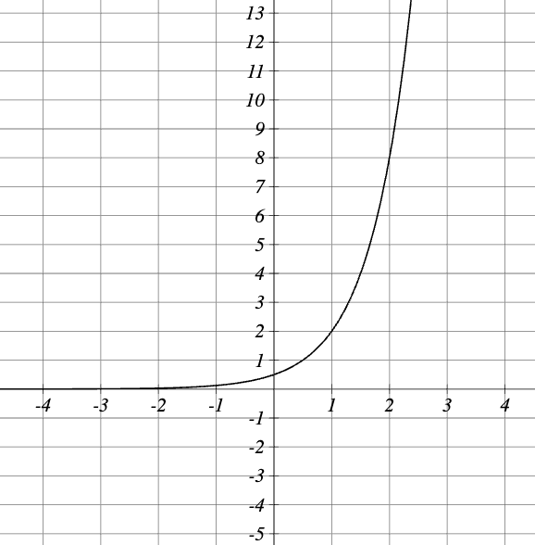

Try It
Write the equation of the exponential function in the form $f\left(x\right)=a⋅b^{x}+k$
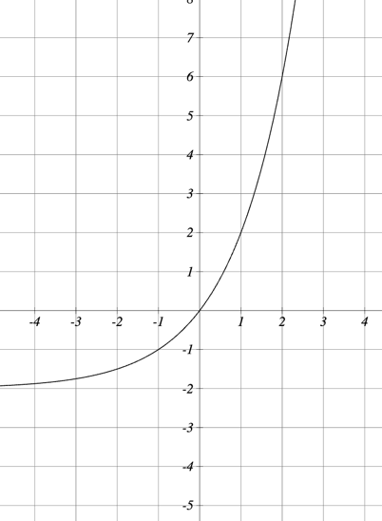

7.2 Exponential Functions

Evaluate Exponential Functions
To evaluate an exponential function with the form $f\left(x\right)=b^{x}$, we substitute x with the given value and calculate the resulting power.

Example
Let $f\left(x\right)=2^{x}$. What is f(3)?

Example
Let $f\left(x\right)=30{\left(2\right)}^{x}$. What is $f(3)$?

Example
Let $f\left(x\right)=5{\left(3\right)}^{x+1}$. Evaluate f(2) without using a calculator.

Try It
For the function $f\left(x\right)=3^{x-1}$ , calculate the following function values exactly:
$$f\left(5\right)=$$

$$f\left(8\right)=$$

Example
The population of India was about 1.25 billion in the year 2013, with an annual growth rate of about 1.2%. This situation is represented by the growth function $P\left(t\right)=1.25{\left(1.012\right)}^{t}$, where t is the number of years since 2013. To the nearest thousandth, what will the population of India be in 2031?

Try It
The population of Pakistan was about 0.182143 billion in the year 2013, with an annual growth rate of about 1.66%.
This situation is represented by the growth function $P\left(t\right)=0.172143{\left(1.0166\right)}^{t}$ where t is the number of years since 2013.
  - To the nearest thousandth, what will the population of Pakistan be in the year 2031?

  - In Example a previous example, we found the population of India in 2031 to be about 1.549 billion. Which statement is true for the year 2031?
- Pakistan's population will exceed India's population.
- India's population will exceed Pakistan's population.
  - By about how much will the larger population exceed the smaller population?

Finding Equations of Exponential Functions

Question Help
Given two data points, write an exponential model
- If one of the data points has the form (0, a), then a is the initial value. Using a, substitute the second point into the equation $f\left(x\right)=ab^{x}$, and solve for b.

- If neither of the data points have the form (0, a), substitute both points into two equations with the form $f\left(x\right)=ab^{x}$. Solve the resulting system of two equations to find a and b.

- Using the a and b found in the steps above, write the exponential function in the form f $f\left(x\right)=ab^{x}$

Example
In 2006, 80 deer were introduced into a wildlife refuge. By 2012, the population had grown to 180 deer. The population was growing exponentially. Write an algebraic function N(t) representing the population N of deer over time t.

Example
Find an exponential function that passes through the points (−2, 6) and (2, 1).

Try It
Find the exponential equation whose graph passes through the points $\left(-2,\frac{2}{9}\right)$ and $(3,54)$.

Question Help
Given the graph of an exponential function, write its equation
- Identify two points on the graph. Choose the y-intercept as one of the two points whenever possible.
- If one of the data points is the y-intercept (0, a), then a is the initial value. Using a, substitute the second point into $f\left(x\right)=ab^{x}$and solve for b.
- If neither of the data points have the form (0, a), substitute both points into two equations with the form $f\left(x\right)=ab^{x}$. Solve the resulting system to find a and b.
- Write the exponential function $f\left(x\right)=ab^{x}$.

Example
Find an equation for the exponential function graphed below.
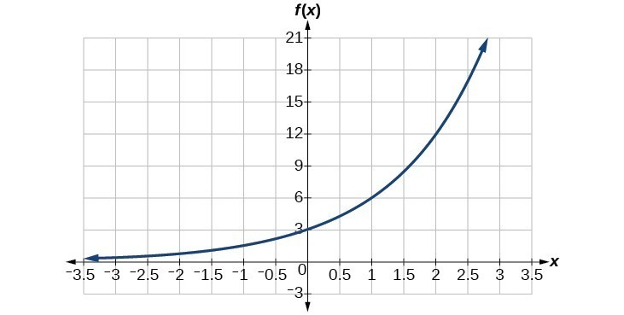

Try It
Find an equation of the graph sketched below.
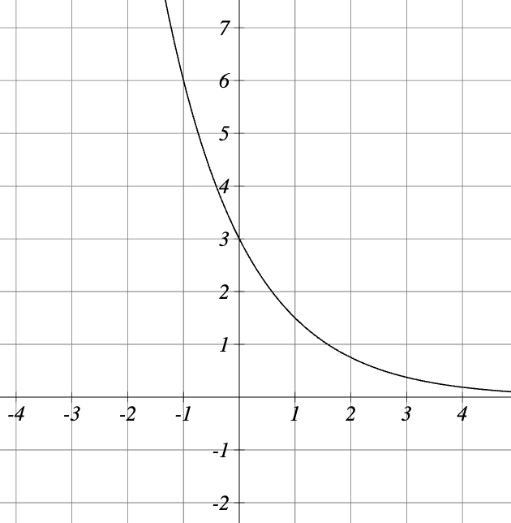

Question Help
Given two points on the curve of an exponential function, use a graphing calculator to find the equation
- Press [STAT].
- Clear any existing entries in columns L1 or L2.
- In L1, enter the x-coordinates given.
- In L2, enter the corresponding y-coordinates.
- Press [STAT] again. Cursor right to CALC, scroll down to ExpReg, and press [ENTER].
- The screen displays the values of a and b in the exponential equation y = a · b^x.
Given two points on the curve of an exponential function, use Desmos to find the equation
- Click the [+] icon in the top left corner and choose "Table."
- In the x₁ column, enter the x-coordinates of the given points.
- In the y₁ column, enter the corresponding y-coordinates.
- Click below the table to enter a new expression.
- Type the model: y₁ ~ a · b^(x₁)
- Desmos will display values for a and b that best fit the data.

Example
Use a graphing calculator to find the exponential equation that includes the points (2, 24.8) and (5, 198.4).

Try It
An exponential function passes through the points (0,11) and (3,297). What are the values of a and b?
a =
b =

Evaluating Exponential Functions with Base e
As compounding frequency increases, the value of $1 invested at 100% interest for 1 year approaches a limit:
Frequency | Value
Annually | $2
Semiannually | $2.25
Quarterly | $2.441406
Monthly | $2.613035
Daily | $2.714567
Hourly | $2.718127
Once per minute | $2.718279
Once per second | $2.718282

Key Takeaway: The Number e
The letter e represents the irrational number ${\left(1+\frac{1}{n}\right)}^{n}$as n increases without bound.
To work with e, we use the approximation: e ≈ 2.718282

Example
Calculate $e^{3.14}$. Round to five decimal places.

Try It
For the function $f\left(x\right)=5e^{x}$, calculate the given values.
  - $f\left(-3\right)$
  - $f\left(-1\right)$
  - $f\left(0\right)$
  - $f(1)$
  - $f(3)$

Example
Graph and state the characteristics of$f\left(x\right)=e^{x}$.

Example
Write the equation for the function described below. Give the horizontal asymptote, domain, and range.
$f\left(x\right)=e^{x}$ is vertically stretched by a factor of 2, reflected across the y-axis, and then shifted up 4 units.

Try It
Match the formula to its graph
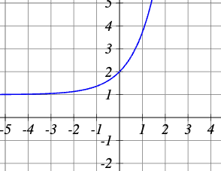 | $$f\left(x\right)=e^{x}-1$$
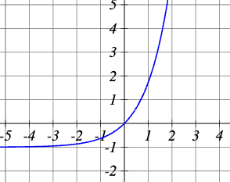 | $$f\left(x\right)=e^{x}+1$$
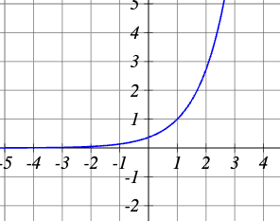 | $$f\left(x\right)=e^{x-1}$$
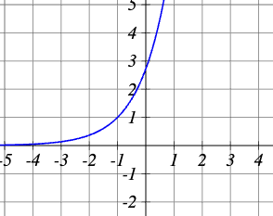 | $$f\left(x\right)=e^{x+1}$$

7.3 Logarithmic Functions

Converting Between Logarithmic and Exponential Form
If you know that $2^{3}=8$, you can say that the logarithm base 2 of 8 is 3: log₂(8) = 3
A logarithm tells us the power we need to raise a base to in order to get a certain number.
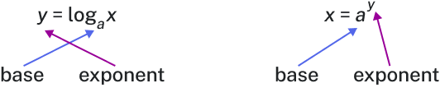
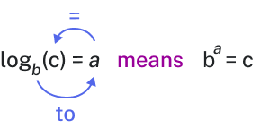

Key Takeaway: Logarithmic Function
A logarithm base b of a positive number x satisfies the following definition:
For x > 0, b > 0, b ≠ 1, $y=\log_{b}{x}$ is equal to $b^{y}=x$
- We read $\log_{b}{x}$ as "the logarithm with base b of x" or "log base b of x."
- The logarithm y is the exponent to which b must be raised to get x.
- If no base b is indicated, the base of the logarithm is assumed to b: .
- Domain of $\log_{b}{x}$:
- Range of $\log_{b}{x}$:

Can we take the logarithm of a negative number?

Question Help
Given an equation in logarithmic form $\log_{b}{x}=y$, convert it to exponential form
- Examine the equation ${y=log}_{b}{x}$ and identify b, y, and x.
- Rewrite $\log_{b}{x}=y$as $b^{y}=x$.

Example
Write the following logarithmic equations in exponential form.
- $\log_{6}{\sqrt{6}}=\frac{1}{2}$
- $log_{3}{9}=2$

Try It
Write the equation $\log_{v}\left(s\right)=w$ in exponential form

Example
Write the following exponential equations in logarithmic form.
- $2^{3}=8$
- $5^{2}=25$
- ${10}^{-4}=\frac{1}{10000}$

Try It
Write each of the following as a logarithmic equation.
- $5^{m}=6$

- $9^{4}=t$

Try It
Write the equation ${10}^{n}=q$ in logarithmic form.

Evaluating Logarithms

Question Help
Given a logarithm of the form $y=\log_{b}{(x)}$evaluate it mentally
- Rewrite the argument x as a power of b: $b^{y}=x$.
- Use previous knowledge of powers of b to identify y by asking, "To what exponent should b be raised in order to get x?"

Example
Solve y = log₄(64) without using a calculator.

Example
Evaluate $y=\log_{3}\left(\frac{1}{27}\right)$ without using a calculator.

Try It
Evaluate $\log_{3}{(81)}$

Try It
Evaluate $\log_{4}\left(\frac{1}{64}\right)$

Common Logarithms
Sometimes we may see a logarithm written without a base. In this case, the base is assumed to be 10.

Key Takeaway: Common Logarithm
A common logarithm is a logarithm with base 10. We write log₁₀(x) simply as log(x).
For x > 0: y = log(x) is equivalent to 10^y = x

Example
Evaluate log(100).

Example
Evaluate log(110).

Try It
Evaluate the logarithm $\log\left(\frac{1}{100}\right)$ without a calculator.

Try It
Evaluate using your calculator. Round to 3 decimal places.
$$\log\left(71\right)=$$
$$\log\left(6814\right)=$$
$$\log\left(0.00315\right)=$$
$$\log\left(0.72\right)=$$

Natural Logarithms
The most frequently used base for logarithms is e. Base e logarithms are called natural logarithms and have their own notation: ln(x).

Key Takeaway: Natural Logarithm
A natural logarithm is a logarithm with base e. We write $\log_{e}{(x)}$ simply as ln(x).
For x > 0: y = ln(x) is equivalent to $e^{y}=x$
Since $y=e^{x}$ and y = ln(x) are inverse functions:

Example
Evaluate y = ln(500) to four decimal places using a calculator.

Example
Evaluate ln(−500).

Try It
Evaluate the following expressions
- $\ln{e^{-5}}$
- $e^{\ln{5}}$
- $e^{\ln{\sqrt{3}}}$
- $\ln\left(\frac{1}{e^{5}}\right)$

Try It
Evaluate $\ln\left(77.4\right)$

Try It
Evaluate $\ln\left(-0.006\right)$

7.4 Graphs of Logarithmic Functions

Domain of Logarithmic Functions
Logarithmic functions are only defined for positive real numbers. The argument of the logarithm must be greater than zero.

Example
For $f\left(x\right)=\log_{4}{(2x-3)}$ set the argument greater than zero and solve:
$$2x-3>0$$

Question Help
Given a logarithmic function, identify the domain
- Set up an inequality showing the argument greater than zero.
- Solve for x.
- Write the domain in interval notation.

Example
What is the domain of $f\left(x\right)=\log_{2}{(x+3)}$?

Example
What is the domain of $f\left(x\right)=log⁡(5-2x)$?

Try It
Identify the domain of each function.
- $f\left(x\right)=log⁡(-7x+6)$
- $f\left(x\right)=\ln\left(7x-1\right)$
- $f\left(x\right)=\log_{9}{(-8x-7)}$

Try It
Find the domain of $y=\log_{2}{(x^{2}-16)}$

Try It
Find the domain of $\log_{6}\left(\frac{x-2}{x-8}\right)$.

Graphing a Logarithmic Function Using a Table of Values
Because every logarithmic function of the form $y=\log_{b}{x}$ is the inverse of an exponential function $y=b^{x}$, their graphs are reflections of each other across the line y = x.

Example
Observe the relationship between the input and output values of $y=2^{x}$ and $x=\log_{2}{y}$.
X | -3 | -2 | -1 | 0 | 1 | 2 | 3
$$f\left(x\right)=2^{x}$$
$$g\left(x\right)=\log_{2}{x}$$
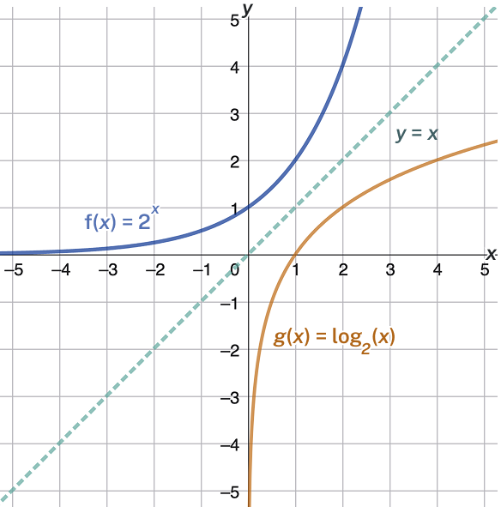
Observations:

Key Takeaway: Characteristics of the Graph of the Parent Function
For any real number x and constant b > 0, b ≠ 1:
- One-to-one function
- Vertical asymptote:
- Domain:
- Range:
- x-intercept:
- y-intercept:
- Increasing if
- Decreasing if
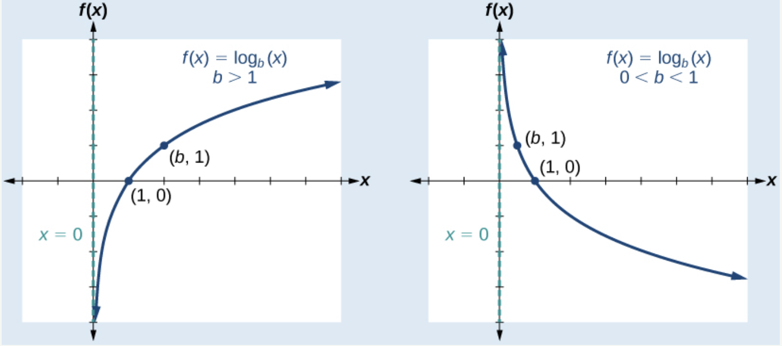

Question Help
Given a logarithmic function of the form $f\left(x\right)=\log_{b}{x}$, graph the function
- Draw and label the vertical asymptote x = 0.
- Plot the x-intercept (1, 0).
- Plot the key point (b, 1).
- Draw a smooth curve through the points.
- State the domain (0, ∞), the range (−∞, ∞), and the vertical asymptote x = 0.

Example
Graph $f\left(x\right)=\log_{5}{x}$. State the domain, range, and asymptote.
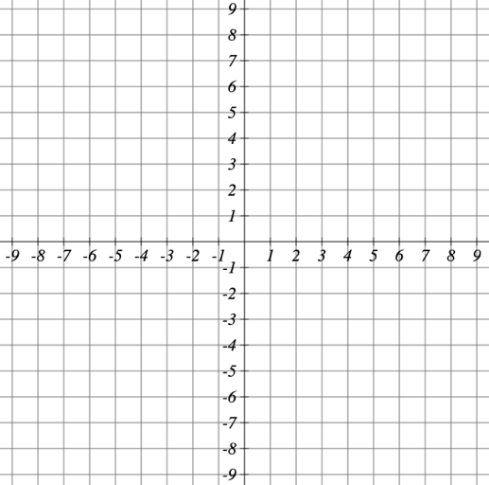

Example
Graph $f\left(x\right)=\log_{\frac{1}{5}}{x}$. State the domain, range, and asymptote.

Try It
Graph $y=\log_{4}{x}$

Try It
Graph $y=\log_{\frac{1}{2}}{x}$

Graphing Transformations of Logarithmic Functions

Graphing a Horizontal Shift
When a constant c is added to the input of $f\left(x\right)=\log_{b}{x}$, the result is a horizontal shift c units in the opposite direction of the sign on c.

Example
Using an online graphing calculator, plot $g\left(x\right)=\log_{b}{(x+c)}$ and $h\left(x\right)=\log_{b}{(x-c)}$. Adjust c to 4.
Which direction does the graph shift? What is the vertical asymptote, x-intercept, and equation for the new function?

Which direction does the graph of h(x) shift? What is the vertical asymptote, x-intercept, and equation for the new function?

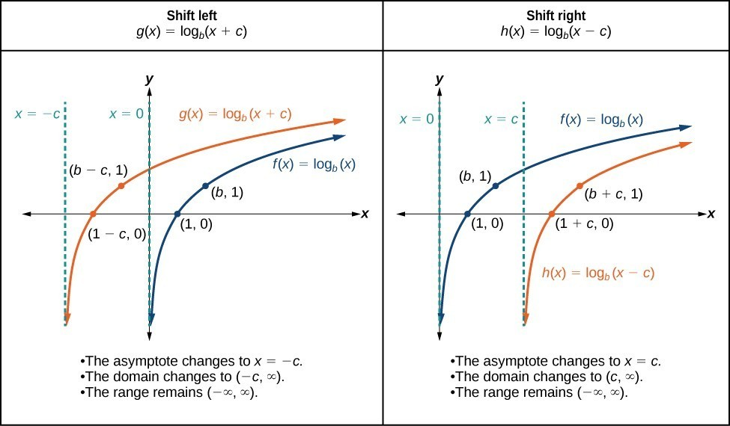

Key Takeaway: Horizontal Shifts of the Parent Function
For any constant c, the function $f\left(x\right)=\log_{b}{(x+c)}$:
- Shifts the parent function left c units if c > 0
- Shifts the parent function right c units if c < 0
- Has the vertical asymptote:
- Has domain:
- Has range:

Question Help
Given a logarithmic function of the form $f\left(x\right)=\log_{b}{(x+c)}$, graph the horizontal shift
- Identify the horizontal shift: left if c > 0, right if c < 0.
- Draw the vertical asymptote x = −c.
- Identify three key points from the parent function. Find new coordinates by subtracting c from the x-coordinate in each point.
- Label the three points.
- State the domain (−c, ∞), range (−∞, ∞), and vertical asymptote x = −c.

Example
Graph the function $f\left(x\right)=\log_{3}{(x-2)}$ alongside its parent function. Include the key points and asymptotes on the graph. State the domain, range, and asymptote.

Try It
Graph the function $f\left(x\right)=\log_{3}{(x+4)}$

Try It
Fill in the blanks to complete the sentence about the graph of $g\left(x\right)=\log_{3}{x}:$
The graph of the function $f\left(x\right)=\log_{3}{(x-7)}$ can be obtained from the graph of $g(x)$ by shifting the graph 7 units.

The domain of f(x) is The range of f(x) is

Graphing a Vertical Shift
When a constant d is added to the parent function $f\left(x\right)=\log_{b}{x}$, the result is a vertical shift d units in the direction of the sign of d.

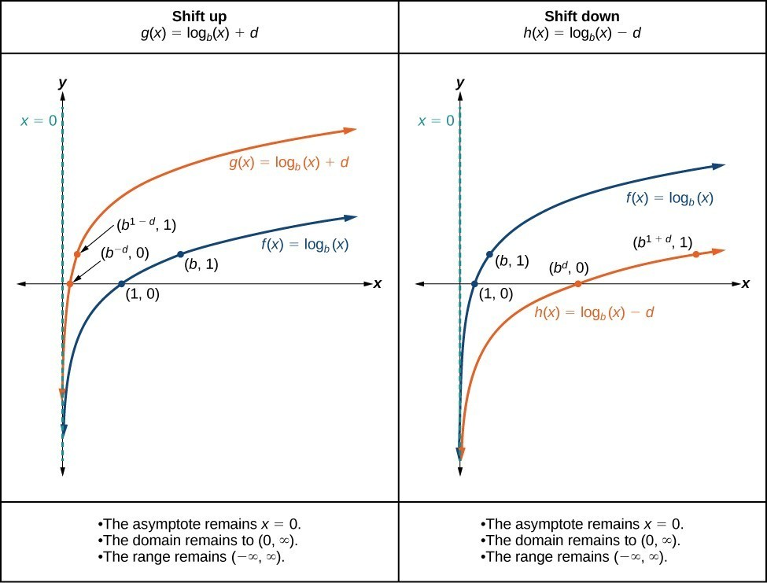

Key Takeaway: Vertical Shifts of the Parent Function
For any constant d, the function $f(x) = \log_{b}(x) + d$:
- Shifts the parent function up d units if d > 0
- Shifts the parent function down d units if d < 0
- Has the vertical asymptote:
- Has domain:
- Has range:

Question Help
Given a logarithmic function of the form $f(x) = \log_{b}(x) + d$, graph the vertical shift
- Identify the vertical shift: up if d > 0, down if d < 0.
- Draw the vertical asymptote x = 0.
- Identify three key points from the parent function. Find new coordinates by adding d to the y-coordinate of each point.
- Label the three points.
- State the domain (0, ∞), range (−∞, ∞), and vertical asymptote x = 0.

Example
Sketch a graph of $f\left(x\right)=\log_{3}{(x)}-2$ alongside its parent function. Include the key points and asymptote on the graph. State the domain, range, and asymptote.

Try It
Sketch a graph of $f\left(x\right)=\log_{5}{(x)}+1$

Try It
Fill in the blanks to complete the sentence about the graph of $g\left(x\right)=\log_{4}{x}:$
The graph of the function $f\left(x\right)=\log_{4}{(x-3)}$ can be obtained from the graph of $g(x)$ by shifting the graph 3 units.

The domain of f(x) is The range of f(x) is

Graphing Stretches and Compressions
When the parent function $f\left(x\right)=\log_{b}{x}$ is multiplied by a constant a > 0, the result is a vertical stretch or compression.

Example
Using an online graphing calculator, plot $g\left(x\right)=a\log_{b}{x}$ and $h\left(x\right)=\frac{1}{a}\log_{b}{x}$ Experiment with a values between 1 and 10.
Both the vertical stretch and compression produce graphs that are increasing. Which transformation produces a function that increases faster?

One of the key points that is commonly defined for transformations of a logarithmic function comes from finding the input that gives an output of y=1. This point can help you determine whether a graph is the result of a vertical compression or stretch. Explain why.

Key Takeaway: Vertical Stretches and Compressions of the Parent Function
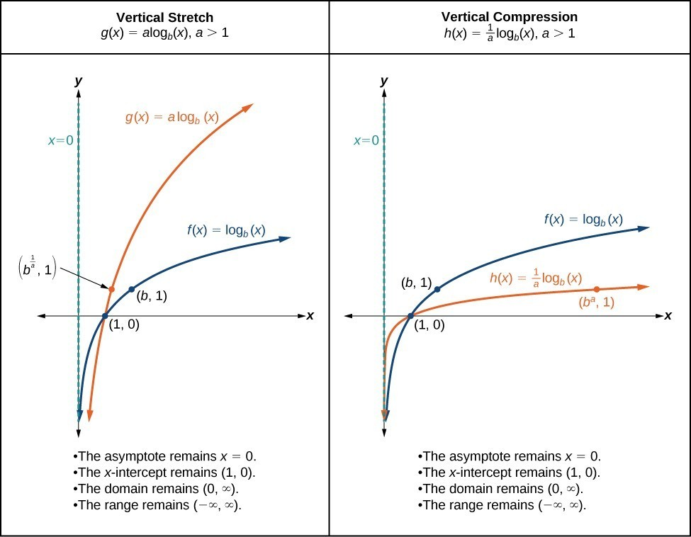
For any constant a > 1, the function $f\left(x\right)=a\log_{b}{x}$:
- Stretches the parent function vertically by a factor of a if a > 1
- Compresses the parent function vertically by a factor of a if 0 < a < 1
- Has the vertical asymptote:
- Has the x-intercept:
- Has domain:
- Has range:

Question Help
Given a logarithmic function of the form $f\left(x\right)=a\log_{b}{x}$, a > 0, graph the stretch or compression
- Identify vertical stretch (|a| > 1) or compression (|a| < 1).
- Draw the vertical asymptote x = 0.
- Identify three key points from the parent function. Find new coordinates by multiplying the y-coordinates by a.
- Label the three points.
- State the domain (0, ∞), range (−∞, ∞), and vertical asymptote x = 0.

Example
Graph the function $f\left(x\right)=2\log_{4}{x}$ alongside its parent function. Include the key points and asymptote on the graph. State the domain, range, and asymptote.

Example
Sketch a graph of $f\left(x\right)=5\log{(x+2)}$

Graphing Reflections
When the parent function $f\left(x\right)=\log_{b}{x}$ is multiplied by −1, the result is a reflection about the x-axis. When the input is multiplied by −1, the result is a reflection about the y-axis.

Example
Using an online graphing calculator,
plot $f\left(x\right)=\log_{b}{x}$, $g\left(x\right)=-\log_{b}{x}$, and $h\left(x\right)=\log_{b}{(-x)}$.
Which represents a vertical reflection?
Which represents a horizontal reflection?
Does the vertical asymptote change?

Key Takeaway: Reflections of the Parent Function
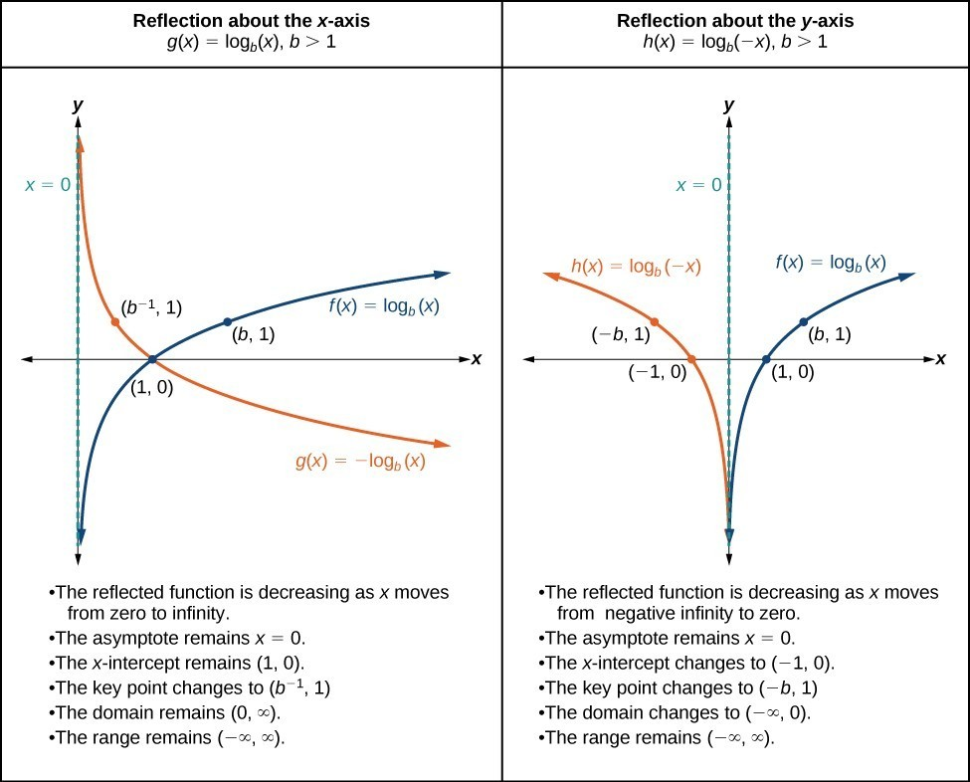
The function $f\left(x\right)=-\log_{b}{x}$:
- Reflects the parent function about the x-axis
- Domain:
- Range:
- Vertical asymptote:
The function $f\left(x\right)=\log_{b}{(-x)}$:
- Reflects the parent function about the y-axis
- Domain:
- Range:
- Vertical asymptote:

Question Help:
Given a logarithmic function with the parent function $f\left(x\right)=\log_{b}{(x)}$, graph a reflection
For $f\left(x\right)=-\log_{b}{x}$:
- Draw the vertical asymptote x = 0.
- Plot the x-intercept (1, 0).
- Reflect the graph of $f\left(x\right)=\log_{b}{(x)}$ about the x-axis.
- Draw a smooth curve through the points.
- State domain (0, ∞), range (−∞, ∞), asymptote x = 0.
For $f\left(x\right)=\log_{b}{(-x)}$:
- Draw the vertical asymptote x = 0.
- Plot the x-intercept (−1, 0).
- Reflect the graph of $f\left(x\right)=\log_{b}{(x)}$ about the y-axis.
- Draw a smooth curve through the points.
- State domain (−∞, 0), range (−∞, ∞), asymptote x = 0.

Example
Graph the function $f\left(x\right)=\log_{b}{(-x)}$ alongside its parent function. Include the key points and asymptote on the graph. State the domain, range, and asymptote.

Try It
Sketch a graph of $f\left(x\right)=4\log_{\frac{1}{4}}{(-x)}$

Try It
Match each equation with its graph:
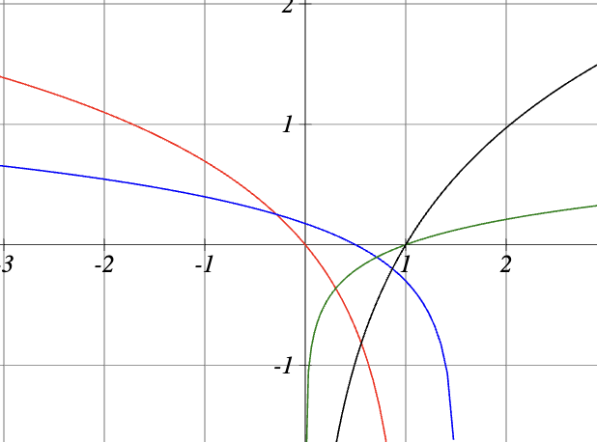
$y=\log\left(1.5-x\right)$
$$y=\ln{(1-x)}$$
$$y=1.4\ln{x}$$
$$y=0.7\log{x}$$

