Precalculus

Rational Functions Guided Notes
This tool is designed to work alongside your Study Plan and class sessions. Before class, you'll use it with the assigned readings by filling in key terms, noting examples, and writing down questions that arise. During class, you'll add to your notes as you deepen your understanding and instructors highlight important concepts. You'll find a mix of fill-in-the-blank sections, reflection spaces, and areas to record real-world examples.

Rational Functions

Key Takeaway: Rational Functions
A rational function is a function that can be written as the quotient of two polynomial functions P(x) and Q(x):
$$f\left(x\right)=\frac{P(x)}{Q(x)}=$$

When a variable is present in the denominator, certain values may cause the denominator to equal zero. A rational expression with a zero in the denominator is not defined.
Recall
Describe the graphs of the reciprocal functions shown below:
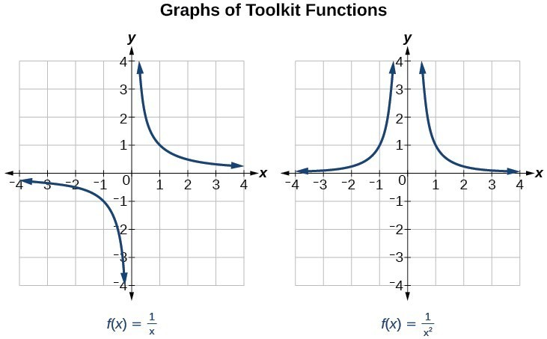

Arrow Notation

Key Takeaway: Arrow Notation
We use arrow notation to show that x or f(x) is approaching a particular value.
Symbol | Meaning
$$x→a^{-}$$ | x approaches a from the left (x < a but close to a)
$$x→a^{+}$$ | x approaches a from the right (x > a but close to a)
$$x→∞$$ | x approaches infinity (x increases without bound)
$$x→-∞$$ | x approaches negative infinity (x decreases without bound)
$$f(x)→∞$$ | the output approaches infinity (increases without bound)
$$f\left(x\right)→-∞$$ | the output approaches negative infinity (decreases without bound)
$$f(x)→a$$ | the output approaches a

Example
For $f\left(x\right)=\frac{1}{x}$, as the input values approach zero from the left:
x | -0.1 | -0.01 | -0.001 | -0.0001
f(x)
In arrow notation:
As the input values approach zero from the right:
x | 0.1 | 0.01 | 0.001 | 0.0001
f(x)
In arrow notation

Example
Use arrow notation to describe the behavior of f(x):
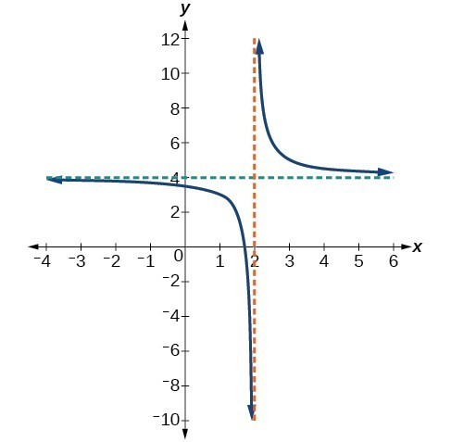
- As $x→-1^{-}$
- As $x→-1^{+}$
- As $x→-∞$
- As $x→∞$

Try It
Use the graph to answer the questions.
- As $x→2^{-}$
- As $x→2^{+}$
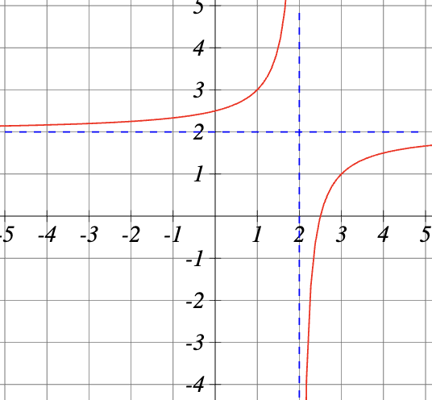
- As $x→-∞$
- As $x→∞$

Local Behavior and Vertical Asymptotes

Key Takeaway: Vertical Asymptote
A vertical asymptote of a graph is a vertical line x = a where the graph tends toward positive or negative infinity as the inputs approach a.
We write: as $x→a$, $f\left(x\right)→∞$, or as $x→a$, $f\left(x\right)→-∞$

Key Takeaway: Horizontal Asymptote
A horizontal asymptote of a graph is a horizontal line y = b where the graph approaches the line as the inputs increase or decrease without bound.
We write: as $x→∞$ or as $x→-∞$, $f\left(x\right)→b$

Example
Use arrow notation to describe the end behavior and local behavior of the function.

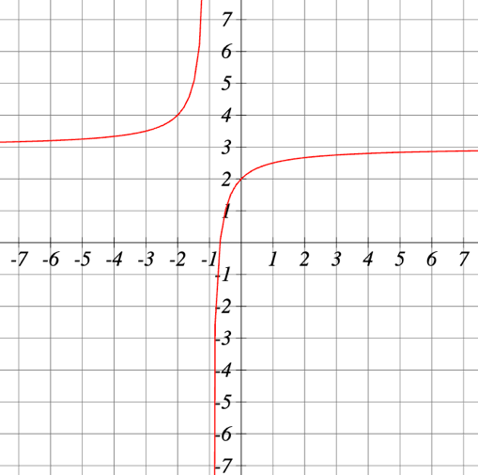
Try It
Describe the local behavior of the function.

Domain and Its Connection on Vertical Asymptotes

Key Takeaway: Domain of a Rational Function
The domain of a rational function includes all real numbers except those that cause the denominator to equal zero.

Question Help: Finding the Domain of a Rational Function
- Set the denominator equal to zero.
- Solve to find the values of the variable that cause the denominator to equal zero.
- The domain contains all real numbers except those found in Step 2.

Example
Find the domain of $f\left(x\right)=\frac{x+3}{x^{2}-9}$

Try It
Find the domain of the function $f\left(x\right)=\frac{30}{11x-13}$

Try It
Find the domain of the function $f\left(x\right)=\frac{7x+17}{x^{2}-12x+32}$

Vertical Asymptotes

Question Help: Identifying Vertical Asymptotes
- Factor the numerator and denominator.
- Note any restrictions in the domain of the function.
- Reduce the expression by canceling common factors in the numerator and denominator.
- Note any values that cause the denominator to be zero in the simplified version. These are where the vertical asymptotes occur.
- Note any restrictions where asymptotes do not occur. These are removable discontinuities.

Example
Find the vertical asymptote and the domain of $f\left(x\right)=\frac{x+3}{x^{2}-9}$

Key Takeaway: Removable Discontinuities
A removable discontinuity (hole) occurs in the graph of a rational function at x = a if a is a zero for a factor in the denominator that is common with a factor in the numerator.
To find it:

If the multiplicity of this factor is greater in the denominator, there is still a vertical asymptote at that value instead.

Example
Find the removable discontinuities of the graph of $f\left(x\right)=\frac{x^{2}-1}{x^{2}-2x-3}$

Example
Find the vertical asymptotes and removable discontinuities of the graph of
$$k\left(x\right)=\frac{x-2}{x^{2}-4}$$

Try It
Consider the rational function:
$$f\left(x\right)=\frac{-28(x+60)(x+5)}{(x+42)(x+27)(x+68)}$$
- List all the values of x where the function has a removable discontinuity

- List all values of x where the function has a vertical asymptote.

Try It
Describe the holes of the function $f\left(x\right)=\frac{x^{2}-9x+8}{x^{2}-12x+32}$

Horizontal and Slant Asymptotes
The horizontal asymptote of a rational function depends on the degrees of the numerator and denominator.
Case 1: Degree of numerator < degree of denominator → horizontal asymptote at y = 0

Example
$$f\left(x\right)=\frac{4x+2}{x^{2}+4x-5}$$

Case 2: Degree of numerator > degree of denominator by one → no horizontal asymptote; slant asymptote exists. Use polynomial long division to find the equation of the slant asymptote (the quotient, without the remainder).

Example
$$f\left(x\right)=\frac{3x^{2}-2x+1}{x-1}$$

If the degree of the numerator is greater than the degree of the denominator by more than one, the end behavior will mimic the graph of the reduced ratio of leading terms.
Case 3: Degree of numerator = degree of denominator → horizontal asymptote at $y=\frac{a_{n}}{b_{n}}$ (ratio of leading coefficients).

Example
$$f\left(x\right)=\frac{3x^{2}+2}{x^{2}+4x-5}$$

Pro Tip
The graph of a rational function may cross a horizontal or slant asymptote but will never cross a vertical asymptote. A rational function will have at most one horizontal or slant asymptote.

Example
You’ll need to graph the rational function $f\left(x\right)=\frac{4x^{a}+2}{x^{b}+2x-3}$ using an online graphing calculator.
Adjust the a and b values to obtain the following asymptotes:
- A slant asymptote a = _______ b = _______
- A horizontal asymptote of y = 0 a = _______ b = _______
- A horizontal asymptote of y = 4 a = _______ b = _______

Example
For the functions below, identify the horizontal or slant asymptote.
- $g\left(x\right)=\frac{6x^{3}-10x}{2x^{3}+5x^{2}}$

- $h\left(x\right)=\frac{x^{2}-4x+1}{x+2}$

- $k\left(x\right)=\frac{x^{2}+4x}{x^{3}-8}$

Example
Find the horizontal and vertical asymptotes of the function
$$f\left(x\right)=\frac{(x-2)(x+3)}{(x-1)(x+2)(x-5)}$$

Try It
Determine the horizontal asymptote for each function.
- $f\left(x\right)=\frac{8x-9}{16x^{2}+1}$

- $g\left(x\right)=\frac{15x+5}{5x-1}$

- $f\left(x\right)=\frac{9}{7-9x^{2}}$

- $p\left(t\right)=\frac{t^{2}}{-2t+8 }$

Try It
Given $f\left(x\right)=\frac{3x^{2}-x-2}{2x^{2}-5x-12}$
- Vertical asymptotes are:

- Horizontal asymptote is:

Try It
Determine the equation of the vertical and slant asymptotes for the rational function.
$$f\left(x\right)=\frac{40x^{2}+36x+2}{-8x-4}$$

Finding Intercepts of Rational Functions

Key Takeaway: Intercepts of Rational Functions
- A rational function will have a y-intercept when the input is zero, if the function is defined at zero. Find it by evaluating r(0).
- A rational function will have x-intercepts at the inputs that cause the output to be zero. Since a fraction equals zero only when the numerator is zero, set the numerator equal to zero and solve.

Example
Find the intercepts of $f\left(x\right)=\frac{(x-2)(x+3)}{(x-1)(x+2)(x-5)}$

Try It
Given
$$f\left(x\right)=\frac{3x+4}{4x^{2}+4x-15}=\frac{3x+4}{(2x+5)(2x-3)}$$
Find:
- The domain in interval notation
- The y-intercept
- The x-intercepts
- The vertical asymptote
- The horizonal asymptote

Graphing Rational Functions

Example
Connect the features of the graph to the equation of the rational function.
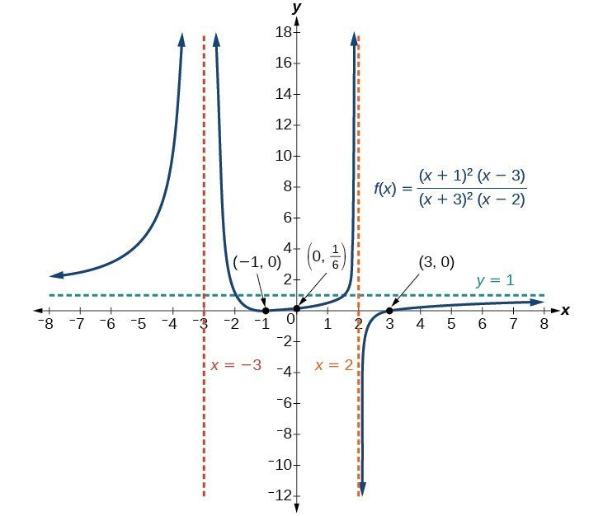

Question Help: Graphing a Rational Function
- Simplify: Factor and reduce common factors if possible.
- Find the Domain: Determine where the denominator equals zero.
- Identify Vertical Asymptotes and Holes: Check if the numerator is also zero at those values — if so, it's a hole; if not, it's a vertical asymptote.
- Find the Horizontal or Slant Asymptote: Compare degrees of numerator and denominator.
- Find the Intercepts: Set numerator = 0 for x-intercepts; evaluate f(0) for the y-intercept.
- Plot Key Points: Calculate points on either side of the vertical asymptotes if needed.
- Sketch the Graph: Draw asymptotes as dashed lines, plot intercepts and key points, draw the curve approaching the asymptotes appropriately.

Example
Graph the function
$$f\left(x\right)=\frac{(x+2)(x-3)}{{\left(x+1\right)}^{2}(x-2)}$$
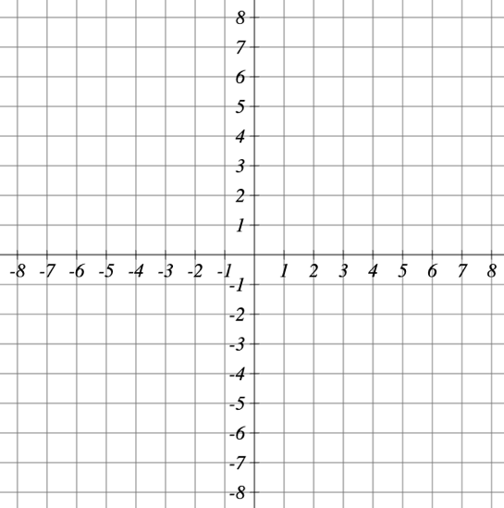

Try It
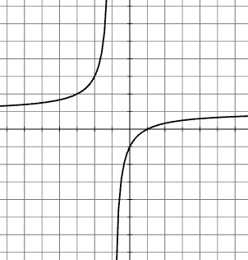
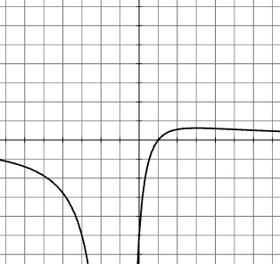
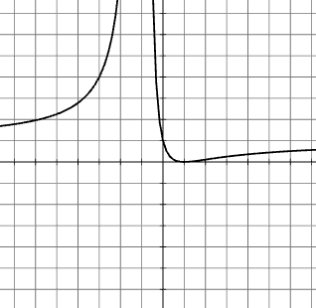
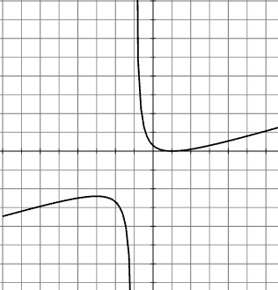
Match each equation type with a graph
- $y=\frac{{\left(x-A\right)}^{2}}{{\left(x-B\right)}^{2}}$
- $y=\frac{x-A}{x-B}$
- $y=\frac{x-A}{{\left(x-B\right)}^{2}}$
- $y=\frac{{\left(x-A\right)}^{2}}{x-B}$

Try It
Graph the function $y=\frac{-3(x-2)}{(x+1)(x-3)}$

Writing Rational Functions

Question Help: Writing a Rational Function from a Graph
- Determine the factors of the numerator. Examine the behavior at the x-intercepts to determine the zeros and their multiplicities.
- Determine the factors of the denominator. Examine the behavior on both sides of each vertical asymptote to determine the factors and their powers.
- Use any clear point on the graph to find the stretch factor a.

Example
Write an equation for the rational function below
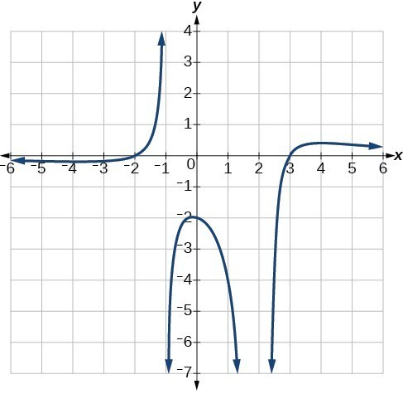

Try It
Write an equation for the graph
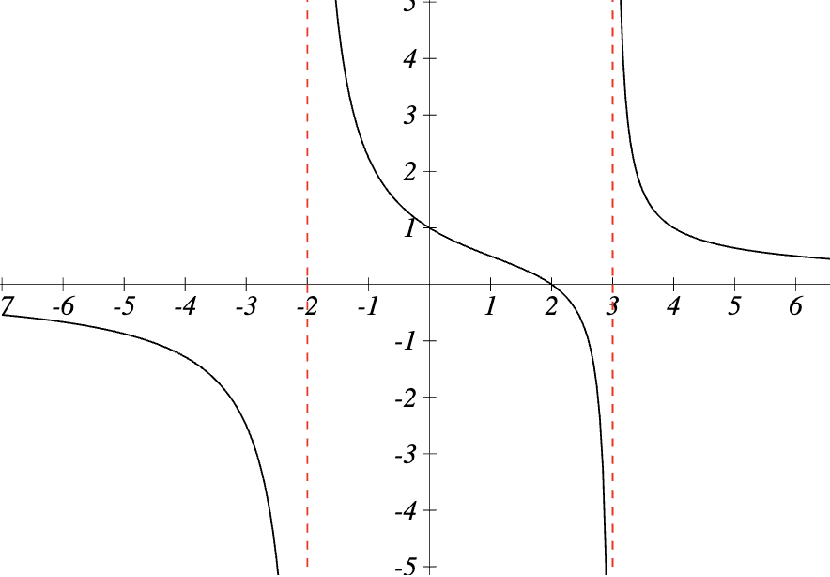

Try It
Write an equation for a rational function with:
- Vertical asymptotes at x = -1 and x = 4
- x-intercepts at x = 6 and x = -6
- y-intercept at y = 4

Applications of Rational Functions

Solving a Rational Equation

Key Takeaway: Rational Equations
A rational equation contains at least one rational expression where the variable appears in at least one of the denominators.
Strategy: Eliminate all denominators by multiplying both sides by the least common denominator (LCD). The LCD contains the highest power of all factors in all denominators.
Pro Tip: When one of the denominators is a binomial like (x+1), always treat it as a single factor — the terms cannot be separated. Writing all binomial denominators in parentheses helps keep track of this.

Example
Solve the rational equation:
$$\frac{7}{2x}-\frac{5}{3x}=\frac{22}{3}$$

Example
What is the least common denominator for a problem with denominators:
$x$, $x-1$, $3x-3$

Question Help: Solving a Rational Equation
- Factor all denominators in the equation.
- Find and exclude values that set each denominator equal to zero.
- Find the LCD.
- Multiply the whole equation by the LCD. If the LCD is correct, there will be no denominators left.
- Solve the remaining equation.
- Check solutions back in the original equation to avoid a solution producing zero in a denominator.

Example
Solve the following rational equation:
$$\frac{2}{x}-\frac{3}{2}=\frac{7}{2x}$$

Example
Solve the following rational equation:
$$\frac{1}{x}=\frac{1}{10}-\frac{3}{4x}$$

Example
Solve the following rational equations and state the excluded values:
- $\frac{3}{x-6}=\frac{5}{x}$

- $\frac{x}{x-3}=\frac{5}{x-3}-\frac{1}{2}$

- $\frac{x}{x-2}=\frac{5}{x-2}-\frac{1}{2}$

Try It
Solve the following rational equation:
$$\frac{a+2}{3}+\frac{8}{2}=\frac{7a+8}{7}$$

Solve Applied Problems Involving Rational Functions

Example
A large mixing tank currently contains 100 gallons of water into which 5 pounds of sugar have been mixed. A tap will open pouring 10 gallons per minute of water into the tank at the same time sugar is poured into the tank at a rate of 1 pound per minute. Find the concentration (pounds per gallon) of sugar in the tank after 12 minutes. Is that a greater concentration than at the beginning?

Try It
A large mixing tank currently contains 90 gallons of water into which 5 pounds of sugar have been mixed. A tap will open pouring 25 gallons per minute of water into the tank at the same time sugar is poured into the tank at a rate of 2 pound per minute.

Try It
A large mixing tank currently contains 120 gallons of water into which 8 pounds of sugar have been mixed. A tap will open pouring 10 gallons per minute of water into the tank at the same time sugar is poured into the tank at a rate of 1 pound per minute.

Try It
Neel and his friend Aleshya are heading out to Atlanta on a road trip. From Neel's front door to downtown Atlanta, the trip is 412.5 miles. Answer the following questions based upon this situation.
Use the relationship, Distance = Rate times Time or d=rt, to write a rational function T(r) that has the rate of travel, r (in mph), as its input and the time of travel (in hours) as its output.
- Solve the equation d = rt for t. What is the new equation?

- Rewrite your new equation as a function where t = T(r) and d = 412.5

- Determine the driving time to reach Atlanta if Neel and Aleshya drive 65 miles per hour.

- If it takes Neel and Aleshya 7.5 hours of driving time to reach Atlanta, determine how fast they drove.

- Give the equation of the vertical asymptote of T(r). What is the significance of the asymptote?

Solving a Rational Inequality
A rational inequality contains at least one rational expression where the variable appears in a denominator, combined with an inequality symbol (<, $≤$, >, or $≥$).

Example
Solve the rational inequality
$$\frac{x-4}{x+2}>0$$

Question Help: Solving a Rational Inequality
- Write the inequality so that one side is zero and the other side is a single rational expression.
- Identify critical values (zeros of the numerator and undefined points from the denominator).
- Use a sign chart to test the sign of the expression in each interval.
- Determine the interval(s) where the expression satisfies the inequality.

Pro Tip
- Include excluded values

- Not setting one side to zero:

- Open vs. closed intervals

Example
Solve the rational inequality
$$\frac{x+3}{x-5}≤0$$

Try It
Solve the rational inequality
$$\frac{x^{2}-16}{x-1}>0$$

Try It
Solve the rational inequality
$$\frac{5x}{x+3}≤4$$

Modeling Using Variation

Direct Variation

Key Takeaway: Direct Variation
If x and y are related by an equation of the form $y=kx^{n}$
then the relationship is direct variation and y varies directly with the nth power of x.
- The nonzero constant k = is called the constant of variation.

Example
A used-car company has just offered their best candidate, Nicole, a position in sales. The position offers 16% commission on her sales. Her earnings depend on the amount of her sales.
Complete the table to model the sales price and earnings.
S, sales price | e = 0.16s | Interpretation
$4,600
$9,200
$18,400

Sketch the graph of the relationship and add notes regarding direct variation

Question Help: Solving a Direct Variation Problem
- Identify the input x and the output y.
- Determine the constant of variation. You may need to divide y by the specified power of x.
- Use the constant of variation to write an equation for the relationship.
- Substitute known values into the equation to find the unknown.

Example
The quantity y varies directly with the cube of x. If y = 25 when x= 2, find y when x is 6.

Try It
The electrical current, in amperes, in a circuit varies directly as the voltage. When 15 volts are applied, the current is 5 amperes. What is the current when 36 volts are applied?

Try It
A number of graphs, tables, equations, and descriptions are shown below. Circle all that represent a direct variation.
- The hiker climbed at a constant rate from the elevation of 3000 feet to 5000 feet on the mountain. | - The temperature changed at a constant rate of 1.5 degrees every 15 minutes starting at 0 degrees Celsius.
  x | 1 | 2 | 3 | 4
  y | 0.5 | -1 | -4.5 | -10
  x | 1 | 2 | 3 | 4
  y | 2 | 4 | 6 | 8
$$y=\frac{1.5}{x+2}+0.5$$ | $$y=1.5x+2$$
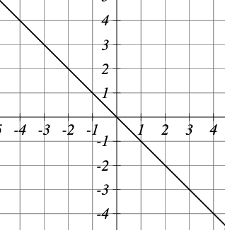 | 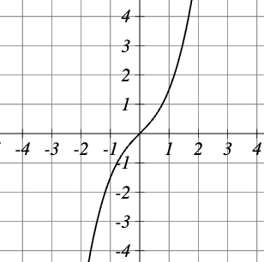

Inverse Variation

Key Takeaway: Inverse Variation
In an inverse variation, the relationship between x and y is: $y=\frac{k}{x^{n}}$
where k is a nonzero constant, and y varies inversely with the power of x

Example
Water temperature in an ocean varies inversely to the water’s depth. Between the depths of 250 feet and 500 feet, the formula $T=\frac{1400}{d}$ gives us the temperature in degrees Fahrenheit at a depth in feet below Earth’s surface.

Consider the Atlantic Ocean, which covers 22% of Earth’s surface. At a certain location, at the depth of 500 feet, the temperature may be 28∘F. Complete the table to model depth and temperature.
d, depth | $$T=\frac{1400}{d}$$ | Interpretation
250
350
500
Sketch the graph of the relationship and add notes regarding direct variation

Example
A tourist plans to drive 100 miles. Find a formula for the time the trip will take as a function of the speed the tourist drives.

Question Help: Solving an Inverse Variation Problem
- Identify the input x and the output y.
- Determine the constant of variation. You may need to multiply y by the specified power of x.
- Use the constant of variation to write an equation for the relationship.
- Substitute known values into the equation to find the unknown.

Example
A quantity y varies inversely with the cube of x. If y = 25 when x = 2, find y when x = 6.

Try It
Suppose z varies inversely with t and that z = 16 when t = 11. What is the value of z when t = 4?

Try It
The loudness, L of a sound (measured in decibels, dB) is inversely proportional to the square of the distance, d, from the source of the sound.
- Give the general equation
- A person 8 feet from a jetski records the sound as 65 decibels. What is k?
- What is the mathematical model for the jetski’s sound?
- How loud is the jetski when the person is 40 feet away?

Joint Variation

Key Takeaway: Joint Variation
Joint variation occurs when a variable varies directly or inversely with multiple variables.
- If x varies directly with both y and z: x = kyz
- If x varies directly with y and inversely with z: $x=\frac{ky}{z}$
Note: Only one constant k is used in a joint variation equation.

Example
A quantity x varies directly with the square of y and inversely with the cube root of z. If x = 6 when y = 2 and z = 8, find x when y = 1 and z = 27.

Try It
Write an equation for z if we know that z varies jointly with x and y.

Try It
Suppose that z varies jointly with x and y.
- Find k if z = 90 when y = 18 and x = 10.
- Use the value of k found in part (a) to write the variation equation in terms of x and y.
- Find z given that y = 27 and x = 18.

