Precalculus

Polynomial Equations Guided Notes
This tool is designed to work alongside your Study Plan and class sessions. Before class, you'll use it with the assigned readings by filling in key terms, noting examples, and writing down questions that arise. During class, you'll add to your notes as you deepen your understanding and instructors highlight important concepts. You'll find a mix of fill-in-the-blank sections, reflection spaces, and areas to record real-world examples.

Dividing Polynomials

Polynomial Long Division
Division of polynomials that contain more than one term has similarities to long division of whole numbers. We can write a polynomial dividend as the product of the divisor and the quotient added to the remainder.

Example
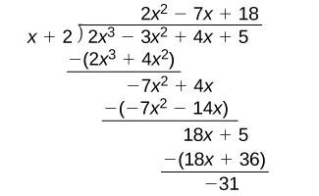
We call this the Division Algorithm and will discuss it more formally after looking at an another example.

Example
Divide $2x^{3}-3x^{2}+4x+5$ by $x+2$ using long division:

Key Takeaway: The Division Algorithm
The Division Algorithm states that given a polynomial dividend f(x) and a non-zero polynomial divisor d(x) where the degree of d(x) is less than or equal to the degree of f(x), there exist unique polynomials q(x) and r(x) such that:
$$f\left(x\right)=d\left(x\right)q\left(x\right)+r(x)$$
- q(x) is the quotient and r(x) is the remainder.
- The remainder is either equal to zero or has degree strictly less than d(x).
- If r(x) = 0, then d(x) divides evenly into f(x), meaning both d(x) and q(x) are factors of f(x).

Question Help: Polynomial Long Division
- Set up the division problem.
- Determine the first term of the quotient by dividing the leading term of the dividend by the leading term of the divisor.
- Multiply the answer by the divisor and write it below the like terms of the dividend.
- Subtract the bottom binomial from the terms above it.
- Bring down the next term of the dividend.
- Repeat steps 2–5 until reaching the last term of the dividend.
- If the remainder is non-zero, express as a fraction using the divisor as the denominator.

Example
Divide $6x^{3}+11x^{2}-31x+15$ by $3x-2$

Try It
Use polynomial long division $-x^{3}-2x^{2}-4x-1$ by $x+2$.

Try It
Find the quotient and remainder using long division for:
$$\frac{x^{2}+10x+29}{x+3}$$

Synthetic Division

Key Takeaway
Synthetic division is a shortcut that can be used when the divisor is a binomial in the form x - k where k is a real number. In synthetic division, only the coefficients are used in the division process.

Example
This is what it looked like to divide using long division:
If we don’t write the variables, and instead line up the coefficients we get synthetic division:

Question Help: Synthetic Division
- Write k for the divisor.
- Write the coefficients of the dividend.
- Bring the lead coefficient down.
- Multiply the lead coefficient by k. Write the product in the next column.
- Add the terms of the second column.
- Multiply the result by k. Write the product in the next column.
- Repeat steps 5 and 6 for the remaining columns.
- Use the bottom numbers to write the quotient. The number in the last column is the remainder (degree 0), the next number from the right has degree 1, the next has degree 2, and so on.
Pro Tip
If a term is missing from the dividend (e.g., no x-term), use 0 as its coefficient so every degree is represented in your list.

Example
Use synthetic division to divide $4x^{3}+10x^{2}-6x-20$ by $x+2$.

Try It
Find the quotient and remainder using long division for:
$$\frac{x^{2}+6x+11}{x+3}$$

Try It
Find the quotient and remainder using synthetic division for:
$$\frac{x^{3}+10x^{2}+20x+10}{x+2}$$

Example
Use synthetic division to divide $-9x^{4}+10x^{3}+7x^{2}-6$ by $x-1$.

Try It
Divide $5x^{4}+5x^{3}-x^{2}+2$ by $x-2$

Complex Numbers

Imaginary Numbers

Example
Consider the square root of -25.
$$\sqrt{-25}=\sqrt{25⋅\left(-1\right)}$$
$$=\sqrt{25}⋅\sqrt{-1}$$
$$=5i$$

Key Takeaway: The Imaginary Unit
The imaginary number i is defined as: $i=\sqrt{-1}$.
Any real multiple of i, like 5i, is also an imaginary number.

Example
Simplify $\sqrt{-9}$

Try It
Express $\sqrt{-12}$ as a fully simplified complex number in terms of i

Complex Numbers

Key Takeaway: Complex Numbers
A complex number is a number z = a + bi, where:
- a and b are real numbers
- a is the real part of the complex number
- b is the imaginary part of the complex number

Example
5 + 2i is a complex number. Label the real and imaginary part.

Try It
Identify the real and imaginary part of the number $6-2i$.

The Complex Plane

Key Takeaway: The Complex Plane
In the complex plane, the horizontal axis is the real axis and the vertical axis is the imaginary axis.
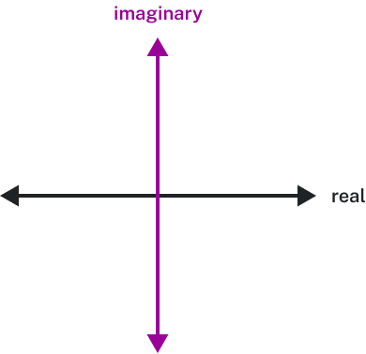
To plot a complex number z = a + bi, treat it like the point (a, b) in the coordinate plane.

Question Help: Plotting Complex Numbers
- Determine the real part and the imaginary part of the complex number.
- Move along the horizontal axis to show the real part of the number.
- Move parallel to the vertical axis to show the imaginary part of the number.
- Plot the point.

Example
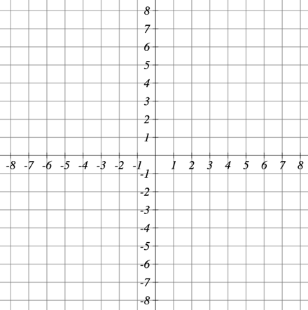
Plot the number $3-4i$on the complex plane.

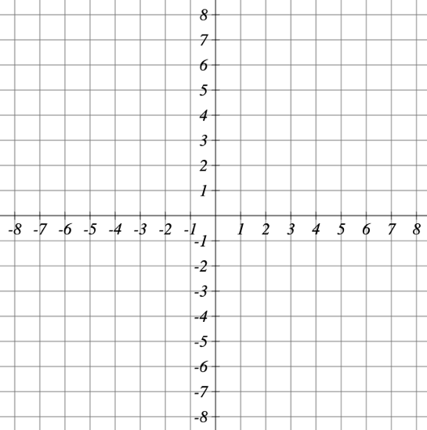
Try It
Plot the complex number $-3-i$

Arithmetic on Complex Numbers

Key Takeaway: Adding and Subtracting Complex Numbers
Adding
$$\left(a+bi\right)+\left(c+di\right)=\left(a+c\right)+\left(b+d\right)i$$
Subtracting
$$\left(a+bi\right)-\left(c+di\right)=\left(a+c\right)-\left(b+d\right)i$$
Combine the real parts and combine the imaginary parts separately.

Example
Add $3-4i$ and $2+5i$

Try It
- Add $\left(14-5i\right)+(21+12i)$

- Subtract $\left(14-5i\right)-(21-12i)$

Example
Visualize the addition of $3-4i$ and $-1+5i$.

Multiplying Complex Numbers

Multiplying a Complex Number by a Real Number

Example
$$3(6+2i)$$

Try It
Simplify $6(4-6i)$

Multiplying Complex Numbers Together

Example
$$(2+5i)(4+i)$$

Try It
Multiply the complex numbers
$$(3+i)(-1+2i)$$

Try It
$${\left(4+i\right)}^{2}$$

Example
Using the complex plane, visualize the product $2(1+2i)$

Example
Using the complex plane, visualize the result of multiplying $1+2i$ by $1+i$.

Simplifying Powers of i

Key Takeaway: The Cycle of Powers of i
The powers of i repeat in a cycle of 4:
Power |  | Value
$$i$$ |  | $$i$$
$$i^{2}$$ |  | -1
$$i^{3}$$ | $$i^{2}⋅i=-1⋅i$$ | $$-i$$
$$i^{4}$$ | $$i^{3}⋅i=-i⋅i=-i^{2}=-(-1)$$ | 1
$$i^{5}$$ | $$i^{4}⋅i=1⋅i$$ | $$i$$
 |  | (cycle repeats)

Example
Evaluate $i^{35}$

Dividing Complex Numbers (Rationalizing the Denominator)

Complex Conjugate
The complex conjugate of $a+bi$ is $a-bi$.
Importantly, complex conjugate pairs have a special property:
$$\left(a+bi\right)\left(a-bi\right)=$$

Example
Find the complex conjugate of each number.
- $2+i\sqrt{5}$

- $-\frac{1}{2}i$

Question Help
How To: Given two complex numbers, divide one by the other.
- Write the division problem as a fraction.
- Determine the complex conjugate of the denominator.
- Multiply the numerator and denominator of the fraction by the complex conjugate of the denominator.
- Simplify.

Example
Suppose we want to divide $c+di$ by $a+bi$, where neither $a$nor $b$ equals zero. We first write the division as a fraction, then find the complex conjugate of the denominator and multiply.
$$\frac{(c+di)}{(a+bi)}=$$

Example
Divide $(2+5i)$ by $(4-i)$

Try It
Simplify the expression completely:
$$\frac{54-42i}{6-6i}$$

Example
Let $f\left(x\right)=x^{2}-5x+2$. Evaluate $f(3+i)$.

Try It
Let $f\left(x\right)=2x^{2}-x$. Evaluate $f(8-i)$.

Example
Let $f\left(x\right)=\frac{2+x}{x+3}$. Evaluate $f(10i)$.

Try It
Let $f\left(x\right)=\frac{x-5}{x-3}$. Evaluate $f(-3i)$.

Zeros of Polynomial Functions

The Rational Zero Theorem
The Rational Zero Theorem states that, if the polynomial
$$f\left(x\right)=a_{n}x^{n}+a_{n-1}x^{n-1}+…+a_{1}x+a_{0}$$
has integer coefficients, then every rational zero of f(x) has the form $\frac{p}{q}$ where:
- p is a factor of the constant term
- q is a factor of the leading coefficient
When the leading coefficient is 1, the possible rational zeros are simply the factors of the constant term.

Question Help: Using the Rational Zero Theorem
- Determine all factors of the constant term and all factors of the leading coefficient.
- Determine all possible values of \dfrac{p}{q}, where p is a factor of the constant term and q is a factor of the leading coefficient. Include both positive and negative candidates.
- Determine which possible zeros are actual zeros by evaluating each case of f!\left(\dfrac{p}{q}\right).

Example
List all possible rational zeros of $f\left(x\right)=2x^{4}-5x^{3}+x^{2}-4$

Try It
Use the Rational Zeros Theorem to find the possible zeros of the polynomial function
$$p\left(a\right)=2a^{3}-9a^{2}+10a-3$$

Try It
Use the Rational Zeros Theorem to find the possible real rational zeros.
$$f\left(x\right)=16x^{4}+8x^{3}-63x^{2}-32x-4$$

The Factor Theorem

Key Takeaway: The Factor Theorem
According to the Factor Theorem, k is a zero of f(x) if and only if (x - k) is a factor of f(x).

Question Help: Using the Factor Theorem
- Use synthetic division to divide the polynomial by (x - k).
- Confirm that the remainder is 0.
- Write the polynomial as the product of (x - k) and the quadratic quotient.
- If possible, factor the quadratic.
- Write the polynomial as the product of factors.

Example
Show that $(x+2)$ is a factor of $x^{3}-6x^{2}-x+30$. Find the remaining factors. Use the factors to determine the zeros.

Try It
Given the polynomial: $P\left(x\right)=2{\left(x-4\right)}^{2}(x^{2}+20)$
- Use the Remainder Theorem to find the remainder when $P(x)$ is divided by $x-4$

- Is $x-4$ a factor of $P\left(x\right)?$

Try It
Given the polynomial: $P\left(x\right)=x^{3}-2x^{2}+2x+18$
- Use the Remainder Theorem to find the remainder when $P(x)$ is divided by $x-1$

- Is $x-1$ a factor of $P\left(x\right)?$

Example
Find the zeros of $f\left(x\right)=4x^{3}-3x-1$ and graph the function.

Try It
Factor the following expression completely given that one of the roots is $x=-5$.

$$x^{3}+15x^{2}+66x+80=$$

Finding Zeros of a Polynomial Function

Question Help: Finding Zeros Using Synthetic Division
- Use the Rational Zero Theorem to list all possible rational zeros.
- Use synthetic division to evaluate a given possible zero. If the remainder is 0, the candidate is a zero. If not, discard the candidate.
- Repeat step 2 using the quotient found. If possible, continue until the quotient is a quadratic.
- Find the zeros of the quadratic function by factoring or using the quadratic formula.

Example
Find the zeros of $f\left(x\right)=4x^{3}-3x-1$.

Try It
Find the zeros of $f\left(x\right)=9x^{3}-15x^{2}+10x-4$.

The Fundamental Theorem of Algebra
The Fundamental Theorem of Algebra states that every non-constant polynomial function has at least one complex zero.
If f(x) is a polynomial of degree n > 0, then f(x) has exactly n linear factors (allowing for multiplicities):
$$f\left(x\right)=a\left(x-c_{1}\right)\left(x-c_{2}\right)…(x-c_{n})$$
Where $c_{1},c_{2},…,c_{n}$ are complex numbers.
Does every polynomial have at least one imaginary zero?

Example
Find the zeros of $f\left(x\right)=3x^{3}+9x^{2}+x+3$ and write the function in factored form (as a product of linear factors).

Example
Find the zeros of $f\left(x\right)=2x^{3}+5x^{2}-11x+4$ and write it in factored form.

Try It
Find the zeros and fully factor the following.
$$f\left(x\right)=x^{3}-7x^{2}+13x-7$$

Try It
Write the polynomial in factored form.
$$P\left(x\right)=6x^{5}-19x^{4}-29x^{3}+170x^{2}-204x+72$$

Linear Factorization Theorem and Complex Conjugate Theorem

Key Takeaway: Linear Factorization Theorem
The Linear Factorization Theorem tells us that a polynomial function will have the same number of factors as its degree, and each factor will be of the form (x - c) where c is a complex number.

Try It
The polynomial of degree 4, P(x) has root multiplicity 2 at $x = 4$and roots of multiplicity 1 at $x = 0$and$x = -2$. The graph passes through the point (1,108). Find the formula for P(x).

Key Takeaway: Complex Conjugate Theorem
If the polynomial function f has real coefficients and a complex zero of the form a + bi, then the complex conjugate a - bi is also a zero.
In other words, complex zeros always come in conjugate pairs when the polynomial has real coefficients.

Question Help: Using the Linear Factorization Theorem
- Use the zeros to construct the linear factors of the polynomial.
- Multiply the linear factors to expand the polynomial.
- Substitute (c, f(c)) into the function to determine the leading coefficient.
- Simplify.

Example
Find a fourth degree polynomial with real coefficients that has zeros of $-3,2,i$ such that $f\left(-2\right)=100$.

Try It
Find a polynomial function of degree 4 with real coefficients that has a zero of $x=3-2i$ and a leading coefficient of $\frac{1}{9}$. The graph of the function is shown.
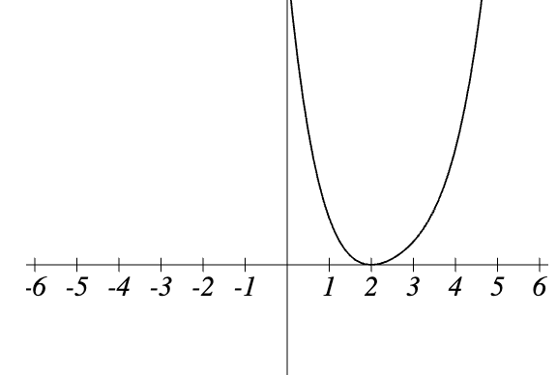

Polynomial Equations and Inequalities

Solving Polynomial Inequalities
Pro Tip: To solve a polynomial inequality, first solve the equality to find the boundary points, then use test values in each interval — or sketch a graph — to determine where the polynomial is positive or negative.

Example
Solve $\left(x+3\right){\left(x+1\right)}^{2}\left(x-4\right)>0$.

Example
Find the domain of the function $v\left(t\right)=\sqrt{6-5t-t^{2}}$

Example
Solve the inequality $x^{4}-2x^{3}-3x^{2}>0$

Try It
Solve the inequality $-s^{3}≤19s^{2}+88s$

Inverse of Polynomial Functions
Recall
Two functions f and g are inverse functions if every coordinate pair (a, b) in f has a corresponding coordinate pair (b, a) in g. Only one-to-one functions have inverses that are also functions.

Question Help: Finding the Inverse of a Polynomial Function
- Verify that f is a one-to-one function.
- Replace f(x) with y.
- Interchange x and y.
- Solve for y, and rename the function $f^{-1}(x)$

Example
Find the inverse of the function $f\left(x\right)=5x^{3}+1$.

Try It
What is the inverse function of $f\left(x\right)=\sqrt[3]{x}-3$

Restricting the Domain

Key Takeaway: Restricting the Domain
If a function is not one-to-one, it cannot have an inverse function. If we restrict the domain so that the function becomes one-to-one, the new function will have an inverse.
Quadratic functions are not one-to-one, so we must restrict their domain before finding an inverse.

Example
Find the inverse function of f:
- $f\left(x\right)={\left(x-4\right)}^{2}$, $x≥4$

- $f\left(x\right)={\left(x-4\right)}^{2}$, $x≤4$

Example
Restrict the domain and then find the inverse of $f\left(x\right)={\left(x-2\right)}^{2}-3$.

Question Help: Finding the Inverse of a Radical Function
- Determine the range of the original function.
- Replace f(x) with y, then solve for x.
- If necessary, restrict the domain of the inverse function to the range of the original function.

Example
Determine the range of the function $f\left(x\right)=\sqrt{x-4}$. Then, find the inverse.

Try It
Find $f^{-1}(x)$ for $f\left(x\right)=\sqrt[9]{2x-9}$

Try It
Find the inverse function of $f\left(x\right)=7+\sqrt[3]{x}$.

