Precalculus

Polynomial Functions Guided Notes
This tool is designed to work alongside your Study Plan and class sessions. Before class, you'll use it with the assigned readings by filling in key terms, noting examples, and writing down questions that arise. During class, you'll add to your notes as you deepen your understanding and instructors highlight important concepts. You'll find a mix of fill-in-the-blank sections, reflection spaces, and areas to record real-world examples.

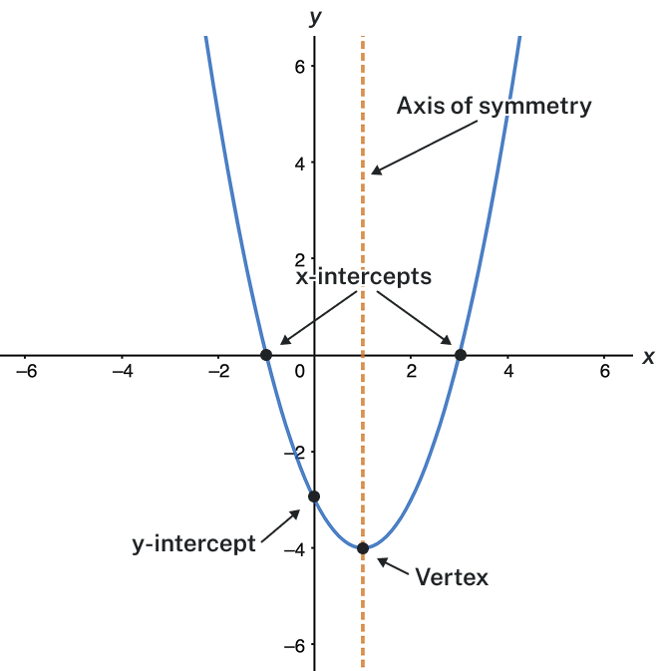
Quadratic Functions
Describe the key features of a parabola

Example
Determine the vertex, axis of symmetry, zeros, and y-intercept of the parabola shown below.
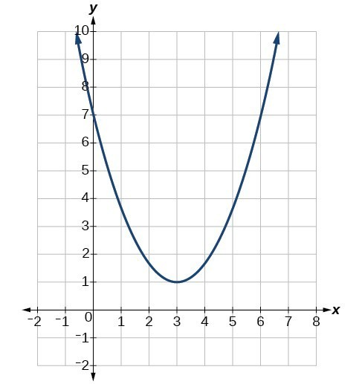

Try It
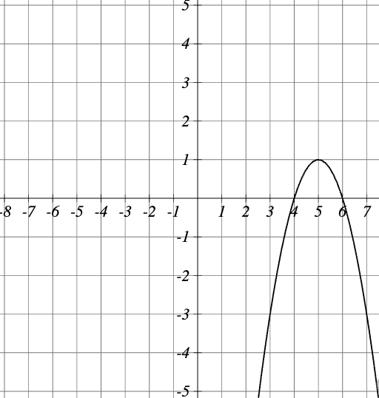
Consider the quadratic function $y=-x^{2}+10x-24$, plotted below. Use the graph to find the key features.
- The vertex is:
- The equation of the line of symmetry is:
- The vertical intercept is the point:
- The horizontal intercept (x-intercepts) are:

Finding the Domain and Range of a Quadratic Function
Any number can be the input value of a quadratic function. Therefore, the domain of any quadratic function is all real numbers. Because parabolas have a maximum or a minimum at the vertex, the range is restricted. The range will consist of all y-values greater than or equal to the y-coordinate of the vertex or less than or equal to the y-coordinate at the turning point, depending on whether the parabola opens up or down.

Question Help: Determine the Domain and Range from the Vertex.
- The domain of any quadratic function is all real numbers.
- Determine whether a is positive or negative.
  - If a is positive, the parabola has a minimum.
  - If a is negative, the parabola has a maximum.
- Determine the maximum or minimum value of the parabola, k.
  - If the parabola has a minimum, the range is given by $f\left(x\right)≥k$, or $k,∞)$.
  - If the parabola has a maximum, the range is given by $f\left(x\right)≤k$, or $(-∞,k]$.

Example
Find the domain and range of $f\left(x\right)=-5x^{2}+9x-1$.

Try It
Consider the parabola given by the equation: $f\left(x\right)=-2x^{2}-4x+1$
- The graph of the function opens:
- Write the domain using interval notation:
- Write the range using interval notation:

Equations of Quadratic Functions
Key Takeaways
- The general form of a quadratic function presents the function in the form
$$f\left(x\right)=ax^{2}+bx+c$$
where a, b, and c are real numbers and $a≠0$.
If a > 0, the parabola opens upward. If a < 0, the parabola opens downward.
- The axis of symmetry is defined by $x=-\frac{b}{2a}$.
- The vertex is $h=-\frac{b}{2a}$ and $k=f\left(h\right)=f(-\frac{b}{2a})$
- The standard form of a quadratic function presents the function in the form
$$f\left(x\right)=a{\left(x-h\right)}^{2}+k$$
Where $(h,k)$ is the vertex.
Because the vertex appears in the standard form of the quadratic function, this form is also known as the vertex form of a quadratic function.

Example
Find the vertex of the quadratic function $f\left(x\right)=2x^{2}-6x+7$. Rewrite the quadratic in standard form (vertex form).
Try It
Find the vertex of the following quadratic equation: $y=x^{2}-8x+10$

Try It
What are the coordinates of the vertex? Is the vertex a minimum or maximum?
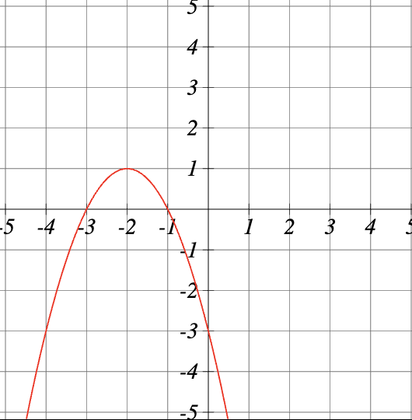
Try It
Find the vertex of the quadratic: $y=-4{\left(x+2\right)}^{2}-3$

Transformations of Quadratic Functions — Standard Form
Key Takeaway: Vertical Shift of a Parabola
You can represent a vertical (up, down) shift of the graph of $f\left(x\right)=x^{2}$ by adding or subtracting a constant, k.
$$f\left(x\right)=x^{2}+k$$
If k > 0, the graph shifts upward, whereas if k < 0, the graph shifts downward.

Example
Using an online graphing calculator, plot the function $f\left(x\right)=x^{2}+k$. Add a slider for the variable k and change k to shift the graph down 4 units, then up 4 units.

Key Takeaway: Horizontal Shift of a Parabola
You can represent a horizontal (left, right) shift of the graph of $f\left(x\right)=x^{2}$ by adding or subtracting a constant, h, to the variable x, before squaring.
$$f\left(x\right)={(x-h)}^{2}$$
If h > 0, the graph shifts toward the right and if h < 0, the graph shifts to the left.
Pro Tip: Remember that the negative sign inside the argument of the vertex form of a parabola (in the parentheses with the variable x) is part of the formula f(x) = (x-h)^2 + k.
If h > 0, we have $f\left(x\right)={(x-h)}^{2}$. You'll see the negative sign, but the graph will shift right.
If h < 0, we have $f\left(x\right)={(x-(-h))}^{2}={(x+h)}^{2}$. You'll see the positive sign, but the graph will shift left.

Example: Using an online graphing calculator, plot the function $f\left(x\right)={(x-h)}^{2}$. Now change the h value to shift the graph 2 units to the right, then 2 units to the left.

Key Takeaway: Stretch or Compress a Parabola
You can represent a stretch or compression (narrowing, widening) of the graph of $f\left(x\right)=x^{2}$ by multiplying the squared variable by a constant, a.
$$f\left(x\right)={ax}^{2}$$
The magnitude of a indicates the stretch of the graph.
If |a| > 1, the point associated with a particular x-value shifts farther from the x-axis, so the graph appears to become narrower, and there is a vertical stretch.
But if |a| < 1, the point associated with a particular x-value shifts closer to the x-axis, so the graph appears to become wider, but in fact there is a vertical compression.

Example
Using an online graphing calculator plot the function f(x) = ax^2. Now adjust the a value to create a graph that has been compressed vertically by a factor of $\frac{1}{3}$ and another that has been vertically stretched by a factor of 3. What are the equations of the two graphs?

Try It
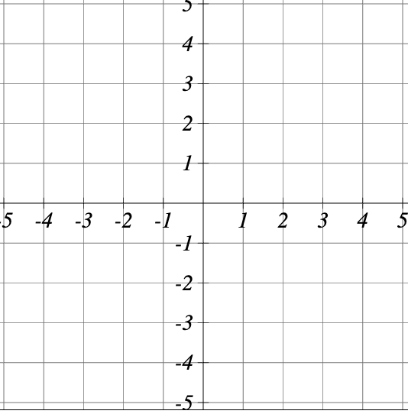
Graph the function $f\left(x\right)=4{\left(x+2\right)}^{2}-1$

Transformations of Quadratic Functions — General Form
For parabolas given in general form: $y=ax^{2}+bx+c$
Key Takeaway
Changing a changes the width of the parabola.
Width of the parabola:
- When |a| > 1, the parabola becomes narrower (steeper)
- When 0 < |a| < 1, the parabola becomes wider (flatter)
- The larger the absolute value of a, the narrower the parabola
Direction of opening:
- If a > 0, the parabola opens upward (U-shaped)
- If a < 0, the parabola opens downward (inverted U-shape)
Stretching and compressing:
- Multiplying a by a factor stretches the graph vertically by that factor
- Dividing a by a factor compresses the graph vertically by that factor
Example
Match each function with its graph.
- $f\left(x\right)=3x^{2}$
- $f\left(x\right)=-3x^{2}$
- $f\left(x\right)=\frac{1}{2}x^{2}$
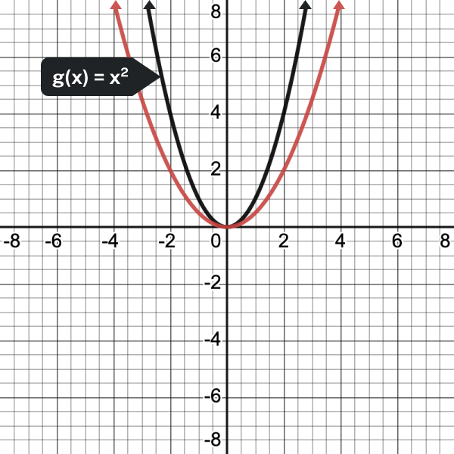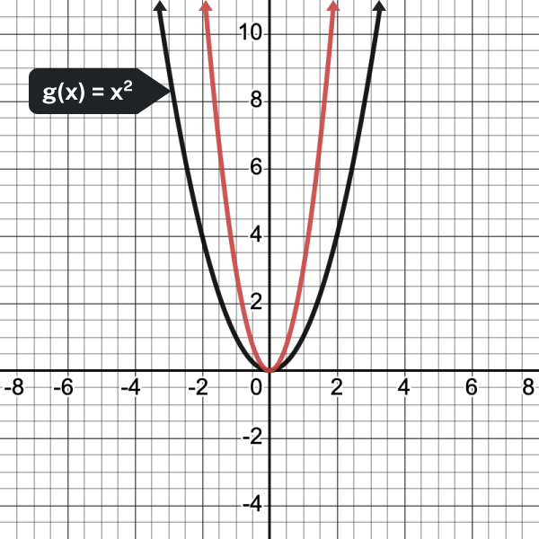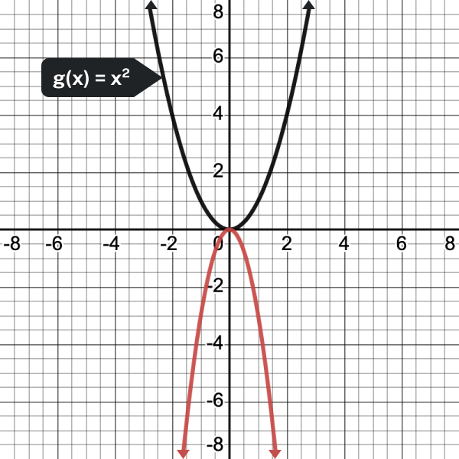
Key Takeaway: Changing c of a Parabola
Changing c moves the parabola up or down so that the y-intercept is (0, c).
- c represents the y-intercept of the parabola
- Positive c shifts the parabola up
- Negative c shifts the parabola down
- The magnitude of c determines the amount of vertical shift

Example
Match each of the following functions with its graph.
- $f\left(x\right)=x^{2}+3$
- $f\left(x\right)=x^{2}-3$
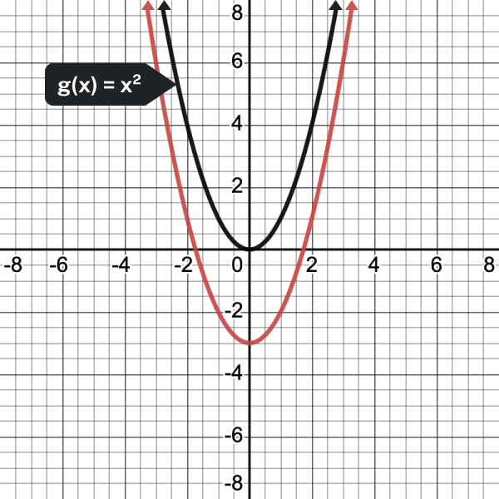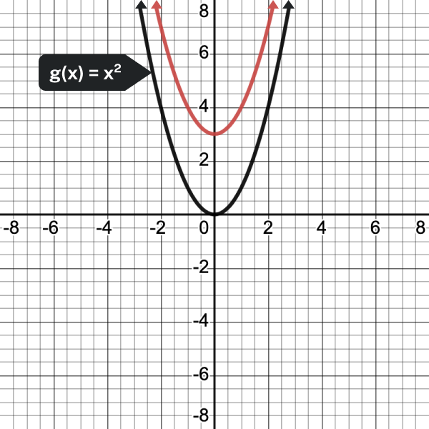
Key Takeaway: Changing b of a Parabola
Changing b affects the horizontal position of the vertex and the axis of symmetry of the parabola.
Axis of symmetry:
- The axis of symmetry is given by $x=-\frac{b}{2a}$
- Changing b shifts this axis left or right
- A positive b shifts the vertex left of the y-axis
- A negative b shifts the vertex right of the y-axis
- The larger the absolute value of b, the greater the shift

Example: Match each of the following functions with its graph
- $f\left(x\right)=x^{2}+2x$
- $f\left(x\right)=x^{2}-2x$
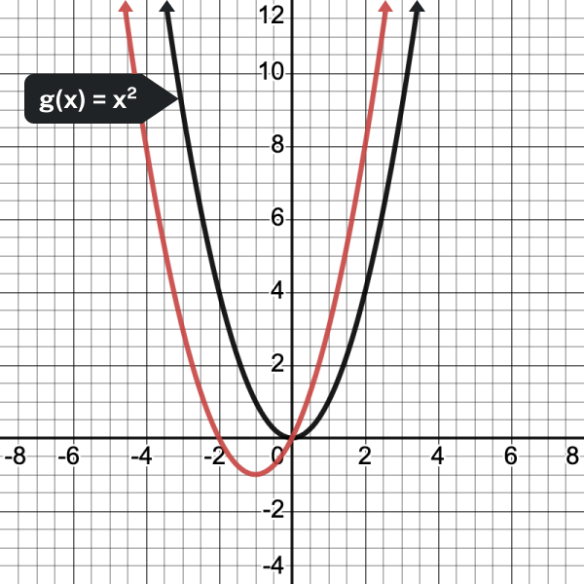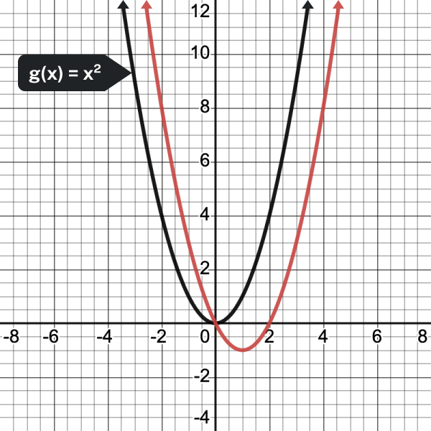
Example
Graph $f\left(x\right)=-2x^{2}+3x-3$.

Try It
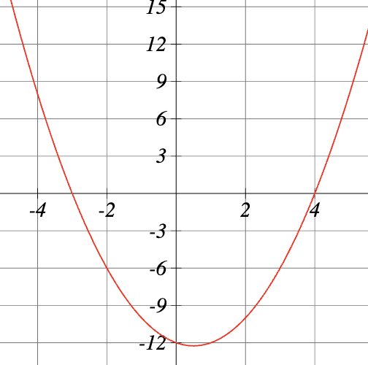
Write the equation of the graph shown

Polynomial Functions
Key Takeaway
Let n be a non-negative integer. A polynomial function is a function that can be written in the form
$$f\left(x\right)=a_{n}x^{n}+…+a_{2}x^{2}+a_{1}x+a_{0}$$
This is called the general form of a polynomial function. Each a is a coefficient and can be any real number. Each product is a term of a polynomial function.

Example
Which of the following are polynomial functions?
$f\left(x\right)=2x^{3}⋅3x+4$
$$g\left(x\right)=-x(x^{2}-4)$$
$$h\left(x\right)=5\sqrt{x}+2$$

Degree and Leading Coefficient of a Polynomial Function
Key Takeaway: Terminology of a Polynomial Function
- The degree of the polynomial is the highest power of the variable that occurs in the polynomial; it is the power of the first variable if the function is in general form.
- The leading term is the term containing the variable with the highest power, also called the term with the highest degree.
- The leading coefficient is the coefficient of the leading term.

Example
Identify the degree, leading term, and leading coefficient of the following polynomial functions.
$$f\left(x\right)=3+2x^{2}-4x^{3}$$
$$g\left(t\right)=5t^{5}-2t^{3}+7t$$
$$h\left(p\right)=6p-p^{3}-2$$

Try It
Find the degree of each term:
- $2x^{9}$
- $-3x^{8}$
- $5x^{6}$
- $4$
Find the degree of the polynomial:
- $y=2x^{9}-3x^{8}+5x^{6}+4$
The leading coefficient of the polynomial is:
- $y=2x^{9}-3x^{8}+5x^{6}+4$

Try It
Find the degree, leading coefficient, and constant term of the polynomial
$$f\left(x\right)=-3+x^{4}+2x^{8}-4x^{7}$$
- Degree:
- Leading coefficient:
- Constant term:

Identifying End Behavior of Polynomial Functions
Complete the end behavior table
 | Even Degree | Odd Degree
Positive leading coefficient
Negative leading coefficient
Pro Tip To identify the end behavior and degree of a polynomial function, it must be in expanded (general) form.

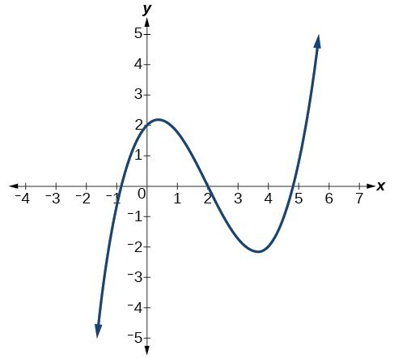
Example
Describe the end behavior and determine a possible degree of the polynomial function in the graph below.

Example
Given the function $f\left(x\right)=-3x^{2}(x-1)(x+4)$, express the function as a polynomial in general form and determine the leading term, degree, and end behavior of the function.

Try It
Describe the long run behavior of $f\left(x\right)=-2x^{6}-3x^{3}-5x^{2}-1$
As $x→-∞, f\left(x\right)→$
As $x→∞, f\left(x\right)→$
Try It
Given the following function $f\left(x\right)=-4\left(x+2\right)\left(x-1\right)\left(x-1\right)$
  - Express the function as a polynomial in general form:
  - The degree is:
  - End behavior:

Identifying Intercepts of Factored Polynomial Functions
Key Takeaway: Factored Form of a Polynomial
A polynomial function in factored form is written as:
$$f\left(x\right)=a\left(x-r_{1}\right)\left(x-r_{2}\right)\left(x-r_{3}\right)…(x-r_{n})$$
where:
- a is the leading coefficient
- $r_{1},r_{2},r_{3}…,r_{n}$ are the zeros (roots) of the function

Example
Find the zeros: $f\left(x\right)=2(x-3)(x+1)(x-5)$

Question Help: Find x-intercepts from factored form.
- Set the function equal to zero: f(x) = 0
- Use the Zero Product Property
- Solve each factor equal to zero
- The solutions are the x-intercepts

Try It
Find the x-intercepts of $g\left(x\right)=x(x-5)(x+7)$

Example
Find the x-intercepts of $h\left(x\right)=-2(x-5)(x+3)(x-2)$

Pro Tip
The leading coefficient affects the shape and direction of the graph but does not change the x-intercepts.

Key Takeaway: Multiplicity
When a factor appears multiple times, we say it has multiplicity greater than 1.

Example
Find the x-intercepts of $f\left(x\right)={\left(x-2\right)}^{2}(x+1)(x-3)$

Question Help: Find the y-intercept.
- Substitute x = 0 into the function
- Evaluate the expression
- The result is the y-coordinate of the y-intercept

Example
Find the y-intercept of $f\left(x\right)=2(x-3)(x+1)(x-5)$

Try It
Find the y-intercept of $g\left(x\right)=(x-2)(x-3)(x+6)$

Graphs of Polynomial Functions

Identifying Local Behavior of Polynomial Functions
In addition to the end behavior of polynomial functions, we are also interested in what happens in the "middle" of the function. In particular, we are interested in locations where graph behavior changes. A turning point is a point at which the function values change from increasing to decreasing or decreasing to increasing.
Example
Given the polynomial function f(x) = (x-2)(x+1)(x-4), written in factored form for your convenience, determine the y and x-intercepts.

Key Takeaway: Intercepts and Turning Points
- A turning point of a graph is a point where the graph changes from increasing to decreasing or decreasing to increasing.
- The y–intercept is the point where the function has an input value of zero.
- The x-intercepts are the points where the output value is zero.
- A polynomial of degree n will have, at most, n x-intercepts and n–1 turning points.

Example
Without graphing the function, determine the local behavior of the function by finding the maximum number of x-intercepts and turning points for $f\left(x\right)=-3x^{10}+4x^{7}-x^{4}+2x^{3}$.

Example
Given the graph of the polynomial function below, determine the least possible degree of the polynomial and whether it is even or odd. Use end behavior, the number of intercepts, and the number of turning points to help you.
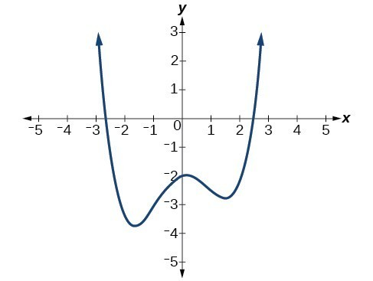
Example
Given the graph of the polynomial function below, determine the least possible degree of the polynomial and whether it is even or odd. Use end behavior, the number of intercepts, and the number of turning points to help you.
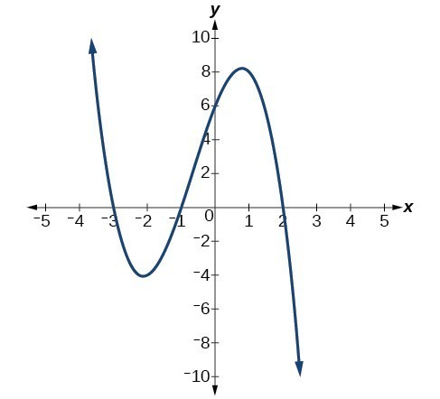

Try It
Describe the number of turning points on the graph of
$$f\left(x\right)=-7x^{10}+4x^{9}-7x^{8}+2x^{7}+x^{6}+x^{4}+x^{3}+6x^{2}-8x$$

Try It
Consider the function $C\left(n\right)=2n^{11}+6n^{9}-3n^{8}-4n$ and complete the description.
There are at most: x-intercepts and at most: turning points.

Try It
What is the least possible degree of the polynomial graphed.
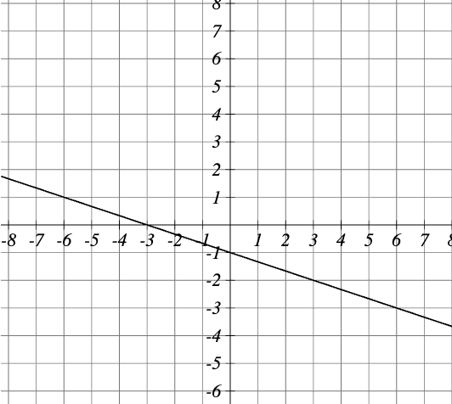
Example
Find the maximum number of turning points of each polynomial function.
  - $f\left(x\right)=-x^{3}+4x^{5}-3x^{2}+1$

  - $f\left(x\right)=-{\left(x-1\right)}^{2}(1+2x^{2})$

Using Factoring to Find Zeros of Polynomial Functions
Question Help: Given a polynomial function f, find the x-intercepts by factoring.
- Set f(x) = 0.
- If the polynomial function is not given in factored form:
  - Factor out any common monomial factors.
  - Factor any factorable binomials or trinomials.
- Set each factor equal to zero and solve to find the x-intercepts.

Example
Find the x-intercepts of $f\left(x\right)=x^{6}-3x^{4}+2x^{2}$

Example
Find the y- and x-intercepts of $f\left(x\right)={\left(x-2\right)}^{2}(2x+3)$.

Example
Find the x-intercepts of $h\left(x\right)=x^{3}+4x^{2}+x-6$

Try It
Find the zeros and the vertical intercept of the function $f\left(x\right)=16x^{3}+4x^{2}-6x$.

Identifying Zeros and Their Behavior

Example
Analyze the behavior of the graph at each of its x-intercepts.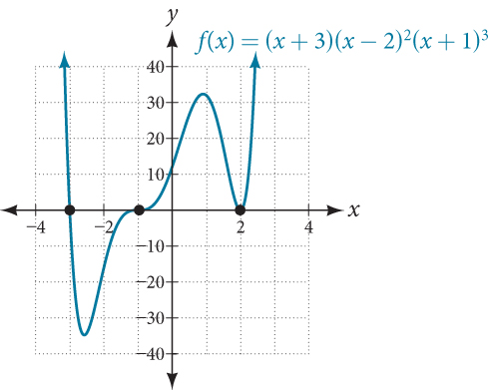

Multiplicities of Zeros and Their Graphs
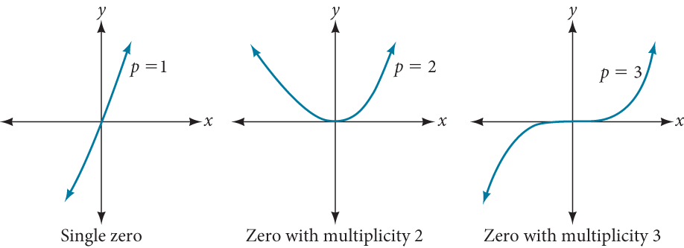
Key Takeaway: Graphical Behavior of Polynomials at x-intercepts
If a polynomial contains a factor of the form ${\left(x-h\right)}^{p}$, the behavior near the x-intercept at (h, 0) is determined by the power p. We say that x = h is a zero of multiplicity p.
- For zeros with even multiplicities, the graphs touch or are tangent to the x-axis at these x-values.
- For zeros with odd multiplicities, the graphs cross or intersect the x-axis at these x-values.
Note: The sum of the multiplicities is the degree of the polynomial function.
Question Help: Given a graph of a polynomial function of degree n, identify the zeros and their multiplicities.
- If the graph crosses the x-axis and appears almost linear at the intercept, it is a single zero.
- If the graph touches the x-axis and bounces off the axis, it is a zero with even multiplicity.
- If the graph crosses the x-axis at a zero, it is a zero with odd multiplicity.
- The sum of the multiplicities is \le n.

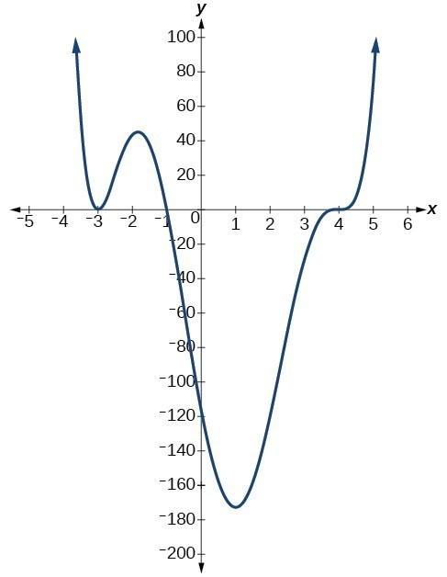
Example
Use the graph of the function of degree 6 to identify the zeros of the function and their possible multiplicities.

Try It
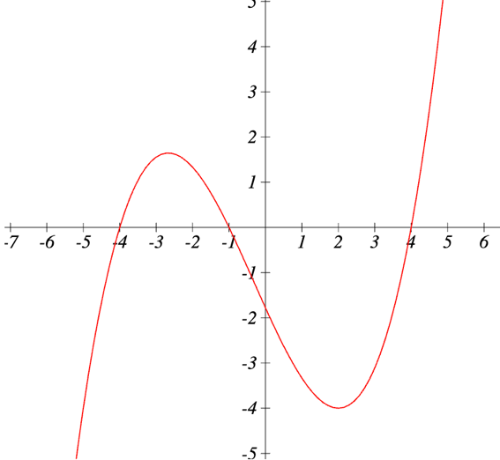
Given the graph of the degree three polynomial, complete the table of values.
Root with x = | Multiplicity
-4
 | 1

Try It
Find the zeros of the given polynomial function and determine if the graph crosses or touches and turns around at each zero.
$$g\left(x\right)=3\left(x+2\right){\left(x-1\right)}^{2}$$

Try It
Use the graph of the function of degree 9 to identify the zeros of the function and their multiplicities.
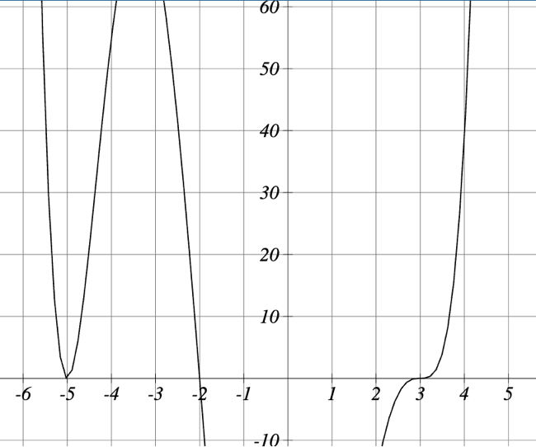

Graphing Polynomials
Question Help: Graph Polynomials by Hand.
- Determine end behavior using the degree and leading coefficient.
- Find all intercepts (x-intercepts and y-intercept).
- Identify multiplicity at each x-intercept.
- Plot intercepts and sketch local behavior at each.
- Connect with smooth curves respecting end behavior.
- Verify with additional points if needed.

Example
Graph f(x) = (x+2)(x-1)(x-4).
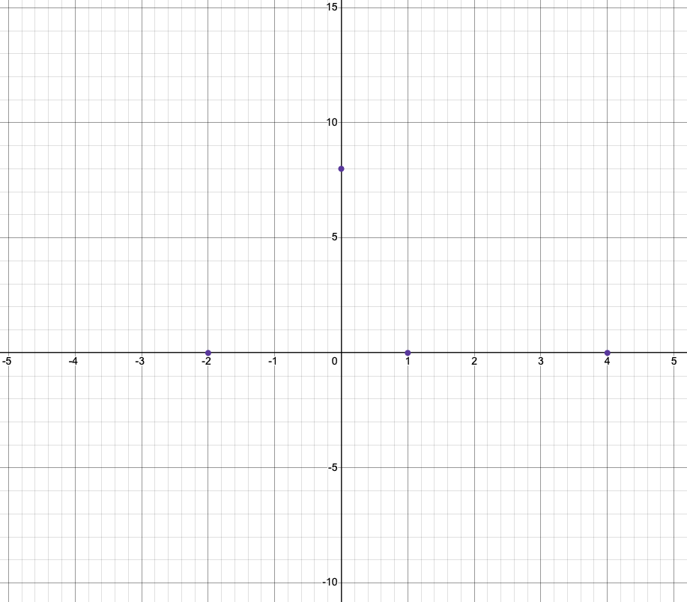
Try It
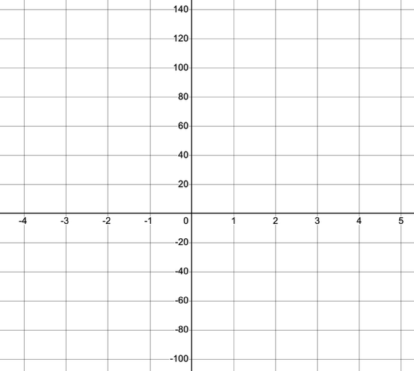
Sketch the graph of g(x) = (x+3)(x-2)(x-1) using the same process.

Example
Graph $f\left(x\right)=-{\left(x+1\right)}^{2}(x-3)$
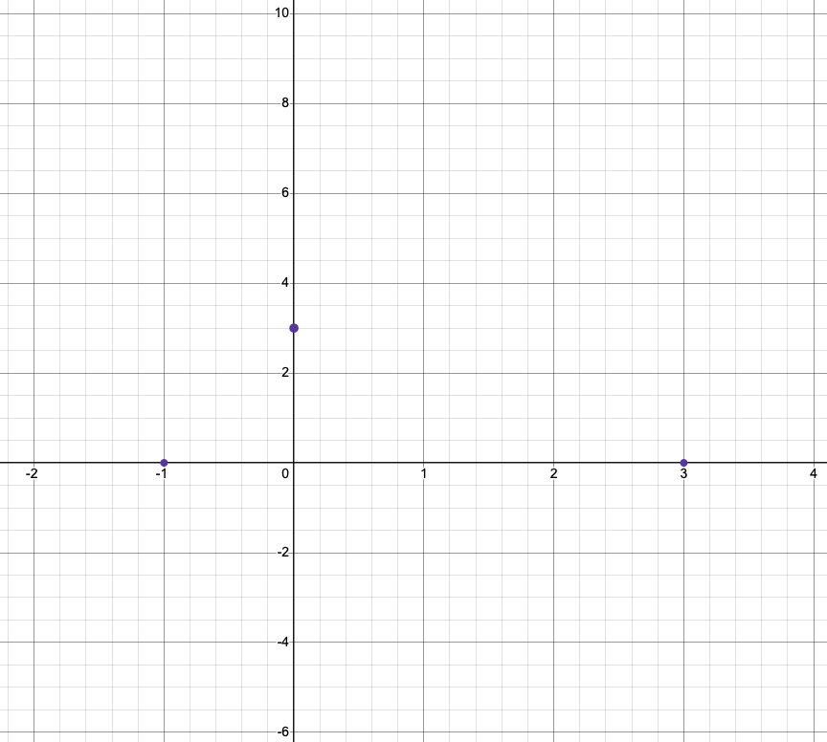
Try It
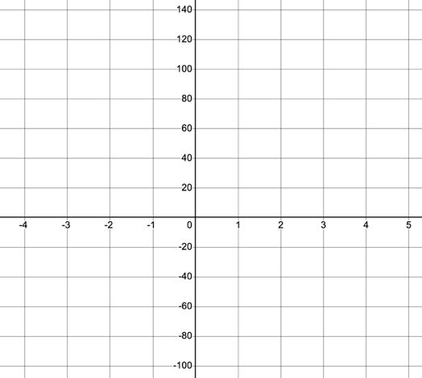
Sketch $g\left(x\right)=\left(x+2\right){\left(x-4\right)}^{2}(x-1)$

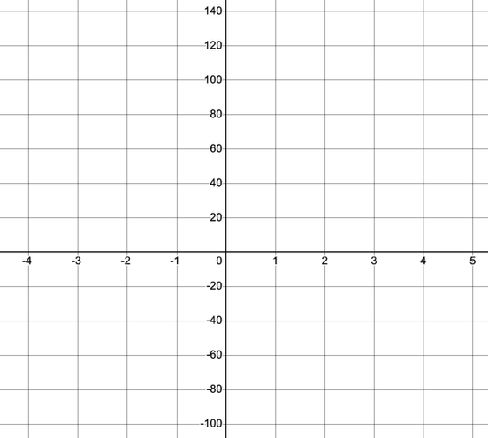

Try It
Graph $f\left(x\right)=x(x+2)(x-1)(x-3)$.

Using the Intermediate Value Theorem
Key Takeaway
The Intermediate Value Theorem states that for two numbers a and b in the domain of f, if a < b and $f\left(a\right)≠f(b)$, then the function f takes on every value between f(a) and f(b).

Example
Show that the function $f\left(x\right)=x^{3}-5x^{2}+3x+6$ has at least two real zeros between x = 1 and x = 4.

Try It
Suppose that f(x) is a continuous function with f(5)=-3 and f(5)=3. Is the statement, “f(x) = 0 for some x in the interval [5,9]” always, sometimes, or never true?

Try It
Suppose that f(x) is a continuous function with f(-2)=-2 and f(2)=2. Is the statement, “f(0) = 0” always, sometimes, or never true?

Try It
Evaluate $f\left(x\right)=x^{3}-5x^{2}+3x+6$ at $x=1$ and $x=3$ to determine if the Intermediate Value Theorem guarantees that a zero exists from [1,3]

Writing Formulas for Polynomial Functions
Key Takeaway: Factored Form of Polynomials
If a polynomial of lowest degree p has zeros at $x=x_{1},x_{2},…,x_{n}$, then the polynomial can be written in the factored form:
$$f\left(x\right)=a{\left(x-x_{1}\right)}^{p_{1}}{\left(x-x_{2}\right)}^{p_{2}}…{\left(x-x_{n}\right)}^{p_{n}}$$
where:
- the powers on each factor can be determined by the behavior of the graph at the corresponding intercept
- the stretch factor a can be determined given a value of the function other than the x-intercept

Question Help: Given a graph of a polynomial function, write a formula for the function.
- Identify the x-intercepts of the graph to find the factors of the polynomial.
- Examine the behavior of the graph at the x-intercepts to determine the multiplicity of each factor.
- Find the polynomial of least degree containing all of the factors found in the previous step.
- Use any other point on the graph (the y-intercept may be easiest) to determine the stretch factor.

Example
Write a formula for the polynomial function shown.
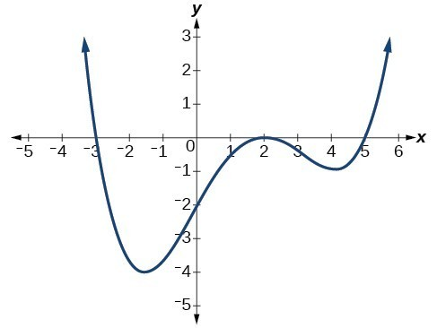
Try It
Write an equation for the function graphed.
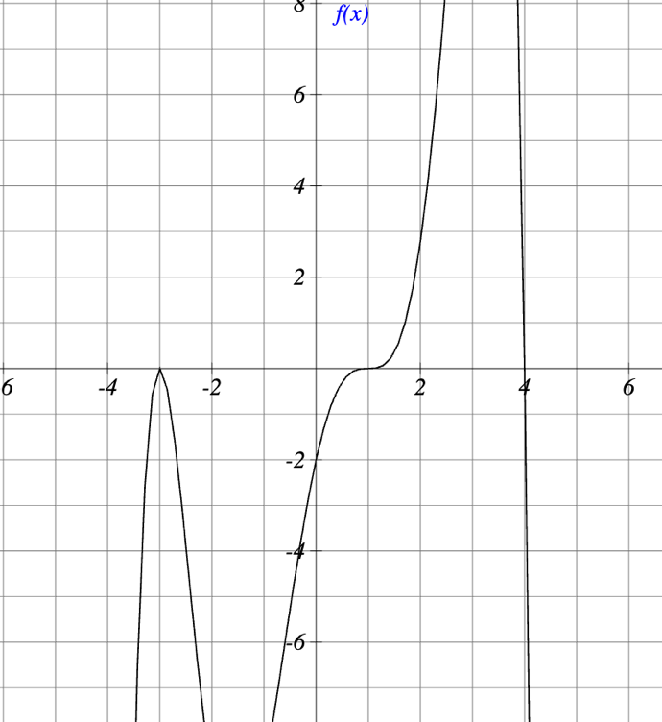
Try It
The polynomial of degree 4 has a root of multiplicity 2 at.x = 1, multiplicity 1 at x = 0 and x = -4 and goes through the point (5,576). Find a function for the polynomial P(x).

Local and Global Extrema
Key Takeaway: Local and Global Extrema
A local maximum or local minimum at x = a (sometimes called the relative maximum or minimum, respectively) is the output at the highest or lowest point on the graph in an open interval around x = a.
- If a function has a local maximum at a, then $f\left(a\right)≥f\left(x\right)$ for all x in an open interval around x = a.
- If a function has a local minimum at a, then $f\left(a\right)≤f(x)$for all x in an open interval around x = a.
A global maximum or global minimum is the output at the highest or lowest point of the function.
- If a function has a global maximum at a, then $f\left(a\right)≥f\left(x\right)$for all x.
- If a function has a global minimum at a, then $f\left(a\right)≤f(x)$for all x.
Q&A — Do all polynomial functions have a global minimum or maximum?
No. Only polynomial functions of even degree have a global minimum or maximum. For example, f(x) = x has neither a global maximum nor a global minimum.

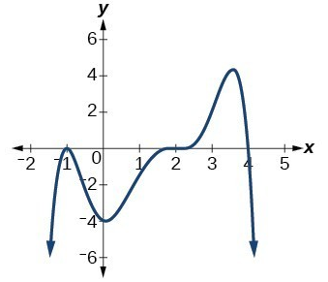
Example
State the local and global extrema of the graph:

Example
Use an online graphing tool to find the maximum and minimum values on the interval [-2, 7] of the function $f\left(x\right)=0.1{\left(x-\frac{5}{3}\right)}^{3}{\left(x+1\right)}^{2}(x-7)$

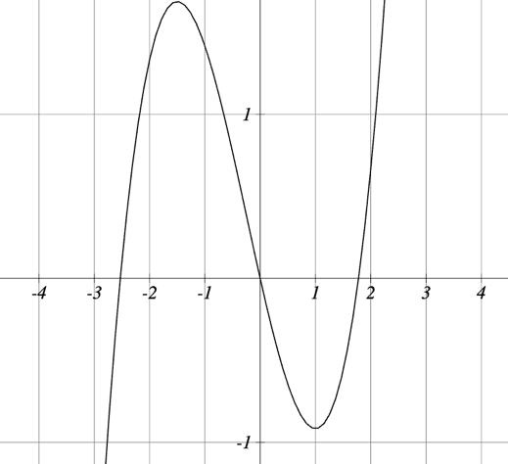
Try It
Use the function graphed to estimate the maximum and minimums of the graph.

