Precalculus

Linear Functions Guided Notes
This tool is designed to work alongside your Study Plan and class sessions. Before class, you'll use it with the assigned readings by filling in key terms, noting examples, and writing down questions that arise. During class, you'll add to your notes as you deepen your understanding and instructors highlight important concepts. You'll find a mix of fill-in-the-blank sections, reflection spaces, and areas to record real-world examples.

Graphs of Linear Functions

Key Takeaway
A linear function is characterized by a constant rate of change and can be represented as a polynomial of degree 1 or as the graph of a straight line.

Representing Linear Functions in Tabular Form
Draw an example of a function table:

In a table representing a linear function, each input-output pair forms a consistent pattern, exhibiting a constant rate of change between y-values. To identify the function as linear, ensure that the difference between consecutive y-values is the same when the x-values increase by a consistent amount.

Try It
Select the tables which could satisfy a linear equation.

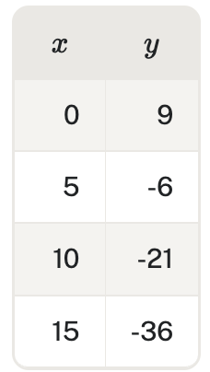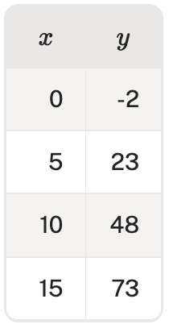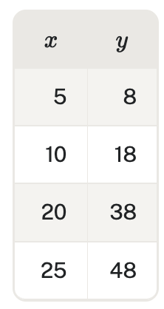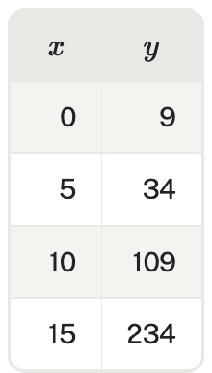

Graphing a Function by Plotting Points

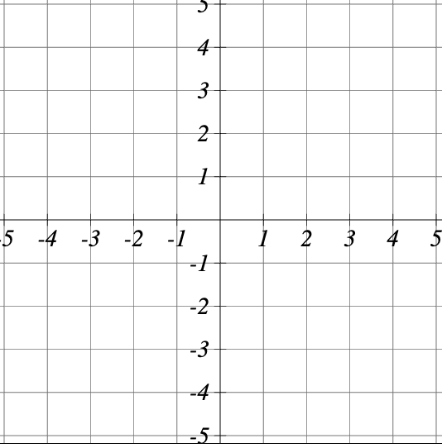
Example
Given the function $f\left(x\right)=2x$, use the input values of 1 and 2 to sketch the graph.
Evaluate $f\left(1\right)=$ Evaluate $f\left(2\right)=$

Graph both points and draw the linear function.

Question Help: Given a linear function, graph by plotting points.

Example

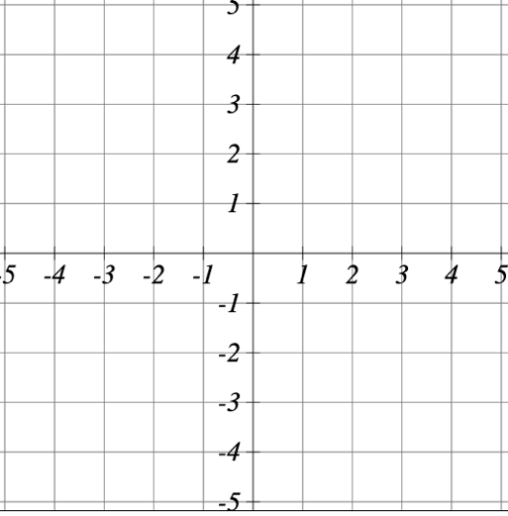
Graph $f\left(x\right)=-\frac{2}{3}x+5$ by plotting points.

Pro Tip: If your equation has a fraction, you’ll have to divide the number plugged in by whatever is in the denominator so choose multiples of the denominator to plug in so it divides evenly.

Try It
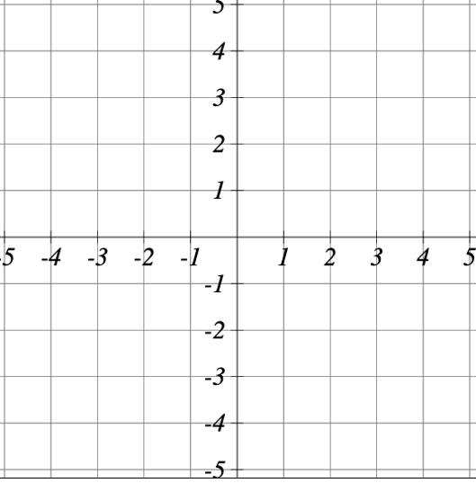
Graph $f\left(x\right)=-\frac{1}{3}x-4$

Interpreting Slope as a Rate of Change

Recall

Slope is defined as the change in y divided by the change in x between any two points on a line.

$$m=\frac{ }{ }$$

Example
Consider driving a car. If you’re traveling at a constant 60 miles per hour this can be represented as a slope:

Example
The population of a city increased 23,400 to 27,800 between 2008 and 2012. Find the change in population per year.

Try It
The graph shows a proportional relationship between the amount of money in Richard’s savings account and the number of weeks Richard has been saving money. Write a statement that correctly reflects the slope of the graph in context.

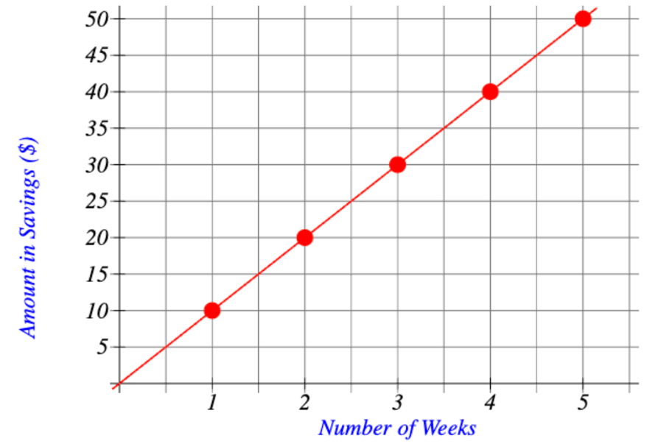

Finding the y-intercept of a Line
Key Takeaway: y-intercept of a Line
The y-intercept of a function is the value of f(x) when $x=0$. In slope-intercept form, $f(x) = mx+b$, the y-intercept is the constant b.

Example
Find the y-intercept of the following: $f\left(x\right)=\frac{1}{2}x-3$.
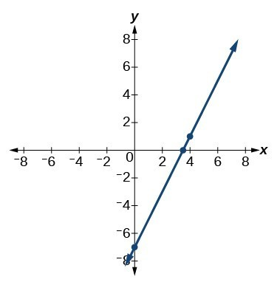
Find the y-intercept of the graph.

Pro Tip
The y-intercept is always written in the form ______________.
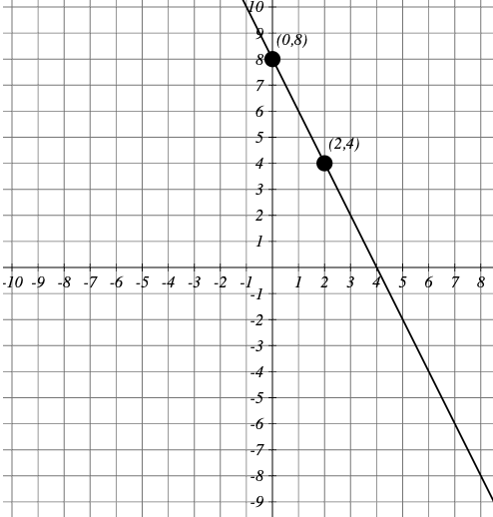
Try It
Find the y-intercept of the line shown in the graph.

Finding the x-intercept of a Line
Key Takeaway
The x-intercept of a function is the value of x where $f\left(x\right)=0$. It can be found by solving the equation $0=mx+b$.

Question Help
Do all linear functions have x-intercepts?
No. However, linear functions of the form y=c, where c is a nonzero real number are the only examples of linear functions with no x-intercept.

Example
Find the x-intercept of the following: $y=\frac{1}{2}x-3$

Try It
What is the x-intercept of $y=-2x-10$?

Graphing a Linear Function Using y-intercept and Slope
Key Takeaway: Graphical Interpretation of a Linear Function
In the equation $f\left(x\right)=mx+b$
- b is the y -intercept of the graph and indicates the point (0, b) at which the graph crosses the y -axis.
- m is the slope of the line and indicates the vertical displacement (rise) and horizontal displacement (run) between each successive pair of points.
Example
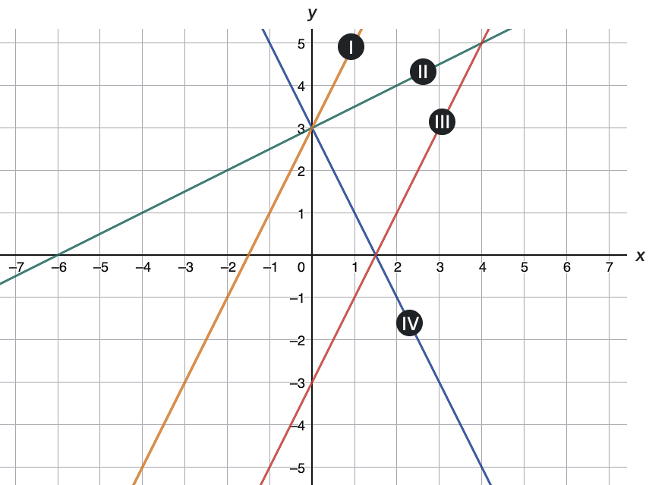
Match each equation of the linear functions with one of the lines on the graph.
- $f\left(x\right)=2x+3$
- $g\left(x\right)=2x-3$
- $h\left(x\right)=-2x+3$
- $j\left(x\right)=\frac{1}{2}x+3$

Question Help: Given the equation for a linear function, graph the function using the y -intercept and slope.
- Evaluate the function at an input value of zero to find the y -intercept.
- Identify the slope.
- Plot the point represented by the y -intercept.
- Use the slope to determine another point on the line.
- Draw a line that passes through the points

Example
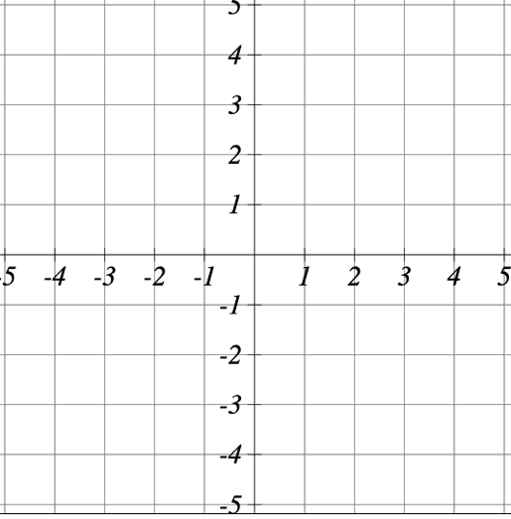
Graph $f\left(x\right)=-\frac{2}{3}x+5$ using the y -intercept and slope.

Writing an Equation from a Graph
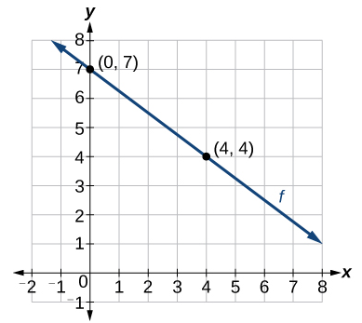
Look at the graph of the function:
Find the slope of the line:

Substitute the slope and one of the coordinates into the point-slope form:

Rewrite the equation into slope-intercept form:

Question Help: Given the graph of a linear function, write an equation to represent the function.
- Identify two points on the line.
- Use the two points to calculate the slope.
- Determine where the line crosses the y -axis to identify the y -intercept.
- Substitute the slope and y -intercept into the slope-intercept form of a line equation.

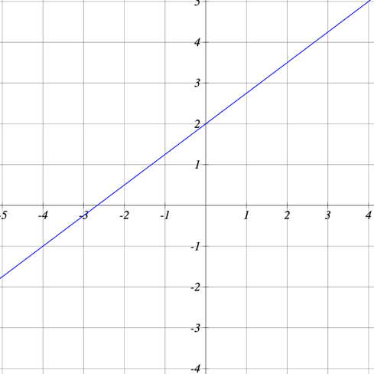
Try It
Write the equation of the line in slope-intercept form

Linear Functions

Key Takeaway: Different Forms of a Linear Function
Standard form: Ax + By = C
Slope-intercept form: y = mx + b where
- m is the slope, and
- b is the y -intercept
Point-slope form: $y-y_{1}=m(x-x_{1})$ where
- m is the slope, and
- $(x_{1},y_{1})$is a point on the line

Slope-Intercept Form
Example
Find the equation of the line for the graph below.
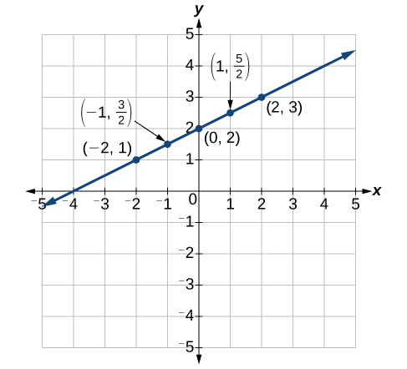
Try It
Given the points (2,-3) and (0,-4) on a line, find the values of m and b for slope-intercept form.

Example
Identify the slope and y -intercept given the equation $y=-\frac{3}{4}x-4$.

Try It
Given the equation $y=3x-1$
  - What is the slope?

  - What is the y-intercept?

  - Use the grid to graph this equation.

Point-Slope Form
Key Takeaway
Point-Slope Form
The point-slope form of the equation of a line is: $y-y_{1}=m(x-x_{1})$
where:
- m is the slope of the line
- $(x_{1},y_{1})$ are the coordinates of any point on the line.
This is an important formula, as it will be used in other areas of Precalculus and often in Calculus to find the equation of a tangent line.
We need only one point and the slope of the line to use the formula. After substituting the slope and the coordinates of one point into the formula, we simplify it and re-write it in slope-intercept form y = mx + b.

Example
Write the equation of the line with slope m = -3 and passing through the point (4, 8) in point-slope form and in slope-intercept form.

Example
Find the equation of the line passing through the points (3, 4) and (0, -3). Write the final equation in slope-intercept form.

Try It
Find the equation of a line with slope $\frac{5}{7}$ that passes through $(1,-5)$.

Try It
Find the equation of a line that passes through (-7,-6) and (3,-2).

Standard Form of a Line
Key Takeaway
The standard form of a line equation is written as Ax + By = C

Example
Write the equation of the line with slope m = -3 and passing through the point (4, 8) in standard form.

Example
Find the equation of the line with m = -6 and passing through the point $(\frac{1}{4},-2)$. Write the equation in standard form.

Try It
Determine the equation of the line passing through the point (0,3) with a slope of m = 3.

Try It
Find the slope, x-intercept, and y-intercept for the following line: $4x+6y-10=0$.

Graphing a Linear Function Using y -intercept and Slope
Pro Tip
Keep in mind that if a function has a y -intercept, we can always find it by setting x = 0 and then solving for y.
Example
Graph $f\left(x\right)=\frac{1}{2}x+1$ using the y -intercept and slope.

Graphing a Linear Function from Point-Slope Form
Question Help: Graphing from point-slope form.
- Identify the point and the slope.
- Graph the point.
- Use the slope to graph a second point.
- Draw the line through the two points.

Example
Graph the function y - 2 = 3(x + 1).

Try It
Graph the line $y+3=-\frac{1}{2}(x+5)$.

Graphing a Linear Function from Standard Form
Question Help: Graphing from standard form using intercepts.
- Set x = 0 and solve for y to find the y -intercept.
- Set y = 0 and solve for x to find the x -intercept.
- Plot both intercepts.
- Draw the line through the two points.

Example
Graph 2x + 3y = 6.

Try It
Graph the line x - 5y = 5.

Vertical and Horizontal Lines
Key Takeaway
The equation of a vertical line is given as x = c where c is a constant. The slope of a vertical line is undefined, and regardless of the y -value of any point on the line, the x -coordinate of the point will be c.
The equation of a horizontal line is given as y = c where c is a constant. The slope of a horizontal line is zero, and for any x -value of a point on the line, the y -coordinate will be c.

Example
Find the equation of a line containing the following points:
  - (-3, -5), (-3, 1), (-3, 3), and (-3, 5)

  - (-2, -2), (0, -2), (3, -2), and (5, -2)

Try It
Write the equation of the line shown below.
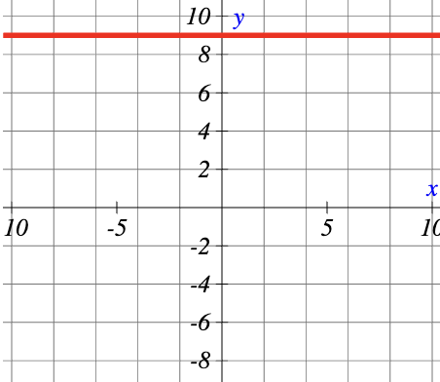
Try It
For each question below, identify the slope, x-intercept, and y-intercept.
Function | Slope | y-intercept | x-intercept
x = 4
y = -5
y = 7x
y = -7-2x
3y + 3x = 6

Writing Equations of Parallel Lines

Example

Suppose we are given the following function: $f\left(x\right)=3x+1$

What is the slope of the line?

Write the equations of three other functions that would be parallel to f(x)

Write the equation of a line parallel to $f\left(x\right)=3x+1$ that passes through the point (1,7).

Question Help: Given the equation of a linear function, write the equation of a line which passes through a given point and is parallel to the given line.
- Find the slope of the function.
- Substitute the slope and given point into point-slope or slope-intercept form.
- Simplify.
Example: Find a line parallel to the graph of f(x) = 3x + 6 that passes through the point (3, 0).

Writing Equations of Perpendicular Lines

Example

Suppose we are given the following function: $f\left(x\right)=2x+4$

What is the slope of the line?

What is the negative reciprocal of the slope?

Write the equations of three other functions that would be perpendicular to f(x)

Write the equation of a line perpendicular to $f\left(x\right)=2x+4$ that passes through the point (4,0).

Question Help: Given the equation of a linear function, write the equation of a line which passes through a given point and is perpendicular to the given line.
- Find the slope of the given function.
- Determine the negative reciprocal of the slope.
- Substitute the new slope and the values for x and y from the given point into g(x) = mx + b.
- Solve for b.
- Write the equation of the line.
Example
Find the equation of a line perpendicular to f(x) = 3x + 3 that passes through the point (3, 0).

Try It
Consider the line with the equation $y=\frac{1}{3}x-6$.
- Give the equation of the line parallel that passes through the point (4,-8)

- Give the equation of the line perpendicular that passes through the point (4,-8)

Question Help: Given two points on a line and a third point, write the equation of the perpendicular line that passes through the point.
- Determine the slope of the line passing through the points.
- Find the negative reciprocal of the slope.
- Use slope-intercept form or point-slope form to write the equation by substituting the known values.
- Simplify.
Example
A line passes through the points (-2, 6) and (4, 5). Find the equation of a line that is perpendicular and passes through the point (4, 5).

Key Takeaway: Equations of Parallel and Perpendicular Lines
- Parallel lines will have the same slope but different y -intercepts.
- Perpendicular lines will have opposite reciprocal slopes.

Writing Equations of Parallel and Perpendicular Lines to Horizontal and Vertical Lines
Example
- Write the equation of a line parallel to y = 4 that goes through the point (-3, 2).

- Write the equation of a line parallel to x = -5 that passes through the point (2, 1).

Example
- Write the equation of a line perpendicular to y = 4 that passes through the point (-1, 4).

- Write the equation of a line perpendicular to x = -2 that passes through the point (-2, 3).

Try It:
- Write the equation of the line parallel to x = 3 that passes through the point (-2, 5).

- Write the equation of the line perpendicular to x = 3 that passes through the point (-2, 5).

Question Help: Writing equations of lines parallel or perpendicular to horizontal and vertical lines.
- A line parallel to y = c is another horizontal line: y = d
- A line parallel to x = c is another vertical line: x = d
- A line perpendicular to y = c is a vertical line: x = d
- A line perpendicular to x = c is a horizontal line: y = d
Use the point given to find the value of x or y.

Fitting Linear Models to Data

Building Linear Models
Question Help: Modeling Linear Functions Problem-Solving Strategy.
- Identify changing quantities, and then define descriptive variables to represent those quantities. When appropriate, sketch a picture or define a coordinate system.
- Look for information that provides values for the variables or values for parts of the functional model, such as slope and initial value.
- Determine what we are trying to find, identify, solve, or interpret.
- Identify a solution pathway from the provided information to what we are trying to find. Often this will involve checking and tracking units, building a table, or even finding a formula for the function being used to model the problem.
- When needed, write a formula for the function.
- Solve or evaluate the function using the formula.
- Reflect on whether your answer is reasonable for the given situation and whether it makes sense mathematically.
- Clearly convey your result using appropriate units, and answer in full sentences when necessary.
Example

Emily is a college student who plans to spend a summer in Seattle. She has saved $3,500 for her trip and anticipates spending $400 each week on rent, food, and activities. How can we write a linear model to represent her situation? What would be the x -intercept, and what can she learn from it?

Example
Hannah plans to pay off a no-interest loan from her parents. Her loan balance is $1,000. She plans to pay $250 per month until her balance is $0. Write a linear model and then find the x-intercept. What does the x-intercept represent?

Question Help: Given a word problem that includes two pairs of input and output values, use the linear function to solve a problem.
- Identify the input and output values.
- Convert the data to two coordinate pairs.
- Find the slope.
- Write the linear model.
- Use the model to make a prediction by evaluating the function at a given x value.
- Use the model to identify an x value that results in a given y value.
- Answer the question posed.
Example
A town's population has been growing linearly. In 2004 the population was 6,200. By 2009 the population had grown to 8,100. Assume this trend continues.
- Predict the population in 2013.

- Identify the year in which the population will reach 15,000.

Try It
In 1994 the moose population in a park was measured to be 4.230. By 1997, the population was measured again to be 4,530. If the population continues to change linearly:
- Find a formula for the moose population, P, in terms of t, the years since 1990.

- What does your model predict the moose population to be in 2006?

Try It
A rental car company charges $30 plus 45 cents per mile driven.
- What is the model for the total cost of the rental after m miles driven?

- What is the total cost of driving 100 miles?

Example
Anna and Emanuel start at the same intersection. Anna walks east at 4 miles per hour while Emanuel walks south at 3 miles per hour. They are communicating with a two-way radio that has a range of 2 miles. How long after they start walking will they fall out of radio contact?

Example
There is a straight road leading from the town of Westborough to Agritown 30 miles east and 10 miles north. A certain distance down this road, it junctions with a second road, perpendicular to the first, leading to the town of Eastborough. If the town of Eastborough is located 20 miles directly east of the town of Westborough, how far is the road junction from Westborough?

Drawing and Interpreting Scatter Plots
A scatter plot is a graph of plotted points that may show a relationship between two sets of data. If the relationship is from a linear model, or a model that is nearly linear, the professor can draw conclusions using his knowledge of linear functions.

Example
The table below shows the number of cricket chirps in 15 seconds, for several different air temperatures, in degrees Fahrenheit. Plot the data to determine whether the data appears to have a linear relationship.
Chirps | 44 | 35 | 20.4 | 33 | 31 | 35 | 18.5 | 37 | 26
Temperature | 80.5 | 70.5 | 57 | 66 | 68 | 72 | 52 | 73.5 | 53
Create a scatterplot to determine if the data has a linear relationship.
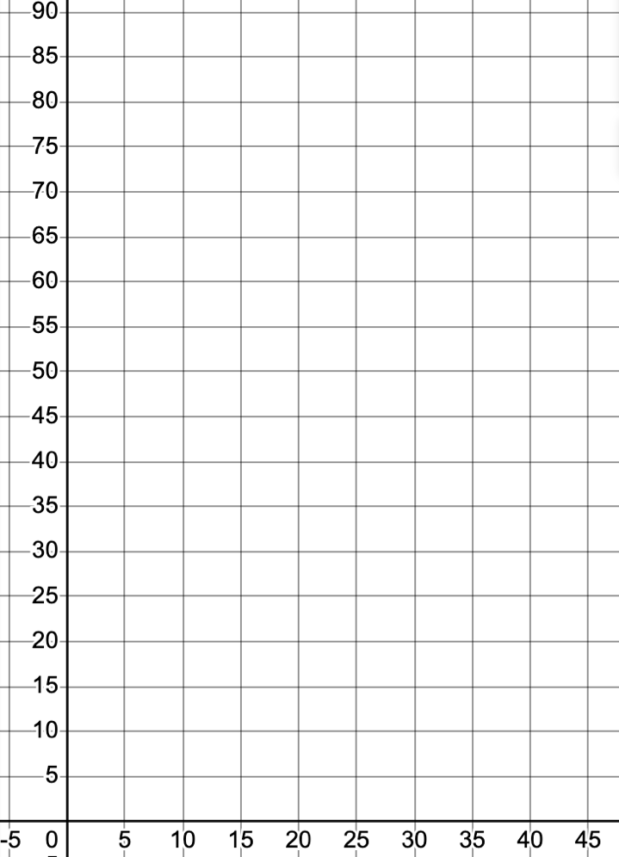

Try It
What type of model is the best choice for the data in the scatterplot?
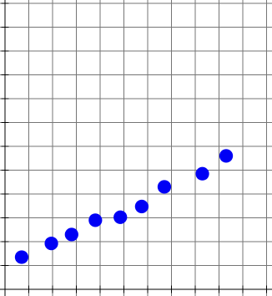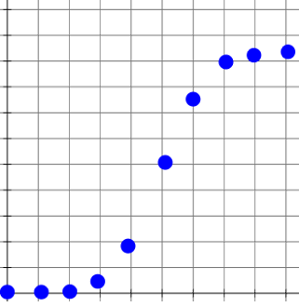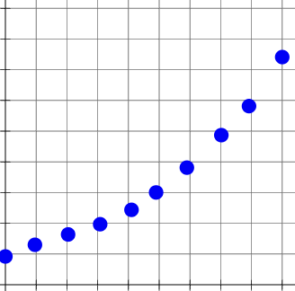

Finding the Line of Best Fit
One way to approximate our linear function is to sketch the line that seems to best fit the data. Then we can extend the line until we can verify the y -intercept. We can approximate the slope of the line by extending it until we can estimate the slope.
Example
Using the cricket chirp data, what is the estimated linear function for the line of best fit?
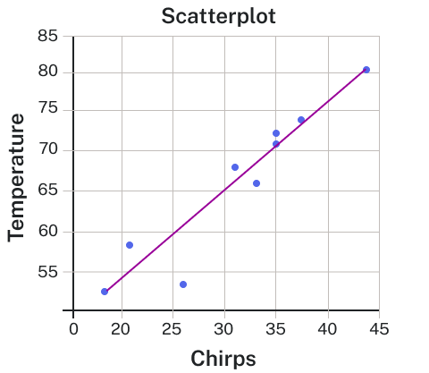
Try It:
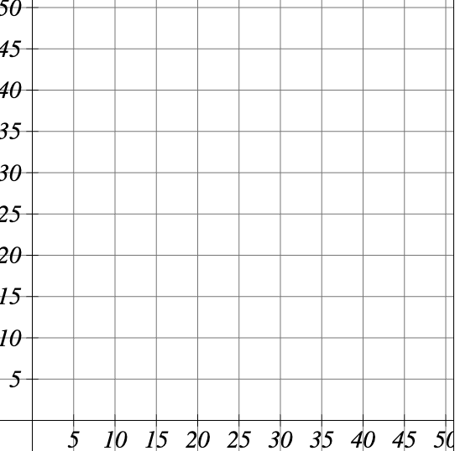
The following is data from the first and second quiz for 8 students.
First Quiz | Second Quiz
13 | 14
19 | 14
22 | 18
24 | 25
41 | 36
45 | 41
47 | 43
50 | 47
Plot the points in the grid, then sketch a line that fits the data.

Finding the Line of Best Fit Using a Graphing Utility
Least squares regression is also called linear regression, and we can use an online graphing calculator to perform linear regression.
Example: Find the least squares regression line using the cricket-chirp data. Use an online graphing calculator.
Chirps | 44 | 35 | 20.4 | 33 | 31 | 35 | 18.5 | 37 | 26
Temperature | 80.5 | 70.5 | 57 | 66 | 68 | 72 | 52 | 73.5 | 53

Question Help: Steps to obtain the regression line in Desmos.
- Click the plus button (add item) in the upper left corner and select table.
- Enter chirps data in the x_1 column.
- Enter temperature data in the y_1 column.
- In the empty cell below the table you created, enter the expression $y_{1}\sim mx_{1}+b$.

Example
Find the equation of the line that best fits the cricket chirp data using the statistical tool. Is it the same or different as the one you found previously? If it is different, why do you think it is different?
Tool: https://lumen-learning.shinyapps.io/linear_regression/

Understanding Interpolation and Extrapolation
Key Takeaway
Different methods of making predictions are used to analyze data.
- The method of interpolation involves predicting a value inside the domain and/or range of the data.
- The method of extrapolation involves predicting a value outside the domain and/or range of the data.
- Model breakdown occurs at the point when the model no longer applies.
Pro Tip: Interpolation occurs within the domain and range of the provided data whereas extrapolation occurs outside.

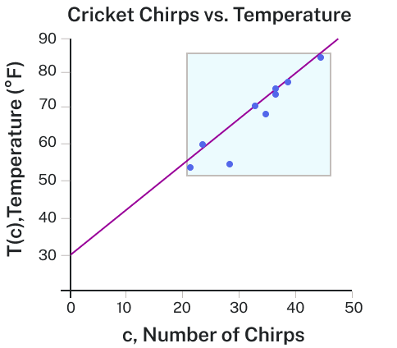
Example
The graph compares the two processes for the cricket-chirp data addressed in the previous example. We can see that interpolation would occur if we used our model to predict temperature when the values for chirps are between 18.5 and 44. Extrapolation would occur if we used our model to predict temperature when the values for chirps are less than 18.5 or greater than 44. Previously, we have found that the estimated equation for the line is y = 1.12x + 31.22.

- Would predicting the temperature when crickets are chirping 30 times in 15 seconds be interpolation or extrapolation? Make the prediction and discuss whether it is reasonable.

- Would predicting the number of chirps crickets will make at 40 degrees be interpolation or extrapolation? Make the prediction and discuss whether it is reasonable.

Try It
The number of QVex phone subscribers, in millions, is recorded in the table below, where the year represents the number of years after 2004.
Year | Subscribers
0 | 33.786
2 | 55.312
4 | 86.047
6 | 128.375
8 | 158.722
10 | 207.896
12 | 255.396
14 | 285.646
C(t) models the number of QVex phone subscribers t years after 2004. Use C(t) to predict the number of subscribers in 2009.
$$C\left(t\right)=18.997t+17.711$$

Is this an example of interpolation or extrapolarion?

Absolute Value Functions
Key Takeaway
The absolute value of a number is a measure of its distance from zero on the number line, regardless of direction. It is always a non-negative value.
For a real number x, the absolute value is denoted by |x| and is defined as:
$$\left|x\right|=\left\{\begin{matrix}x & if x≥0 \\ -x & if x<0\end{matrix}\right.$$

Example
Describe all values x within or including a distance of 4 units from the number 5.

Try It
Describe all values x within a distance of 3 units from the number 2.

Example
Suppose we have a resistor rated at 680 ohms, $±$ 5%. Use the absolute value function to express the range of possible values of the actual resistance.

Try It
Students who score within 20 points of 80 will pass a test. Write this as a distance from 80 using absolute value notation.

Graphing an Absolute Value Function
The most significant feature of the absolute value graph is the corner point at which the graph changes direction. This point is shown at the origin in the graph of f(x) = |x|.
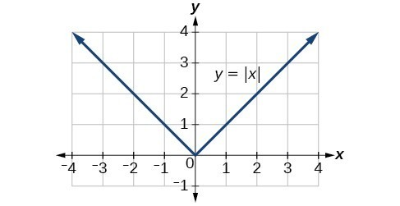
Example
Write an equation for the absolute value function graphed.
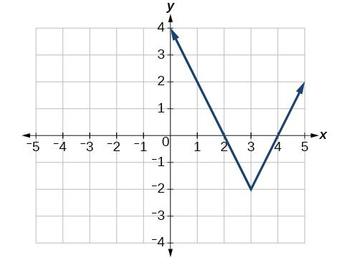
Try It
Write the equation for the absolute value function that is horizontally shifted left 2 units, is vertically flipped, and vertically shifted up 3 units.

Solving Absolute Value Equations
Key Takeaway
The general form of an absolute value equation is: |A| = B where A is the expression and B is a non-negative number.
For real numbers A and B, an equation of the form |A| = B, with$B≥0$, will have solutions when A = B or A = -B. If B < 0, the equation |A| = B has no solution.
An absolute value equation in the form |ax + b| = c has the following properties:
- If c < 0, |ax + b| = c has no solution.
- If c = 0, |ax + b| = c has one solution.
- If c > 0, |ax + b| = c has two solutions.

Question Help: Given an absolute value equation, solve it.
- Isolate the absolute value expression on one side of the equation.
- Write two separate equations: one where the expression equals B, and one where it equals -B.
- Solve each equation separately.
- Check for extraneous solutions by substituting each found solution back into the original equation.

Example
Solve the absolute value equation: |6x + 4| = 8

Example
Solve the absolute value equations
- |3x + 4| = -9

- |3x - 5| - 4 = 6

- |-5x + 10| = 0

Pro Tip
When solving absolute value equations, the absolute value expression must be isolated on one side of the equation before setting up the two cases to remove the absolute value bars. Use the properties of equality to isolate the absolute value expression, but avoid multiplying into or dividing from any expression inside the bars. An absolute value expression is always positive. If your absolute value equation leads to an absolute value expression being set equal to a negative value, you have no solution. Try to catch this case before you split your absolute value equation into two separate equations.
Try It
Solve the following absolute value equation for x. $\left|4x-1\right|=11$

Try It
Solve the following absolute value equation for x. $-8-2\left|-3x-4\right|=-10$

Solving Absolute Value Inequalities
Key Takeaway
For an algebraic expression X and k > 0, an absolute value inequality is an inequality of the form:
|X| < k is equivalent to -k < X < k
or
|X| > k is equivalent to X < -k or X > k

Example
Suppose we want to know all possible returns on an investment if we could earn some amount of money within $200 of $600. Write and solve an absolute value inequality.

Example
Describe all values x within a distance of 4 from the number 5.

Example
Solve the following $\left|x-1\right|≤3$

Example
Given the equation $y=-\frac{1}{2}\left|4x-5\right|+3$, determine the x -values for which the y -values are negative.

Try It
Solve each inequality and give your answers in interval notation.
- $\left|2x-7\right|<1$

- $\left|4x-8\right|≥9$

