Precalculus

Introduction to Calculus Guided Notes
This tool is designed to work alongside your Study Plan and class sessions. Before class, you'll use it with the assigned readings by filling in key terms, noting examples, and writing down questions that arise. During class, you'll add to your notes as you deepen your understanding and instructors highlight important concepts. You'll find a mix of fill-in-the-blank sections, reflection spaces, and areas to record real-world examples.

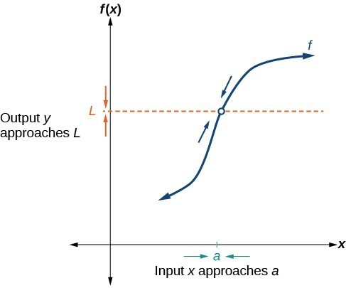
Understanding Limit Notation
We can describe the behavior of the function as the input values get close to a specific value. If the limit of a function f(x)=L, then as the input x gets closer and closer to a, the output y-coordinate gets closer and closer to L. We say that the output "approaches" L.
We write the equation of a limit as
$$⁡\lim_{x→a}{f(x)} = L$$
This notation indicates that as x approaches a both from the left of x=a and the right of x=a, the output value approaches L.

Example
Consider the function
$$f(x) =\frac{x^{2}-6x-7}{x-7}$$
We can factor the function:
$f(x) =\frac{\left(x-7\right)\left(x+1\right)}{x-7}$ [Cancel like factors in numerator and denominator.]
$f(x) = x+1$, $x≠7$ [Simplify.]

What happens at x=7?

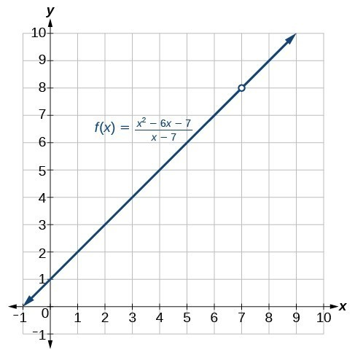
What happens at x =.7 is completely different from what happens at points close to x = 7.
$$\lim_{x→7}{f\left(x\right)}=8$$
This notation indicates that 7 is not in the domain of the function. Notice that the limit of a function can exist even when f(x) is not defined at x=a. Much of our subsequent work will be determining limits of functions as x nears a, even though the output at x=a does not exist.

Can the limit of the function exist even when the function is not defined?

Key Takeaway: The Limit of a Function
A quantity L is the limit of a function f(x) as x approaches a if, as the input values of x approach a (but do not equal a), the corresponding output values of f(x) get closer to L. Note that the value of the limit is not affected by the output value of f(x) at a. Both a and L must be real numbers. We write it as
$$\lim_{x→a}{f(x)}=L$$

Example
For the following limit, define a, f(x), and L.
$$\lim_{x→2}{(3x+5)}=11$$

Try It
For the following limit, define a, f(x), and L.
$$\lim_{x→-4}{(4x^{2}-3x+1)}=77$$

Understanding Left-Hand Limits and Right-Hand Limits
We can approach the input of a function from either side of a value—from the left or the right.
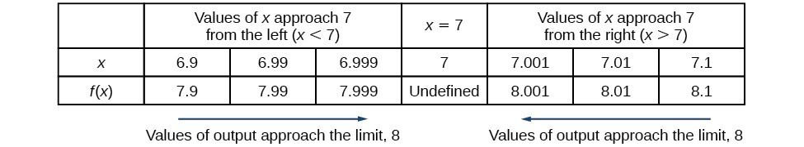
What are the x-values approaching x=7 from the left?

How do we indicate the left-hand limit?

What are the x-values approaching x=7 from the right?

How do we indicate the right-hand limit?

Key Takeaway: One-Sided Limits
The left-hand limit of a function f(x) as x approaches a from the left is equal to L, denoted by
$$\lim_{x→a^{-}}{f(x)}=L$$
The right-hand limit of a function f(x), as x approaches a from the right, is equal to L, denoted by
$$\lim_{x→a^{+}}{f(x)}=L$$
The values of f(x) can get as close to the limit L as we like by taking values of x sufficiently close to a but greater than a. Both a and L are real numbers.

Understanding Two-Sided Limits

Key Takeaway: Two-Sided Limits
The limit of a function f(x), as x approaches a, is equal to L, that is,
$$\lim_{x→a}{f(x)}=L$$if and only if
$$\lim_{x→a^{-}}{f(x)}=\lim_{x→a^{+}}{f(x)}=$$
What does this mean?

Finding a Limit Using a Graph
To visually determine if a limit exists as x approaches a, we observe the graph of the function when x is very near to x=a. We observe the behavior of the graph on both sides of a.
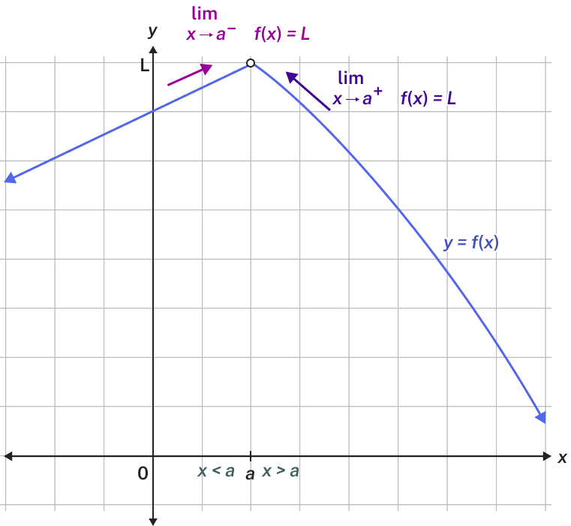
How do we determine if a left-hand limit exists on a graph?

How do we determine if a right-hand limit exists on a graph?

Question Help
Given a function f(x), use a graph to find the limits and a function value as x approaches a.
- Examine the graph to determine whether a left-hand limit exists.
- Examine the graph to determine whether a right-hand limit exists.
- If the two one-sided limits exist and are equal, then there is a two-sided limit—what we normally call a "limit."
- If there is a point at x=a, then f(a) is the corresponding function value.

Example
Use the graph to answer the following questions.
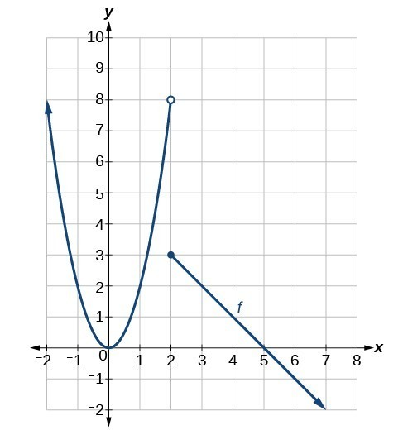
a. $\lim_{x→2^{-}}{f(x)}$
b. $\lim_{x→2^{+}}{f(x)}$
c. $\lim_{x→2}{f(x)}$
d. $f(2)$

Try It
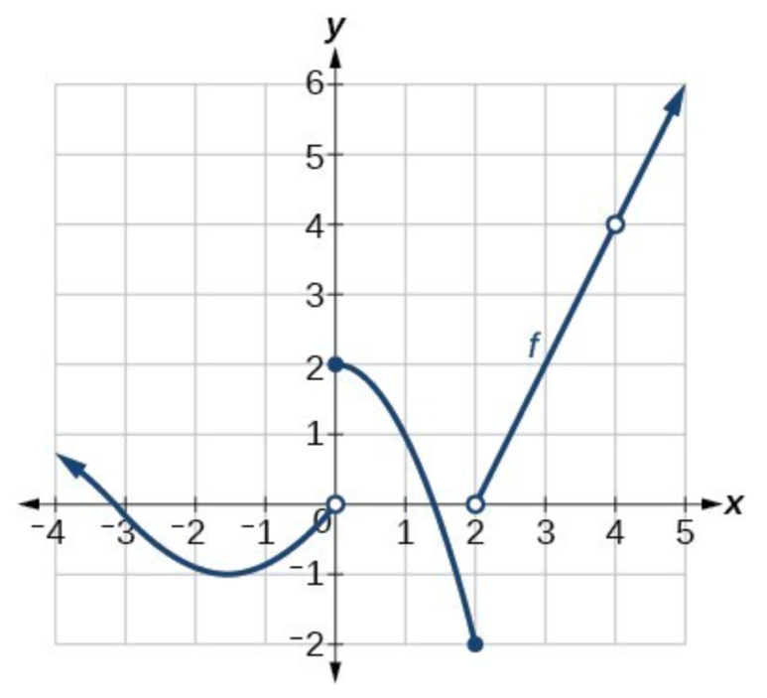
Using the graph of the function y=f(x), estimate the given limits.
- $\lim_{x→0^{-}}{f(x)}=$
- $\lim_{x→0^{+}}{f(x)}=$
- $\lim_{x→0}{f(x)}=$
- $\lim_{x→2^{-}}{f(x)}=$
- $\lim_{x→2^{+}}{f(x)}=$
- $\lim_{x→2}{f(x)}=$
- $\lim_{x→4^{-}}{f(x)}=$
- $\lim_{x→4^{+}}{f(x)}=$
- $\lim_{x→4}{f(x)}=$

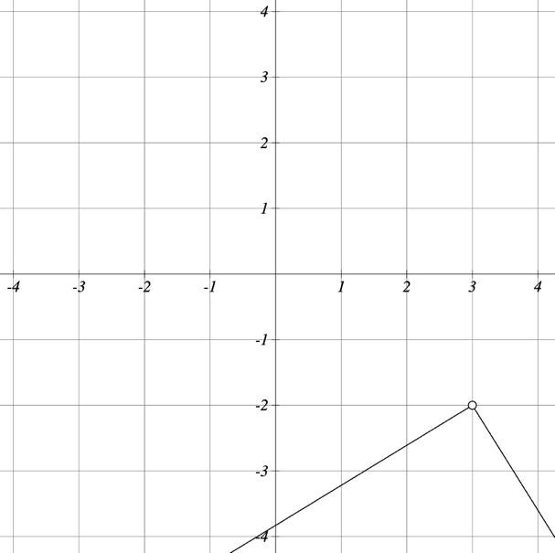
Try It

- $\lim_{x→3^{-}}{f(x)}=$
- $\lim_{x→3^{+}}{f(x)}=$
- $\lim_{x→3}{f(x)}=$

Finding a Limit Using a Table

Question Help
Given a function f, use a table to find the limit as x approaches a and the value of f(a), if it exists.
- Choose several input values that approach a from both the left and right. Record them in a table.
- Evaluate the function at each input value. Record them in the table.
- Determine if the table values indicate a left-hand limit and a right-hand limit.
- If the left-hand and right-hand limits exist and are equal, there is a two-sided limit.
- Replace x with a to find the value of f(a).

Example
Numerically estimate the limit of the following expression by setting up a table of values on both sides of the limit.
$$\lim_{x→0}\left(\frac{5\sin\left(x\right)}{3x}\right)$$
x | -0.1 | -0.01 | -0.001 | 0 | 0.001 | 0.01 | 0.1
f(x)

Try It
Numerically estimate the limit of the following function by making a table:
$$\lim_{x→0}\left(\frac{6\sin\left(x\right)}{4x}\right)$$
x | -0.1 | -0.01 | -0.001 | 0 | 0.001 | 0.01 | 0.1
f(x)

Try It

Guess the value of the limit (if it exists) by evaluating the function at the given values.
$$\lim_{x→0}\left(\frac{\sin\left(2x\right)}{x}\right)$$
x | -0.1 | -0.01 | -0.001 | 0 | 0.001 | 0.01 | 0.1
f(x)

Example
With the use of a graphing utility, if possible, determine the left- and right-hand limits of the following function as x approaches 0. If the function has a limit as x approaches 0, state it. If not, discuss why there is no limit.
$$f(x) = 3\sin\left(\frac{π}{x}\right)$$

Try It
Numerically estimate the following limit:
$$\lim_{x→0}\left(\sin\left(\frac{5}{x}\right)\right)$$

20.2 Properties of Limits

Finding the Limit of a Sum, a Difference, and a Product
Knowing the properties of limits allows us to compute limits directly. We can add, subtract, multiply, and divide the limits of functions as if we were performing the operations on the functions themselves to find the limit of the result.

Key Takeaway: Properties of Limits
Let a, k, A, and B represent real numbers, and f and g be functions, such that $\lim_{x→a}{f(x)}=A$ and $\lim_{x→a}{g(x)}=B$. For limits that exist and are finite, the properties of limits are summarized below.
Constant, k | $$\lim_{x→a}{k}=$$
Constant times a function | $$\lim_{x→a}{[k⋅f\left(x\right)]}=$$
Sum of functions | $$\lim_{x→a}{[f\left(x\right)+g(x)]}=$$
Difference of functions | $$\lim_{x→a}{[f\left(x\right)-g(x)]}=$$
Product of functions | $$\lim_{x→a}{[f\left(x\right)⋅g(x)]}=$$
Quotient of functions | $$\lim_{x→a}\left[\frac{f\left(x\right)}{g\left(x\right)}\right]=$$
Function raised to an exponent | $$\lim_{x→a}{[f{\left(x\right)}^{n}]}$$
Nth root of a function | $$\lim_{x→a}{\sqrt[n]{f(x)}}$$
Polynomial function | $$\lim_{x→a}{p(x)}=$$

Example
Evaluate $\lim_{x→3}{(2x+5)}$

Try It
Evaluate the following limit.
$$\lim_{x→5}{(x+3)}$$

Try It
Evaluate the limit.
$$\lim_{y→-2}{(-2y+1)}$$

Finding the Limit of a Polynomial
What is a polynomial?

Question Help
Given a function containing a polynomial, find its limit.
- Use the properties of limits to break up the polynomial into individual terms.
- Find the limits of the individual terms.
- Add the limits together.
- Alternatively, evaluate the function for a.

Example
Evaluate
$$\lim_{x→3}{(5x^{2})}$$

Try It
Evaluate
$$\lim_{x→2}{(-2x^{3}-2)}$$

Example
Evaluate
$$\lim_{y→5}{(x^{4}+2x^{3}-x^{2}-2)}$$

Try It
Evaluate the following limit:
$$\lim_{x→-5}{(-x^{5}+3x^{4}-7x^{3}-2x^{2}+8x+7)}$$

Finding the Limit of a Power or a Root
When a limit includes a power or a root, we need another property to help us evaluate it. The square of the limit of a function equals the limit of the square of the function; the same goes for higher powers. Likewise, the square root of the limit of a function equals the limit of the square root of the function; the same holds true for higher roots.

Example
Evaluate
$$\lim_{x→2}{{\left(3x+1\right)}^{5}}$$
.

Try It
Evaluate the following limit:
$$\lim_{x→4}{{\left(-3x+1\right)}^{3}}$$

Finding the Limit of a Quotient

Question Help
Given the limit of a function in quotient form, use factoring to evaluate it.
- Factor the numerator and denominator completely.
- Simplify by dividing any factors common to the numerator and denominator.
- Evaluate the resulting limit, remembering to use the correct domain.

Example
Evaluate
$$\lim_{x→2}\left(\frac{x^{2}-6x+8}{x-2}\right)$$
.

Try It
Evaluate the following limit:
$$\lim_{x→-5}\left(\frac{x^{2}+6x+5}{-5-x}\right)$$

Try It
Evaluate
$$\lim_{x→9}\left(\frac{x^{2}-3x-54}{x-9}\right)$$

Example
Evaluate
$$\lim_{x→5}\left(\frac{\frac{1}{x}-\frac{1}{5}}{x-5}\right)$$

Try It
Evaluate
$$\lim_{x→-2}\left(\frac{\frac{1}{2}+\frac{1}{x}}{10+5x}\right)$$

Question Help
Given a limit of a function containing a root, use a conjugate to evaluate.
- If the quotient as given is not in indeterminate (0/0) form, evaluate directly.
- Otherwise, rewrite the sum (or difference) of two quotients as a single quotient, using the least common denominator (LCD).
- If the numerator includes a root, rationalize the numerator; multiply the numerator and denominator by the conjugate of the numerator. Recall that a±√b are conjugates.
- Simplify.
- Evaluate the resulting limit.

Example
Evaluate
$$\lim_{x→0}\left(\frac{\sqrt{25-x}-5}{x}\right)$$

Try It
Evaluate the following limit:
$$\lim_{h→0}\left(\frac{\sqrt{16-h}-4}{h}\right)$$

Try It
Evaluate the following limit:
$$\lim_{x→0}\left(\frac{\sqrt{3x+64}-8}{x}\right)$$

Example
Evaluate
$$\lim_{x→4}\left(\frac{4-x}{\sqrt{x}-2}\right)$$

Try It
Evaluate the following limit.
$$\lim_{x→5}\left(\frac{x-5}{\sqrt{x}-\sqrt{5}}\right)$$

Question Help
Given a quotient with absolute values, evaluate its limit.
- Try factoring or finding the LCD.
- If the limit cannot be found, choose several values close to and on either side of the input where the function is undefined.
- Use the numeric evidence to estimate the limits on both sides.

Example
Evaluate
$$\lim_{x→4}\left(\frac{|x-7|}{x-7}\right)$$

Try It
$$\lim_{x→-5^{-}}\left(\frac{-5-x}{|x+5|}\right)$$

20.3 Continuity
What is a continuous function?

Key Takeaway: Stepwise Function
A function that remains level for an interval and then jumps instantaneously to a higher value is called a stepwise function.
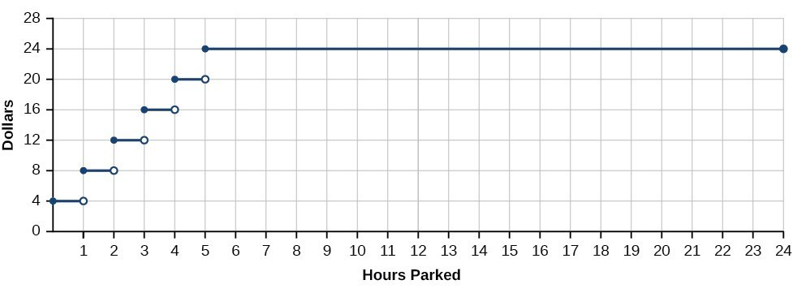

Key Takeaway: Discontinuous Function
A function that has any hole or break in its graph is known as a discontinuous function.

Example
Condition 1: According to Condition 1, the function f(a) defined at x=a must exist. In other words, there is a y-coordinate at x=a.
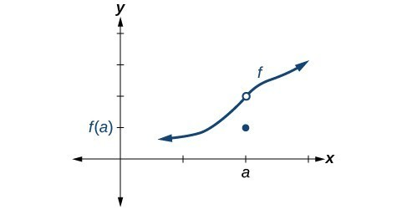
Condition 2: According to Condition 2, at x=a the limit, written lim(x→a) f(x), must exist. This means that at x=a the left-hand limit must equal the right-hand limit. There could still be a hole in the graph at x=a.
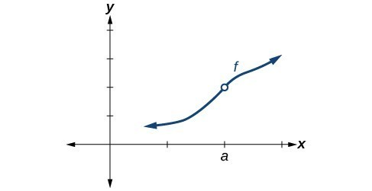
Condition 3: According to Condition 3, the corresponding y coordinate at x=a fills in the hole in the graph of f. This is written lim(x→a) f(x) = f(a).
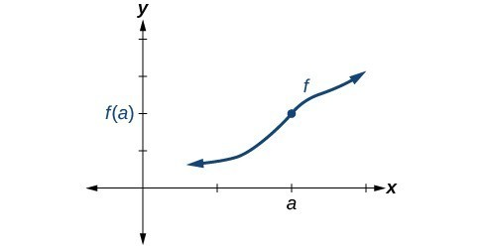
Satisfying all three conditions means that the function is continuous.

Key Takeaway: Definition of Continuity
A function f(x) is continuous at $x=a$ provided all three of the following conditions hold true:
Condition 1: f(a) exists.
Condition 2: $\lim_{x→a}{f(x)}$ exists at $x=a$.
Condition 3: $\lim_{x→a}{f(x)}=f(a)$.
If a function f(x) is not continuous at $x=a$, the function is discontinuous at x=a.

Identifying Discontinuities

Key Takeaway: Jump Discontinuity
A function f(x) has a jump discontinuity at $x=a$ if the left- and right-hand limits both exist but are not equal:
$$\lim_{x→a^{-}}{f\left(x\right)≠\lim_{x→a^{+}}{f(x)} }$$
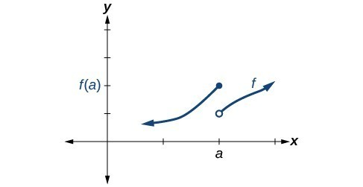

Identifying Removable Discontinuity

Key Takeaway: Removable Discontinuity
A function f(x) has a removable discontinuity at $x=a$ if the limit, $\lim_{x→a}{f(x)}$, exists, but either
- f(a) does not exist, or
- f(a), the value of the function at x=a, does not equal the limit, $f\left(a\right)≠\lim_{x→a}{f(x)}$,.

Example
Identify all discontinuities for the following functions as either a jump or a removable discontinuity.
a. $f(x) =\frac{x^{2}-2x-15}{x-5}$

b. $g(x) = \begin{matrix}x+1 & x<2 \\ -x & x≥2\end{matrix}$

Try It
Identify all discontinuities for the following functions as either a jump or a removable discontinuity.
a. $f(x) =\frac{x^{2}-6x}{x-6}$

b. $g(x) = \begin{matrix}\sqrt{x} & 0≤x<9 \\ 2x & x≥9\end{matrix}$

Recognizing Continuous and Discontinuous Real-Number Functions
Many of the functions we have encountered in earlier chapters are continuous everywhere. They never have a hole in them, and they never jump from one value to the next.

Key Takeaway: Continuous Functions
The following functions are continuous everywhere:
- Polynomial functions.
- Exponential functions
- Sine functions.
- Cosine functions.
The following functions are continuous everywhere they are defined on their domain:
- Logarithmic functions.
- Tangent functions
- Rational functions.

Question Help
Given a function f(x), determine if the function is continuous at $x=a$.
- Check Condition 1: f(a) exists.
- Check Condition 2: $\lim_{x→a}{f(x)}$ exists at $x=a$.
- Check Condition 3: $\lim_{x→a}{f(x)}=f(a)$.
- If all three conditions are satisfied, the function is continuous at $x=a$. If any one of the conditions is not satisfied, the function is not continuous at $x=a$.

Example
Determine whether the function $f(x)=\begin{matrix}4x & x≤3 \\ 8+x & x>3\end{matrix}$
- $x=3$

- $x=\frac{8}{3}$

Try It
Determine whether the function $f(x)=\begin{matrix}\frac{3}{x} & x≤3 \\ -4x+14 & x>3\end{matrix}$, is continuous at $x=3$.

Example
Determine whether the function $f(x)=\frac{x^{2}-25}{x-5}$is continuous at $x=5$.

Try It
Determine whether the function $f(x)=\frac{9-x^{2}}{x^{2}-3x}$ is continuous at $x=3$. If not, state the type of discontinuity.

Try It
Determine whether the function $f(x)=\frac{x^{2}-9}{x-3}$ is continuous at $x=1$. If not, state the type of discontinuity.

Determining the Input Values for Which a Function Is Discontinuous

Question Help
Given a piecewise function, determine whether it is continuous at the boundary points.
- For each boundary point a of the piecewise function, determine the left- and right-hand limits as x approaches a, as well as the function value at a.
- Check each condition for each value to determine if all three conditions are satisfied.
  - Determine whether each value satisfies condition 1: f(a) exists.
  - Determine whether each value satisfies condition 2: $\lim_{x→a}{f(x)}$exists.
  - Determine whether each value satisfies condition 3: $\lim_{x→a}{f(x)}=f(a)$
- If all three conditions are satisfied, the function is continuous at $x=a$. If any one of the conditions fails, the function is not continuous at $x=a$.

Example
Determine whether the function f is discontinuous for any real numbers.
$$f\left(x\right)=\left\{\begin{matrix}x+1 & x<2 \\ 3 & 2≤x<4 \\ x^{2}-11 & x≥4\end{matrix}\right.$$

Try It
Determine where the function is discontinuous.
$$f\left(x\right)=\left\{\begin{matrix}-x+3 & x<4 \\ -2x+7 & 4≤x≤9 \\ -x-3 & x>9\end{matrix}\right.$$

Try It
Sketch a graph of f(x) and determine if it is continuous. If not, determine where it is discontinuous.
$$f\left(x\right)=\left\{\begin{matrix}2x+2 & x≤1 \\ -x^{2}+5 & 1<x≤5 \\ -x-16 & x>5\end{matrix}\right.$$
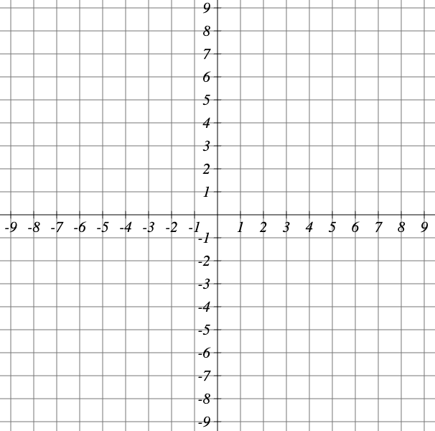

Determining Whether a Function Is Continuous

Question Help
Given a piecewise function, determine whether it is continuous.
- Determine whether each component function of the piecewise function is continuous. If there are discontinuities, do they occur within the domain where that component function is applied?
- For each boundary point $x=a$ of the piecewise function, determine if each of the three conditions hold.

Example
Determine whether the function below is continuous. If it is not, state the location and type of each discontinuity.
$$f(x)=\begin{matrix}\sin{(x)} & x<0 \\ x^{3} & x>0\end{matrix}$$

20.4 Derivatives

Finding the Average Rate of Change of a Function
How do we calculate slope?

Key Takeaway: Average Rate of Change
The average rate of change (AROC) between two points $(a, f(a))$ and $(a+h, f(a+h))$on the curve of f is the slope of the line connecting the two points and is given by
AROC = $\frac{f\left(a+h\right)-f\left(a\right)}{h}$

Example
Find the average rate of change connecting the points (2,−6) and (−1,5).

Try It
Find the average rate of change connecting the points (-2,6.5) and (2.5,2.5)

Understanding the Instantaneous Rate of Change

Key Takeaway: Derivative
The derivative, or instantaneous rate of change, of a function f at $x=a$, is given by
$$f^{'}\left(a\right)=\lim_{h→0}{\frac{f\left(a+h\right)-f(a)}{h}}$$What are the different ways we can interpret the derivative?

Question Help
Given a function f, find the derivative by applying the definition of the derivative.
- Calculate $f(a+h).$
- Calculate $f(a)$.
- Substitute and simplify $\frac{f\left(a+h\right)-f\left(a\right)}{h}$.
- Evaluate the limit if it exists: $f^{'}\left(a\right)=\lim_{h→0}{\frac{f\left(a+h\right)-f(a)}{h}}$.

Example
Find the derivative of the function $f(x)=x²-3x+5$ at $x=a$.

Try It
Find the derivative of the function $f\left(x\right)=4x^{2}-2x+5$ at $x=a$

Example
Find the derivative of $f\left(x\right)=2x^{2}+6$

Finding Derivatives of Rational Functions
To find the derivative of a rational function, we will sometimes simplify the expression using algebraic techniques we have already learned.

Example
Find the derivative of the function $f(x)=\frac{3+x}{2-x}$ at $x=a$.

Try It
Find the derivative of the function $f(x)=\frac{-3x+3}{-2x-1}$ at $x=a$.

Try It
If $f(x)=\frac{3x+8}{7x+4}$ find $f'(x)$.

Finding Derivatives of Functions with Roots
To find derivatives of functions with roots, we use the methods we have learned to find limits of functions with roots, including multiplying by a conjugate.

Example
Find the derivative of the function $f(x)=4\sqrt{x}$ at $x=36$.

Try It
Find the derivative of the function $f(x)=5\sqrt{x}$ at $x=1$.

Try It
Find the derivative of $f\left(x\right)=-3\sqrt{x}$, then find $f'(25)$.

Finding Instantaneous Rates of Change

Example
Using the function, $s(t)=-16t²+64t+6$, what is the instantaneous velocity of the ball at 1 second and 3 seconds into its flight?

Try It
The position of a ball is given by $s(t)=-4t²+48t+4$, what is the instantaneous velocity of the ball 3 seconds into the flight?

Using Graphs to Find Instantaneous Rates of Change
How can we estimate instantaneous rate of change from a graph?

Question Help
Given a graph of a function f(x), find the instantaneous rate of change of the function at $x=a$.
- Locate $x=a$ on the graph of the function f(x).
- Draw a tangent line, a line that goes through x=a at a and at no other point in that section of the curve. Extend the line far enough to calculate its slope as $\frac{change in y}{change in x}$.

Example
From the graph of the function y=f(x), estimate each of the following:
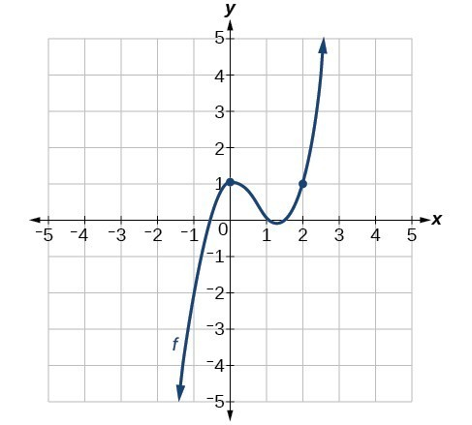
a. $f(0)$
b. $f(2)$
c. $f'(0)$
d. $f'(2)$

Try It
Using the graph of the function $f\left(x\right)=-2x^{3}-4x^{2}+4x+2$. Estimate the following.
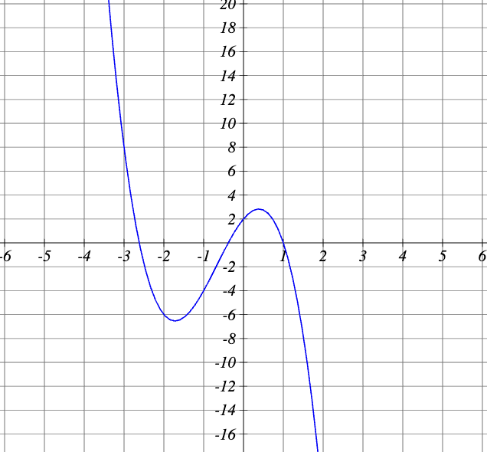
a. $f(2)$
b. $f'(2)$
c. $f(-3)$
d. $f'(-3)$

Finding Points Where a Function's Derivative Does Not Exist
Explain why each graph is not differentiable at one point in its domain.
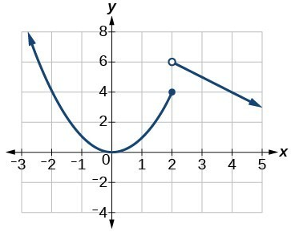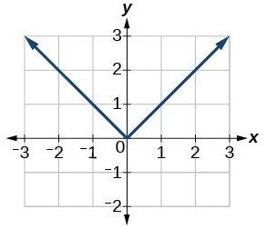
Explain why each graph is not differentiable at one point in its domain.
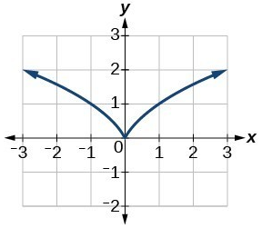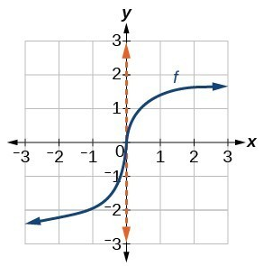

Key Takeaway: Differentiability
A function f(x) is differentiable at $x=a$ if the derivative exists at $x=a,$ which means that $f'(a)$ exists.
There are four cases for which a function f(x) is not differentiable at a point $x=a$:
- When there is a discontinuity at $x=a$.
- When there is a corner point at $x=a$.
- When there is a cusp at $x=a$.
- Any other time when there is a vertical tangent at $x=a$.

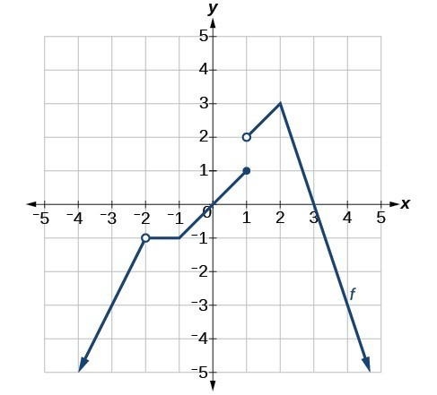
Example
Determine where the function is:
a. continuous
b. discontinuous
c. differentiable
d. not differentiable
At the points where the graph is discontinuous or not differentiable, state why.

Try It
Determine where the function is discontinuous and not differentiable from its graph.
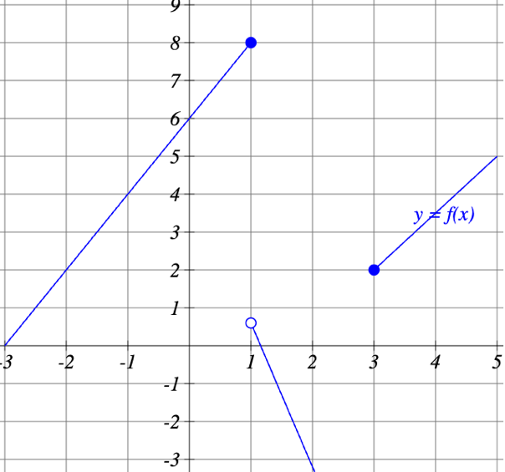

Finding an Equation of a Line Tangent to the Graph of a Function
What is the point-slope form equation?

Key Takeaway: Equation of the Tangent Line
The equation of a line tangent to the curve of a function f at a point $x=a$ is
$$y = f'(a)(x-a) + f(a)$$

Question Help
Given a function f, find the equation of a line tangent to the function at $x=a$.
- Find the derivative of $f\left(x\right)$ at $x=a$ using $f^{'}\left(a\right)=\lim_{h→0}{\frac{f\left(a+h\right)-f(a)}{h}}$
- Evaluate the function at $x=a$. This is $f(a)$.
- Substitute $(a, f(a))$ and $f'(a)$ into $y = f'(a)(x-a) + f(a)$.
- Write the equation of the tangent line in the form $y=mx+b.$

Example
Find the equation of a line tangent to the curve $f(x)=x²-4x$at $x=3$.

Try It
Find the equation of a line tangent to the curve $f\left(x\right)=3x^{2}-4x+1$at $x=-2$.

