Precalculus

Conic Sections Guided Notes
This tool is designed to work alongside your Study Plan and class sessions. Before class, you'll use it with the assigned readings by filling in key terms, noting examples, and writing down questions that arise. During class, you'll add to your notes as you deepen your understanding and instructors highlight important concepts. You'll find a mix of fill-in-the-blank sections, reflection spaces, and areas to record real-world examples.

19.1 Ellipses

Writing Equations of Ellipses in Standard Form
A conic section, or conic, is a shape resulting from intersecting a right circular cone with a plane. The angle at which the plane intersects the cone determines the shape.
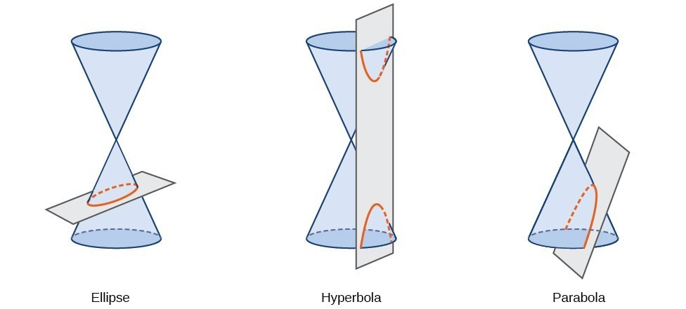

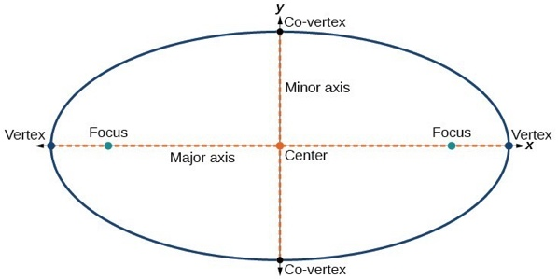
Writing Equations of Ellipses Centered at the Origin in Standard Form
The key features of the ellipse are its center, vertices, co-vertices, foci, and lengths and positions of the major and minor axes. There are four variations of the standard form of the ellipse, categorized first by the location of the center (the origin or not the origin), and then by the position (horizontal or vertical).

Key Takeaway: Standard Form of an Ellipse
The standard form of the equation of a horizontal ellipse with center (0,0) and major axis on the x-axis is
$$\frac{x^{2}}{a^{2}}+\frac{y^{2}}{b^{2}}=1$$where
- $a>b$
- the length of the major axis is $2a$
- the coordinates of the vertices are $(±a, 0)$
- the length of the minor axis is $2b$
- the coordinates of the co-vertices are$(0, ±b)$
- the coordinates of the foci are $(±c, 0)$, where $c²=a²-b^{2}$
The standard form of the equation of a vertical ellipse with center (0,0) and major axis on the y-axis is
$$\frac{x^{2}}{b^{2}}+\frac{y^{2}}{a^{2}} = 1$$where
- $a>b$
- the length of the major axis is $2a$
- the coordinates of the vertices are $(0, ±a)$
- the length of the minor axis is $2b$
- the coordinates of the co-vertices are $(±b, 0)$
- the coordinates of the foci are $(0, ±c)$, where$c²=a²-b²$
Note that the vertices, co-vertices, and foci are related by the equation $c²=a²-b²$. When we are given the coordinates of the foci and vertices of an ellipse, we can use this relationship to find the equation of the ellipse in standard form.

Question Help
Given the vertices and foci of an ellipse centered at the origin, write its equation in standard form.
- Determine whether the major axis lies on the x- or y-axis.
  - If the coordinates of the vertices and foci have the form $(±a, 0)$ and $(±c, 0)$, then the major axis is the x-axis. Use the standard form $\frac{x^{2}}{a^{2}}+\frac{y^{2}}{b^{2}}= 1.$
  - If the given coordinates of the vertices and foci have the form $(0, ±a)$ and $(0, ±c)$, respectively, then the major axis is the y-axis. Use the standard form $\frac{x^{2}}{b^{2}} +\frac{y^{2}}{a^{2}} = 1$.
- Use the equation $c²=a²-b²$, along with the given coordinates of the vertices and foci, to solve for $b²$.
- Substitute the values for $a²$ and $b²$ into the standard form of the equation determined in Step 1.

Example
What is the standard form equation of the ellipse that has vertices $(±8, 0)$ and foci $(±5, 0)$?

Try It
What is the standard form equation of the ellipse that has vertices $(0, ±4)$ and foci $(0, ±\sqrt{15})$?

Try It
What is the equation of the ellipse graphed.
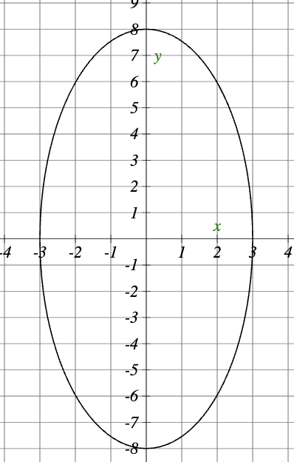

Pro Tip
Ellipses are symmetrical, so the coordinates of the vertices of an ellipse centered around the origin will always have the form $(±a, 0)$ or $(0, ±a).$ Similarly, the coordinates of the foci will always have the form $(±c, 0)$or $(0, ±c)$. Knowing this, we can use a and c from the given points, along with the equation $c^{2}=a^{2}-b^{2}$, to find b².

Writing Equations of Ellipses Not Centered at the Origin
Like the graphs of other equations, the graph of an ellipse can be translated.

Key Takeaway: Ellipse with a Center (h,k)
The standard form of the equation of an ellipse with center $(h, k)$ and major axis parallel to the x-axis is
$$\frac{{\left(x-h\right)}^{2}}{a^{2}} +\frac{{\left(y-k\right)}^{2}}{b^{2}} = 1$$where
- $a>b$
- the length of the major axis is $2a$
- the coordinates of the vertices are $(h±a, k)$
- the length of the minor axis is $2b$
- the coordinates of the co-vertices are $(h, k±b)$
- the coordinates of the foci are$(h±c, k)$, where $c²=a²-b²$
The standard form of the equation of an ellipse with center$(h,k)$ and major axis parallel to the y-axis is
$$\frac{{\left(x-h\right)}^{2}}{b^{2}}+\frac{{\left(y-k\right)}^{2}}{a^{2}} = 1$$where
- $a>b$
- the length of the major axis is $2a$
- the coordinates of the vertices are $(h, k±a)$
- the length of the minor axis is $2b$
- the coordinates of the co-vertices are $(h±b, k)$
- the coordinates of the foci are$(h, k±c),$ where $c²=a²-b²$

Question Help
Given the vertices and foci of an ellipse not centered at the origin, write its equation in standard form.
- Determine whether the major axis is parallel to the x- or y-axis.
  - If the y-coordinates of the given vertices and foci are the same, then the major axis is parallel to the x-axis. Use the standard form $\frac{{\left(x-h\right)}^{2}}{a^{2}} +\frac{{\left(y-k\right)}^{2}}{b^{2}} = 1$.
  - If the x-coordinates of the given vertices and foci are the same, then the major axis is parallel to the y-axis. Use the standard form $\frac{{\left(x-h\right)}^{2}}{b^{2}}+\frac{{\left(y-k\right)}^{2}}{a^{2}}= 1$.
- Identify the center of the ellipse$(h,k)$using the midpoint formula and the given coordinates for the vertices.
- Find $a²$ by solving for the length of the major axis, $2a$, which is the distance between the given vertices.
- Find $c²$ using h and k, found in Step 2, along with the given coordinates for the foci.
- Solve for b² using the equation $c^{2}=a^{2}-b^{2}$.
- Substitute the values for h, k, $a²,$ and $b²$ into the standard form of the equation determined in Step 1.

Example
What is the standard form equation of the ellipse that has vertices (−2,−8) and (−2, 2) and foci (−2,−7) and (−2, 1)?

Try It
What is the standard form equation of the ellipse that has vertices (−3,3) and (5,3) and foci $(1-2\sqrt{3}, 3)$ and $(1+2\sqrt{3}, 3)$?

Try It
An ellipse has endpoints of its axes at the points $(-2,4)$, $(0,4)$, $(-1,-3)$ and $(-1,11)$.

Graphing Ellipses Centered at the Origin
Just as we can write the equation for an ellipse given its graph, we can graph an ellipse given its equation. To graph ellipses centered at the origin, we use the standard form $\frac{x^{2}}{a^{2}} +\frac{y^{2}}{b^{2}}= 1$, $a>b$ for horizontal ellipses and $\frac{x^{2}}{b^{2}}+\frac{y^{2}}{a^{2}}= 1$, $a>b$ for vertical ellipses.

Question Help
Given the standard form of an equation for an ellipse centered at $(0,0)$, sketch the graph.
- Use the standard forms of the equations of an ellipse to determine the major axis, vertices, co-vertices, and foci.
  - If the equation is in the form $\frac{x^{2}}{a^{2}}+\frac{y^{2}}{b^{2}}= 1$, where $a>b$, then the major axis is the x-axis, the coordinates of the vertices are $(±a, 0)$, the coordinates of the co-vertices are $(0, ±b)$, and the coordinates of the foci are $(±c, 0$).
  - If the equation is in the form $\frac{x^{2}}{b^{2}}+\frac{y^{2}}{a^{2}}= 1$, where $a>b$, then the major axis is the y-axis, the coordinates of the vertices are $(0, ±a)$, the coordinates of the co-vertices are $(±b, 0)$, and the coordinates of the foci are $(0, ±c).$
- Solve for c using the equation $c²=a²-b²$.
- Plot the center, vertices, co-vertices, and foci in the coordinate plane, and draw a smooth curve to form the ellipse.

Example
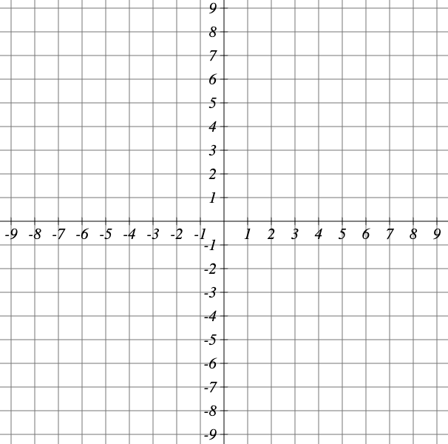
Graph the ellipse given by the equation, $\frac{x^{2}}{9}+\frac{y^{2}}{25}= 1$. Identify and label the center, vertices, co-vertices, and foci.

Try It
Graph the ellipse given by the equation $\frac{x^{2}}{36}+\frac{y^{2}}{4}= 1$. Identify and label the center, vertices, co-vertices, and foci.

Example
Graph the ellipse given by the equation $4x²+25y²=100$. Rewrite the equation in standard form. Then identify and label the center, vertices, co-vertices, and foci.

Try It
Graph the ellipse given by the equation $49x²+16y²=784$. Rewrite the equation in standard form. Then identify and label the center, vertices, co-vertices, and foci.

Graphing Ellipses Not Centered at the Origin
When an ellipse is not centered at the origin, we can still use the standard forms to find the key features of the graph. When the ellipse is centered at some point, $(h,k)$, we use the standard forms $\frac{{\left(x-h\right)}^{2}}{a^{2}}+\frac{{\left(y-k\right)}^{2}}{b^{2}}= 1$, $a>b$ for horizontal ellipses and $\frac{{\left(x-h\right)}^{2}}{b^{2}}+\frac{{\left(y-k\right)}^{2}}{a^{2}}= 1$, $a>b$for vertical ellipses.

Question Help
Given the standard form of an equation for an ellipse centered at $(h,k)$, sketch the graph.
- Use the standard forms of the equations of an ellipse to determine the center, position of the major axis, vertices, co-vertices, and foci.
  - If the equation is in the form $\frac{{\left(x-h\right)}^{2}}{a^{2}}+\frac{{\left(y-k\right)}^{2}}{b^{2}}= 1$, where $a>b$, then the center is $(h,k)$, the major axis is parallel to the x-axis, the coordinates of the vertices are $(h±a, k)$, the coordinates of the co-vertices are (h, k±b), and the coordinates of the foci are $(h±c, k)$.
  - If the equation is in the form $\frac{{\left(x-h\right)}^{2}}{b^{2}}+\frac{{\left(y-k\right)}^{2}}{a^{2}}= 1$, where$a>b$, then the center is $(h,k)$, the major axis is parallel to the y-axis, the coordinates of the vertices are $(h, k±a)$, the coordinates of the co-vertices are $(h±b, k)$, and the coordinates of the foci are $(h, k±c).$
- Solve for c using the equation $c²=a²-b²$.
- Plot the center, vertices, co-vertices, and foci in the coordinate plane, and draw a smooth curve to form the ellipse.

Example
Graph the ellipse given by the equation, $\frac{{\left(x+2\right)}^{2}}{4}+\frac{{\left(y-5\right)}^{2}}{9}= 1$. Identify and label the center, vertices, co-vertices, and foci.

Try It
Graph the ellipse given by the equation $\frac{{\left(x-4\right)}^{2}}{36}+\frac{{\left(y-2\right)}^{2}}{20}= 1$. Identify and label the center, vertices, co-vertices, and foci.

Question Help
Given the general form of an equation for an ellipse centered at $(h,k)$, express the equation in standard form.
- Recognize that an ellipse described by an equation in the form $ax²+by²+cx+dy+e=0$is in general form.
- Rearrange the equation by grouping terms that contain the same variable. Move the constant term to the opposite side of the equation.
- Factor out the coefficients of the x² and y² terms in preparation for completing the square.
- Complete the square for each variable to rewrite the equation in the form of the sum of multiples of two binomials squared set equal to a constant, $m₁(x-h)²+m_{2}{\left(y-k\right)}^{2}=m_{3}$, where m₁, m₂, and m₃ are constants.
- Divide both sides of the equation by the constant term to express the equation in standard form.

Example
Graph the ellipse given by the equation $4x²+9y²-40x+36y+100=0$. Identify and label the center, vertices, co-vertices, and foci.

Try It
Express the equation of the ellipse given in standard form. Identify the center, vertices, co-vertices, and foci of the ellipse.
$$4x²+y²-24x+2y+21=0$$

19.2 Hyperbolas
What do paths of comets, supersonic booms, ancient Grecian pillars, and natural draft cooling towers have in common? They can all be modeled by the same type of conic.
Locating the Vertices and Foci of a Hyperbola
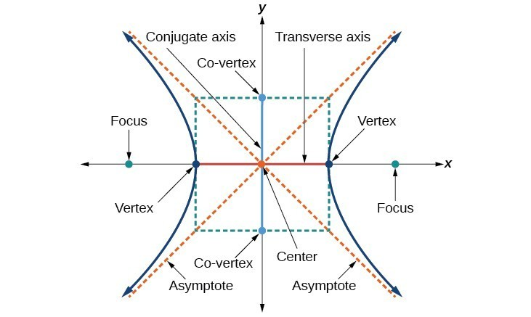

Key Takeaway: Hyperbola Centered at (0,0)
The standard form of the equation of a hyperbola with center (0,0) and transverse axis on the x-axis is
$$\frac{x^{2}}{a^{2}}-\frac{y^{2}}{b^{2}}= 1$$where
- the length of the transverse axis is $2a$ and the coordinates of the vertices are $(±a, 0)$
- the length of the conjugate axis is$2b$ and the coordinates of the co-vertices are$(0, ±b)$
- the coordinates of the foci are $(±c, 0)$
- the equations of the asymptotes are $y=±\frac{b}{a}x$
The standard form of the equation of a hyperbola with center (0,0) and transverse axis on the y-axis is
$$\frac{y^{2}}{a^{2}}-\frac{x^{2}}{b^{2}}= 1$$where
- the length of the transverse axis is $2a$ and the coordinates of the vertices are $(0, ±a)$
- the length of the conjugate axis is $2b$ and the coordinates of the co-vertices are $(±b, 0)$
- the coordinates of the foci are$(0, ±c)$
- the equations of the asymptotes are $y=±\frac{a}{b}x$
Note that the vertices, co-vertices, and foci are related by the equation $c²=a²+b²$. When we are given the equation of a hyperbola, we can use this relationship to identify its vertices and foci.

Question Help
Given the equation of a hyperbola in standard form, locate its vertices and foci.
- Determine whether the transverse axis lies on the x- or y-axis. Notice that a² is always under the variable with the positive coefficient. So, if you set the other variable equal to zero, you can easily find the intercepts. In the case where the hyperbola is centered at the origin, the intercepts coincide with the vertices.
  - If the equation has the form $\frac{x^{2}}{a^{2}}-\frac{y^{2}}{b^{2}}= 1$, then the transverse axis lies on the x-axis. The vertices are located at$(±a, 0)$, and the foci are located at $(±c, 0)$.
  - If the equation has the form $\frac{y^{2}}{a^{2}}-\frac{x^{2}}{b^{2}}= 1$, then the transverse axis lies on the y-axis. The vertices are located at $(0, ±a)$, and the foci are located at$(0, ±c)$.
- Solve for a using the equation$a=\sqrt{a^{2}}.$
- Solve for c using the equation $c=\sqrt{a^{2}+b^{2}}$.

Example
Identify the vertices and foci of the hyperbola with equation $\frac{y^{2}}{49}-\frac{x^{2}}{32}= 1$.

Try It
Identify the vertices and foci of the hyperbola with equation $\frac{x^{2}}{9}-\frac{y^{2}}{25}= 1$.

Try It
Identify the vertices and foci of the hyperbola with the equation $\frac{y^{2}}{6^{2}}-\frac{y^{2}}{8^{2}}= 1$

Writing Equations of Hyperbolas in Standard Form

Hyperbolas Centered at the Origin
Reviewing the standard forms given for hyperbolas centered at (0,0), we see that the vertices, co-vertices, and foci are related by the equation $c²=a²+b²$. Note that this equation can also be rewritten as $b²=c²-a²$. This relationship is used to write the equation for a hyperbola when given the coordinates of its foci and vertices.

Question Help
Given the vertices and foci of a hyperbola centered at (0, 0), write its equation in standard form.
- Determine whether the transverse axis lies on the x- or y-axis.
  - If the given coordinates of the vertices and foci have the form $(±a, 0)$ and $(±c, 0)$, respectively, then the transverse axis is the x-axis. Use the standard form $\frac{x^{2}}{a^{2}}-\frac{y^{2}}{b^{2}}= 1$.
  - If the given coordinates of the vertices and foci have the form $(0, ±a)$ and $(0, ±c),$respectively, then the transverse axis is the y-axis. Use the standard form $\frac{y^{2}}{a^{2}}-\frac{x^{2}}{b^{2}}= 1.$
- Find $b²$ using the equation $b²=c²-a².$
- Substitute the values for $a²$and $b²$ into the standard form of the equation determined in Step 1.

Example
What is the standard form equation of the hyperbola that has vertices $(±6, 0)$ and foci $(±2\sqrt{10}, 0)$?

Try It
What is the standard form equation of the hyperbola that has vertices $(0, ±2)$ and foci $(0, ±2\sqrt{5})$?

Try It
Write the standard equation for the hyperbola shown in the graph.
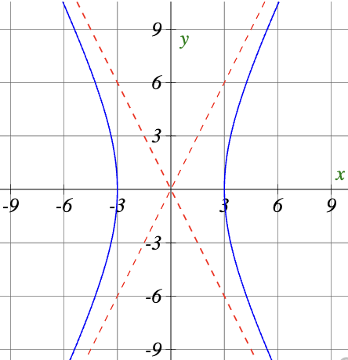

Hyperbolas Not Centered at the Origin
Like the graphs for other equations, the graph of a hyperbola can be translated. If a hyperbola is translated h units horizontally and k units vertically, the center of the hyperbola will be $(h,k)$. This translation results in the standard form of the equation we saw previously, with x replaced by $(x-h)$ and y replaced by $(y-k)$.

Key Takeaway: Hyperbolas Centered at (h,k)
The standard form of the equation of a horizontal hyperbola with center $(h,k)$ and transverse axis parallel to the x-axis is
$$\frac{{\left(x-h\right)}^{2}}{a^{2}}-\frac{{\left(y-k\right)}^{2}}{b^{2}}= 1$$where
- the length of the transverse axis is $2a$
- the coordinates of the vertices are $(h±a, k)$
- the length of the conjugate axis is $2b$
- the coordinates of the co-vertices are $(h, k±b)$
- the distance between the foci is 2c, where $c²=a²+b²$
- the coordinates of the foci are $(h±c, k)$
The asymptotes of the hyperbola coincide with the diagonals of the central rectangle. The length of the rectangle is 2a and its width is 2b. The slopes of the diagonals are $±\frac{b}{a}$, and each diagonal passes through the center $(h,k)$. Using the point-slope formula, it is simple to show that the equations of the asymptotes are $y=±\frac{b}{a}(x-h)+k$.
The standard form of the equation of a vertical hyperbola with center $(h,k)$ and transverse axis parallel to the y-axis is
$$\frac{{\left(y-k\right)}^{2}}{a^{2}}-\frac{{\left(x-h\right)}^{2}}{b^{2}}= 1$$where
- the length of the transverse axis is $2a$
- the coordinates of the vertices are $(h, k±a)$
- the length of the conjugate axis is $2b$
- the coordinates of the co-vertices are $(h±b, k)$
- the distance between the foci is 2c, where $c²=a²+b²$
- the coordinates of the foci are $(h, k±c)$
Using the reasoning above, the equations of the asymptotes are $y=±\frac{a}{b}(x-h)+k.$
Like hyperbolas centered at the origin, hyperbolas centered at a point $(h,k)$ have vertices, co-vertices, and foci that are related by the equation $c²=a²+b²$.
Question Help
Given the vertices and foci of a hyperbola centered at $(h,k)$, write its equation in standard form.
- Determine whether the transverse axis is parallel to the x- or y-axis.
  - If the y-coordinates of the given vertices and foci are the same, then the transverse axis is parallel to the x-axis. Use the standard form $\frac{{\left(x-h\right)}^{2}}{a^{2}}-\frac{{\left(y-k\right)}^{2}}{b^{2}}= 1$.
  - If the x-coordinates of the given vertices and foci are the same, then the transverse axis is parallel to the y-axis. Use the standard form $\frac{{\left(y-k\right)}^{2}}{a^{2}}-\frac{{\left(x-h\right)}^{2}}{b^{2}}= 1.$
- Identify the center of the hyperbola, $(h,k),$ using the midpoint formula and the given coordinates for the vertices.
- Find $a²$ by solving for the length of the transverse axis, 2a, which is the distance between the given vertices.
- Find $c²$using h and k found in Step 2 along with the given coordinates for the foci.
- Solve for b² using the equation $b²=c²-a².$
- Substitute the values for h, k, a², and b² into the standard form of the equation determined in Step 1.

Example
What is the standard form equation of the hyperbola that has vertices at (0,−2) and (6,−2) and foci at (−2,−2) and (8,−2)?

Try It
What is the standard form equation of the hyperbola that has vertices (1,−2) and (1, 8) and foci (1,−10) and (1,16)?

Try It

Write the equation of the hyperbola centered at (−9,2). The length of the vertical transverse axis is 8 and the length of the conjugate axis is 18.

Graphing Hyperbolas

Question Help
Given a standard form equation for a hyperbola centered at (0,0), sketch the graph.
- Determine which of the standard forms applies to the given equation.
- Use the standard form identified in Step 1 to determine the position of the transverse axis; coordinates for the vertices, co-vertices, and foci; and the equations for the asymptotes.
  - If the equation is in the form $\frac{x^{2}}{a^{2}}-\frac{y^{2}}{b^{2}}= 1$, then the transverse axis is on the x-axis, the coordinates of the vertices are $(±a, 0),$ the coordinates of the co-vertices are $(0, ±b)$, the coordinates of the foci are$(±c, 0)$, and the equations of the asymptotes are $y=±(b/a)x$.
  - If the equation is in the form $\frac{y^{2}}{a^{2}}-\frac{x^{2}}{b}= 1$, then the transverse axis is on the y-axis, the coordinates of the vertices are $(0, ±a)$, the coordinates of the co-vertices are $(±b, 0)$, the coordinates of the foci are $(0, ±c)$, and the equations of the asymptotes are $y=±\frac{a}{b}x$.
- Solve for the coordinates of the foci using the equation $c=±\sqrt{a^{2}+b^{2}}.$
- Plot the vertices, co-vertices, foci, and asymptotes in the coordinate plane, and draw a smooth curve to form the hyperbola.

Example
Graph the hyperbola given by the equation $\frac{y^{2}}{64}-\frac{x^{2}}{36}= 1$. Identify and label the vertices, co-vertices, foci, and asymptotes.

Try It
Graph the hyperbola given by the equation $\frac{x^{2}}{144}-\frac{y^{2}}{81}= 1$. Identify and label the vertices, co-vertices, foci, and asymptotes.

Try It
Sketch the graph of $\frac{y^{2}}{16}-\frac{x^{2}}{9}= 1$.

Graphing Hyperbolas Not Centered at the Origin

Question Help
Given a general form for a hyperbola centered at $(h,k)$, sketch the graph.
- Convert the general form to that standard form. Determine which of the standard forms applies to the given equation.
- Use the standard form identified in Step 1 to determine the position of the transverse axis; coordinates for the center, vertices, co-vertices, foci; and equations for the asymptotes.
  - If the equation is in the form $\frac{{\left(x-h\right)}^{2}}{a^{2}}-\frac{{\left(y-k\right)}^{2}}{b^{2}}= 1$, then the transverse axis is parallel to the x-axis, the center is $(h,k)$, the coordinates of the vertices are $(h±a, k)$, the coordinates of the co-vertices are $(h, k±b)$, the coordinates of the foci are $(h±c, k)$, and the equations of the asymptotes are $y=±\frac{b}{a}(x-h)+k$.
  - If the equation is in the form $\frac{{\left(y-k\right)}^{2}}{a^{2}}-\frac{{\left(x-h\right)}^{2}}{b^{2}}= 1$, then the transverse axis is parallel to the y-axis, the center is $(h,k)$, the coordinates of the vertices are $(h, k±a)$, the coordinates of the co-vertices are $(h±b, k)$, the coordinates of the foci are $(h, k±c),$ and the equations of the asymptotes are $y=±\frac{a}{b}(x-h)+k$.
- Solve for the coordinates of the foci using the equation $c=±\sqrt{a^{2}+b^{2}}$.
- Plot the center, vertices, co-vertices, foci, and asymptotes in the coordinate plane and draw a smooth curve to form the hyperbola.

Example
Graph the hyperbola given by the equation $9x²-4y²-36x-40y-388=0$. Identify and label the center, vertices, co-vertices, foci, and asymptotes.

Try It
Graph the hyperbola given by the standard form of an equation $\frac{{\left(y+4\right)}^{2}}{100}-\frac{{\left(x-3\right)}^{2}}{64}= 1$. Identify and label the center, vertices, co-vertices, foci, and asymptotes.

Try It
Sketch a graph of $\frac{{\left(y+2\right)}^{2}}{4}-{\left(x+2\right)}^{2}= 1$

19.3 Parabolas

Graphing Parabolas with Vertices at the Origin
When a plane cuts through a cone and is parallel to the edge of the cone, an unbounded curve is formed. This curve is a parabola.
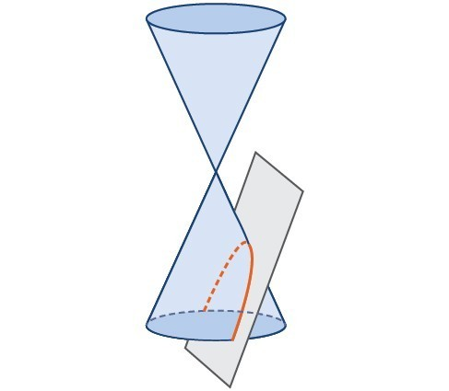
What is a parabola?
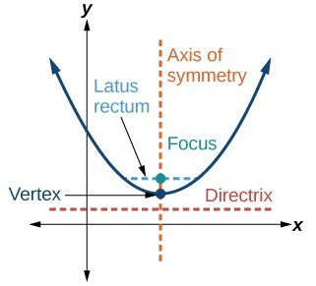
Explain each of the features:
- The axis of symmetry
- The vertex
- The latus rectum.

Key Takeaway: Standard Forms of Parabolas with Vertex (0, 0)
Axis of Symmetry: x-axis. Equation: $y^{2}=4px$. Focus:$(p, 0)$. Directrix: $x=-p$. Endpoints of Latus Rectum: $(p, ±2p$).
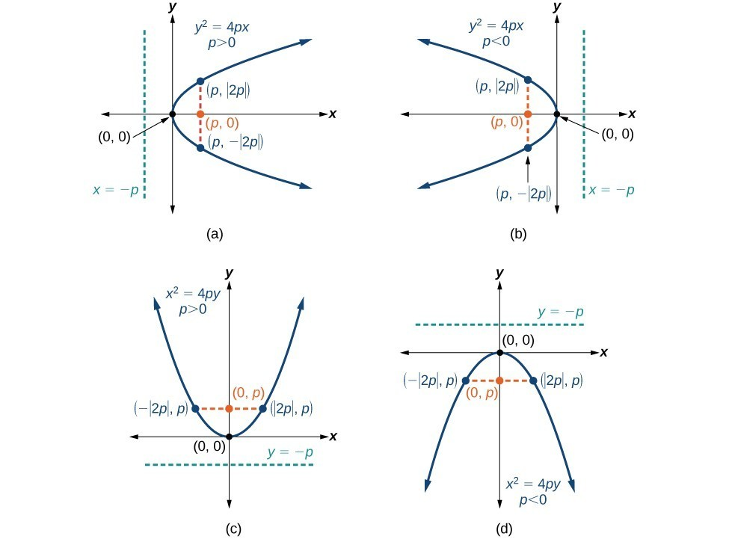
Axis of Symmetry: y-axis. Equation: $x^{2}=4py$. Focus: $(0, p)$. Directrix: $y=-p.$ Endpoints of Latus Rectum: $(±2p, p)$.

Question Help
Given a standard form equation for a parabola centered at (0, 0), sketch the graph.
- Determine which of the standard forms applies to the given equation: $y²=4px$ or $x²=4py$.
- Use the standard form identified in Step 1 to determine the axis of symmetry, focus, equation of the directrix, and endpoints of the latus rectum.
  - If the equation is in the form $y²=4px$, then the axis of symmetry is the x-axis, y=0; set 4p equal to the coefficient of x in the given equation to solve for p (if p>0, the parabola opens right; if p<0, the parabola opens left); use p to find the coordinates of the focus, $(p,0)$; use p to find the equation of the directrix, $x=-p$; use p to find the endpoints of the latus rectum, $(p, ±2p)$.
  - If the equation is in the form $x²=4p$y, then the axis of symmetry is the y-axis, $x=0$; set 4p equal to the coefficient of y in the given equation to solve for p (if p>0, the parabola opens up; if p<0, the parabola opens down); use p to find the coordinates of the focus, (0,p); use p to find the equation of the directrix, $y=-p;$ use p to find the endpoints of the latus rectum, $(±2p, p)$.
- Plot the focus, directrix, and latus rectum, and draw a smooth curve to form the parabola.

Example
Graph $y²=24x$. Identify and label the focus, directrix, and endpoints of the latus rectum.

Try It
Graph $y²=-16x$. Identify and label the focus, directrix, and endpoints of the latus rectum.

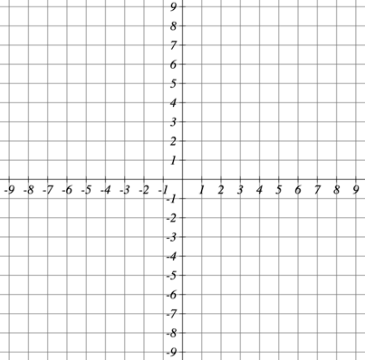

Example
Graph $x²=-6y$. Identify and label the focus, directrix, and endpoints of the latus rectum.

Try It
Graph $x²=8y$. Identify and label the focus, directrix, and endpoints of the latus rectum.

Try It
Find the focus, directrix, focal diameter, vertex and axis of symmetry for the parabola:
$$-19.6y=x^{2}$$

Graphing Parabolas with Vertices Not at the Origin

Key Takeaway: Parabolas with Vertex (h,k)
Axis of Symmetry: $y=k.$ Equation: $(y-k)²=4p\left(x-h\right)$. Focus:$\left(h+p, k\right)$. Directrix: $x=h-p$. Endpoints of Latus Rectum: $\left(h+p, k±2p\right)$.
Axis of Symmetry: $x=h$. Equation: $(x-h)²=4p\left(y-k\right).$ Focus: $(h, k+p)$ . Directrix: $y=k-p$. Endpoints of Latus Rectum: $\left(h±2p, k+p\right)$.

Question Help
Given a standard form equation for a parabola centered at $(h, k)$, sketch the graph.
- Determine which of the standard forms applies to the given equation: $(y-k)²=4p(x-h)$ or $(x-h)²=4p(y-k)$.
- Use the standard form identified in Step 1 to determine the vertex, axis of symmetry, focus, equation of the directrix, and endpoints of the latus rectum.
  - If the equation is in the form $(y-k)²=4p(x-h)$, then: identify h and k for the vertex, $(h,k)$; use k to determine the axis of symmetry, $y=k$; set 4p equal to the coefficient of $(x-h)$ to solve for p (if p>0, opens right; if p<0, opens left); find the focus, $(h+p, k)$; find the directrix, $x=h-p$; find the endpoints of the latus rectum, $(h+p, k±2p)$.
  - If the equation is in the form $(x-h)²=4p(y-k)$, then: identify h and k for the vertex, $(h,k);$ use h to determine the axis of symmetry, $x=h$; set $4p$ equal to the coefficient of $(y-k)$ to solve for p (if p>0, opens up; if p<0, opens down); find the focus, $(h, k+p)$; find the directrix, $y=k-p$; find the endpoints of the latus rectum, $(h±2p, k+p)$.
- Plot the vertex, axis of symmetry, focus, directrix, and latus rectum, and draw a smooth curve to form the parabola.

Example
Graph $(y-1)²=-16(x+3)$. Identify and label the vertex, axis of symmetry, focus, directrix, and endpoints of the latus rectum.

Try It
Graph $(y+1)²=4(x-8)$. Identify and label the vertex, axis of symmetry, focus, directrix, and endpoints of the latus rectum.

Example
Graph $x²-8x-28y-208=0$. Identify and label the vertex, axis of symmetry, focus, directrix, and endpoints of the latus rectum.

Try It
Graph $(x+2)²=-20(y-3)$. Identify and label the vertex, axis of symmetry, focus, directrix, and endpoints of the latus rectum.

Try It

Find the focus, directrix, vertex, and axis of symmetry for the parabola

$${8\left(y+3\right)=\left(x+2\right)}^{2}$$

Graph the parabola:

Writing Equations of Parabolas in Standard Form
In the previous examples, we used the standard form equation of a parabola to calculate the locations of its key features. We can also use the calculations in reverse to write an equation for a parabola when given its key features.

Question Help
Given its focus and directrix, write the equation for a parabola in standard form.
- Determine whether the axis of symmetry is the x- or y-axis.
  - If the given coordinates of the focus have the form $(p, 0)$, then the axis of symmetry is the x-axis. Use the standard form $y²=4px$.
  - If the given coordinates of the focus have the form $(0, p)$, then the axis of symmetry is the y-axis. Use the standard form $x²=4py$.
- Multiply $4p$.
- Substitute the value from Step 2 into the equation determined in Step 1.

Example
What is the equation for the parabola with focus $\left(-\frac{1}{2}, 0\right)$ and directrix $x=\frac{1}{2}$?

Try It
What is the equation for the parabola with focus $(0, 7/2)$and directrix $y=-\frac{7}{2}$?

Try It
Find the equation of the parabola that has a focus at $(-1,5)$ and a vertex at $(3,5)$.

19.4 Rotation of Axes

Identifying Nondegenerate Conics in General Form
The general form is set equal to zero, and the terms and coefficients are given in a particular order, as shown below.
$$Ax²+Bxy+Cy²+Dx+Ey+F=0$$where A, B, and C are not all zero. We can use the values of the coefficients to identify which type of conic is represented by a given equation.
You may notice that the general form equation has an xy term that we have not seen in any of the standard form equations. The xy term rotates the conic whenever B is not equal to zero.

Write down one example of an equation of each conic section:
- Ellipse
- Circle
- Hyperbola
- Parabola
- One line

Key Takeaway: General Form of Conic Sections
A nondegenerate conic section has the general form
$$Ax²+Bxy+Cy²+Dx+Ey+F=0$$
When B=0, and A and C are nonzero real numbers, the conic has not been rotated:
- Ellipse: $Ax²+Cy²+Dx+Ey+F=0$, $A≠C$ and AC>0
- Circle: $Ax²+Cy²+Dx+Ey+F=0$, A=C
- Hyperbola: $Ax²-Cy²+Dx+Ey+F=0$ or $-Ax²+Cy²+Dx+Ey+F=0$, where A and C are positive
- Parabola: $Ax²+Dx+Ey+F=0$ or $Cy²+Dx+Ey+F=0$

Question Help
Given the equation of a conic, identify the type of conic.
- Rewrite the equation in the general form, $Ax²+Bxy+Cy²+Dx+Ey+F=0$.
- Identify the values of A and C from the general form.
- If A and C are nonzero, have the same sign, and are not equal to each other, then the graph is an ellipse.
- If A and C are equal and nonzero and have the same sign, then the graph is a circle.
- If A and C are nonzero and have opposite signs, then the graph is a hyperbola.
- If either A or C is zero, then the graph is a parabola.

Example
Identify the graph of each of the following nondegenerate conic sections.
a. $4x²-9y²+36x+36y-125=0$b. $9y²+16x+36y-10=0$
c. $3x²+3y²-2x-6y-4=0$
d. $-25x^{2}-4y^{2}+100x+16y+20=0$

Try It

Identify the graph of each of the conic sections
- $16x^{2}-25y^{2}-128x-200y-544=0$

- $4x^{2}+9y^{2}-54y+49=0$

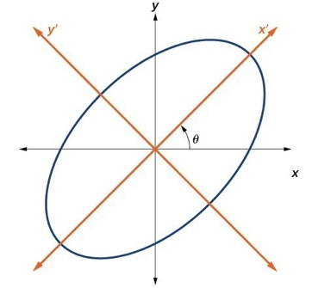
Finding a New Representation of the Given Equation after Rotating through a Given Angle
When we add an xy term, we are rotating the conic about the origin. If the x- and y-axes are rotated through an angle, say θ, then every point on the plane may be thought of as having two representations: (x,y) on the Cartesian plane with the original x-axis and y-axis, and (x′,y′) on the new plane defined by the new, rotated axes, called the x′-axis and y′-axis.
Show how we derive the equations of rotation:

Key Takeaway: Equations of Rotation
If a point (x,y) on the Cartesian plane is represented on a new coordinate plane where the axes of rotation are formed by rotating an angle θ from the positive x-axis, then the coordinates of the point with respect to the new axes are (x′,y′). We can use the following equations of rotation to define the relationship between (x,y) and (x′,y′):
$$x=x'cos θ-y'sin θ \\ y=x'sin θ+y'cos θ$$

Question Help
Given the equation of a conic, find a new representation after rotating through an angle.
- Find x and y where $x=x'cos θ-y'sin θ$ and $y=x'sin θ+y'cos θ.$
- Substitute the expression for x and y into the given equation, then simplify.
- Write the equations with x′ and y′ in standard form.

Example
Find a new representation of the equation $2x²-xy+2y²-30=0$ after rotating through an angle of $θ=45°$.

Writing Equations of Rotated Conics in Standard Form

Question Help
Given an equation for a conic in the xy system, rewrite the equation without the xy term in terms of x′ and y′, where the x′ and y′ axes are rotations of the standard axes by θ degrees.
- Find $cot(2θ)$.
- Find $sin θ$and $cos θ$.
- Substitute $sin θ$ and $cos θ$ into $x=x'cos θ-y'sin θ$ and $y=x'sin θ+y'cos θ$.
- Substitute the expression for x and y into the given equation, and then simplify.
- Write the equations with x′ and y′ in the standard form with respect to the rotated axes.

Example
Rewrite the equation $8x²-12xy+17y²=20$ in the $x'y'$system without an $x'y'$ term.

Try It
Rewrite $13x²-6\sqrt{3}xy+7y²=16$ in the$x'y'$ system without the $x'y'$term.

Example
Graph the following equation relative to the $x'y'$ system: $x²+12xy-4y²=30$.

Identifying Conics without Rotating Axes
Now we have come full circle. How do we identify the type of conic described by an equation? What happens when the axes are rotated? Recall, the general form of a conic is
$$Ax²+Bxy+Cy²+Dx+Ey+F=0$$
If we apply the rotation formulas to this equation we get the form
$$A'x'²+B'x'y'+C'y'²+D'x'+E'y'+F'=0$$
It may be shown that $B²-4AC=B'²-4A'C'$.
Why does the discriminant help us identify the conic section?

Key Takeaway: The Discriminant
If the equation $Ax²+Bxy+Cy²+Dx+Ey+F=0$ is transformed by rotating axes into the equation $A'x'²+B'x'y'+C'y'²+D'x'+E'y'+F'=0$, then $B²-4AC=B'²-4A'C'.$
The equation $Ax²+Bxy+Cy²+Dx+Ey+F=0$ is an ellipse, a parabola, or a hyperbola, or a degenerate case of one of these.
If the discriminant, $B²-4AC$, is:
- <0, the conic section is an ellipse
- =0, the conic section is a parabola
- 0, the conic section is a hyperbola

Example
Identify the conic for each of the following without rotating axes.
a. $5x²+2\sqrt{3}xy+2y²-5=0$
b. $5x²+2\sqrt{3}xy+12y²-5=0$

Try It
Identify the conic for each of the following without rotating axes.
a. $x²-9xy+3y²-12=0$
b. $10x²-9xy+4y²-4=0$

19.5 Conic Sections in Polar Coordinates

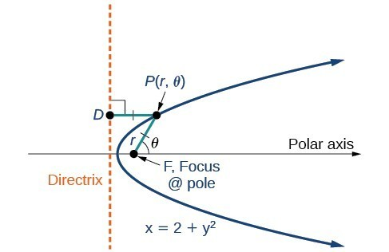
Identifying a Conic in Polar Form
If F is a fixed point, the focus, and D is a fixed line, the directrix, then we can let e be a fixed positive number, called the eccentricity, which we can define as the ratio of the distances from a point on the graph to the focus and the point on the graph to the directrix. Then the set of all points P such that $e=\frac{PF}{PD}$ is a conic.
For a conic with eccentricity e:
- if $0≤e<1$, the conic is an ellipse
- if $e=1$, the conic is a parabola
- if $e>1$, the conic is a hyperbola
With this definition, we may now define a conic in terms of the directrix, $x=±p$, the eccentricity e, and the angle θ. Thus, each conic may be written as a polar equation, an equation written in terms of r and θ.

Key Takeaway: Polar Equations of Conics
For a conic with a focus at the origin, if the directrix is $x=±p$, where p is a positive real number, and the eccentricity is a positive real number e, the conic has a polar equation
$$r =\frac{ep}{1±e cos θ}$$
For a conic with a focus at the origin, if the directrix is $y=±p$, where p is a positive real number, and the eccentricity is a positive real number e, the conic has a polar equation
$$r =\frac{ep}{1±e sin θ}$$

Question Help
Given the polar equation for a conic, identify the type of conic, the directrix, and the eccentricity.
- Multiply the numerator and denominator by the reciprocal of the constant in the denominator to rewrite the equation in standard form.
- Identify the eccentricity e as the coefficient of the trigonometric function in the denominator.
- Compare e with 1 to determine the shape of the conic.
- Determine the directrix as $x=p$ if cosine is in the denominator and $y=p$ if sine is in the denominator. Set ep equal to the numerator in standard form to solve for x or y.

Example
For each of the following equations, identify the conic with focus at the origin, the directrix, and the eccentricity.
a. $r =\frac{6}{3+2 sin θ}$b. $r =\frac{12}{4+5 cos θ}$c.$r =\frac{7}{2-2 sin θ}$

Try It
Identify the conic with focus at the origin, the directrix, and the eccentricity for
$$r =\frac{2}{3-cos θ}$$

Graphing the Polar Equations of Conics
Describe the two steps we follow to graph a conic section in polar form:

Example
Graph $r =\frac{5}{3+3 cos θ}$.
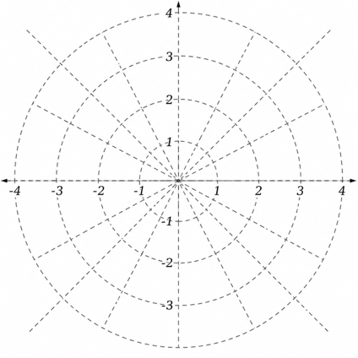

Example
Graph $r =\frac{8}{2-3 sin θ}$.

Example
Graph $r =\frac{10}{5-4 cos θ}$

Try It
Graph $r =\frac{2}{4-cos θ}$.

Defining Conics in Terms of a Focus and a Directrix.

Question Help
Given the focus, eccentricity, and directrix of a conic, determine the polar equation.
- Determine whether the directrix is horizontal or vertical. If the directrix is given in terms of y, we use the general polar form in terms of sine. If the directrix is given in terms of x, we use the general polar form in terms of cosine.
- Determine the sign in the denominator. If p<0, use subtraction. If p>0, use addition.
- Write the coefficient of the trigonometric function as the given eccentricity.
- Write the absolute value of p in the numerator and simplify the equation.

Example
Find the polar form of the conic given a focus at the origin, $e=3$ and directrix $y=-2$.

Example
Find the polar form of a conic given a focus at the origin, $e=3/5$, and directrix $x=4$.

Try It
Find the polar form of the conic given a focus at the origin, $e=1$, and directrix $x=-1$.

Example
Convert the conic $r =\frac{1}{5-5 sin θ}$to rectangular form.

Try It
Convert the conic $r =\frac{2}{1+2 cos θ}$ to rectangular form.

