Precalculus

Polar Functions Guided Notes
This tool is designed to work alongside your Study Plan and class sessions. Before class, you'll use it with the assigned readings by filling in key terms, noting examples, and writing down questions that arise. During class, you'll add to your notes as you deepen your understanding and instructors highlight important concepts. You'll find a mix of fill-in-the-blank sections, reflection spaces, and areas to record real-world examples.

17.1 Polar Coordinates

Introduction to the Polar Coordinate Plane
In the rectangular coordinate system (or Cartesian plane), points are labeled $(x,y)$ and plotted by moving horizontally and vertically from the origin. In this system, location is described in terms of horizontal and vertical distances.
In the polar coordinate system, instead of moving along perpendicular axes, we locate points using a distance from the origin and an angle from a fixed direction.

Key Takeaway: Polar Coordinates
The polar coordinate plane includes:
- The pole, corresponding to (0,0)
- The polar axis
- Distance, measured as r and often marked by concentric circles centered at the pole
- Angles, marked using the unit circle angles
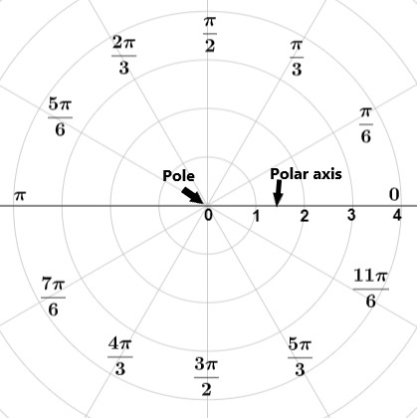

Plotting Points Using Polar Coordinates
The polar grid is represented as a series of concentric circles radiating out from the pole, or the origin of the coordinate plane.
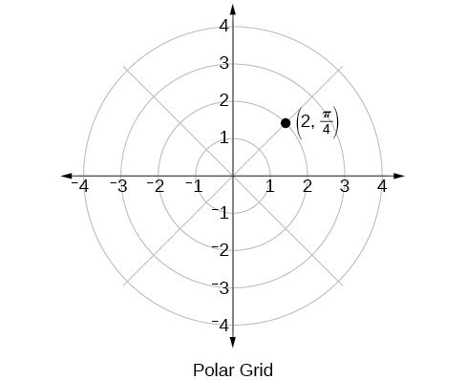
For example, to plot the point $\left(2,\frac{π}{4}\right)$, we would move $π/4$units in the counterclockwise direction and then a length of 2 from the pole.

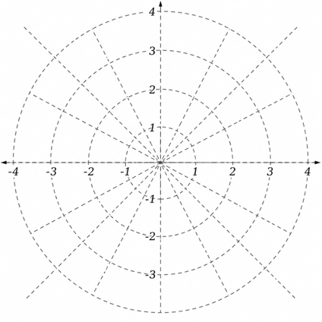
Example
Plot the point $\left(3,\frac{π}{2}\right)$ on the polar grid.

Try It
Plot the point$\left(2,\frac{π}{3}\right)$ in the polar grid.
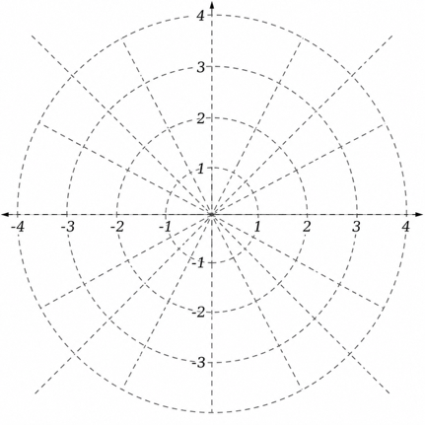

Example
Plot the point $\left(-2,\frac{π}{6}\right)$on the polar grid.
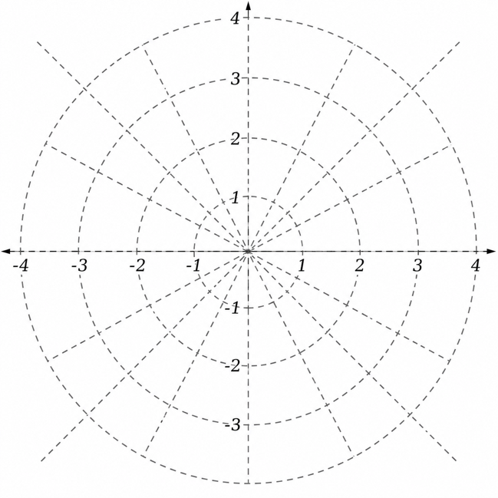

Try It
Plot the polar point $(3,-{225}^{∘})$
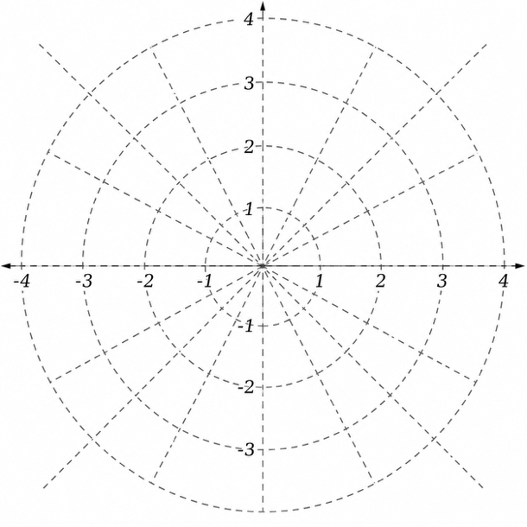

Converting Between Polar Coordinates and Rectangular Coordinates

Key Takeaway: Converting Polar to Rectangular Coordinates
To convert polar coordinates $(r,θ)$ to rectangular coordinates $(x,y)$, let
$$x=r\cos{θ} \\ y=r\sin{θ}$$
Question Help
Given polar coordinates, convert to rectangular coordinates.
- Given the polar coordinate $(r,θ),$ write $x=r\cos{θ}$ and $y=r\sin{θ}$.
- Evaluate $\cos{θ}$and $\sin{θ}.$
- Multiply $\cos{θ}$by r to find the x-coordinate of the rectangular form.
- Multiply $\sin{θ}$by r to find the y-coordinate of the rectangular form.

Example
Write the polar coordinates $\left(3,\frac{π}{2}\right)$ as rectangular coordinates.

Example
Write the polar coordinates $(-2, 0)$ as rectangular coordinates.

Try It
Write the polar coordinates $\left(-1,\frac{2π}{3}\right)$ as rectangular coordinates.

Try It
Convert the point with polar coordinates $\left(5,\frac{π}{4}\right)$ to Cartesian coordinates.

Converting from Rectangular Coordinates to Polar Coordinates
To convert rectangular coordinates to polar coordinates, we will use two other familiar relationships. With this conversion, however, we need to be aware that a set of rectangular coordinates will yield more than one polar point.

Key Takeaway: Converting Rectangular to Polar Coordinates
Converting from rectangular coordinates to polar coordinates requires the use of one or more of the relationships:
$$\cos{θ}=\frac{x}{r}$$or $x=r\cos{θ}$
$\sin{θ}=\frac{y}{r}$ or $y=r\sin{θ}$
$$r²=x²+y^{2} \\ \tan{θ}=\frac{y}{x}$$

Example
Convert the rectangular coordinates (3, 3) to polar coordinates.

Transforming Equations between Polar and Rectangular Forms
Question Help
Given an equation in polar form, graph it using a graphing calculator.
- Change the MODE to POL, representing polar form.
- Press the Y= button to bring up a screen allowing the input of six equations: r₁, r₂, ..., r₆.
- Enter the polar equation, set equal to r.
- Press GRAPH.

Example
Write the Cartesian equation $x²+y²=9$in polar form.

Example
Rewrite the Cartesian equation $x²+y²=6y$ as a polar equation.

Example
Rewrite the Cartesian equation $y=3x+2$ as a polar equation.

Try It
Rewrite the Cartesian equation $y²=3-x²$in polar form.

Identify and Graph Polar Equations by Converting to Rectangular Equations

Example
Convert the polar equation $r=2\sec{θ}$ to a rectangular equation and draw its corresponding graph.

Example
Rewrite the polar equation $r=\frac{3}{1-2\cos{θ}}$ as a Cartesian equation.

Try It
Rewrite the polar equation $r=2\sin{θ}$ in Cartesian form.

Try It

Rewrite the polar equation $r=10\cos{(θ)}$

Example
Rewrite the polar equation $r=\sin{(2θ)}$ in Cartesian form.

17.2 Graphing in Polar Coordinates

Testing Polar Equations for Symmetry.

Key Takeaway: Symmetry Tests
A polar equation describes a curve on the polar grid. The graph of a polar equation can be evaluated for three types of symmetry:
- A graph is symmetric with respect to the line $θ=π/2$ (y-axis) if replacing $(r,θ)$ with $(-r,-θ)$ yields an equivalent equation.
- A graph is symmetric with respect to the polar axis (x-axis) if replacing $(r,θ)$ with $(-r,π-θ)$ yields an equivalent equation.
- A graph is symmetric with respect to the pole (origin) if replacing $(r,θ)$ with $(-r,θ)$ yields an equivalent equation.
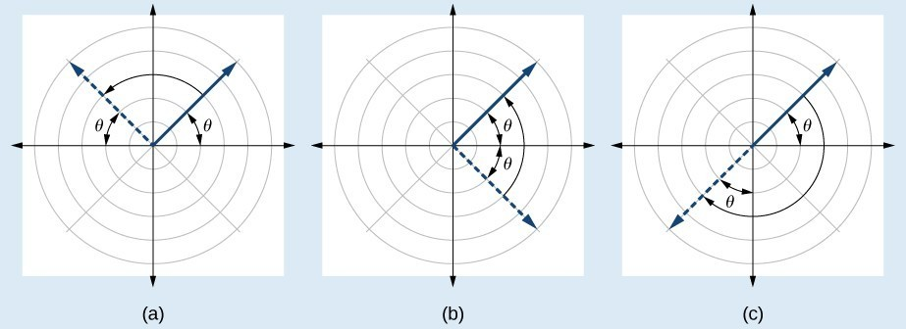

Question Help
Given a polar equation, test for symmetry.
- Substitute the appropriate combination of components for $(r,θ)$: $(-r,-θ)$ for $θ=\frac{π}{2}$ symmetry; $(r,-θ)$for polar axis symmetry; and $(-r,θ)$for symmetry with respect to the pole.
- If the resulting equations are equivalent in one or more of the tests, the graph produces the expected symmetry.

Example
Test the equation $r=2\sin{θ}$ for symmetry.

Try It
Test the equation for symmetry: $r=-2\cos{θ}$.

Try It
Determine whether the graph of the polar equation is symmetric with respect to the 𝑥-axis, the 𝑦-axis, or the origin.
$$r^{2}=7\cos{(5θ)}$$

Graphing Polar Equations by Plotting Points

Finding Zeros and Maxima
To find the zeros of a polar equation, we solve for the values of θ that result in r=0. We use the same process as for polynomial functions: set the equation equal to zero and then solve.

Example
Find the zeros and maximum |r| and, if necessary, the polar axis intercepts of $r=2\sin{θ}.$

Try It
Without converting to Cartesian coordinates, test the given equation for symmetry and find the zeros and maximum values of |r|: $r=3\cos{θ}.$

Graphing Circles and the Classic Polar Curves
There are five classic polar curves: cardioids, limaçons, lemniscates, rose curves, and Archimedes' spirals. We will briefly touch on the polar formulas for the circle before moving on to the classic curves and their variations.

Key Takeaway: Circles in Polar Form
Some of the formulas that produce the graph of a circle in polar coordinates are given by $r=a\cos{θ}$and $r=a\sin{θ}$, where a is the diameter of the circle or the distance from the pole to the farthest point on the circumference. The radius is $|a|/2$, or one-half the diameter. For $r=a\cos{θ}$, the center is $\left(\frac{a}{2}, 0\right)$. For $r=a\sin{θ}$, the center is $\left(\frac{a}{2}, π\right)$.
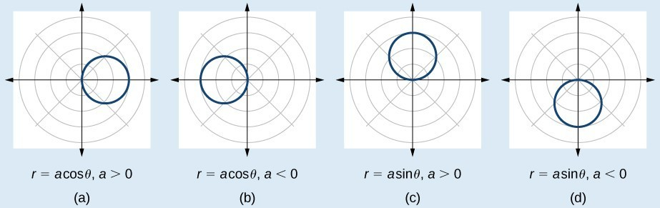

Example
Sketch the graph of $r=4\cos{θ}$.

Try It

Create a table of values of $r=3\cos{(θ)}$ and determine what type of curve it represents.

Investigating Cardioids

Key Takeaway: Cardioids
The formulas that produce the graphs of a cardioid are given by $r=a±b\cos{θ}$ and $r=a±b\sin{θ}$ where a>0, b>0, and $\frac{a}{b}=1$. The cardioid graph passes through the pole.
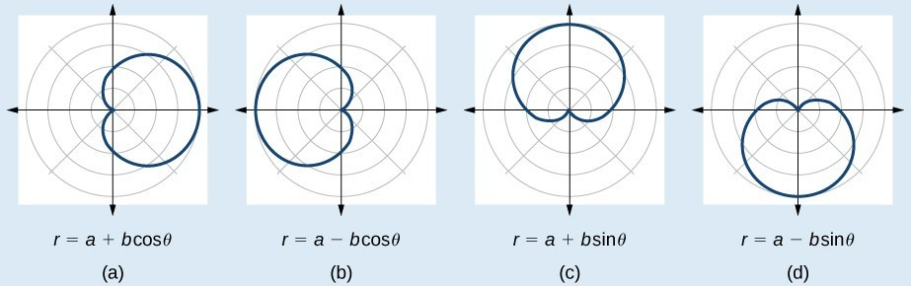
Question Help
Given the polar equation of a cardioid, sketch its graph.
- Check equation for the three types of symmetry.
- Find the zeros. Set $r=0.$
- Find the maximum value of the equation according to the maximum value of the trigonometric expression.
- Make a table of values for r and θ.
- Plot the points and sketch the graph.

Example
Sketch the graph of $r=2+2\cos{θ}$.

Investigating Limaçons
The word limaçon is Old French for "snail," a name that describes the shape of the graph.

Key Takeaway: Limaçons
The formulas that produce the graph of a dimpled one-loop limaçon are given by $r=a±b cos θ$ and $r=a±b\sin{θ}$ where a>0, b>0, and $1<\frac{a}{b}<2.$
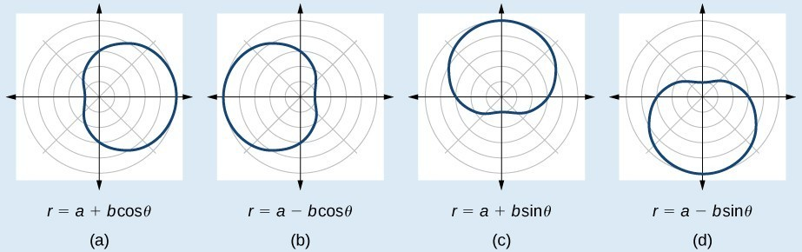

Question Help
Given a polar equation for a one-loop limaçon, sketch the graph.
- Test the equation for symmetry. Remember that failing a symmetry test does not mean that the shape will not exhibit symmetry. Often the symmetry may reveal itself when the points are plotted.
- Find the zeros.
- Find the maximum values according to the trigonometric expression.
- Plot the points and sketch the graph.

Example
Graph the equation $r=4-3\sin{θ}$.
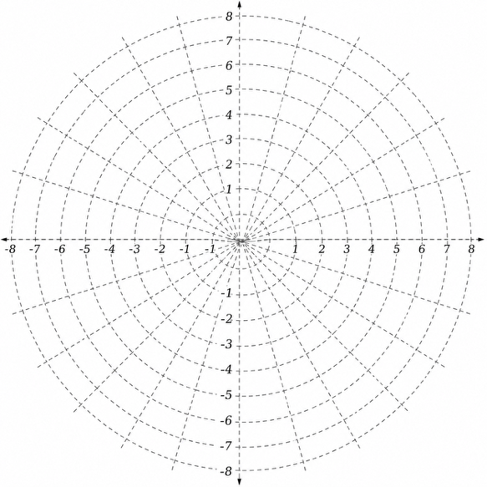

Try It
Sketch the graph of $r=3-2\cos{θ}$.

Key Takeaway: Inner-Loop Limaçons
The formulas that generate the inner-loop limaçons are given by $r=a±b\cos{θ}$and $r=a±b\sin{θ}$ where a>0, b>0, and a<b. The graph of the inner-loop limaçon passes through the pole twice: once for the outer loop, and once for the inner loop.

Example
Sketch the graph of $r=2+5\cos{θ}$.

Investigating Lemniscates
The lemniscate is a polar curve resembling the infinity symbol ∞ or a figure 8. Centered at the pole, a lemniscate is symmetrical by definition.

Key Takeaway: Lemniscates
The formulas that generate the graph of a lemniscate are given by $r²=a^{2}\cos{2θ}$ and $r²=a^{2}\sin{2θ}$where a≠0. The formula $r²=a^{2}\sin{2θ}$ is symmetric with respect to the pole. The formula $r²=a^{2}\cos{2θ}$ is symmetric with respect to the pole, the line $θ=\frac{π}{2}$, and the polar axis.
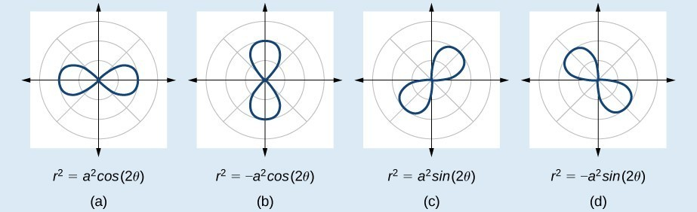

Example
Sketch the graph of $r²=4\cos{2θ}$.
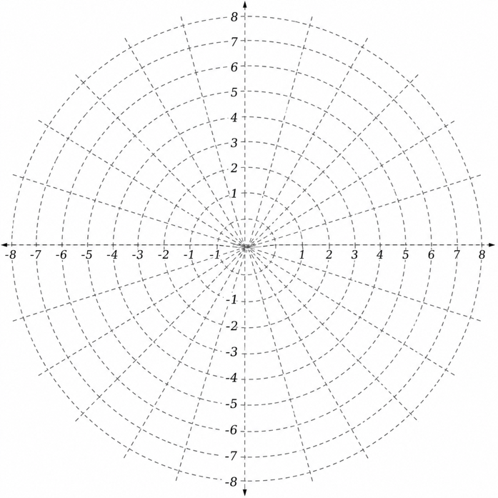

Investigating Rose Curves
The next type of polar equation produces a petal-like shape called a rose curve. Although the graphs look complex, a simple polar equation generates the pattern.

Key Takeaway: Rose Curves
The formulas that generate the graph of a rose curve are given by $r=a\cos{nθ}$ and $r=a\sin{nθ}$ where $a≠0$. If n is even, the curve has $2n$ petals. If n is odd, the curve has n petals.
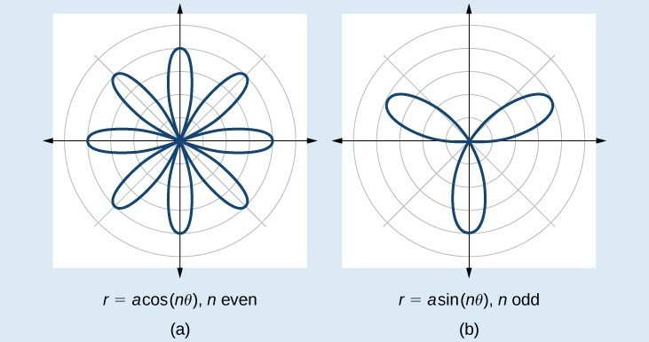
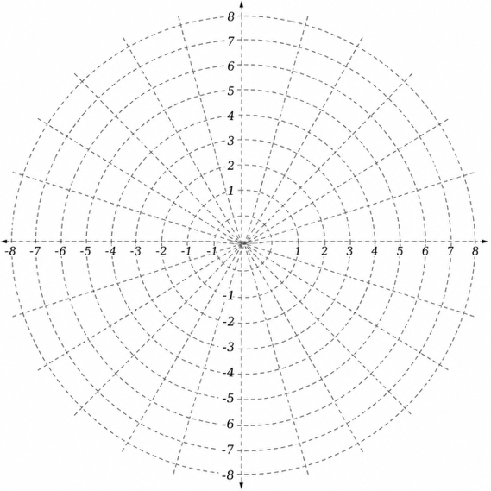
Example
Sketch the graph of $r=2\cos{(4θ).}$

Try It
Sketch the graph of $r=4\sin{(2θ)}.$
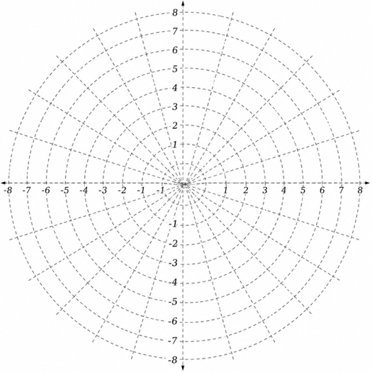

Example
Sketch the graph of $r=2\sin{(5θ)}$.

Try It
Sketch the graph of $r=3\cos{(3θ).}$

Investigating the Archimedes' Spiral
The final polar equation we will discuss is the Archimedes' spiral, named for its discoverer, the Greek mathematician Archimedes (c. 287 BCE – c. 212 BCE), who is credited with numerous discoveries in the fields of geometry and mechanics.

Key Takeaway: Archimedes' Spiral
The formula that generates the graph of the Archimedes' spiral is given by $r=θ$ for $θ≥0$. As θ increases, r increases at a constant rate in an ever-widening, never-ending, spiraling path.
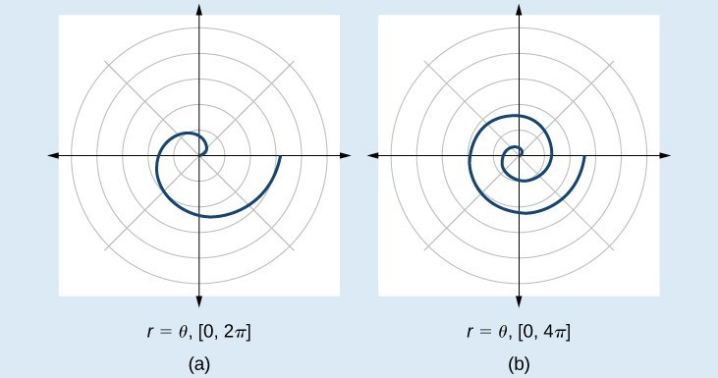
Question Help
Given an Archimedes' spiral over $[0,2π]$, sketch the graph.
- Make a table of values for r and θ over the given domain.
- Plot the points and sketch the graph.

Example
Sketch the graph of $r=θ$ over $[0,2π]$.

Try It
Sketch the graph of $r=-θ$ over the interval $[0,4π]$.

17.3 Polar Form of Complex Numbers

Plotting Complex Numbers in the Complex Plane
Plotting a complex number $a+bi$ is similar to plotting a real number, except that the horizontal axis represents the real part of the number, a, and the vertical axis represents the imaginary part of the number, bi.
Question Help
Given a complex number $a+bi$, plot it in the complex plane.
- Label the horizontal axis as the real axis and the vertical axis as the imaginary axis.
- Plot the point in the complex plane by moving a units in the horizontal direction and b units in the vertical direction.

Example
Plot the complex number $2-3i$ in the complex plane.
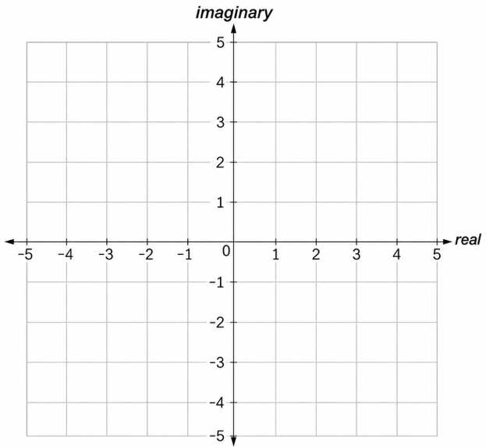

Try It
Plot the point $1+5i$ in the complex plane.

Finding the Absolute Value of a Complex Number

Key Takeaway: Absolute Value of a Complex Number
Given $z=x+yi$, a complex number, the absolute value of z is defined as
$$|z|=\sqrt{x^{2}+y^{2}}$$It is the distance from the origin to the point (x,y).

Example
Find the absolute value of $z=√5-i$.

Try It
Find the absolute value of the complex number $z=12-5i$.

Example
Given $z=3-4i$, find $|z|$.

Try It
Given$z=1-7i$, find $|z|$.

Try It
Find the magnitude of the complex number$z=\sqrt{6}+7i$.

Writing Complex Numbers in Polar Form
The polar form of a complex number expresses a number in terms of an angle θ and its distance from the origin r. Given a complex number in rectangular form expressed as $z=x+yi$, we use the same conversion formulas as we do to write the number in trigonometric form.
We use the term modulus to represent the absolute value of a complex number, or the distance from the origin to the point (x,y).

Key Takeaway: Modulus
The modulus is the distance from the origin to the point represented by the complex number. This can be found as the absolute value of the complex number.

Key Takeaway: Polar Form of a Complex Number
Writing a complex number in polar form involves the following conversion formulas:
$$x=r\cos{θ} \\ y=r\sin{θ} \\ r=\sqrt{x^{2}+y^{2}}$$
Making a direct substitution, we have $z=x+yi=(r\cos{θ})+i(r\sin{θ})=r(\cos{θ}+i\sin{θ})$, where r is the modulus and θ is the argument. We often use the abbreviation $r cis θ$ to represent $r(\cos{θ}+i\sin{θ})$.

Example
Express the complex number $4i$ using polar coordinates.

Try It
Express $z=3i$as $r cis θ$ in polar form.

Example
Find the polar form of $-4+4i$.

Try It
Write $z=\sqrt{3}+i$ in polar form.

Try It
Convert the complex number $\frac{9\sqrt{3}}{2}-\frac{9}{2}i$ to polar form.

Converting a Complex Number from Polar to Rectangular Form

Example
Convert the polar form of the given complex number to rectangular form: $z=12\left(\cos\left(\frac{π}{6}\right)+i\sin\left(\frac{π}{6}\right)\right)$

Example
Find the rectangular form of the complex number given r=13 and tan $θ=\frac{5}{12}$.

Try It
Convert the complex number to rectangular form: $z=4\left(\cos\left(\frac{11π}{6}\right)+i\sin\left(\frac{11π}{6}\right)\right)$

Try It
Convert the polar form complex number $3\left(\cos\left(\frac{4π}{3}\right)+i\sin\left(\frac{4π}{3}\right)\right)$ to rectangular form.

Finding Products and Quotients of Complex Numbers in Polar Form

Key Takeaway: Products of Complex Numbers
If $z_{1}=r_{1}\left(\cos{θ_{1}}+i\sin{θ₁}\right)$ and $z_{2}=r_{2}\left(\cos{θ_{2}}+i\sin{θ₂}\right)$, then the product of these numbers is given as:
$$z_{1}z_{2}=r_{1}r_{2}\left[\cos\left(θ_{1}+θ_{2}\right)+i\sin{(θ₁+θ₂)}\right] \\ z₁z₂=r_{1}r_{2}cis(θ₁+θ₂)$$Notice that the product calls for multiplying the moduli and adding the angles.

Example
Find the product of z₁z₂, given $z₁=4(\cos\left(80°\right)+i\sin{(80°)})$ and $z₂=2(\cos\left(145°\right)+i\sin{(145°)})$.

Finding Quotients of Complex Numbers in Polar Form
The quotient of two complex numbers in polar form is the quotient of the two moduli and the difference of the two arguments.

Key Takeaway: Quotients of Complex Numbers
If $z₁=r₁(\cos{θ_{1}}+i\sin{θ₁})$ and $z₂=r₂(\cos{θ_{2}}+i\sin{θ₂})$, then the quotient of these numbers is
$\frac{z_{1}}{z_{2}}=\frac{r_{1}}{r_{2}}[\cos\left(θ_{1}-θ_{2}\right)+i\sin{(θ₁-θ₂)}]$, $z₂≠0$
$\frac{z_{1}}{z_{2}}=\frac{r_{1}}{r_{2}}cis(θ₁-θ₂)$, $z₂≠0$
Notice that the moduli are divided, and the angles are subtracted.
Question Help
Given two complex numbers in polar form, find the quotient.
- Divide r₁/r₂.
- Find θ₁−θ₂.
- Substitute the results into the formula: $z=r(cos θ+i sin θ)$. Replace r with r₁/r₂, and replace θ with θ₁−θ₂.
- Calculate the new trigonometric expressions and multiply through by r.

Example
Find the quotient of $z₁=2(cos(213°)+i sin(213°))$ and $z₂=4(cos(33°)+i sin(33°))$.

Try It
Find the product and the quotient of $z₁=2\sqrt{3}(cos(150°)+i sin(150°))$ and $z₂=2(cos(30°)+i sin(30°))$.

Try It
Perform the indicated operation. Give your answer in polar form and in rectangular form.
$$\left[3\left(\cos\left(\frac{3π}{5}\right)+i\sin\left(\frac{3π}{5}\right)\right)\right]⋅\left[4\left(\cos\left(\frac{17π}{30}\right)+i\sin\left(\frac{17π}{30}\right)\right)\right]$$

Finding Powers and Roots of Complex Numbers in Polar Form

Key Takeaway: De Moivre's Theorem
If $z=r(cos θ+i sin θ)$ is a complex number, then
$$zⁿ=r^{n} \left[cos\left(nθ\right)+i sin\left(nθ\right)\right] \\ zⁿ=r^{n} cis\left(nθ\right)$$where n is a positive integer.

Example
Evaluate the expression $(1+i)⁵$ using De Moivre's Theorem.

Finding Roots of Complex Numbers in Polar Form
To find the nth root of a complex number in polar form, we use the nth Root Theorem or De Moivre's Theorem and raise the complex number to a power with a rational exponent. There are several ways to represent a formula for finding nth roots of complex numbers in polar form.

Key Takeaway: The nth Root Theorem
To find the nth root of a complex number in polar form, use the formula given as
$$z^{\frac{1}{n}}=r^{\frac{1}{n}}[cos\left(\frac{θ}{n}+\frac{2kπ}{n}\right)+i sin\left(\frac{θ}{n}+\frac{2kπ}{n}\right)]$$where k=0, 1, 2, 3, ..., n−1. We add 2kπ/n to θ/n in order to obtain the periodic roots.

Example
Evaluate the cube roots of $z=8\left(cos\left(\frac{2π}{3}\right)+i sin\left(\frac{2π}{3}\right)\right)$.

Try It
Find the four fourth roots of $16(cos(120°)+i sin(120°)).$

