Precalculus

Right Triangle Trigonometry Guided Notes
This tool is designed to work alongside your Study Plan and class sessions. Before class, you'll use it with the assigned readings by filling in key terms, noting examples, and writing down questions that arise. During class, you'll add to your notes as you deepen your understanding and instructors highlight important concepts. You'll find a mix of fill-in-the-blank sections, reflection spaces, and areas to record real-world examples.

16.1 Right Triangle Trigonometry

Using Right Triangles to Evaluate Trigonometric Functions
Recall
$\cos{t}=x$ and $\sin{t}=y$
These ratios still apply to the sides of a right triangle when no unit circle is involved and when the triangle is not in standard position and is not being graphed using (x,y) coordinates.
Key Takeaway: Labeling Right Triangle Sides
The sides of a right triangle in relation to angle t are the hypotenuse, the opposite side, and the adjacent side.
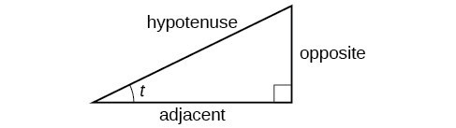

Understanding Right Triangle Relationships
Given a right triangle with an acute angle of t,
$$\sin{(t)}=\frac{opposite}{hypotenuse} \\ \cos{(t)}=\frac{adjacent}{hypotenuse} \\ \tan{(t)}=\frac{opposite}{adjacent}$$
What does SOH CAH TOA represent?

Question Help
Given the side lengths of a right triangle and one of the acute angles, find the sine, cosine, and tangent of that angle.
- Find the sine as the ratio of the opposite side to the hypotenuse.
- Find the cosine as the ratio of the adjacent side to the hypotenuse.
- Find the tangent as the ratio of the opposite side to the adjacent side.
Example
Given the triangle, find the value of cos α.
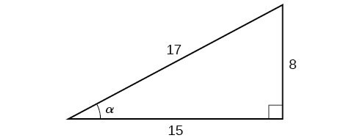

Try It
Given the triangle, find the value of sin t.
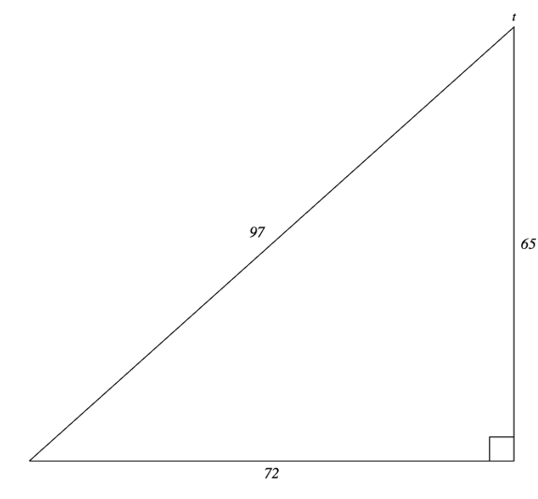

Relating Angles and Their Functions
When working with right triangles, the same rules apply regardless of the orientation of the triangle
Question Help
Given the side lengths of a right triangle, evaluate the six trigonometric functions of one of the acute angles.
- If needed, draw the right triangle and label the angle provided.
- Identify the angle, the adjacent side, the side opposite the angle, and the hypotenuse of the right triangle.
- Find the required function:
  - sine as the ratio of the opposite side to the hypotenuse
  - cosine as the ratio of the adjacent side to the hypotenuse
  - tangent as the ratio of the opposite side to the adjacent side
  - secant as the ratio of the hypotenuse to the adjacent side
  - cosecant as the ratio of the hypotenuse to the opposite side
  - cotangent as the ratio of the adjacent side to the opposite side
Example
Evaluate sin α, cos α, tan α, sec α, csc α, and cot α.
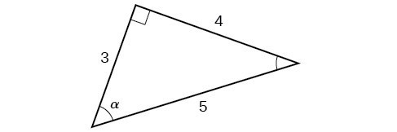
Try It
Evaluate sin t, cos t, tan t, sec t, csc t, and cot t
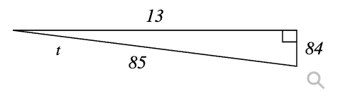

Try It
For the triangle below, find the missing side length. Then find cos(A) and cot(A).
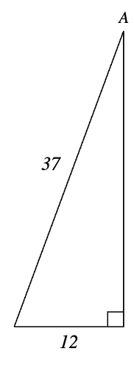

Finding Trigonometric Functions of Special Angles Using Side Lengths
We have already discussed the trigonometric functions as they relate to the special angles on the unit circle. Now, we can use those relationships to evaluate triangles that contain those special angles.
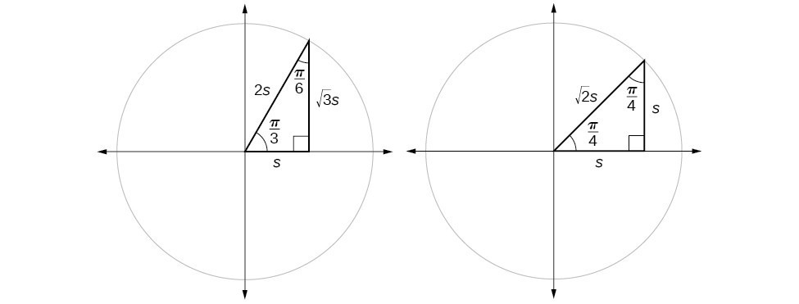
We can then use the ratios of the side lengths to evaluate trigonometric functions of special angles.

Key Takeaway: Ratios of Special Right Triangles
For every special right triangle:
For $45°$ or $\frac{π}{4}$ angles:
$$\cos{(x)}=\sin{(x)}=\frac{\sqrt{2}}{2} \\ \tan{(x)}=\cot{(x)}=1 \\ \sec{(x)}=\csc{(x)}=\sqrt{2}$$
For $30°$ or $\frac{π}{6}$ angles:
$$\cos{(x)}=\frac{\sqrt{3}}{2}$$ | $$\sin{(x)}=\frac{1}{2}$$ | $$\tan{(x)}=\frac{\sqrt{3}}{3}$$
$$\sec{(x)}=\frac{2\sqrt{3}}{3}$$ | $$\csc{(x)}=2$$ | $$\cot{(x)}=\sqrt{3}$$
For $60°$ or $\frac{π}{3}$ angles:
$$\cos{(x)}=\frac{1}{2}$$ | $$\sin{(x)}=\frac{\sqrt{3}}{2}$$ | $$\tan{(x)}=\sqrt{3}$$
$$\sec{(x)}=2$$ | $$\csc{(x)}=\frac{2\sqrt{3}}{3}$$ | $$\cot{(x)}=\frac{\sqrt{3}}{3}$$
Example
Find the exact value of the trigonometric functions of $\frac{π}{3}$, using side lengths.

Try It
Find the exact value of the trigonometric functions of $\frac{π}{4}$, using side lengths.

Using Equal Cofunction of Complements
Example
If we look more closely at the relationship between the sine and cosine of the special angles relative to the unit circle, we will notice a pattern.
$$\sin\left(\frac{π}{3}\right)=\cos\left(\frac{π}{6}\right)=\frac{\sqrt{3}}{2} \\ \sin\left(\frac{π}{6}\right)=\cos\left(\frac{π}{3}\right)=\frac{1}{2}$$
If any two angles are complementary, the sine of one is the cosine of the other, and vice versa.
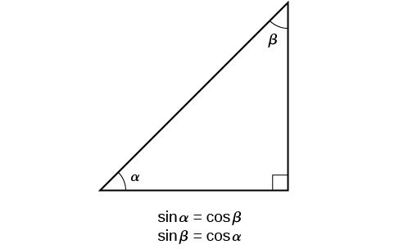
Key Takeaway: Cofunction Identities
$\cos{t}=\sin\left(\frac{π}{2}-t\right)$ $\sin{t}=\cos\left(\frac{π}{2}-t\right)$
$\tan{t}=\cot\left(\frac{π}{2}-t\right)$ $\csc{t}=\sec\left(\frac{π}{2}-t\right)$
Question Help
Given the sine and cosine of an angle, find the sine or cosine of its complement.
- To find the sine of the complementary angle, find the cosine of the original angle.
- To find the cosine of the complementary angle, find the sine of the original angle.
Example
If $\sin{t}=\frac{5}{12}$, find $\cos\left(\frac{π}{2}-t\right)$.

Try It
If $\csc\left(\frac{π}{6}\right)=2$, find $\sec\left(\frac{π}{3}\right).$

Using Trigonometric Functions
In previous examples, we evaluated the sine and cosine in triangles where we knew all three sides. But the real power of right-triangle trigonometry emerges when we look at triangles in which we know an angle but do not know all the sides.
Question Help
Given a right triangle, the length of one side, and the measure of one acute angle, find the remaining sides.
- For each side, select the trigonometric function that has the unknown side as either the numerator or the denominator. The known side will in turn be the denominator or the numerator.
- Write an equation setting the function value of the known angle equal to the ratio of the corresponding sides.
- Using the value of the trigonometric function and the known side length, solve for the missing side length.
Example
Find the unknown sides of the triangle
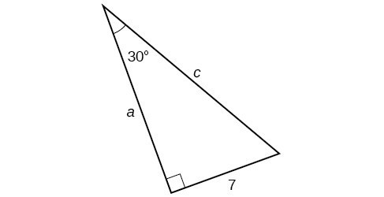

Try It
A right triangle has one angle of $\frac{π}{3}$ and a hypotenuse of 20. Find the unknown sides and angle of the triangle.

Try It
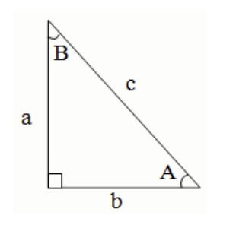
Suppose a = 2 and A = 32 degrees. Find
    - b =
    - c =
    - B =

16.2 Inverse Trigonometric Functions

Understanding and Using the Inverse Sine, Cosine, and Tangent Functions
In order to use inverse trigonometric functions, we need to understand that an inverse trigonometric function "undoes" what the original trigonometric function "does," as is the case with any other function and its inverse. In other words, the domain of the inverse function is the range of the original function, and vice versa.

Example

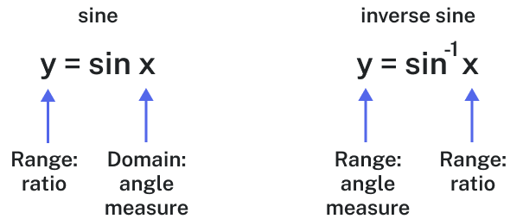
If $f(x)=\sin{x}$, then we would write $f^{-1}(x)=\sin^{-1}{x}$. The following examples illustrate the inverse trigonometric functions:
- Since $\sin\left(\frac{π}{6}\right)=1/2$, then $\frac{π}{6}=\sin^{-1}\left(\frac{1}{2}\right).$
- Since $\cos{(π)}=-1$, then $π=$
- Since $\tan{(π/4)}=1$, then $π/4=$
Key Takeaway: Inverse Trig Functions
The inverse sine function $y=\sin^{-1}{x}$ means $x=\sin{y}$. The inverse sine function is sometimes called the arcsine function, and notated $\arcsin{x}$.
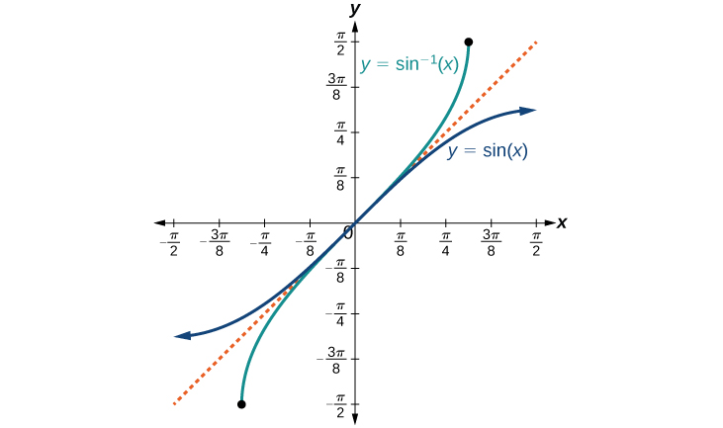
What are the domain and range of inverse sine?

The inverse cosine function $y=\cos^{-1}{x}$ means $x=\cos{y}$. The inverse cosine function is sometimes called the arccosine function, and notated $\arccos{x}$.
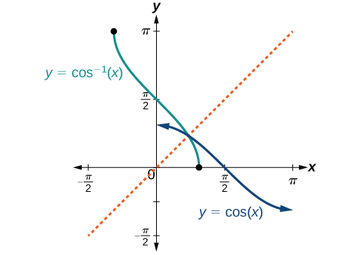
What are the domain and range of inverse cosine?

The inverse tangent function $y=\tan^{-1}{x}$ means $x=\tan{y}$. The inverse tangent function is sometimes called the arctangent function, and notated $\arctan{x}$.
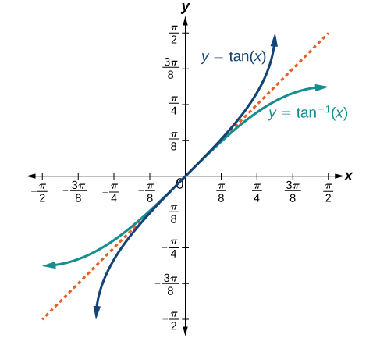
What are the domain and range of inverse tangent?

To find the domain and range of inverse trigonometric functions, switch the domain and range of the original functions. Each graph of the inverse trigonometric function is a reflection of the graph of the original function about the line y=x.

Example
Given $\sin\left(\frac{5π}{12}\right)≈0.96593$, write a relation involving the inverse sine.

Try It
Given $\cos\left(0.5\right)≈0.8776$, write a relation involving the inverse cosine.

Finding the Exact Value of Expressions Involving the Inverse Sine, Cosine, and Tangent Functions
Question Help
Given a "special" input value, evaluate an inverse trigonometric function.
- Find angle x for which the original trigonometric function has an output equal to the given input for the inverse trigonometric function.
- If x is not in the defined range of the inverse, find another angle y that is in the defined range and has the same sine, cosine, or tangent as x, depending on which corresponds to the given inverse function.
Example
Evaluate each of the following.
a. $\sin^{-1}\left(\frac{1}{2}\right)$b. $\sin^{-1}\left(-\frac{\sqrt{2}}{2}\right)$c. $\cos^{-1}\left(-\frac{\sqrt{3}}{2}\right)$d. $\tan^{-1}{(1)}$
Try It
Evaluate each of the following.
a. $\sin^{-1}\left(-1\right)$
b. $\tan^{-1}{(-1)}$
c. $\cos^{-1}\left(-1\right)$
d. $\cos^{-1}\left(-\frac{1}{2}\right)$
Try It
Evaluate each of the following. Give an answer in radians.
- $\sin^{-1}{(-1)}=$
- $\sin^{-1}\left(\frac{\sqrt{3}}{2}\right)=$
- $\sin^{-1}\left(\frac{1}{2}\right)=$

Using a Calculator to Evaluate Inverse Trigonometric Functions
Example
Evaluate $\sin^{-1}\left(0.97\right)$ using a calculator.

Try It
Evaluate $\cos^{-1}{(-0.4)}$ using a calculator. Round to four decimal places.
- Answer in radians.

- Answer in degrees.
Try It
Use your calculator to evaluate $\sin^{-1}{(-0.69)}$. Round your answer to 3 decimal places.

Question Help
Find an angle given two sides of a right triangle.
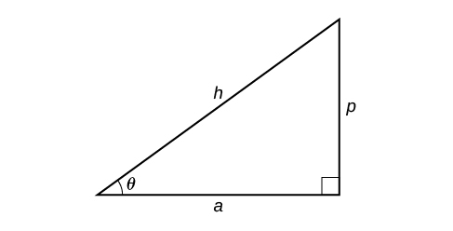
- If one given side is the hypotenuse of length h and the side of length a adjacent to the desired angle is given, use the equation $θ=\cos^{-1}\left(\frac{a}{h}\right).$
- If one given side is the hypotenuse of length h and the side of length p opposite to the desired angle is given, use the equation $θ=\sin^{-1}\left(\frac{p}{h}\right)$.
- If the two legs (the sides adjacent to the right angle) are given, then use the equation $θ=\tan^{-1}\left(\frac{p}{a}\right).$
Example
Solve the triangle for the angle θ.
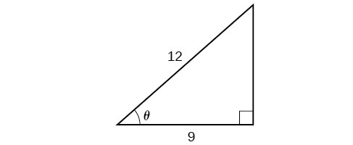
Try It
Solve the triangle for the angle θ.
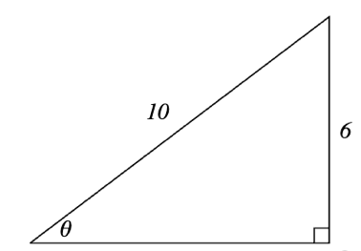
Try It
For the right triangle below, find the measure of the angle in degrees. Round your answer to 2 decimal places.
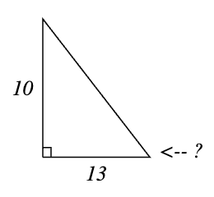

Finding Exact Values of Composite Functions with Inverse Trigonometric Functions
For any trigonometric function, $f(f^{-1}(y))=y$ for all y in the proper domain for the given function.
Key Takeaway: Compositions of a Trigonometric Function and Its Inverse
$\sin{(\sin^{-1}{x})}=x$ for $-1≤x≤1$
$\cos{(\cos^{-1}{x})}=x$ for $-1≤x≤1$
$\tan{(\tan^{-1}{x})}=x$ for $-∞<x<∞$
$\sin^{-1}{(\sin{x})}=x$ only for $-\frac{π}{2}≤x≤\frac{π}{2}$
$\cos^{-1}{(\cos{x})}=x$ only for $0≤x≤π$
$\tan^{-1}{(\tan{x})}=x$ only for $-\frac{π}{2}<x<\frac{π}{2}$
Question Help
Given an expression of the form $f^{-1}(f(θ))$ where $f(θ)=\sin{θ}$, $\cos{θ}$, or $\tan{θ}$, evaluate.
- If θ is in the restricted domain of f, then $f^{-1}(f(θ))=θ$.
- If not, then find an angle ϕ within the restricted domain of f such that $f(ϕ)=f(θ)$. Then $f^{-1} \left(f\left(θ\right)\right)=ϕ$.

Example
Evaluate the following:
a. $\sin^{-1}\left(\sin\left(\frac{π}{3}\right)\right)$
b. $\sin^{-1}\left(\sin\left(\frac{2π}{3}\right)\right)$
c. $\cos^{-1}\left(\cos\left(\frac{2π}{3}\right)\right)$
d. $\cos^{-1}\left(\cos\left(-\frac{π}{3}\right)\right)$
Try It
Evaluate $\tan^{-1}\left(\tan\left(\frac{π}{8}\right)\right)$ and $\tan^{-1}\left(\tan\left(\frac{11π}{9}\right)\right)$.

Evaluating Compositions of the Form f⁻¹(g(x))
Question Help
Given functions of the form $\sin^{-1}{(\cos{x})}$ and $\cos^{-1}{(\sin{x})}$, evaluate them.
- If x is in $[0,π]$, then $\sin^{-1}{(\cos{x})}=\frac{π}{2}-x$.
- If x is not in $[0,π]$, then find another angle y in $[0,π]$ such that cos $y=\cos{x}$. $\sin^{-1}{(\cos{x})}=\frac{π}{2}-y$.
- If x is in $[-\frac{π}{2},\frac{π}{2}]$, then $\cos^{-1}{(\sin{x})}=\frac{π}{2}-x$.
- If x is not in $[-\frac{π}{2},\frac{π}{2}]$, then find another angle y in $[-\frac{π}{2},\frac{π}{2}]$ such that sin $y=\sin{x}$. $\cos^{-1}{(\sin{x})}=\frac{π}{2}-y$.
Example
Evaluate $\sin^{-1}\left(\cos\left(\frac{13π}{6}\right)\right)$
  - by direct evaluation.

  - by the method described in the Question Help.

Try It
Evaluate $\cos^{-1}\left(\sin\left(-\frac{11π}{4}\right)\right)$

Try It
Evaluate $\cos^{-1}\left(\sin\left(\frac{π}{3}\right)\right)$

Evaluating Compositions of the Form f(g⁻¹(x))
Example
Find an exact value for $\sin\left(\cos^{-1}\left(\frac{4}{5}\right)\right).$

Try It
Evaluate $\cos\left(\tan^{-1}\left(\frac{5}{12}\right)\right)$.

Example
Find an exact value for $\sin\left(\tan^{-1}\left(\frac{7}{4}\right)\right)$.

Try It
Evaluate $\cos\left(\sin^{-1}\left(\frac{7}{9}\right)\right)$.

Try It
Evaluate $\tan\left(\cos^{-1}\left(-\frac{10}{11}\right)\right)$.

Example
Find a simplified expression for $\cos\left(\sin^{-1}\left(\frac{x}{3}\right)\right)$ for $-3≤x≤3$.

Try It
Find a simplified expression for $\sin\left(\tan^{-1}\left(4x\right)\right)$ for $-\frac{1}{4}≤x≤\frac{1}{4}$.

16.3 Non-right Triangles: Law of Sines

Using the Law of Sines to Solve Oblique Triangles
What is an oblique triangle?

Example
There are three configurations that give us enough information to solve an oblique triangle:
- ASA (angle-side-angle): We know the measurements of two angles and the included side.
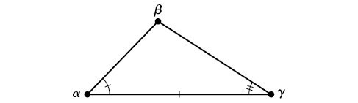
- AAS (angle-angle-side): We know the measurements of two angles and a side that is not between the known angles.
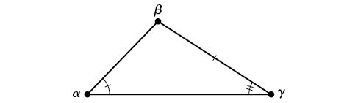
- SSA (side-side-angle): We know the measurements of two sides and an angle that is not between the known sides.
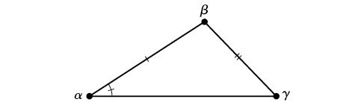
Key Takeaway: Law of Sines
$$\frac{\sin{α}}{a}=\frac{\sin{β}}{b}=\frac{\sin{γ}}{c} \\ \frac{a}{\sin{α}}=\frac{b}{\sin{β}}=\frac{c}{\sin{γ}}$$
To solve an oblique triangle, use any pair of applicable ratios.
Example
Solve the triangle to the nearest tenth.
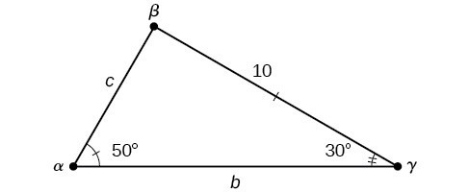

Try It
Solve the triangle to the nearest tenth, given angle $α=98°$, angle $γ=43°,$ and side $b=22$.

Try It
Solve the triangle if $∠A={37}^{∘}$, $∠C={75}^{∘}$, $b=15$

Using the Law of Sines to Solve SSA Triangles
Key Takeaway: The Ambiguous Case
Oblique triangles in the category SSA may have four different outcomes, depending on the known sides a and b and known angle α.
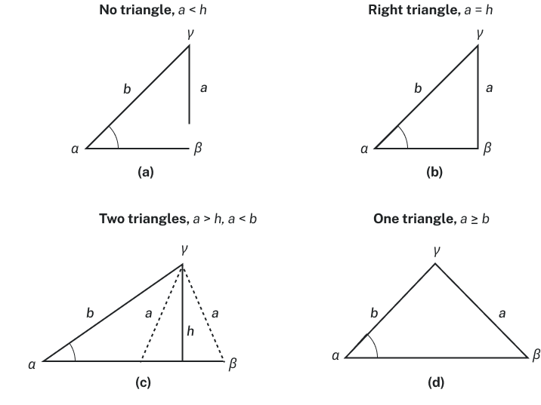
Example
Solve the triangle for the missing side and find the missing angle measures to the nearest tenth.
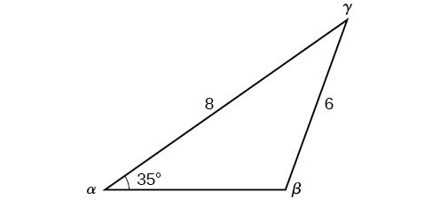
Try It
Given α=80°, a=120, and b=121, find the missing side and angles. If there is more than one possible solution, show both.

Example
Solve for the unknown side and angles. Round your answers to the nearest tenth.
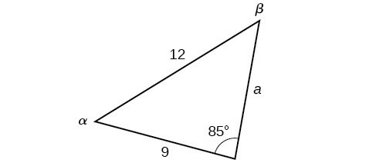

Try It
Given α=80°, a=100, b=10, find the missing side and angles. If there is more than one possible solution, show both. Round your answers to the nearest tenth.

Example
Find all possible triangles if one side has length 4 opposite an angle of 50°, and a second side has length 10.

Try It
Determine the number of triangles possible given a=31, b=26, β=48°.

Try It
Solve triangle 𝐴𝐵𝐶 if ∠𝐴 =39.1°, 𝑎 =186.2, and 𝑏 =249.6.

Finding the Area of an Oblique Triangle Using the Sine Function
Now that we can solve a triangle for missing values, we can use some of those values and the sine function to find the area of an oblique triangle.
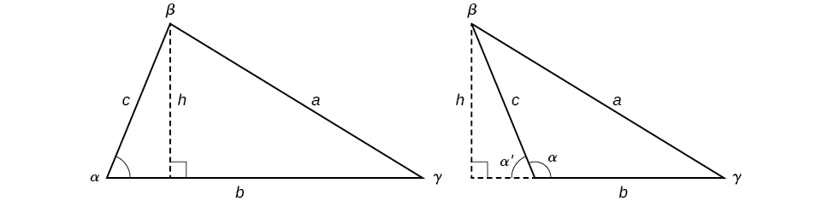
Key Takeaway: Area of an Oblique Triangle
The formula for the area of an oblique triangle is given by
$$A=\frac{1}{2}bc\sin{α}$$
$$A=\frac{1}{2}ac\sin{β}$$
$$A=\frac{1}{2}ab\sin{γ}$$This is equivalent to one-half of the product of two sides and the sine of their included angle.
Example
Find the area of a triangle with sides $a=90$, $b=52$, and angle $γ=102°.$ Round the area to the nearest integer.

Try It
Find the area of the triangle given β=42°, a=7.2 ft, c=3.4 ft. Round the area to the nearest tenth.

Try It
A triangle has side lengths of 29 and 15 and an included angle measuring 53 degrees. Find the area of the triangle.

16.4 Non-right Triangles: Law of Cosines

Solving Triangles with the Law of Cosines
Question Help
The Law of Cosines states that the square of any side of a triangle is equal to the sum of the squares of the other two sides minus twice the product of the other two sides and the cosine of the included angle.
$$a^{2}=b^{2}+c^{2}-2bc\cos{α}$$
$$b^{2}=a^{2}+c^{2}-2ac\cos{β}$$
$$c^{2}=a^{2}+b^{2}-2ab\cos{γ}$$

Pro Tip
When solving for an angle, the corresponding opposite side measure is needed. We can use another version of the Law of Cosines to solve for an angle.
$$\cos{α}=\frac{b^{2}+c^{2}-a^{2}}{2bc}$$
$$\cos{β}=\frac{a^{2}+c^{2}-b^{2}}{2ac}$$
$$\cos{γ}=\frac{a^{2}+b^{2}-c^{2}}{2ab}$$
Question Help
Given two sides and the angle between them (SAS), find the measures of the remaining side and angles of a triangle.
- Sketch the triangle. Identify the measures of the known sides and angles. Use variables to represent the measures of the unknown sides and angles.
- Apply the Law of Cosines to find the length of the unknown side or angle.
- Apply the Law of Sines or Cosines to find the measure of a second angle.
- Compute the measure of the remaining angle.
Example
Find the unknown side and angles of the triangle
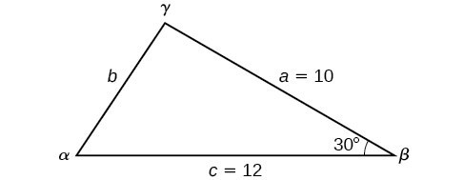
Try It
Find the missing side and angles of the given triangle: α=30°, b=12, c=24.

Example
Find the angle α for the given triangle if side a=20, side b=25, and side c=18.

Try It
Given a=5, b=7, and c=10, find the missing angles.

Using Heron's Formula to Find the Area of a Triangle
Key Takeaway: Heron's Formula
Heron's formula finds the area of oblique triangles in which sides a, b, and c are known.
$$Area=\sqrt{s\left(s-a\right)\left(s-b\right)\left(s-c\right)}$$
where $s=\frac{a+b+c}{2}$ is one half of the perimeter of the triangle, sometimes called the semi-perimeter.
Example
Find the area of the triangle using Heron's formula.
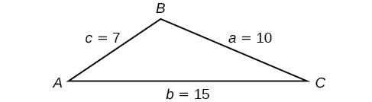
Try It
Use Heron's formula to find the area of a triangle with sides of lengths a=29.7 ft, b=42.3 ft, and c=38.4 ft.

Try It
Find the area of the triangle.
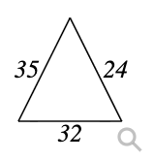

Example
A Chicago city developer wants to construct a building consisting of artist's lofts on a triangular lot bordered by Rush Street, Wabash Avenue, and Pearson Street. The frontage along Rush Street is approximately 62.4 meters, along Wabash Avenue it is approximately 43.5 meters, and along Pearson Street it is approximately 34.1 meters. How many square meters are available to the developer?
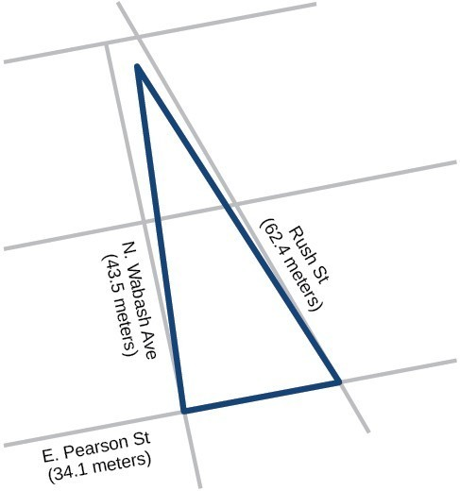
Try It
Find the area of a triangle given a=4.38 ft, b=3.79 ft, and c=5.22 ft.

Try It
A triangular parcel of land has sides of lengths 550 feet, 240 feet and 522 feet.
- What is the area of the parcel of land?

- If the land is valued at $2,200 per acre (1 acre is 43,560 sq feet), what is the value of the parcel of land?

