Precalculus

Trigonometric Identities and Equations Guided Notes
This tool is designed to work alongside your Study Plan and class sessions. Before class, you'll use it with the assigned readings by filling in key terms, noting examples, and writing down questions that arise. During class, you'll add to your notes as you deepen your understanding and instructors highlight important concepts. You'll find a mix of fill-in-the-blank sections, reflection spaces, and areas to record real-world examples.

15.1 Simplifying Trigonometric Expressions with Identities

Verify the Fundamental Trigonometric Identities
Pythagorean Identities
$$\sin^{2}{θ}+\cos^{2}{θ}=1 \\ 1+\cot^{2}{θ}=\csc^{2}{θ} \\ 1+\tan^{2}{θ}=\sec^{2}{θ}$$

Example
Prove:
$$1+\cot^{2}{θ}=\csc^{2}{θ}$$

Example
Show how $1+\tan^{2}{θ}=\sec^{2}{θ}$ is obtained from $\sin^{2}{θ}+\cos^{2}{θ}=1$

Question Help
Given a trigonometric identity, verify that it is true.
- Work on one side of the equation. It is usually better to start with the more complex side, as it is easier to simplify than to build.
- Look for opportunities to factor expressions, square a binomial, or add fractions.
- Noting which functions are in the final expression, look for opportunities to use the identities and make the proper substitutions.
- If these steps do not yield the desired result, try converting all terms to sines and cosines.
Example
Verify the identity $\frac{\sec^{2}{θ}-1}{\sec^{2}{θ}}=sin²θ$.

Reciprocal and Quotient Identities
The next set of fundamental identities is the set of reciprocal identities, which relate trigonometric functions that are reciprocals of each other.
Reciprocal Identities
$\sin{θ} =\frac{1}{\csc{θ}}$, $\csc{θ} =\frac{1}{\sin{θ}}$
$\cos{θ} =\frac{1}{\sec{θ}}$, $\sec{θ} =\frac{1}{\cos{θ}}$
$\tan{θ}=\frac{1}{\cot{θ}}$, $\cot{θ} =\frac{1}{\tan{θ}}$
Quotient Identities
$$\tan{θ}=\frac{\sin{θ}}{\cos{θ}} \\ \cot{θ}=\frac{\cos{θ}}{\sin{θ}}$$

Example
Graph both sides of the identity $\cot{θ} =\frac{1}{\tan{θ}}$. In other words, on the graphing calculator, graph $y=\cot{θ}$ and $y=\frac{1}{\tan{θ}}$.
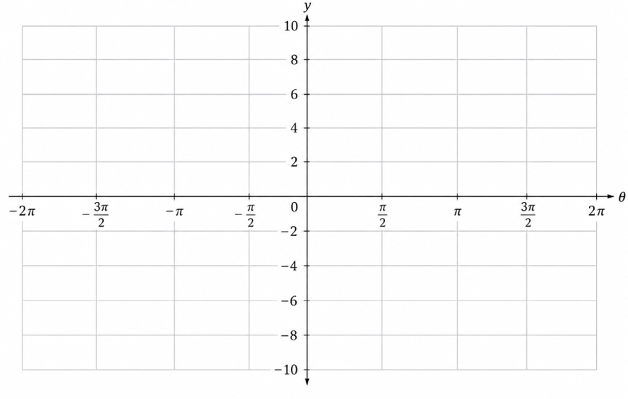
Example
Verify $\tan{θ}\cos{θ}=\sin{θ}$.

Try It
Verify the identity $\csc{θ}\cos{θ}\tan{θ}=1$.

Even and Odd Identities
Even-Odd Identities
$\tan{(-θ)}=-\tan{θ}$, $\cot{(-θ)}=-\cot{θ}$
$\sin{(-θ)}=-\sin{θ}$, $\csc{(-θ)}=-\csc{θ}\cos{(-θ)}=\cos{θ}$, $\sec{(-θ)}=\sec{θ}$
To sum up, only two of the trigonometric functions, cosine and secant, are even. The other four functions are odd, verifying the even-odd identities.
Example
Verify the following equivalency using the even-odd identities:
$(1+\sin{x})[1+\sin\left(-x\right)]=\cos^{2}{x}$.

Try It
Show that $\frac{\cot{θ}}{\csc{θ}}=\cos{θ}$.

Example
Create an identity for the expression $2\tan{θ}\sec{θ}$ by rewriting strictly in terms of sine.

Example
Verify the identity: $\frac{\left[\sin^{2}{(-θ)}-\cos^{2}\left(-θ\right)\right]}{\left[\sin\left(-θ\right)-\cos\left(-θ\right)\right]}=\cos{θ}-\sin{θ}$.

Example
Verify the identity
$$\frac{\sin^{2}{θ}-1}{\tan{θ}\sin{θ}-\tan{θ}}=\frac{\sin{θ}+1}{\tan{θ}}$$.

Example
Verify the identity: $(1-\cos^{2}{x})(1+\cot^{2}{x})=1$.

Simplify Trigonometric Expressions Using Algebra and the Identities
Example
Use $\cos{θ}=x$to write the following trigonometric expression as an algebraic expression: $2\cos^{2}{θ}+\cos{θ}-1$.

Example
Rewrite the trigonometric expression by factoring: $4\cos^{2}{θ}-1$.

Try It
Rewrite the trigonometric expression: $25-9\sin^{2}{θ}$.

Example
Simplify the expression by using identities: $\csc^{2}{θ}-\cot^{2}{θ}$.

Try It
Simplify and write the trigonometric expression as a single trigonometric function:
$$\frac{1+\cos{y}}{1+\sec{y}}$$

Try It
Use algebraic techniques to verify the identity
$$\frac{\cos{θ}}{1+\sin{θ}}=\frac{1-\sin{θ}}{\cos{θ}}$$
(Hint: Multiply the numerator and denominator on the left side by $1-\sin{θ}$.)

15.2 Sum and Difference Identities
Finding the exact value of the sine, cosine, or tangent of an angle is often easier if we can rewrite the given angle in terms of two angles that have known trigonometric values.
Recall
The unit circle contains all the special angles along with their cosine and sine values. Remember that each ordered pair is in the form $(\cos{x},\sin{x})$.
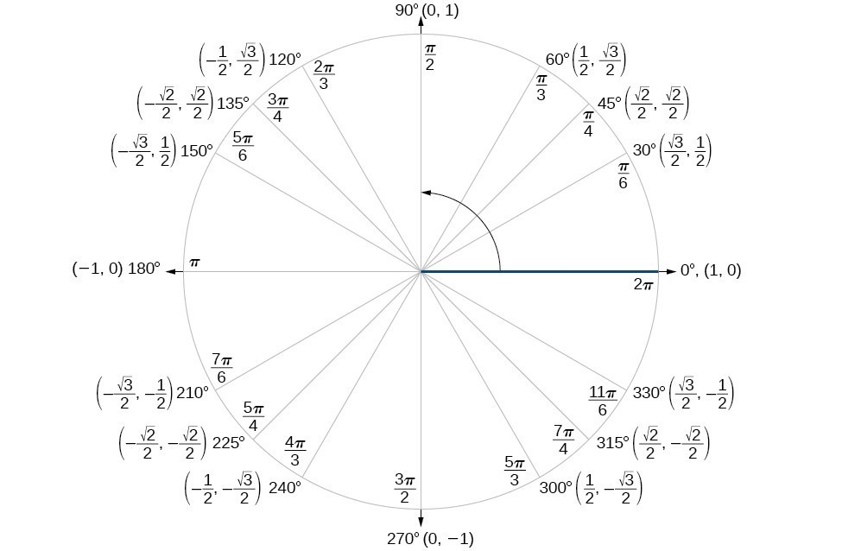

Use Sum and Difference Formulas for Cosine
We will begin with the sum and difference formulas for cosine, so that we can find the cosine of a given angle if we can break it up into the sum or difference of two of the special angles.
Key Takeaway: Sum and Difference of Cosine
Sum formula for cosine: $\cos{(α+β)}=\cos{α}\cos{β} -\sin{α}\sin{β}$
Difference formula for cosine: $\cos{(α-β)}=\cos{α}\cos{β}+\sin{α}\sin{β}$
Question Help
Given two angles, find the cosine of the difference between the angles.
- Write the difference formula for cosine.
- Substitute the values of the given angles into the formula.
- Simplify.
Example
Using the formula for the cosine of the difference of two angles, find the exact value of $\cos\left(\frac{5π}{4}-\frac{π}{6}\right).$

Try It
Find the exact value of $\cos\left(\frac{π}{3}-\frac{π}{4}\right).$

Example
Find the exact value of $\cos{(75°)}.$

Try It
Find the exact value of $\cos{(105°}).$

Try It
Use the sum formula for cosine to find the exact value of $\cos{(165°)}.$

Use Sum and Difference Formulas for Sine
The sum and difference formulas for sine can be derived in the same manner as those for cosine, and they resemble the cosine formulas.
Key Takeaway: Sum and Difference Formula for Sine
$$\sin{(α+β)}=\sin{α}\cos{β}+\cos{α}\sin{ β}$$
$$\sin{(α+β)}=\sin{α}\cos{β}+\cos{α}\sin{ β}$$

Question Help
Given two angles, find the sine of the difference between the angles.
- Write the difference formula for sine.
- Substitute the given angles into the formula.
- Simplify.

Example
Use the sum and difference identities to evaluate the difference of the angles and show that part a equals part b.
a. $\sin{(45°-30°)}$

b. $\sin{(135°-120°)}$

Example
Find the exact value of $\sin\left(\cos^{-1}\left(\frac{1}{2}\right)+\sin^{-1}\left(\frac{3}{5}\right)\right)$.

Try It
Use the sum or difference formula for sine to determine the exact value of $\sin\left(\frac{11π}{12}\right)$

Use Sum and Difference Formulas for Tangent
Key Takeaway: Sum and Difference Formula for Tangent
$$\tan{(α+β)}=\frac{\tan{α}+\tan{β}}{1+\tan{α}\tan{β}}$$
$$\tan{(α-β)}=\frac{\tan{α}-\tan{β}}{1+\tan{α}\tan{β}}$$

Question Help
Given two angles, find the tangent of the sum of the angles.
- Write the sum formula for tangent.
- Substitute the given angles into the formula.
- Simplify.
Example
Find the exact value of $\tan\left(\frac{π}{6}+\frac{π}{4}\right).$

Try It
Find the exact value of $\tan\left(\frac{2π}{3}+\frac{π}{4}\right)$.

Try It
Use the sum or difference formula for tangent to determine the exact value of $\tan\left(\frac{17π}{12}\right)$.

Example
Given $\sin{α}=\frac{3}{5}$, $0<α<\frac{π}{2}$, $cos β=-\frac{5}{13}$, $π<β<\frac{3π}{2}$, find:
a. $\sin{(α+β)}$
b. $\cos{(α+β)}$
c. $\tan{(α+β)}$
d. $\tan{(α+β)}$

15.3 Double Angle, Half Angle, and Reduction Formulas

Using Double-Angle Formulas to Find Exact Values
Key Takeaway: Double Angle Formulas
$$\sin{(2θ)}=2\sin{θ}\cos{θ} \\ \cos{(2θ)}=\cos^{2}{θ}-\sin^{2}{θ}=1-2\sin^{2}{θ}=2\cos^{2}{θ}-1 \\ \tan{(2θ)}=\frac{2\tan{θ}}{1-\tan^{2}{θ}}$$
Question Help
Given the tangent of an angle and the quadrant in which it is located, use the double-angle formulas to find the exact value.
- Draw a triangle to reflect the given information.
- Determine the correct double-angle formula.
- Substitute values into the formula based on the triangle.
- Simplify.
Example
Given that $\tan{θ}=-\frac{3}{4}$ and θ is in quadrant II, find the following:
a. $\sin{(2θ)}$
b. $\cos{(2θ)}$
c. $\tan{(2θ)}$

Try It
Given $\sin{α}=\frac{5}{8}$, with θ in quadrant I, find $\cos{(2α)}.$

Try It
Given $\sin{x}=\frac{8}{9}$, with x is in the second quadrant, determine the exact values of the following.
$$\sin{(2x)}=$$

$$\cos\left(2x\right)=$$

$$\tan{(2x)}=$$

Example
Use the double-angle formula for cosine to write $\cos{(6x)}$ in terms of $\cos{(3x)}$

Using Double-Angle Formulas to Verify Identities
Establishing identities using the double-angle formulas is performed using the same steps we used to derive the sum and difference formulas. Choose the more complicated side of the equation and rewrite it until it matches the other side.
Example
Establish the following identity using double-angle formulas: $1+\sin{(2θ)}=(\sin{θ}+\cos{θ})².$

Example
Verify the identity: $\tan{(2θ)}=\frac{2}{\cot{θ}-\tan{θ}}$.

Try It
Verify the identity: $\cos{(2θ)}\cos{θ}=\cos^{3}{θ}-\cos{θ}\sin^{2}{θ}$.

Use Reduction Formulas to Simplify an Expression
Key Takeaway: Reduction Formulas
$$\sin^{2}{θ}=\frac{\left[1-\cos\left(2θ\right)\right]}{2}$$
$$\cos^{2}{θ}=\frac{\left[1+\cos\left(2θ\right)\right]}{2}$$
$$\tan^{2}{θ}=\frac{\left[1-\cos\left(2θ\right)\right]}{\left[1+\cos\left(2θ\right)\right]}$$
Example
Write an equivalent expression for $\cos^{4}{x}$ that does not involve any powers of sine or cosine greater than 1.

Example
Use the power-reducing formulas to prove $\sin^{3}{(2x)}=\left[\frac{1}{2}\sin\left(2x\right)\right]\left[1-\cos\left(4x\right)\right]$.

Try It
Use the power-reducing formulas to prove that $10\cos^{4}{x}=\frac{15}{4}+5\cos\left(2x\right)+\frac{5}{4\cos\left(4x\right)}$.

Using Half-Angle Formulas to Find Exact Values
Key Takeaway: Half Angle Formulas
$$\sin{(α/2)}=±\sqrt{\frac{1-\cos{α}}{2}} \\ \cos{(α/2)}=±\sqrt{\frac{1+\cos{α}}{2}} \\ \tan{(α/2)}=±\sqrt{\frac{1-\cos{α}}{1+\cos{α}}} =\frac{\sin{α}}{1+\cos{α}} =\frac{1-\cos{α}}{\sin{α}}$$
Example
Find $\sin{(15°) }$using a half-angle formula.

Question Help
Given the tangent of an angle and the quadrant in which the angle lies, find the exact values of trigonometric functions of half of the angle.
- Draw a triangle to represent the given information.
- Determine the correct half-angle formula.
- Substitute values into the formula based on the triangle.
- Simplify.
Example
Given that $\tan{α}=\frac{8}{15}$ and α lies in quadrant III, find the exact value of the following:
a. $\sin\left(\frac{α}{2}\right)$
b. $\cos\left(\frac{α}{2}\right)$
c. $\tan\left(\frac{α}{2}\right)$

Try It
Given that $\sin{α}=-\frac{4}{5}$ and α lies in quadrant IV, find the exact value of $\cos\left(\frac{α}{2}\right).$

15.4 Sum-to-Product and Product-to-Sum Formulas

Expressing Products as Sums

Expressing Products as Sums for Cosine
Key Takeaway: Product-to-Sum Formulas
$$\cos{α}\cos{β} =\frac{1}{2}[\cos\left(α-β\right)+\cos{(α+β)}] \\ \sin{α}\cos{β} =\frac{1}{2}[\sin\left(α+β\right)+\sin{(α-β)}] \\ \sin{α}\sin{β} =\frac{1}{2}[\cos{(α-β)}-\cos{(α+β)}] \\ \cos{α}\sin{β} =\frac{1}{2}[\sin\left(α+β\right)-\sin{(α-β)}]$$
Question Help
Given a product of cosines, express as a sum.
- Write the formula for the product of cosines.
- Substitute the given angles into the formula.
- Simplify.
Example
Write the following product of cosines as a sum: $2\cos\left(\frac{7x}{2}\right)\cos\left(\frac{3x}{2}\right).$

Try It
Use the product-to-sum formula to write the product as a sum or difference: $\cos{(2θ)}\cos{(4θ)}.$

Try It
Write this product as a sum: $4\cos{(30y)}\cos{(22y)}.$

Expressing the Product of Sine and Cosine as a Sum
Example
Express the following product as a sum containing only sine or cosine and no products: $\sin{(4θ)}\cos{(2θ)}$.

Try It
Use the product-to-sum formula to write the product as a sum: $\sin{(x+y)}\cos{(x-y)}.$

Try It
Write the product as a sum: $4\sin{(28x)}\cos{(16x)}.$

Expressing Products of Sines in Terms of Cosine
Example
Write $\cos{(3θ)}\cos{(5θ)}$ as a sum or difference.

Try It
Use the product-to-sum formula to evaluate $\cos\left(\frac{11π}{12}\right)\cos\left(\frac{π}{12}\right).$

Expressing Sums as Products
Key Takeaway: Sum-to-Product Formulas
$$\sin{α}+\sin{β}=2\sin\left(\frac{α+β}{2}\right)\cos\left(\frac{α-β}{2}\right) \\ \sin{α}-\sin{β}=2\sin\left(\frac{α-β}{2}\right)\cos\left(\frac{α+β}{2}\right) \\ \cos{α}-\cos{β}=-2\sin\left(\frac{α+β}{2}\right)\sin\left(\frac{α-β}{2}\right) \\ \cos{α}+\cos{β}=2\cos\left(\frac{α+β}{2}\right)\cos\left(\frac{α-β}{2}\right)$$
Example
Write the following difference of sines expression as a product: $\sin{(4θ)}-\sin{(2θ).}$

Try It
Use the sum-to-product formula to write the sum as a product: $\sin{(3θ)}+\sin{(θ)}.$

Try It
Write the sum-to-product: $\cos{(10.1x)}+\cos{(5.9x)}.$

Example
Evaluate $\cos\left(15°\right)-\cos{(75°)}.$

Example
Prove the identity: $\frac{\cos\left(4t\right)-\cos\left(2t\right)}{\sin\left(4t\right)+\sin\left(2t\right)}=-\tan{t}.$

15.5 Solving Trigonometric Equations

Solving Linear Trigonometric Equations in Sine and Cosine
Trigonometric equations may have an infinite number of solutions.
What do we need to do to find all possible solutions for a trigonometric equation?

Example
Find all possible exact solutions for the equation $\cos{θ}=\frac{1}{2}.$

Example
Find all possible exact solutions for the equation $\sin{t}=\frac{1}{2}$.

Question Help
Given a trigonometric equation, solve using algebra.
- Look for a pattern that suggests an algebraic property, such as the difference of squares or a factoring opportunity.
- Substitute the trigonometric expression with a single variable, such as x or u.
- Solve the equation the same way an algebraic equation would be solved.
- Substitute the trigonometric expression back in for the variable in the resulting expressions.
- Solve for the angle.

Example
Solve the equation exactly
$2\cos{θ}-3=-5$, $0≤θ<2π$.

Try It
Solve exactly the following linear equation on the interval $[0,2π)$:
$2\sin{x}+1=0$.

Try It
Find all solutions to $2\sin{θ}=-\sqrt{2}$ on the interval $0≤θ<2π$.

Solve Trigonometric Equations Using a Calculator
Not all functions can be solved exactly using only the unit circle. When we must solve an equation involving an angle other than one of the special angles, we will need to use a calculator. Make sure it is set to the proper mode, either degrees or radians, depending on the criteria of the given problem.
Example
Use a calculator to solve the equation $\sin{θ}=0.8$, where θ is in radians.

Example
Use a calculator to solve the equation $\sec{θ}=-4$, giving your answer in radians.

Try It
Solve $\cos{θ}=-0.2$. on the interval $[0,2π)$.
Round your answers to four decimal places.

Try It
Solve $\sin{θ}=0.72$. on the interval $0≤θ<2π$.

Solving Equations Involving a Single Trigonometric Function
Example
Solve the problem exactly: $2\sin^{2}{θ}-1=0$, $0≤θ<2π$.

Example
Solve the following equation exactly: $\csc{θ}=-2$, $0≤θ<4π$.

Example
Solve the equation exactly: $\tan\left(θ-\frac{π}{2}\right)=1$, $0≤θ<2π$.

Try It
Find all solutions for $\tan{x}=\sqrt{3}$.

Try It
Find all solutions for $\tan{t}=-1$, $0≤t<2π$.

Example
Identify all exact solutions to the equation $2(\tan{x}+3)=5+\tan{x}$, $0≤x<2π$.

Solving Trigonometric Equations in Quadratic Form
Example
Solve the equation exactly: $\cos^{2}{θ}+3\cos{θ}-1=0$, $0≤θ<2π$.

Example
Solve the equation exactly: $2\sin^{2}{θ}-5\sin{θ}+3=0$, $0≤θ≤2π$.

Try It
Solve $\sin^{2}{θ}=2\cos{θ}+2$, $0≤θ≤2π$.
(Hint: Make a substitution to express the equation only in terms of cosine.)

Try It
Solve $2\sin^{2}{w}-\sin{w}-1=0$ for all solutions in the interval $0≤w≤2π$.

Try It
Solve exactly: $2\sin^{2}{θ}+\sin{θ}=0$, $0≤θ<2π$.

Example
Solve the equation quadratic in form exactly: $2\sin^{2}{θ}-3\sin{θ}+1=0$, $0≤θ<2π$.

Try It
Solve the quadratic equation $2\cos^{2}{θ}+\cos{θ}=0$ on the interval $0≤θ<2π$.

Solving Trigonometric Equations Using Fundamental Identities
While algebra can be used to solve several trigonometric equations, we can also use the fundamental identities because they make solving equations simpler. Remember that the techniques we use for solving are not the same as those for verifying identities.
Example
Use identities to solve exactly the trigonometric equation over the interval $0≤x<2π$:
$\cos{x}\cos{(2x)}+\sin{x}\sin{(2x)}=\frac{\sqrt{3}}{2}$.

Example
Solve the equation exactly using a double-angle formula: $\cos{(2θ)}=\cos{θ}$.

Example
Solve the equation exactly using an identity: $3\cos{θ}+3=2\sin^{2}{θ}, 0≤θ<2π$.

Try It
Solve $12\cos^{2}{(x)}-5\sin\left(x\right)-10=0$ for all solutions on the interval $0≤θ<2π$

Solving Trigonometric Equations with Multiple Angles
Sometimes it is not possible to solve a trigonometric equation with identities that have a multiple angle, such as sin(2x) or cos(3x).
Example
Solve exactly: $\cos{(2x)}=\frac{1}{2}$ on $[0,2π)$.

15.6 Modeling with Trigonometric Equations
Any motion that repeats itself in a fixed time period is considered periodic motion and can be modeled by a sinusoidal function. Sinusoidal functions oscillate above and below the midline, are periodic, and repeat values in set cycles.
Recall
The general forms of a sinusoidal equation are given as
$y=A\sin{(Bt-C)}+D$ or $y=A\cos{(Bt-C)}+D$
where amplitude = $|A|$, B is related to period such that period=$\frac{2π}{B}$, C is the phase shift such that $\frac{C}{B}$ denotes the horizontal shift, and D represents the vertical shift from the graph's parent graph.
The difference between the sine and the cosine graphs is that the sine graph begins with the average value of the function and the cosine graph begins with the maximum or minimum value of the function.

Modeling Periodic Behavior
Example
The average monthly temperatures for a small town in Oregon are given in a table. Find a sinusoidal function of the form $y=Asin(Bt-C)+D$ that fits the data (round to the nearest tenth) and sketch the graph.
Month | Temperature
January | 42.5
February | 44.5
March | 48.5
April | 52.5
May | 58
June | 63
July | 68.5
August | 69
September | 64.5
October | 55.5
November | 46.5
December | 43.5

Example
The hour hand of the large clock on the wall in Union Station measures 24 inches in length. At noon, the tip of the hour hand is 30 inches from the ceiling. At 3 PM, the tip is 54 inches from the ceiling, and at 6 PM, 78 inches. At 9 PM, it is again 54 inches from the ceiling, and at midnight, the tip of the hour hand returns to its original position 30 inches from the ceiling. Let y equal the distance from the tip of the hour hand to the ceiling x hours after noon. Find the equation that models the motion of the clock and sketch the graph.

Example
The height of the tide in a small beach town is measured along a seawall. Water levels oscillate between 7 feet at low tide and 15 feet at high tide. On a particular day, low tide occurred at 6 AM and high tide occurred at noon. Approximately every 12 hours, the cycle repeats. Find an equation to model the water levels.

Try It
The daily temperature in the month of March in a certain city varies from a low of 24°F at midnight to a high of 40°F at noon. Let t=0 correspond to noon.
- Find a cosine function to model daily temperature.

- Find the first time after noon when the temperature reaches the freezing point 32𝐹. Give your answer in hours after noon.

- Find the next time when the temperature again reaches 32°F

Try It
Outside temperature over a day can be modeled as a sinusoidal function. Suppose you know the temperature varies between 73 and 97 degrees during the day and the average daily temperature first occurs at 9 AM. How many hours after midnight, to two decimal places, does the temperature first reach 82 degrees?

Modeling Harmonic Motion
Harmonic motion is a form of periodic motion, but there are factors to consider that differentiate the two types. While general periodic motion applications cycle through their periods with no outside interference, harmonic motion requires a restoring force. Examples of harmonic motion include springs, gravitational force, and magnetic force.

Simple Harmonic Motion
Key Takeaway: Simple Harmonic Motion
Simple harmonic motion equations are given in terms of displacement:
$$d=a\cos{(ωt)}$$
$$d=a\sin{(ωt)}$$
where $|a|$ is the amplitude, $\frac{2π}{ω}$ is the period, and $\frac{ω}{2π}$ is the frequency, or the number of cycles per unit of time.
Example
For the given functions, find the maximum displacement, the period, and the frequency. Then, sketch the graph.
a. $y=5\sin{(3t)}$

b. $y=6\cos{(πt)}$

c. $y=5\cos\left(\frac{π}{2}t\right)$
Try It
A weight on a spring oscillates vertically with position given by $y=7\cos\left(\frac{π}{3}t\right)$ cm, where t is time in seconds. Find:
a. The maximum displacement of the weight
b. The period of oscillation
c. The frequency
d. At what time during the first period does the weight first reach y=3.5 cm?

Damped Harmonic Motion
In reality, a pendulum does not swing back and forth forever, nor does an object on a spring bounce up and down forever. What is typically the damping factor?

Key Takeaway: Damped Harmonic Motion
In damped harmonic motion, the displacement of an oscillating object from its rest position at time t is given as
$$f(t)=ae^{-}ᶜᵗ\sin{(ωt)}$$
$$f(t)=ae^{-}ᶜᵗ\cos{(ωt)}$$
where c is a damping factor, $|a|$ is the initial displacement, and $\frac{2π}{ω}$ is the period.
Example
Model the equations that fit the two scenarios and use a graphing utility to graph the functions: Two mass-spring systems exhibit damped harmonic motion at a frequency of 0.5 cycles per second. Both have an initial displacement of 10 cm. The first has a damping factor of 0.5 and the second has a damping factor of 0.1.

Example
Find and graph a function of the form $y=ae^{-}ᶜᵗ\cos{(ωt)}$ that models the information given.
a. a=20, c=0.05, p=4

b. a=2, c=1.5, f=3

Try It
The following equation represents a damped harmonic motion model: $f(t)=5e^{-6}ᵗ\cos{(4t)}$
Find the initial displacement, the damping constant, and the frequency.

Example
Find and graph a function of the form $y=ae^{-}ᶜᵗ\sin{(ωt)}$ that models the information given.
a. a=7, c=10, p=π/6

b. a=0.3, c=0.2, f=20

Try It
Write the equation for damped harmonic motion given a=10, c=0.5, and p=2.

Try It
A spring oscillates with a frequency of 10 cycles per second. Its initial displacement is 14 centimeters and its damping factor is 0.25. Give the function, 𝑓(𝑡) that describes the position of the spring 𝑡 seconds after it starts oscillating.

Modeling with Trigonometric Equations
Example
The average person's blood pressure is modeled by the function $f(t)=20\sin{(160πt)}+100$, where f(t) represents the blood pressure at time t, measured in minutes. Interpret the function in terms of period and frequency. Sketch the graph and find the blood pressure reading.

Example
A spring measuring 10 inches in natural length is compressed by 5 inches and released. It oscillates once every 3 seconds, and its amplitude decreases by 30% every second. Find an equation that models the position of the spring t seconds after being released.

Try It
A mass suspended from a spring is raised a distance of 5 cm above its resting position. The mass is released at time t=0 and allowed to oscillate. After 1/3 second, it is observed that the mass returns to its highest position. Find a function to model this motion relative to its initial resting position.

Example
A guitar string is plucked and vibrates in damped harmonic motion. The string is pulled and displaced 2 cm from its resting position. After 3 seconds, the displacement of the string measures 1 cm. Find the damping constant.

Bounding Curves in Harmonic Motion
Harmonic motion graphs may be enclosed by bounding curves. When a function has a varying amplitude, such that the amplitude rises and falls multiple times within a period, we can determine the bounding curves from part of the function.
Example
Graph the function $f(x)=\cos\left(2πx\right)\cos{(16πx)}$.

Modeling the Same Periodic Function with Sine and Cosine
Key Takeaway: Sine vs. Cosine
Any periodic phenomenon can be modeled using either a sine or cosine function. The key is understanding that cosine and sine functions are phase shifts of each other:
$$\cos{(x)}=\sin{(x+π/2)}$$
$$\sin{(x)}=\cos{(x-π/2)}$$
When modeling real-world periodic behavior, you can choose whichever function makes the mathematics simpler or aligns better with your reference point.
Example
Suppose the temperature in Phoenix, Arizona follows this pattern: maximum temperature 85°F at 3:00 PM (t=15 hours), minimum temperature 65°F at 3:00 AM (t=3 hours), and the pattern repeats every 24 hours. Let's find both sine and cosine functions to model this behavior.

Question Help: Converting Between Sine and Cosine
When you have one trigonometric function and need to write the equivalent using the other:
- From cosine to sine: Replace cos with sin and adjust the phase shift by subtracting 1/4 the period from the argument.
- From sine to cosine: Replace sin with cos and adjust the phase shift by adding 1/4 the period to the argument.
- Check your work: Both functions should give the same values at key points (maximum, minimum, zeros).
Try It
A Ferris wheel has a diameter of 50 feet with its center 30 feet above the ground. The wheel completes one revolution every 8 minutes. If a rider starts at the bottom of the wheel when t=0:
a. Write a cosine function h(t) to model the rider's height above ground.

b. Write an equivalent sine function for the same motion.

Pro Tip
How do we decide whether to choose a sine or cosine function?

Example
A sound wave oscillates with amplitude 0.5 units, frequency 440 Hz (hertz glossary: a unit measuring cycles per second), and passes through the origin (0,0) while increasing.

