Precalculus

Periodic Functions Guided Notes
This tool is designed to work alongside your Study Plan and class sessions. Before class, you'll use it with the assigned readings by filling in key terms, noting examples, and writing down questions that arise. During class, you'll add to your notes as you deepen your understanding and instructors highlight important concepts. You'll find a mix of fill-in-the-blank sections, reflection spaces, and areas to record real-world examples.

14.1 Graphs of the Sine and Cosine Function

The Standard Graph of y=sin(x) and y=cos(x)

Recall
Sine and cosine functions relate real number values to the x- and y-coordinates of a point on the unit circle.
Example
Let's start with the sine function. We can create a table of values and use them to sketch a graph. The table below lists some of the values for the sine function on a unit circle.
x | 0 | $$\frac{π}{6}$$ | $$\frac{π}{4}$$ | $$\frac{π}{3}$$ | $$\frac{π}{2}$$ | $$\frac{2π}{3}$$ | $$\frac{3π}{4}$$ | $$\frac{5π}{6}$$ | $$π$$
$$\sin{x}$$
Plotting the points from the table and continuing along the x-axis gives the shape of the sine function.
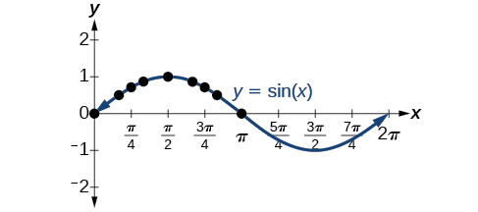
Example
Again, we can create a table of values and use them to sketch a graph. The table below lists some of the values for the cosine function on a unit circle.
x | 0 | $$\frac{π}{6}$$ | $$\frac{π}{4}$$ | $$\frac{π}{3}$$ | $$\frac{π}{2}$$ | $$\frac{2π}{3}$$ | $$\frac{3π}{4}$$ | $$\frac{5π}{6}$$ | $$π$$
$$\sin{x}$$
As with the sine function, we can plot points to create a graph of the cosine function.
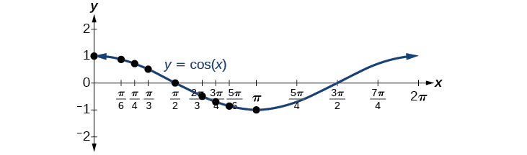
Key Takeaway: Period of a Function
The period of a trigonometric function is the length of one complete cycle of the function's graph.
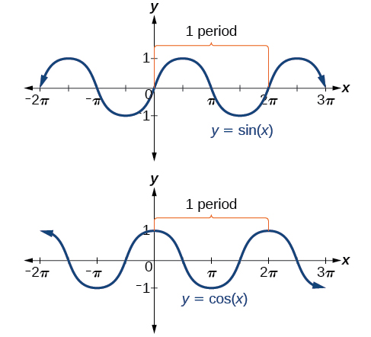

Symmetry of Sine and Cosine
Describe the symmetry of sine and cosine

Key Takeaway: Characteristics of Sine and Cosine Graphs
The sine and cosine functions have several distinct characteristics:
- They are periodic functions with a period of:
- The domain of each function is:
- The range of each function is:

Period and Amplitude
As we can see, sine and cosine functions have a regular period and range. If we watch ocean waves or ripples on a pond, we will see that they resemble the sine or cosine functions. However, they are not necessarily identical. Some are taller or longer than others. A function that has the same general shape as a sine or cosine function is known as a sinusoidal function.
Key Takeaway: General Form of Sine and Cosine
The general forms of sinusoidal functions are
$y=A\sin{(Bx-C)}+D$ and $y=A\cos{(Bx-C)}+D$

Determining the Period of Sinusoidal Functions
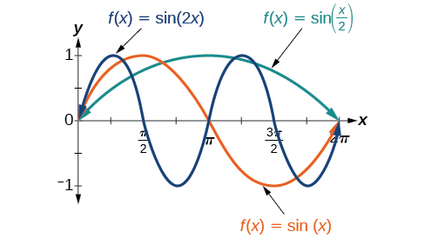
Key Takeaway: Period of Sinusoidal Functions
For a sinusoidal function in the form $y=A\sin{(Bx-C)}+D$ or $y=A\cos{(Bx-C)}+D$, the period is $\frac{2π}{|B|}$.
Example
Determine the period of the function $f\left(x\right)=\sin\left(\frac{π}{6}x\right)$.

Try It
Determine the period of the function $f\left(x\right)=\cos\left(\frac{x}{3}\right)$.

Determining Amplitude
A represents the vertical stretch factor, and its absolute value |A| is the amplitude.
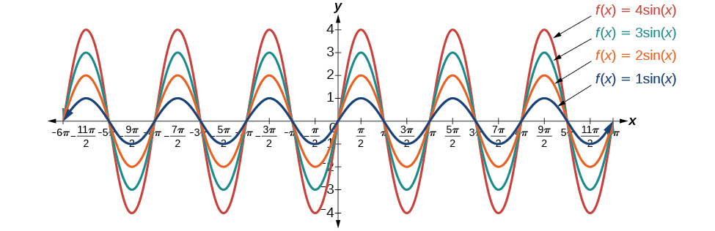
What happens if |A| < 1?

Key Takeaway: Amplitude of Sinusoidal Functions
For a sinusoidal function in the form $y=A\sin{(Bx-C)}+D$ or $y=A\cos{(Bx-C)}+D$, the amplitude is |A|.
In addition, |A| = amplitude = 1/2 |maximum−minimum|
Example
What is the amplitude of the sinusoidal function $f\left(x\right)=-4\sin{(x)}$? Is the function stretched or compressed vertically?

Try It
What is the amplitude of the sinusoidal function $f\left(x\right)=\frac{1}{2}\cos{(x)}$? Is the function stretched or compressed vertically?

Phase Shift of y=sin x and y=cos x
Key Takeaway: Phase Shift and Vertical Shift for Sine and Cosine
Given an equation in the form $y=A\sin{(Bx-C)}+D$ or $y=A\cos{(Bx-C)}+D$, $\frac{C}{B}$ is the phase shift and $D$ is the vertical shift.
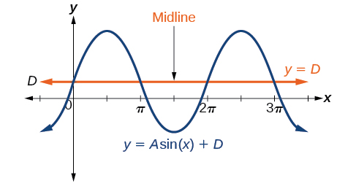
When will the phase shift move the function to the right? What about to the left?

Example
Determine the direction and magnitude of the phase shift for $f(x)=\sin\left(x+\frac{π}{6}\right)-2$.

Try It
Determine the direction and magnitude of the phase shift for $f\left(x\right)=3\cos\left(x-\frac{π}{2}\right)$.

Example
Determine the direction and magnitude of the vertical shift for $f\left(x\right)=\cos\left(x\right)-3$.

Try It
Determine the direction and magnitude of the vertical shift for $f\left(x\right)=3\sin\left(x\right)+2$.

Question Help
Given a sinusoidal function in the form $y=A\sin{(Bx-C)}+D$, identify the midline, amplitude, period, and phase shift.
- Determine the amplitude as$|A|.$
- Determine the period as $P=\frac{2π}{\left|B\right|}$.
- Determine the phase shift as $\frac{C}{B}$.
- Determine the midline as $y=D.$
Example
Determine the midline, amplitude, period, and phase shift of the function $y=3\sin{(2x)}+1$.

Try It
Determine the midline, amplitude, period, and phase shift of the function $y=\frac{1}{2}cos\left(\frac{x}{3}-\frac{π}{3}\right).$

Try It
Given the function $y=7\sin{(7\left(x-8\right))}+7.$
The amplitude is:
The period is:
The horizontal shift is:
The equation of the midline is:

Writing the Function for a Sine or Cosine Graph
Example
Determine the formula for the cosine function graphed.
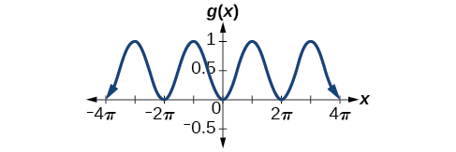
Try It
Determine the formula for the sine function in the graph.
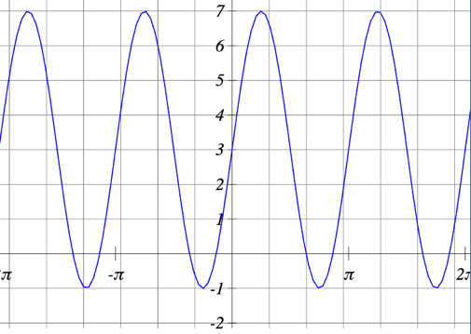
Try It
Give the equation for the function shown below.
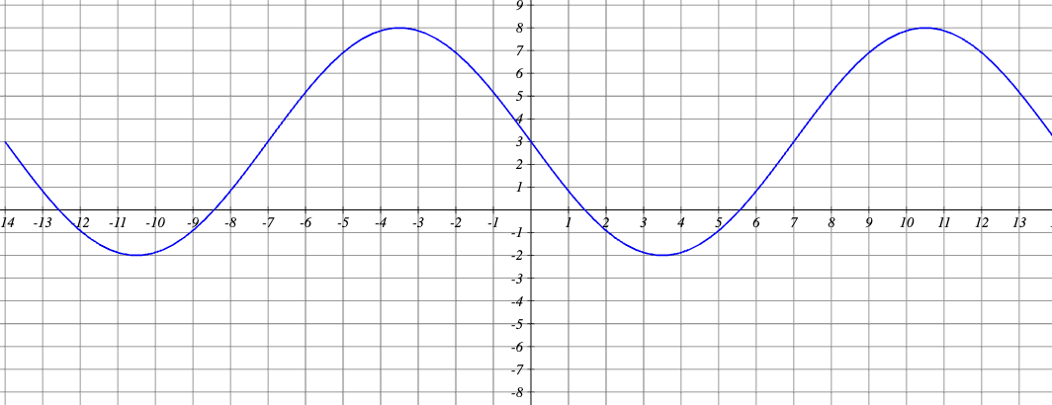
Example
Determine the equation for the sinusoidal function.
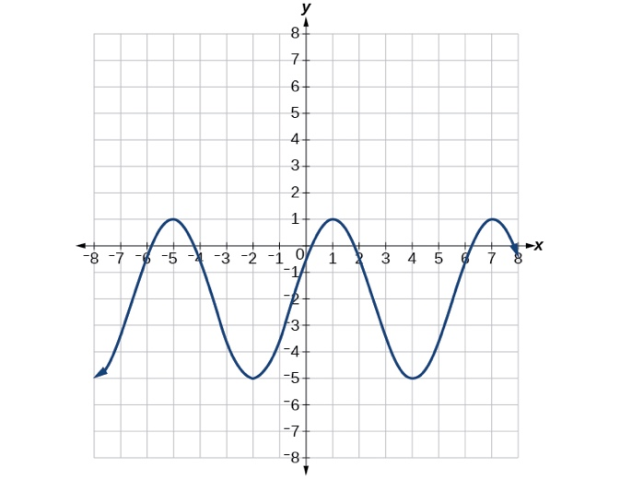

Try It
Write a formula for the function graphed.
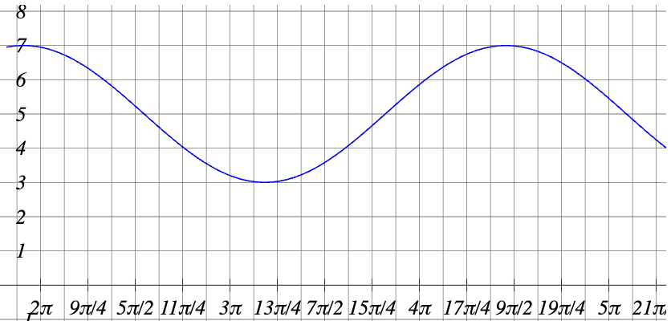

Graphing Transformations of y=sin x and y=cos x
Throughout this section, we have learned about types of variations of sine and cosine functions and used that information to write equations from graphs. Now we can use the same information to create graphs from equations.
Question Help
Given the function $y=A\sin{(Bx)},$sketch its graph.
- Identify the amplitude, $|A|$.
- Identify the period, $P=\frac{2π}{\left|B\right|}$.
- Start at the origin, with the function increasing to the right if A is positive or decreasing if A is negative.
- At $x=\frac{π}{2\left|B\right|}$ there is a local maximum for $A>0$or a minimum for $A<0$, with $y=A$.
- The curve returns to the x-axis at $x=\frac{π}{\left|B\right|}$.
- There is a local minimum for $A>0$ (maximum for $A<0$) at $x=\frac{3π}{2\left|B\right|}$ with $y=-A$.
- The curve returns again to the x-axis at $x=\frac{2π}{\left|B\right|}$.
Example
Sketch a graph of $f(x)=-2\sin\left(\frac{πx}{2}\right)$.
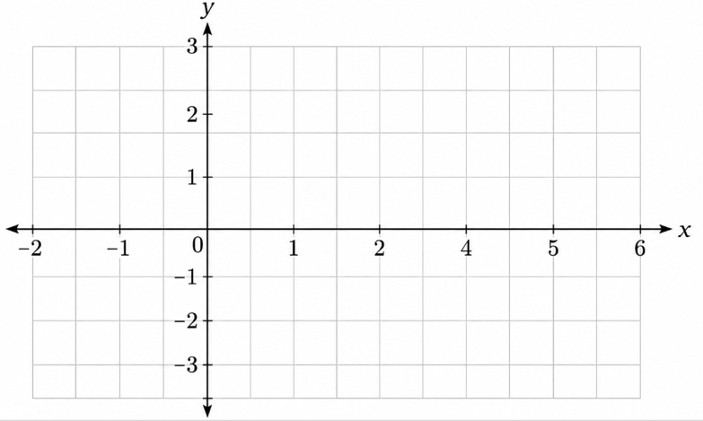

Try It
Sketch a graph of $g\left(x\right)=\frac{1}{4}\cos{(4x)}$. Determine the midline, amplitude, period, and phase shift.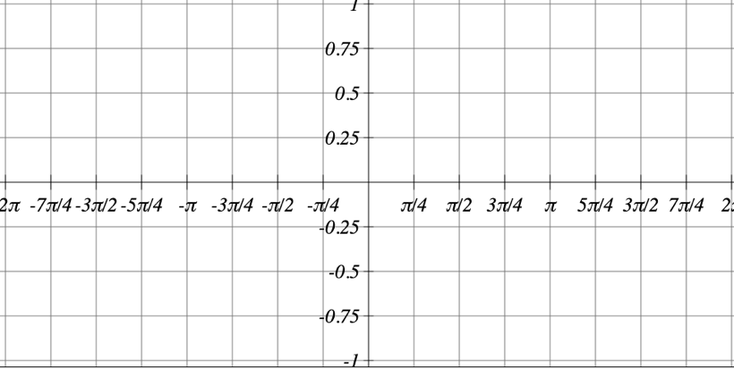
Question Help
Given a sinusoidal function with a phase shift and a vertical shift, sketch its graph.
- Express the function in the general form $y=A\sin{(Bx-C)}+D$or $y=A\cos{(Bx-C)}+D$.
- Identify the amplitude, $|A|$.
- Identify the period, $P=\frac{2π}{\left|B\right|}$.
- Identify the phase shift, $\frac{C}{B}$.
- Draw the graph of $f(x)=A\sin{(Bx)}$ shifted to the right or left by $\frac{C}{B}$ and up or down by $D$.
Example
Sketch a graph of $f(x)=3\sin\left(\frac{π}{4}x-\frac{π}{4}\right)$.
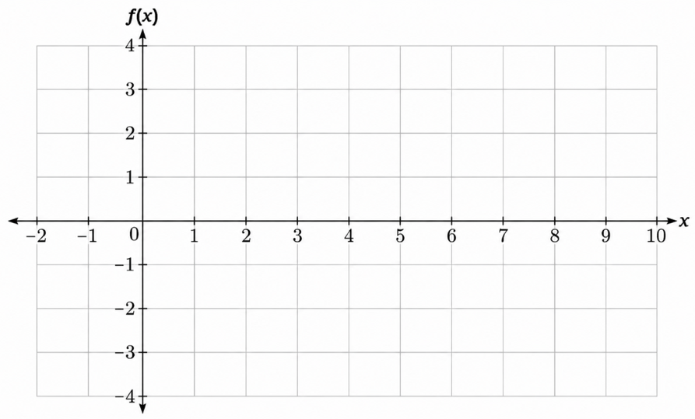

Try It
Draw a graph of $g\left(x\right)=-\frac{3}{4}\cos\left(2x-\frac{π}{3}\right)$. Determine the midline, amplitude, period, and phase shift.
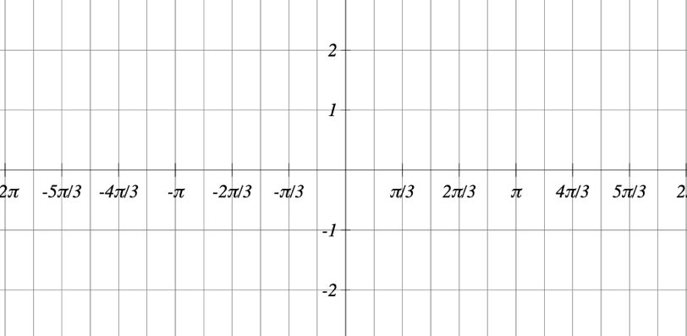
Example
Given $y=-2\cos\left(\frac{π}{2}x+π\right)+3$, determine the amplitude, period, phase shift, and horizontal shift. Then graph the function.
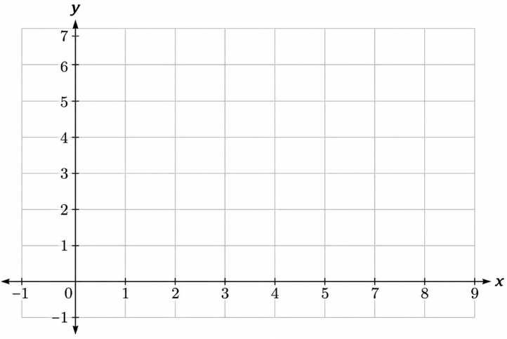
Try It
Given $f(x)=3\cos\left(x-\frac{5π}{3}\right)+1$, determine the amplitude, period, phase shift, and horizontal shift. Then graph the function.
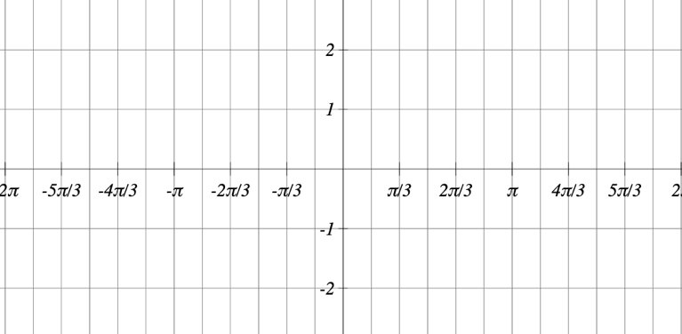

14.2 Graphs of the Other Trigonometric Functions

Analyzing the Graph of y=tan x and Its Variations
We will begin with the graph of the tangent function, plotting points as we did for the sine and
x | $$-\frac{π}{2}$$ | $$-\frac{π}{3}$$ | $$-\frac{π}{4}$$ | $$-\frac{π}{6}$$ | $$0$$ | $$\frac{π}{6}$$ | $$\frac{π}{4}$$ | $$\frac{π}{3}$$ | $$\frac{π}{2}$$
tan(x) | undefined | $$-\sqrt{3}$$ | $$-1$$ | $$-\frac{\sqrt{3}}{3}$$ | $$0$$ | $$\frac{\sqrt{3}}{3}$$ | $$1$$ | $$\sqrt{3}$$ | undefined
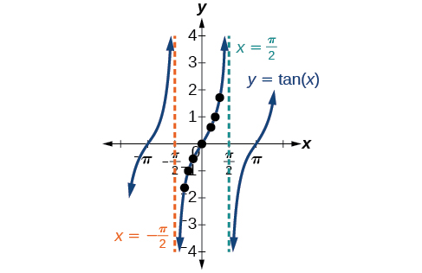
Why can’t the term amplitude be interpreted in the same way for tangent?

Key Takeaway: Features of the Graph of y=Atan(Bx)
- The stretching factor is |A| (tangent does not have an amplitude)
- The period is $P=\frac{π}{\left|B\right|}.$
- The domain is:
- The range is:
- The asymptotes occur at:

Graphing One Period of a Stretched or Compressed Tangent Function
Question Help
Given the function $f(x)=A\tan{(Bx)}$, graph one period.
- Identify the stretching factor, $|A|$.
- Identify B and determine the period, $P=\frac{π}{\left|B\right|}$.
- Draw vertical asymptotes at $x=-\frac{P}{2}$ and $x=\frac{P}{2}$.
- For $A>0$, the graph approaches the left asymptote at negative output values and the right asymptote at positive output values (reverse for $A<0$).
- Plot reference points at $\left(\frac{P}{4}, A\right)$, (0, 0), and $\left(-\frac{P}{4}, -A\right)$, and draw the graph through these points.
Example
Sketch a graph of one period of the function $y=0.5\tan\left(\frac{π}{2}x\right)$
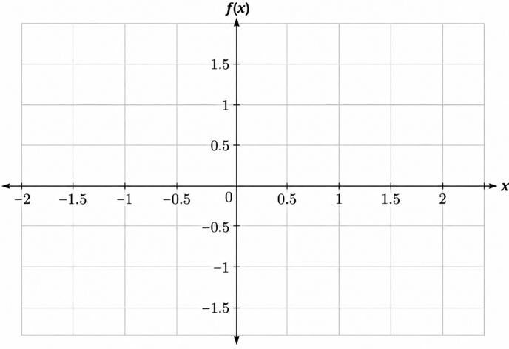
Try It
Sketch a graph of $f\left(x\right)=3\tan\left(\frac{π}{6}x\right)$.
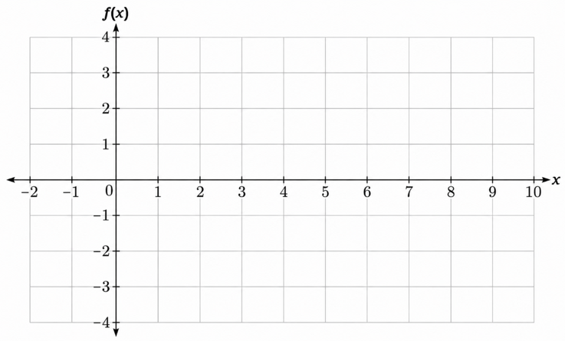

Graphing Transformations of y=tan x

Key Takeaway: Features of the Graph of y=Atan(Bx−C)+D
- The period is:
- The domain is:
- The range is:
- The vertical asymptotes occur at:
Question Help
Given the function $y=A\tan{(Bx-C)}+D$, sketch the graph of one period.
- Identify the stretching/compressing factor, $|A|.$
- Identify B and determine the period, $P=\frac{π}{\left|B\right|}$.
- Identify C and determine the phase shift, $\frac{C}{B}$.
- Draw the graph of $y=A\tan{(Bx)}$ shifted to the right by $\frac{C}{B}$and up by D.
- Sketch the vertical asymptotes, which occur at $x=\frac{C}{B}+\frac{π}{2\left|B\right|}k$, where k is an odd integer.
- Plot any three reference points and draw the graph through these points.
Example
Graph one period of the function $y=-2\tan\left(πx+π\right)-1$.

Example
Find a formula for the function.
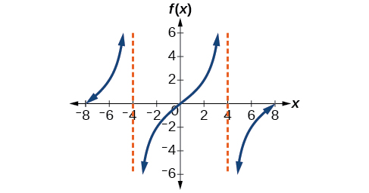
Try It
Find a formula for the function.
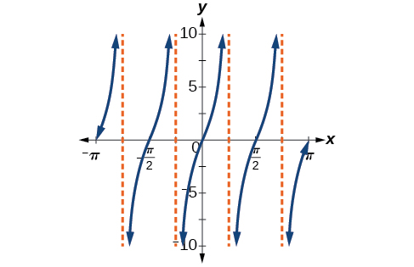

Analyzing the Graphs of y=sec x and y=csc x and Their Variations
The secant was defined by the reciprocal identity $\sec{x}=\frac{1}{\cos{x}}$.
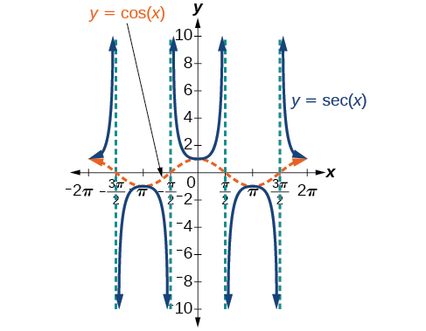
When is the secant function undefined?

As we did for the tangent function, we will again refer to the constant |A| as the stretching factor, not the amplitude.

Key Takeaway: Features of the Graph of y=Asec(Bx)
- The period is:
- The domain is:
- The range is:
- The vertical asymptotes occur at:
Question Help
Given a function of the form $y=A\sec{(Bx)}$, graph one period.
- Express the function given in the form $y=A\sec{(Bx)}$.
- Identify the stretching/compressing factor, $|A|$.
- Identify B and determine the period, $P=\frac{2π}{\left|B\right|}.$
- Sketch the graph of $y=A\cos{(Bx)}$.
- Use the reciprocal relationship between $y=\cos{x}$ and $y=\sec{x}$ to draw the graph of $y=A\sec{(Bx)}$.
- Sketch the asymptotes.
- Plot any two reference points and draw the graph through these points.
Example
Graph one period of $f(x)=2.5\sec{(0.4x)}$.
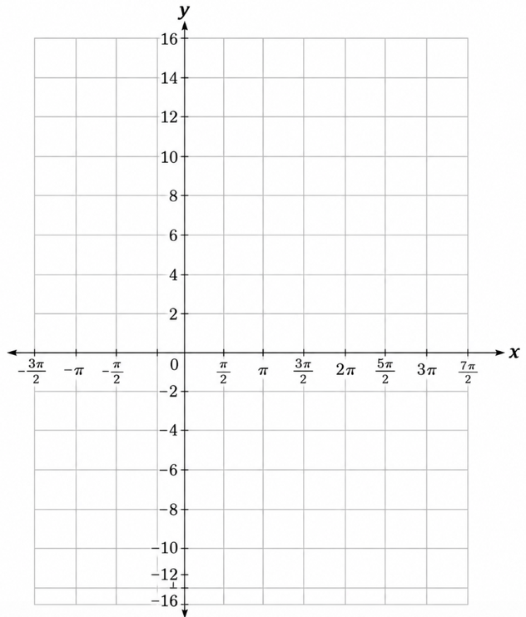
Try It
Graph one period of $f(x)=\sec{(3x)}.$

Similar to the secant, the cosecant is defined by the reciprocal identity $\csc{x}=\frac{1}{\sin{x}}$.
When does the graph of cosecant have vertical asymptotes?
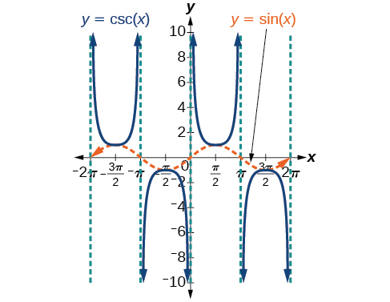
The graph of cosecant is similar to the graph of secant.

Key Takeaway: Features of the Graph of y=Acsc(Bx)
- The amplitude is:
- The period is:|.
- The domain is:
- The range is:
- The asymptotes occur at:
Question Help
Given a function of the form $y=A\csc{(Bx)}$ , graph one period.
- Express the function given in the form $y=A\csc{(Bx)}$.
- Identify the stretching/compressing factor, $|A|.$
- Identify B and determine the period, $P=\frac{2π}{\left|B\right|}$.
- Draw the graph of $y=A\sin{(Bx)}.$
- Use the reciprocal relationship between y=sin x and y=csc x to draw the graph of $y=A\csc{(Bx)}$
- Sketch the asymptotes.
- Plot any two reference points and draw the graph through these points.
Example
Graph one period of $f\left(x\right)=-3\csc\left(4x\right)$
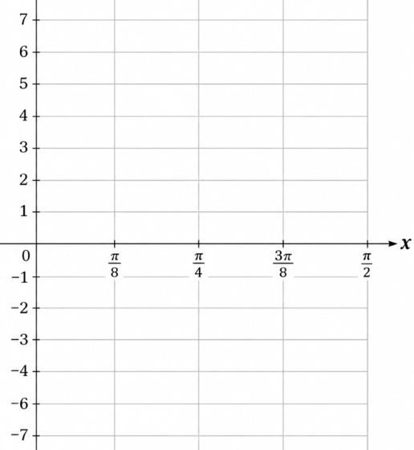
Try It
Graph one period of $f(x)=0.5\csc{(2x)}$.
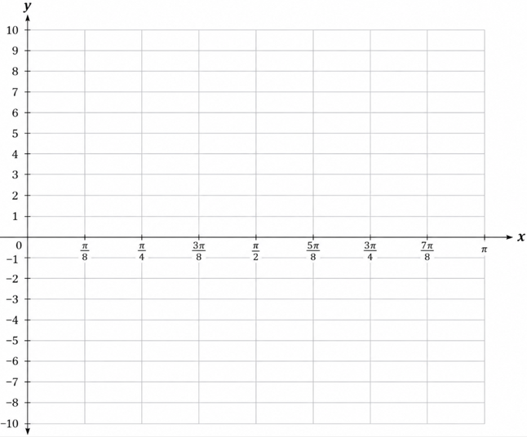

Graphing Transformations of y=sec x and y=csc x
For shifted, compressed, and/or stretched versions of the secant and cosecant functions, we can follow similar methods to those we used for tangent and cotangent.

Key Takeaway: Features of the Graph of y=Asec(Bx−C)+D
- The period is $\frac{2π}{\left|B\right|}$.
- The domain is $x≠\frac{C}{B}+\frac{π}{2\left|B\right|}k$, where k is an odd integer.
- The range is $(-∞,-|A|] ∪ \left[\left|A\right|,∞\right)$
- The vertical asymptotes occur at $x=\frac{C}{B}+\frac{π}{2\left|B\right|}k$, where k is an odd integer.
- There is no amplitude.

Key Takeaway: Features of the Graph of y=Acsc(Bx−C)+D
- The period is $\frac{2π}{\left|B\right|}$.
- The domain is $x≠\frac{C}{B}+\frac{π}{\left|B\right|}k$, where k is an integer.
- The range is $(-∞,-|A|] ∪ \left[\left|A\right|,∞\right)$
- The vertical asymptotes occur at $x=\frac{C}{B}+\frac{π}{\left|B\right|}k$, where k is an integer.
- There is no amplitude.

Question Help
Given a function of the form $f(x)=A\sec\left(Bx-C\right)+D$, graph one period.
- Identify the stretching/compressing factor, $\left|A\right|.$
- Identify B and determine the period, $\frac{2π}{\left|B\right|}$.
- Identify C and determine the phase shift, $\frac{C}{B}$.
- Use the graph of $y=A\cos{(Bx)}$ to help draw the graph of $y=A\sec{(Bx)}$ but shift it to the right by $\frac{C}{B}$ and up by $D$.
- Sketch the vertical asymptotes, which occur at $x=\frac{C}{B}+\frac{π}{2\left|B\right|}k$, where k is an odd integer.

Example
Graph one period of $y=4\sec\left(\frac{π}{3}x-\frac{π}{2}\right)+1$.
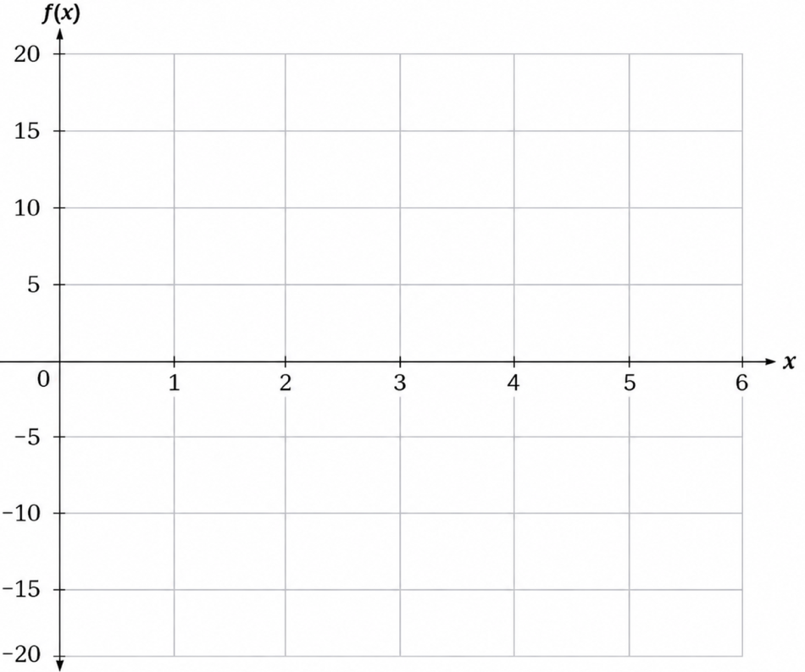
Try It
Graph one period of $f\left(x\right)=-6\sec\left(4x+2\right)-8$.
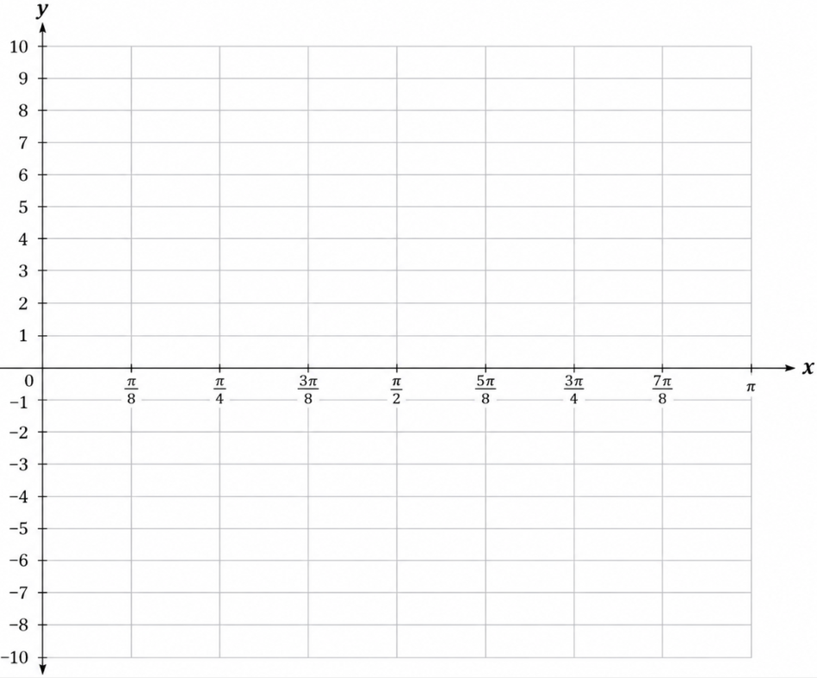
Question Help
Given a function of the form $f(x)=A\csc{(Bx-C)}+D$, graph one period.
- Express the function given in the form $f(x)=A\csc{(Bx-C)}+D$.
- Identify the stretching/compressing factor, $|A|.$
- Identify B and determine the period, $\frac{2π}{\left|B\right|}$.
- Identify C and determine the phase shift, $\frac{C}{B}$.
- Use the graph of $f\left(x\right)=A\sin{(Bx)}$ to help draw the graph of $f(x)=A\csc{(Bx)}$ but shift it to the right by $\frac{C}{B}$ and up by $D$.
- Sketch the vertical asymptotes, which occur at $x=C/B+\frac{π}{\left|B\right|k}$, where k is an integer.
Example
Sketch a graph of $y=2\csc\left(\frac{π}{2}x\right)+1$. What are the domain and range of this function?
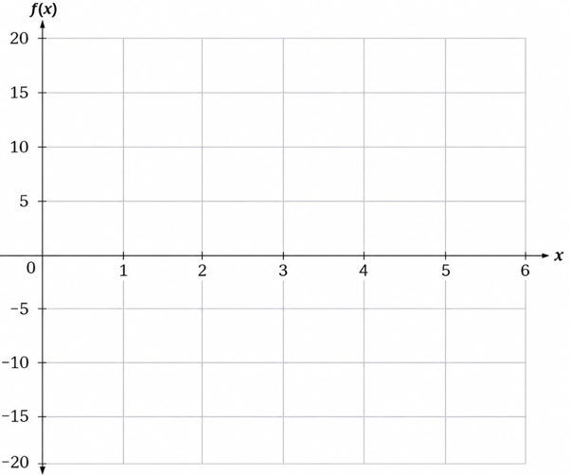
Try It
Given the graph of $f(x)=2\cos\left(\frac{π}{2}x\right)+1$, sketch the graph of $g(x)=2\sec\left(\frac{π}{2}x\right)+1$ on the same axes.
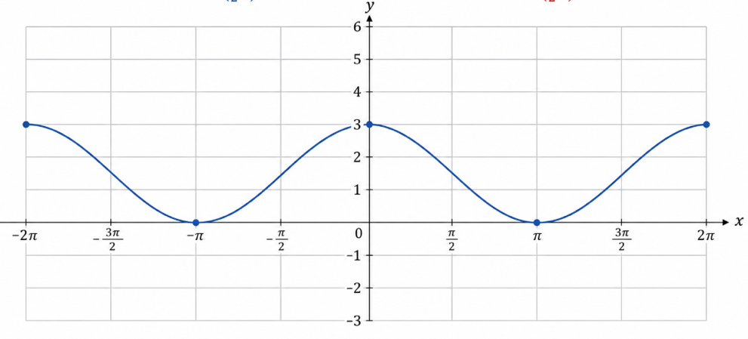

Analyzing the Graph of y=cot x and Its Variations
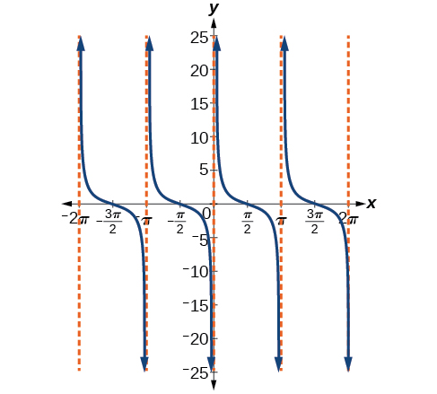
The cotangent is defined by the reciprocal identity $\cot{x}=\frac{1}{\tan{x}}$.
When is cotangent undefined?

Key Takeaway: Features of the Graph of y=Acot(Bx)
- The amplitude is:
- The period is:
- The domain is:
- The range is:
- The asymptotes occur at:

Graphing Variations of y=cot x
Question Help
Given a modified cotangent function of the form $f(x)=A\cot{(Bx)},$ graph one period.
- Identify the stretching factor, $|A|$.
- Identify the period, $P=\frac{π}{\left|B\right|}$.
- Draw the graph of $y=A\tan{(Bx)}$.
- Plot any two reference points.
- Sketch the asymptotes.

Example
Determine the stretching factor, period, and phase shift of $y=3\cot{(4x)}$, and then sketch a graph.
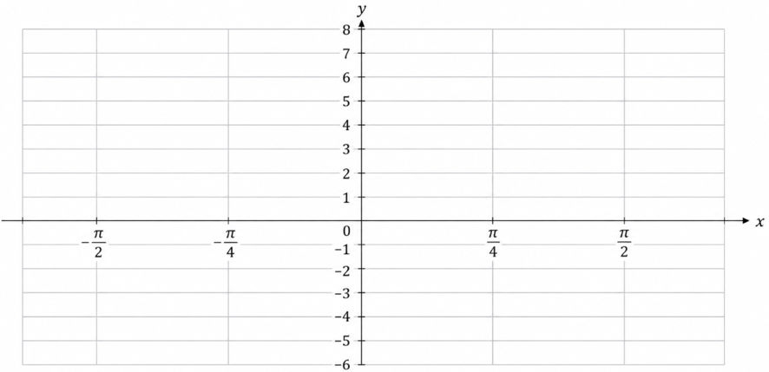
Question Help
Given a modified cotangent function of the form $f(x)=A\cot{(Bx-C)}+D$, graph one period.
- Identify the stretching factor, $|A|$ .
- Identify the period, $P=\frac{π}{\left|B\right|}$.
- Identify the phase shift, $\frac{C}{B}$.
- Draw the graph of $y=A \tan{(Bx) }$shifted to the right by $\frac{C}{B}$ and up by D.
- Sketch the asymptotes $x=\frac{C}{B}+\frac{π}{\left|B\right|k}$, where k is an integer.
- Plot any three reference points and draw the graph through these points.
Example
Sketch a graph of one period of the function $f(x)=4\cot\left(\frac{π}{8}x-\frac{π}{2}\right)-2$.
