Precalculus

Trigonometric Identities and Equations Guided Notes
This tool is designed to work alongside your Study Plan and class sessions. Before class, you'll use it with the assigned readings by filling in key terms, noting examples, and writing down questions that arise. During class, you'll add to your notes as you deepen your understanding and instructors highlight important concepts. You'll find a mix of fill-in-the-blank sections, reflection spaces, and areas to record real-world examples.

13.1 Angles

Drawing Angles
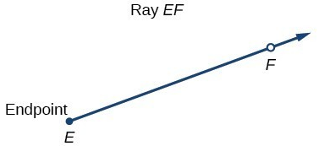
Properly defining an angle first requires that we define a ray.
What is a ray?

The ray shown can be named as $\vec{EF}$.

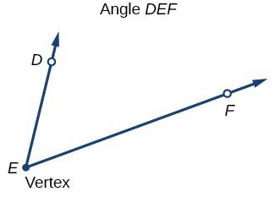
What is an angle?

Key Takeaway: Angle
An angle is the union of two rays having a common endpoint. The endpoint is called the vertex of the angle, and the two rays are the sides of the angle.

Greek letters are often used as variables for the measure of an angle. Commonly used letters include θ (theta), φ or φ (phi), α (alpha), β (beta), and γ (gamma).

How are angles drawn? Use the picture to help describe the process.
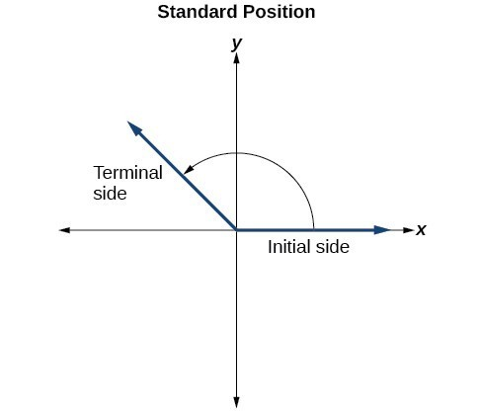

Key Takeaway: Angle Measure
The angle measure is the amount of rotation from the initial side to the terminal side.

Key Takeaway: Quadrantal Angles
Quadrantal angles are angles whose terminal side lies on an axis, including 0°, 90°, 180°, 270°, or 360°.
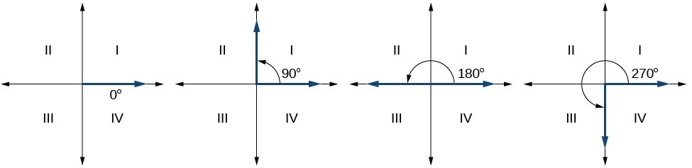

Key Takeaway: Quadrants
The coordinate plane is divided into four quadrants. Quadrant numbering begins at the positive x-axis and rotates counterclockwise.
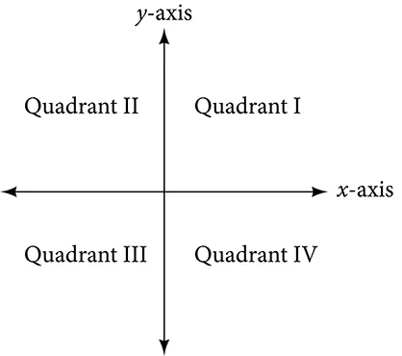

Question Help
- Determine which quadrant the angle belongs in:
  - Quadrant 1: angles between 0° and 90°.
  - Quadrant 2: angles between 90° and 180°.
  - Quadrant 3: angles between 180° and 270°.
  - Quadrant 4: angles between 270° and 360°.
- Draw an angle that lands proportionately within the desired quadrant.

Example
Sketch an angle of 30° in standard position.

Try It
Show an angle of 240° on a circle in standard position.

Key Takeaway: Negative Angles
A positive angle in standard position rotates counterclockwise from the positive x-axis. A negative angle in standard position rotates clockwise from the positive x-axis.
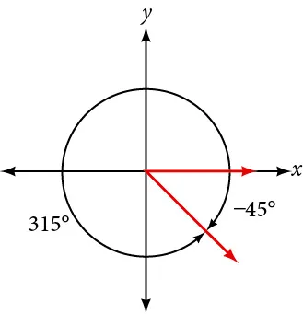

Example
Sketch an angle of -135° in standard position.

Radians
Dividing a circle into 360 parts is an arbitrary choice, although it creates the familiar degree measurement. We may choose other ways to divide a circle.

Recall
An arc may be a portion of a full circle, a full circle, or more than a full circle, represented by more than one full rotation. The length of the arc around an entire circle is called the circumference of that circle.
Show how to find one radian:

Key Takeaway: Radian
One radian is the measure of the central angle of a circle such that the length of the arc between the initial side and the terminal side is equal to the radius of the circle. A full revolution (360°) equals 2π radians. A half revolution (180°) is equivalent to π radians.

Pro Tip
What does it mean if an angle is described without a specific unit (for example without a degree symbol)?

Using Radians

Example
Find the radian measure of one-third of a full rotation.

Try It
Find the radian measure of three-fourths of a full rotation.

Identifying Special Angles Measured in Radians
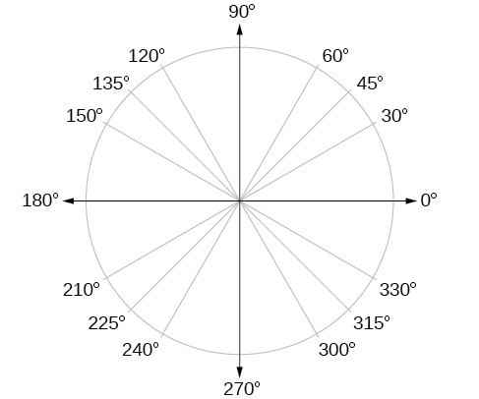
It is common to encounter multiples of 30, 45, 60, and 90 degrees. Memorizing these angles will be very useful as we study the properties associated with angles.

Converting between Radians and Degrees
Because degrees and radians both measure angles, we need to be able to convert between them. We can easily do so using a proportion.

Key Takeaway: Converting between Radians and Degrees
To convert between degrees and radians, use the proportion $\frac{θ}{180} =\frac{θᴿ}{π}$
- $radian ×\frac{180}{π}$
- $degree ×\frac{π}{180}$

Example
Convert each radian measure to degrees.
- $π/6$

- $3$

Try It
Convert $-\frac{3π}{4}$ radians to degrees.

Try It
Convert $\frac{19π}{18}$ radians to degrees.

Example
Convert 15 degrees to radians.

Try It
Convert 126° to radians.

Try It
Convert 498° to radians.

Try It
Graph $θ=\frac{7π}{4}$ in standard form.

Degrees, Minutes, and Seconds
Not all angles will be special angles, or even whole number values. Decimal degrees express angles as a decimal number (like 42.75°), while DMS form (degrees, minutes, seconds) breaks angles into whole degrees, minutes, and seconds (like 42° 45' 0").

Key Takeaway: DMS Form (Degrees, Minutes, Seconds)
DMS is a notation used to express decimal valued angles.
One degree equals 60 minutes and one minute equals 60 seconds.
Angles in this form are represented as D° M' S".

Converting from Decimal Degrees to DMS Form
When converting from decimal degrees to DMS form, we separate the whole number part (degrees) from the decimal part, then convert the decimal portion into minutes and seconds.

Example
Convert 47.58° to DMS form.

Question Help
- The whole number part is the degrees.
- Multiply the decimal part by 60 to get minutes.
- If the minutes have a decimal part, multiply that decimal by 60 to get seconds.
- Write your answer in DMS notation: degrees° minutes' seconds".

Converting from DMS Form to Decimal Degrees
To convert from DMS form to decimal degrees, we work backwards by converting minutes and seconds into decimal fractions of a degree.

Example
Convert 38° 27' 36" to decimal degree form.

Question Help
- Start with the degrees as your base number.
- Divide the minutes by 60 and add to the degrees.
- Divide the seconds by 3600 (since 60 × 60 = 3600) and add to the result.
- Write your answer with appropriate decimal places.

Try It
Convert the angle from its decimal representation to Degree-Minute-Seconds representation:

155.7365 =

197.8985 =

Convert the angle from its Degree-Minute-Seconds representation to decimal representation:

40° 15' 22" =

298° 43' 46" =

Using a Calculator for DMS Conversions
Most scientific and graphing calculators have built-in functions to convert between decimal degrees and DMS form.
For TI-84 Calculators:

Question Help
- Enter the decimal degree value.
- Press 2nd then APPS (ANGLE menu).
- Select option 4: ►DMS.
- Press ENTER. For example, entering 47.58 and using ►DMS displays 47° 34' 48".

Converting DMS to Decimal:

Question Help
- Enter the degrees.
- Press 2nd then APPS (ANGLE menu). Select option 1: °.
- Enter the minutes. Press 2nd then APPS (ANGLE menu). Select option 2: '.
- Enter the seconds. Press 2nd then APPS (ANGLE menu). Select option 3: ". Press ENTER.

Converting Radians to DMS Form
Sometimes you need to convert an angle given in radians to DMS form. This requires a two-step process: first convert radians to decimal degrees, then convert decimal degrees to DMS form.
To convert from radians to degrees, use the conversion: degrees = radians × 180°/π

Example
Convert 2.5 radians to DMS form.

Example
Convert 2.99 radians to DMS form.

Finding Coterminal Angles
It is possible for more than one angle to have the same terminal side. If two angles in standard position have the same terminal side, they are coterminal angles. Every angle greater than 360° or less than 0° is coterminal with an angle between 0° and 360°, and it is often more convenient to find the coterminal angle within the range of 0° to 360° than to work with an angle that is outside that range.

Key Takeaway: Coterminal Angles
Two angles in standard position have the same terminal side.

Key Takeaway: Reference Angles
An angle's reference angle is the size of the smallest acute angle, t', formed by the terminal side of the angle t and the horizontal axis.

Question Help
How To: Given an angle greater than 360°, find a coterminal angle between 0° and 360°
- Subtract 360° from the given angle.
- If the result is still greater than 360°, subtract 360° again until the result is between 0° and 360°.
- The resulting angle is coterminal with the original angle.

Example
Find the least positive angle θ that is coterminal with an angle measuring 800°, where $0° ≤ θ < 360°.$

Try It
Find an angle α that is coterminal with an angle measuring 870°, where $0° ≤ α < 360°.$

Question Help
How To: Given an angle with measure less than 0°, find a coterminal angle having a measure between 0° and 360°.
- Add 360° to the given angle.
- If the result is still less than 0°, add 360° again until the result is between 0° and 360°.
- The resulting angle is coterminal with the original angle.

Example
Graph the angle with measure −45° on a circle and find a positive coterminal angle α such that $0° ≤ α < 360°.$

Try It
Find an angle β that is coterminal with an angle measuring −300° such that $0° ≤ β < 360°.$

Question Help
How To: Finding a reference angle
- First find the coterminal angle between 0° and 360°.
- Find the angle between the terminal side and the nearest x-axis.
  - For angles in the second quadrant: subtract the angle from 180°.
  - For angles in the third quadrant: subtract 180°.
  - For angles in the fourth quadrant: subtract the angle from 360°.

Try It
- Find the angle between 0∘ and 360° that is coterminal with the −2737° angle.

- Find the reference angle for −2737°

Finding Coterminal Angles Measured in Radians

Question Help
Given an angle greater than π, find a coterminal angle between 0 and π.
- Subtract 2π from the given angle.
- If the result is still greater than 2π, subtract 2π again until the result is between 0 and 2π.
- The resulting angle is coterminal with the original angle.

Example
Find an angle β that is coterminal with $\frac{19π}{4}$, where $0 ≤β<2π$.

Try It
Find an angle of measure θ that is coterminal with an angle of measure $-\frac{17π}{6}$ where $0≤θ<2π$.

Try It
The angle between $0$ and $2π$ in radians that is coterminal with the angle $\frac{35π}{4}$ is …

Finding Complementary and Supplementary Angles

Key Takeaway: Complementary and Supplementary Angles
Complementary angles are two angles whose measures add up to:
Supplementary angles are two angles whose measures add up to:

Pro Tip
What types of angles can have a complement? What types of angles can have a supplement?

Example
- Find the complement of 37°.

- Find the supplement of 125°.

Try It
Find the supplement of 19°.

Finding Complements and Supplements in Radians
When working with radians, complementary angles sum to $\frac{π}{2}$radians (which equals 90°) and supplementary angles sum to $π$ radians (which equals 180°).

Example
- Find the complement of $\frac{π}{6}$ radians.

- Find the supplement of $\frac{2π}{3}$ radians.

Question Help
How To: Finding Complements in Radians
- Use the formula: Complement = $π/2 - angle$.
- Find a common denominator to subtract the fractions.
- Simplify the result.
- Verify that the sum equals $π/2$.

Question Help
How To: Finding Supplements in Radians
- Use the formula: Supplement = $π - angle.$
- Find a common denominator to subtract the fractions.
- Simplify the result.
- Verify that the sum equals $π$.

Try It
- Find the supplement of the angle $\frac{π}{4}$

- Find the complement of the angle $\frac{π}{4}$

Finding Complements and Supplements in DMS Form

Example
- Find the complement of 35° 20' 15".

- Find the supplement of 72° 45' 20".

Question Help
How To: Finding Complements or Supplements in DMS Form
- Write 90° in DMS form as 89° 59' 60" (this makes subtraction easier), or write 180° as 179° 59' 60".
- Subtract seconds from seconds, minutes from minutes, degrees from degrees.
- Simplify your answer.
If you need to borrow, remember: 1° = 60' and 1' = 60".

Try It
Find the supplement and complement of ${52}^{∘}11'9"$.
- The supplement is

- The complement is

13.2 Arcs and Sectors

Determining the Length of an Arc
The radian measure $θ$ of an angle was defined as the ratio of the arc length s of a circular arc to the radius r of the circle, $θ=s/r.$ From this relationship, we can find arc length along a circle, given an angle.

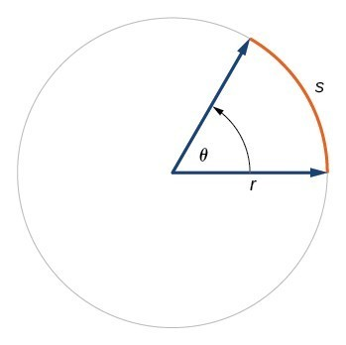
Key Takeaway: Arc Length on a Circle
In a circle of radius r, the length of an arc s subtended by an angle with measure $θ$ in radians is $s=rθ$

Question Help
How To: Given a circle of radius r, calculate the length s of the arc subtended by a given angle of measure θ.
- If necessary, convert θ to radians.
- Multiply the radius r by the radian measure of $θ$: $s=rθ$.

Example
Assume the orbit of Mercury around the sun is a perfect circle. Mercury is approximately 36 million miles from the sun.
  - In one Earth day, Mercury completes 0.0114 of its total revolution. How many miles does it travel in one day?

  - Use your answer from part (a) to determine the radian measure for Mercury's movement in one Earth day.

Try It
Find the arc length along a circle of radius 10 units subtended by an angle of 215°.

Try It
In a circle of radius 17 cm, the length of the arc subtended by a central angle of 105° is approximately:

Finding the Area of a Sector of a Circle
In addition to arc length, we can also use angles to find the area of a sector of a circle. A sector is a region of a circle bounded by two radii and the intercepted arc, like a slice of pizza or pie.

The area of a circle with radius r can be found using the formula $A=πr².$

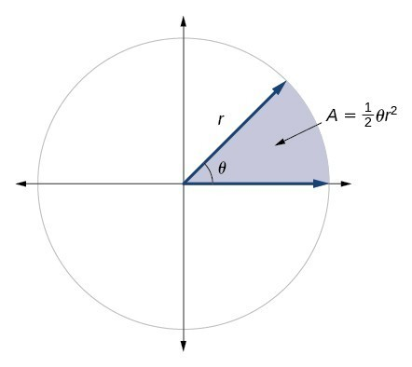
Key Takeaway: Area of a Sector
The area of a sector of a circle with radius r subtended by an angle θ, measured in radians, is $A=\frac{1}{2}θr^{2}$

Question Help
How To: Given a circle of radius r, find the area of a sector defined by a given angle θ.
- If necessary, convert θ to radians.
- Multiply half the radian measure of θ by the square of the radius r: $A=\frac{1}{2}θr^{2}$.

Example
An automatic lawn sprinkler sprays a distance of 20 feet while rotating 30 degrees. What is the area of the sector of grass the sprinkler waters?

Try It
In central pivot irrigation, a large irrigation pipe on wheels rotates around a center point. A farmer has a central pivot system with a radius of 400 meters. If water restrictions only allow her to water 150 thousand square meters a day, what angle should she set the system to cover? Write the answer in radian measure to two decimal places.

Use Linear and Angular Speed to Describe Motion on a Circular Path

Key Takeaway: Angular Speed
As a point moves along a circle of radius r, its angular speed, ω, is the angular rotation θ per unit time, t.
$$ω=\frac{θ}{t}$$

Key Takeaway: Linear Speed
The linear speed, v, of the point can be found as the distance traveled, arc length s, per unit time, t.
$$v=\frac{s}{t}$$

When the angular speed is measured in radians per unit time, linear speed and angular speed are related by the equation $v=rω$.
This equation states that the angular speed in radians, ω, representing the amount of rotation occurring in a unit of time, can be multiplied by the radius r to calculate the total arc length traveled in a unit of time, which is the definition of linear speed.

Question Help
How To: Given the amount of angle rotation and the time elapsed, calculate the angular speed.
- If necessary, convert the angle measure to radians.
- Divide the angle in radians by the number of time units elapsed: ω=θ/t. The resulting speed will be in radians per time unit.

Example
A water wheel completes 1 rotation every 5 seconds. Find the angular speed in radians per second.

Try It
An old vinyl record is played on a turntable rotating clockwise at a rate of 45 rotations per minute. Find the angular speed in radians per second.

Question Help
How To: Given the radius of a circle, an angle of rotation, and a length of elapsed time, determine the linear speed.
- Convert the total rotation to radians if necessary.
- Divide the total rotation in radians by the elapsed time to find the angular speed: apply $ω=\frac{θ}{t}$.
- Multiply the angular speed by the length of the radius to find the linear speed, expressed in terms of the length unit used for the radius and the time unit used for the elapsed time: apply $v=rω$.

Example
A bicycle has wheels 28 inches in diameter. A tachometer determines the wheels are rotating at 180 RPM (revolutions per minute). Find the speed the bicycle is traveling down the road.

Try It
A satellite is rotating around Earth at 0.25 radians per hour at an altitude of 242 km above Earth. If the radius of Earth is 6378 kilometers, find the linear speed of the satellite in kilometers per hour.

13.3 Sine and Cosine Functions
To define our trigonometric functions, we begin by drawing a unit circle, a circle centered at the origin with radius 1.
For any angle t, we can label the intersection of the terminal side and the unit circle by its coordinates, (x,y). The coordinates x and y will be the outputs of the trigonometric functions f(t)=cos t and f(t)=sin t, respectively. This means x=cos t and y=sin t.
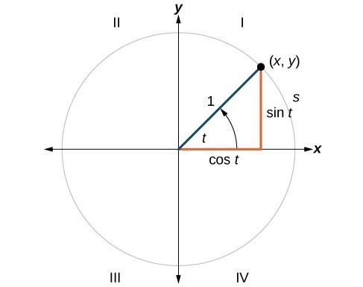

Key Takeaway: Unit Circle
A unit circle has a center at (0,0) and radius 1. In a unit circle, the length of the intercepted arc is equal to the radian measure of the central angle.

Defining Sine and Cosine Functions

Key Takeaway: Sine and Cosine Functions
If $t$ is a real number and a point $(x,y)$on the unit circle corresponds to an angle of $t$, then $cos t=x$ and $sin t=y$.

Question Help
How To: Given a point P(x,y) on the unit circle corresponding to an angle of t, find the sine and cosine.
- The sine of t is equal to the y-coordinate of point P: $sin t=y$.
- The cosine of t is equal to the x-coordinate of point P: $cos t=x$.

Example
Point P is a point on the unit circle corresponding to an angle of t. Find cos(t) and sin(t).
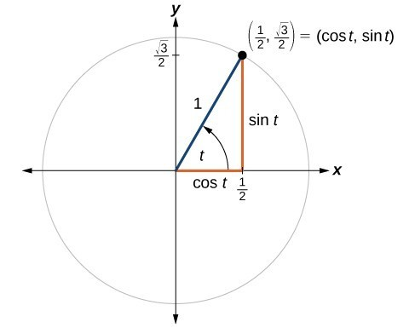

Try It
An angle t corresponds to a point on the unit circle at $\left(-\frac{\sqrt{2}}{2},\frac{\sqrt{2}}{2}\right)$ . Find $\cos{t}$ and $\sin{t}$.
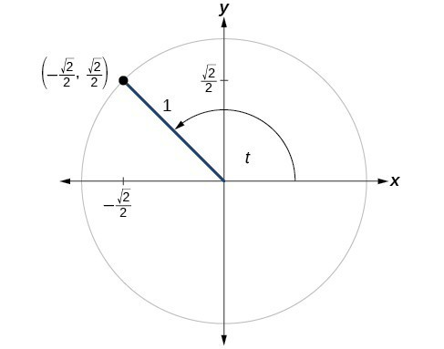

Finding Sines and Cosines of Angles on an Axis
For quadrantal angles, the corresponding point on the unit circle falls on the x- or y-axis. In that case, we can easily calculate cosine and sine from the values of x and y.

Example
Find $cos(90°)$ and $sin(90°).$

Try It
Find cosine and sine of the angle π.

The Pythagorean Identity
The equation for the unit circle is $x²+y²=1$. Because $x=\cos{t}$ and $y=\sin{t}$, we can substitute for x and y to get $cos²t+sin²t=1$. This equation is known as the Pythagorean Identity.

Key Takeaway: Pythagorean Identity
The Pythagorean Identity states that, for any real number t, $cos²t+sin²t=1$

Question Help
How To: Given the sine of some angle t and its quadrant location, find the cosine of t.
- Substitute the known value of $\sin{t}$ into the Pythagorean Identity.
- Solve for $\cos{t}$
- Choose the solution with the appropriate sign for the x-values in the quadrant where t is located.

Example
If $\sin{t}=\frac{3}{7}$and t is in the second quadrant, find cos(t).

Try It
If $\sin{t}=-\frac{8}{17}$and t is in the third quadrant, find cos(t).

Try It
If $\sin{θ}=\frac{2\sqrt{6}}{7}$and $θ$ is in the 2nd quadrant, find the exact value of $\cos{θ}$.

Pro Tip
How do we determine if the solution is positive or negative?

Finding Sines and Cosines of 45° Angles

Example
At $t=\frac{π}{4}$, which is 45 degrees, the radius of the unit circle bisects the first quadrantal angle.
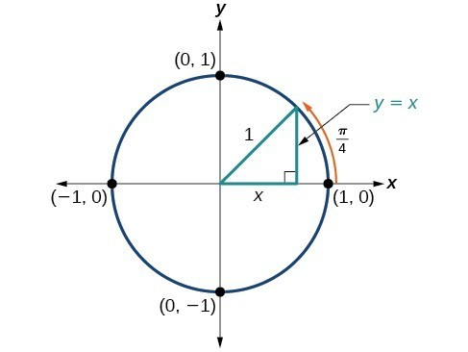
What is the coordinate of the point formed by an angle of 45 degrees?

Finding Sines and Cosines of 30° and 60° Angles

Example
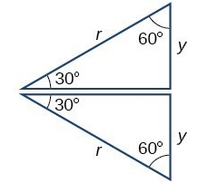

What are the sine and cosine values for 30 and 60 degrees?

Sine and cosine values for the most commonly encountered angles in the first quadrant:
Angle | 0 | $\frac{π}{6}$ or 30° | $\frac{π}{4}$ or 45° | $\frac{π}{3}$ or 60°
Cosine
Sine

Using a Calculator to Find Sine and Cosine

Question Help
How To: Given an angle in radians, use a graphing calculator to find the cosine.
- If the calculator has degree mode and radian mode, set it to radian mode.
- Press the COS key.
- Enter the radian value of the angle and press the close-parentheses key ")".
- Press ENTER.

Example
Evaluate $\cos{\frac{5π}{3}}$ using a graphing calculator or computer.

Try It
Evaluate $\cos\left(\frac{π}{2}\right)$.

Finding Sine and Cosine with Reference Angles

Key Takeaway: Reference Angle
An angle's reference angle is the acute angle formed by the terminal side of the angle and the horizontal axis. A reference angle is always an angle between 0 and 90°, or 0 and π/2 radians.
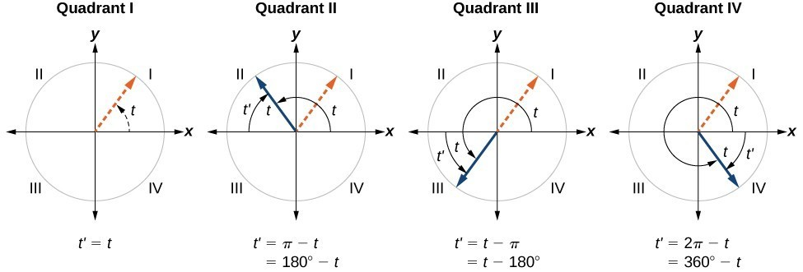

Question Help
How To: Given an angle between $0$ and $2π$, find its reference angle.
- An angle in the first quadrant is its own reference angle.
- For an angle in the second or third quadrant, the reference angle is $|π-t|$ or $|180°-t|$.
- For an angle in the fourth quadrant, the reference angle is $2π-t$ or $360°-t$.
- If an angle is less than 0 or greater than $2π$, add or subtract 2π as many times as needed to find an equivalent angle between 0 and $2π$.

Example
Find the reference angle of 225°.

Try It
Find the reference angle of $\frac{5π}{3}$.

Question Help
How To: Given an angle in standard position, find the reference angle, and the cosine and sine of the original angle.
- Measure the angle between the terminal side of the given angle and the horizontal axis. This is the reference angle.
- Determine the values of the cosine and sine of the reference angle.
- Give the cosine the same sign as the x-values in the quadrant of the original angle.
- Give the sine the same sign as the y-values in the quadrant of the original angle.

Example
- Using a reference angle, find the exact value of $cos⁡(150)$ and $sin⁡(150)$.

- Using the reference angle, find $\cos{\frac{5π}{4}}$ and $\sin{\frac{5π}{4}}$.

Try It
  - Use the reference angle of 45° to find $cos⁡(315)$ and $sin⁡(315)$..

  - Use the reference angle of $\frac{π}{6}$ to find $\cos\left(-\frac{π}{6}\right)$ and $\sin\left(-\frac{π}{6}\right)$

The Full Unit Circle
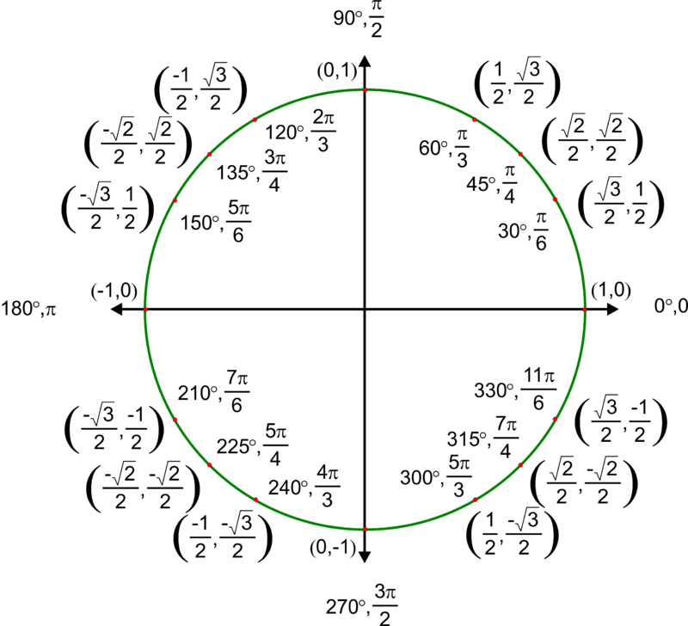

Question Help
How To: Given the angle of a point on a circle and the radius of the circle, find the (x,y) coordinates of the point.
- Find the reference angle by measuring the smallest angle to the x-axis.
- Find the cosine and sine of the reference angle using the ordered pair.
- Determine the appropriate signs for x and y in the given quadrant.

Example
Find the coordinates of the point on the unit circle at an angle of $\frac{7π}{6}$.

Try It
Find the coordinates of the point on the unit circle at an angle of $\frac{5π}{3}$.

13.4 The Other Trigonometric Functions

Find Exact Values of the Trigonometric Functions Secant, Cosecant, Tangent, and Cotangent

Key Takeaway: Tangent, Secant, Cosecant, and Cotangent
If $t$ is a real number and $(x,y)$ is a point where the terminal side of an angle of t radians intercepts the unit circle, then:
$\tan{t}=\frac{y}{x}$, $x≠0$
$\sec{t}=\frac{1}{x}$, $x≠0$
$\csc{t}=\frac{1}{y}$, $y≠0$
$\cot{t}=\frac{x}{y}$, $y≠0$

Example
The point $\left(-\frac{\sqrt{3}}{2},\frac{1}{2}\right)$ is on the unit circle. Find $\sin{t}$, $\cos{t}$, $\tan{t}$, $\sec{t}$, $\csc{t}$ and $\cot{t}$.

Try It
The point $\left(\frac{\sqrt{2}}{2}, -\frac{\sqrt{2}}{2}\right)$ is on the unit circle. Find $\sin{t}$, $\cos{t}$, $\tan{t}$, $\sec{t}$, $\csc{t}$ and $\cot{t}$.

Example
Find $\sin{t}$, $\cos{t}$, $\tan{t}$, $\sec{t}$, $\csc{t}$ and $\cot{t}$ when $t=\frac{π}{6}$.

Try It
Find $\sin{t}$, $\cos{t}$, $\tan{t}$, $\sec{t}$, $\csc{t}$ and $\cot{t}$ when $t=\frac{π}{3}$.

Angle | 0 | $\frac{π}{6}$ or 30° | $\frac{π}{4}$ or 45° | $\frac{π}{3}$ or 60° | $\frac{π}{2}$ or 90°
Tangent
Secant
Cosecant
Cotangent

Using Reference Angles to Evaluate Tangent, Secant, Cosecant, and Cotangent
Explain the mnemonic phrase “A Smart Trig Class.”
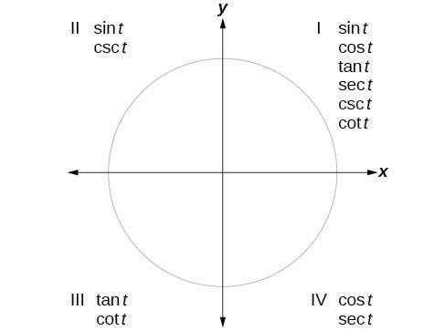

Question Help
How To: Given an angle not in the first quadrant, use reference angles to find all six trigonometric functions.
- Measure the angle formed by the terminal side of the given angle and the horizontal axis. This is the reference angle.
- Evaluate the function at the reference angle.
- Observe the quadrant where the terminal side of the original angle is located. Based on the quadrant, determine whether the output is positive or negative.

Example
Use reference angles to find all six trigonometric functions of $-\frac{5π}{6}$.

Try It
Use reference angles to find all six trigonometric functions of $-\frac{7π}{4}$.

Try It
If $θ=\frac{2π}{3}$, the find the exact values for the following.

$$\sec{θ}=$$
$$\csc{θ}=$$
$$\tan{θ}=$$
$$\cot{θ}=$$

Using Even and Odd Trigonometric Functions
We can test whether a trigonometric function is even or odd by drawing a unit circle with a positive and a negative angle.
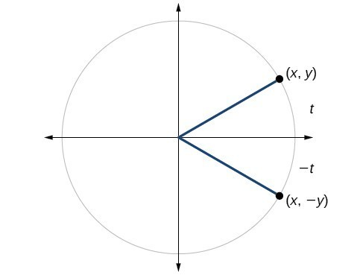

Key Takeaway: Even and Odd Trigonometric Functions
An even function is one in which $f(-x)=f(x)$. An odd function is one in which $f(-x)=-f(x).$
Cosine and secant are even:
$\cos{(-t)}=cos⁡(t)$ and $\sec{(-t)}=\sec{(t)}$
Sine, tangent, cosecant, and cotangent are odd:
$\sin\left(-t\right)=-\sin{(t)}$, $\tan\left(-t\right)=-\tan{(t)}$, $\csc{(-t)}=-\csc{(t)}$, $\cot{(-t)}=-\cot{(t)}$

Example
If $\sec{(t)}=2$, what is $\sec{(-t)}$?

Try It
If $\cot{(t)}=\sqrt{3}$, what is $\cot{(-t)}$?

Recognize and Use Fundamental Identities

Key Takeaway: Fundamental Identities
We can derive some useful identities from the six trigonometric functions. The other four trigonometric functions can be related back to the sine and cosine functions using these basic relationships:
$$\tan{t}=\frac{\sin{t}}{\cos{t}}$$
$$\sec{t}=\frac{1}{\cos{t}}$$
$$\csc{t}=\frac{1}{\sin{t}}$$
$$\cot{t}=\frac{1}{\tan{t}}=\frac{\cos{t}}{\sin{t}}$$

Example
Given $\sin{({45}^{∘}})=\frac{\sqrt{2}}{2}$, $\cos{({45}^{∘}})=\frac{\sqrt{2}}{2}$, evaluate $\tan{({45}^{∘})}$.
Given $\sin{(\frac{5π}{6}})=\frac{1}{2}$, $\cos{(\frac{5π}{6}})=-\frac{\sqrt{3}}{2}$, evaluate $\sec\left(\frac{5π}{6}\right)$.

Try It
Evaluate $csc\left(\frac{7π}{6}\right)$.

Example
Simplify $\frac{\sec{t}}{\tan{t}}$.

Try It
Simplify $\sec{(t)}\cos{(t)}$.

Alternate Forms of the Pythagorean Identity
Show how we can use these fundamental identities to derive alternative forms of the Pythagorean Identity:
      - Divide by $\cos^{2}{t}$

      - Divide by $\sin^{2}{t}$

Key Takeaway: Alternate Pythagorean Identities
$$1+\tan^{2}{t}=\sec^{2}{t}$$
$$\cot^{2}{t}+1=\csc^{2}{t}$$

Example
If $\cos{t}=\frac{12}{13}$ and t is in quadrant IV, find the values of the other five trigonometric functions.

Try It
If $\sec{(t)}=-\frac{29}{20}$ and $0<t<π$, find the values of the other five functions.

Try It
If $\sin{(t)}=\frac{2}{3}$ and $θ$ is in Quadrant II, find the values of the other five functions.

