Precalculus

Probability and Counting Theory Guided Notes
This tool is designed to work alongside your Study Plan and class sessions. Before class, you'll use it with the assigned readings by filling in key terms, noting examples, and writing down questions that arise. During class, you'll add to your notes as you deepen your understanding and instructors highlight important concepts. You'll find a mix of fill-in-the-blank sections, reflection spaces, and areas to record real-world examples.

12.1 Counting Principles

The Addition Principle
What do we use the Addition Principle for?

Key Takeaway: The Addition Principle
According to the Addition Principle, if one event can occur in m ways and a second event with no common outcomes can occur in n ways, then the first or second event can occur in $m+n$ ways.

Example
There are 2 vegetarian entrées and 5 meat entrées at a restaurant. How many entrée options does a customer have?

Example
A student is shopping for a new computer. He is deciding among 3 desktop computers and 4 laptop computers. What is the total number of computer options?

Try It
At a diner breakfast buffet, Mariam counts 22 oranges, 8 bananas, 19 mangos, and 23 watermelon slices. Which of the following is the total number of fruit choices at the buffet?

The Multiplication Principle

Key Takeaway: The Multiplication Principle
According to the Multiplication Principle, if one event can occur in m ways and a second event can occur in n ways after the first event has occurred, then the two events can occur in $m×n$ ways. This is also known as the Fundamental Counting Principle.

Example
Suppose we are choosing an appetizer, an entrée, and a dessert. If there are 2 appetizer options, 3 entrée options, and 2 dessert options on a fixed-price dinner menu, there are a total of 12 possible choices of one each as shown in the tree diagram.
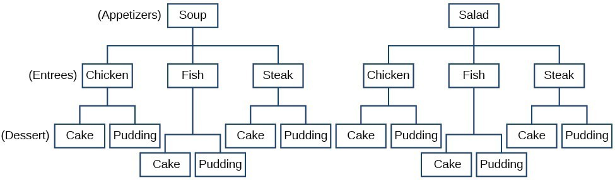
List all possible meals with one appetizer, one entrée, and one dessert:

What would be a faster way to find the total number of options?

Example
Diane packed 2 skirts, 4 blouses, and a sweater for her business trip. She will need to choose an outfit from these choices. How many outfit combinations are possible?

Try It
Determine whether to use the Addition Principle or the Multiplication Principle to solve this probability problem. Then perform the calculations.
How many outcomes are possible when tossing a coin and rolling a 6-sided die?

Permutations

Finding the Number of Permutations of n Distinct Objects Using the Multiplication Principle
We arrange letters into words and digits into numbers, line up for photographs, decorate rooms, and more. An ordering of objects is called a permutation.

Example
To solve permutation problems, it is often helpful to draw line segments for each option. That enables us to determine the number of each option so we can multiply.
Suppose we have four paintings, and we want to find the number of ways we can hang three of the paintings in order on the wall. We can draw three lines to represent the three places on the wall.
___ × ___ × ___
There are four options for the first place, so we write a 4 on the first line.
___ × ___ × ___
After the first place has been filled, there are three options for the second place.
___ × ___ × ___
After the second place has been filled, there are two options for the third place.
___ × ___ × ___
How many possible permutations are there?

Question Help: Given n distinct options, determine how many permutations there are.
- Determine how many options there are for the first situation.
- Determine how many options are left for the second situation.
- Continue until all the spots are filled.
- Multiply the numbers together.

Example

At a swimming competition, nine swimmers compete in a race.
- How many ways can they place first, second, and third?

- How many ways can they place first, second, and third if a swimmer named Ariel wins first place?

- How many ways can all nine swimmers line up for a photo?

Try It
A designer has a palette of 15 colors to work with and wants to design a flag with 3 vertical stripes. Each stripe must be a different color. How many possible unique flags can be created?

Finding the Number of Permutations of n Distinct Objects Using a Formula
For some permutation problems, it is inconvenient to use the Multiplication Principle because there are so many numbers to multiply. Fortunately, we can solve these problems using a formula.

Example
Imagine a club of six people. They need to elect a president, a vice president, and a treasurer. Six people can be elected president, any one of the five remaining people can be elected vice president, and any of the remaining four people could be elected treasurer. The number of ways this may be done is $6×5×4=120$. Using factorials we get the same result:
$$\frac{6!}{3!}=\frac{6∙5∙4∙3!}{3!}=6∙5∙4=120$$

Key Takeaway: Formula for Permutations of n Distinct Objects Taken r at a Time
The number of permutations of n distinct objects taken r at a time is:
$$P(n,r) =\frac{n!}{\left(n-r\right)!}$$

Example
A professor is creating an exam of 9 questions from a test bank of 12 questions. How many ways can she select and arrange the questions?

Try It
A pianist has a repertoire of 21 pieces and plans to play 4 different pieces at a recital. How many different possible recital programs can be created?

Finding the Number of Permutations of n Non-Distinct Objects
We have studied permutations where all of the objects involved were distinct. What happens if some of the objects are indistinguishable?

Example
Suppose there is a sheet of 12 stickers. If all of the stickers were distinct, there would be 12! ways to order the stickers. However, 4 of the stickers are identical stars, and 3 are identical moons. Because all the objects are not distinct, many of the 12! permutations we counted are duplicates.
This means we need to divide by the number of ways to order the 4 stars and the ways to order the 3 moons to find the number of unique permutations of the stickers. There are 4! ways to order the stars and 3! ways to order the moons.

How many ways are there to order the sheet of stickers?

Key Takeaway: Formula for Finding the Number of Permutations of n Non-Distinct Objects
If there are n elements in a set and r₁ are alike, r₂ are alike, r₃ are alike, and so on through rₖ, the number of permutations can be found by:
$$\frac{n!}{r_{1}! · r_{2}! · … · rₖ!}$$

Example
Find the number of rearrangements of the letters in the word DISTINCT.

Try It
Find the number of distinguishable permutations that can be made using all the letters in the word: "AABBCC"

Try It
  - Calculate the number of distinguishable permutations possible using all the letters in the word: TALLAHASSEE

  - Calculate the number of distinguishable permutations possible using all the letters in the word: TENNESSEE

Combinations
When we are selecting objects and the order does not matter, we are dealing with combinations. A selection of r objects from a set of n objects where the order does not matter can be written as C(n,r).

Key Takeaway: Formula for Combinations of n Distinct Objects
Given n distinct objects, the number of ways to select r objects where the order does not matter from the set is:
$$C(n,r) = nCr =\frac{n!}{r!\left(n-r\right)!}$$
Note the similarity and difference between the formulas for permutations and combinations:

Example
An earlier problem considered choosing 3 of 4 possible paintings to hang on a wall. We found that there were 24 ways to select 3 of the 4 paintings in order. But, what if we did not care about the order? We would expect a smaller number because selecting paintings 1,2,3 would be the same as selecting paintings 2,3,1.
Show how to find the number of ways to select 3 of the 4 paintings, disregarding the order of the paintings:

Example
A fast-food restaurant offers five side dish options. Your meal comes with two side dishes.
- How many ways can you select your side dishes?

- How many ways can you select 3 side dishes?

Try It
Evaluate ${}_{24}C_{8}$

Try It
A person going to a party needs to bring 3 different varieties of chips. At the store, she finds 16 different varieties available. How many different possible selections of chips can she make?

Try It
At a charity benefit with 33 people in attendance, three $50 gift certificates are given away as door prizes. Assuming no person receives more than one prize, in how many ways can the gift certificates be awarded?

Finding the Number of Subsets of a Set
We have looked only at combination problems in which we chose exactly r objects. In some problems, we want to consider choosing every possible number of objects.

Example
A pizza restaurant offers 5 toppings. Any number of toppings can be ordered. How many different pizzas are possible?
- There is C(5,0) = 1 way to order a pizza with no toppings.
- There are C(5,1) = 5 ways to order a pizza with exactly one topping.
If we continue this process, we get:

Key Takeaway: Formula for the Number of Subsets of a Set
A set containing n distinct objects has $2^{n}$subsets.

Example
A restaurant offers butter, cheese, chives, and sour cream as toppings for a baked potato. How many ways are there to order a potato?

Try It
An ice cream shop has 5 different toppings available. Customers can choose any number of toppings from 0 up to 5 (even unusual combinations are allowed).
How many different possible topping combinations are there?

12.2 Binomial Theorem
A polynomial with two terms is called a binomial. We already know how to multiply binomials and to raise binomials to powers but raising a binomial to a high power can be tedious and time-consuming. The Binomial Theorem is a powerful tool that allows us to expand expressions raised to a power without multiplying the binomial by itself n times.

Binomial Coefficients
Have you ever noticed that there's a pattern to the coefficients when you expand ${\left(x+y\right)}^{n}$? These coefficients, known as binomial coefficients, follow a specific pattern that appears in Pascal's Triangle.

Key Takeaway: Binomial Coefficients
If n and r are integers greater than or equal to 0 with n ≥ r, then the binomial coefficient is:
$$\left(\begin{matrix}n \\ r\end{matrix}\right)=C\left(n,r\right)=\frac{n!}{r!\left(n-r\right)!}$$

Example
Find each binomial coefficient.
- $\left(\begin{matrix}5 \\ 3\end{matrix}\right)$

- $\left(\begin{matrix}9 \\ 2\end{matrix}\right)$

- $\left(\begin{matrix}9 \\ 7\end{matrix}\right)$

Try It
Evaluate the binomial coefficient $\left(\begin{matrix}6 \\ 3\end{matrix}\right)$

Try It
Evaluate the binomial coefficient $\left(\begin{matrix}58 \\ 0\end{matrix}\right)$

Try It
Evaluate the binomial coefficient $\left(\begin{matrix}14 \\ 14\end{matrix}\right)$

The patterns that emerge from calculating binomial coefficients and that are present in Pascal's Triangle are handy and should be memorized over time as mathematical facts much in the same way that you just "know" 4 and 3 make 7.
When we expand ${\left(x+y\right)}^{n}$ by multiplying, the result is called a binomial expansion.
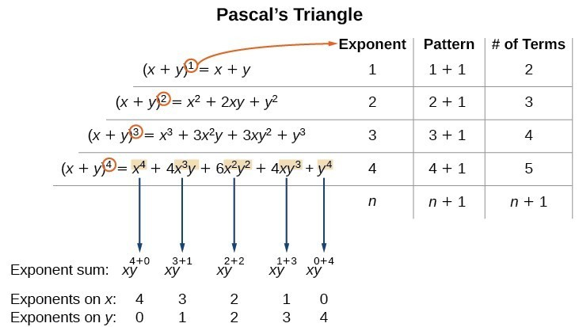
Describe some patterns:

The coefficients can be described by Pascal’s Triangle:
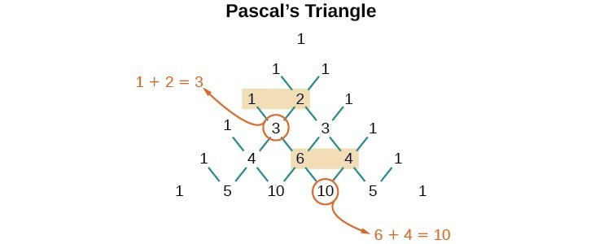
These patterns lead us to the Binomial Theorem.

Key Takeaway: Binomial Theorem
The Binomial Theorem is a formula that can be used to expand any binomial.
$$\left(x+y\right)ⁿ = \sum_{k=0}^{n}{\left(\begin{matrix}n \\ k\end{matrix}\right)x^{n-k}y^{k}}$$
$$= xⁿ + \left(\begin{matrix}n \\ 1\end{matrix}\right)xⁿ⁻¹y + \left(\begin{matrix}n \\ 2\end{matrix}\right)xⁿ⁻²y² + ⋯ + \left(\begin{matrix}n \\ n-1\end{matrix}\right)xyⁿ⁻¹ + yⁿ$$

Question Help
Given a binomial, write it in expanded form.
- Determine the value of n according to the exponent.
- Evaluate the k=0 through k=n terms using the Binomial Theorem formula.
- Simplify.

Example: Write in expanded form.
- ${\left(x+y\right)}^{5}$

- ${\left(3x-y\right)}^{4}$

Try It
Use the binomial theorem to expand the expression ${\left(2x+1\right)}^{3}$

Using the Binomial Theorem to Find a Single Term

Key Takeaway: The (r+1)th Term of a Binomial Expansion
The ${\left(r+1\right)}^{th}$ term of the binomial expansion of ${\left(x+y\right)}^{n}$ is:
$$\left(\begin{matrix}n \\ r\end{matrix}\right)x^{n-r}y^{r}$$

Question Help
Given a binomial, write a specific term without fully expanding.
- Determine the value of n according to the exponent.
- Determine (r+1).
- Determine r.
- Replace r in the formula for the ${\left(r+1\right)}^{th}$ term of the binomial expansion.

Example
Find the tenth term of ${\left(x+2y\right)}^{16}$without fully expanding the binomial.

Try It
Find the 3rd term in the expansion of ${\left(4x+y\right)}^{8}$

Try It
In the expansion of ${\left(x+4\right)}^{9}$, which term contains the factor $x^{4}$?

Try It
Consider the binomial expansion of ${\left(x^{5}-y^{3}\right)}^{9}$. Find…
  - The number of the term that contains $x^{15}y^{18}$

  - The coefficient of the term in part a)

12.3 Probability
Describe each of the following terms:
- Experiment
- Outcomes
- Sample Space
- Event
The likelihood of an event is known as probability. The probability of an event p is a number that always satisfies 0 ≤ p ≤ 1, where 0 indicates an impossible event and 1 indicates a certain event.

Key Takeaway: Probability
The probability of an event is a description of how likely it is that an event will happen.
A probability is a number between 0 and 1, where probabilities closer to 100% are very likely to occur and probabilities closer to 0% are very unlikely to occur. A probability of 0% means the event is impossible, and a probability of 100% means the event will certainly occur.
To calculate the probability of an event, we divide the number of possible outcomes of the event by the number of possible outcomes of the sample space:
$$P\left(outcome\right)=\frac{Number of ways that outcome can occur}{Total number of outcomes}$$
Note: all outcomes must be equally likely to use this formula.
A probability model is a mathematical description of an experiment listing all possible outcomes and their associated probabilities. The sum of all probabilities in a probability model must equal 1.

Question Help
Given a probability event where each event is equally likely, construct a probability model.
- Identify every outcome.
- Determine the total number of possible outcomes.
- Compare each outcome to the total number of possible outcomes.

Example
Construct a probability model for rolling a single, fair die, with the event being the number shown on the die.

Try It
Let's consider a coin flip experiment where 𝐻 represents heads and 𝑇 represents tails.
  - Write the sample space S for a single coin flip

  - Write the sample space S for flipping the coin twice

Try It
In a survey, 496 people admitted to running a red light in the last year, while 394 people said they had not run a red light. If one person is selected at random from this group, what is the probability they have run a red light in the last year?

Computing Probabilities of Equally Likely Outcomes

Key Takeaway: Probability of an Event with Equally Likely Outcomes
The probability of an event E in an experiment with sample space S with equally likely outcomes is given by:
$$P\left(E\right)=\frac{number of elements in E}{number of elements in S}=\frac{n\left(E\right)}{n\left(S\right)}$$
E is a subset of S, so it is always true that 0 ≤ P(E) ≤ 1.

Example
A number cube (a fair six-sided die) is rolled.
- Find the probability of rolling an odd number.

- Find the probability of the event "rolling a number less than or equal to 4."

Try It
In a survey of 20 students about their course enrollment, each student was asked "How many classes are you enrolled in this semester?" The results are shown in the table below, where each cell represents one student's response.
4 | 5 | 3 | 6
5 | 6 | 4 | 5
5 | 4 | 3 | 4
3 | 6 | 4 | 3
4 | 3 | 6 | 4

Create a probability distribution using these results. Count the number of students taking each number of classes and divide by the total number of students surveyed to find each probability. Round all probabilities to four decimal places

  - What is the probability that a randomly selected student from this survey is taking 3 or fewer classes? Round your answer to four decimal places.

Try It
A spinner is divided into 12 equal sections numbered from 1 to 12. Use this spinner to find the probability of landing on:
- An odd number.

- A multiple of 4.

Computing the Probability of the Union of Two Events

Key Takeaway: Probability of the Union of Two Events
The union of two events E and F, written $E∪F$, is the event that occurs if either or both events occur.
The probability of the union of two events E or F equals the sum of the probability of E and the probability of F minus the probability of E and F occurring together (the intersection, written $E∩F$):
$$P(E or F) = P(E∪F) = P(E) + P(F) - P(E∩F)$$
The union symbol ∪ represents the word or — all elements that could be present in E or in F.
The intersection symbol ∩ represents the word and — only elements present in both E and F.

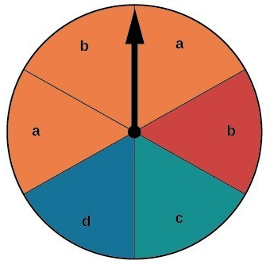
Example
Suppose the spinner is spun. We want to find $P(orange∪b).$
- There are 6 sections, and 3 are orange:
P(orange) =
- There are 6 sections, and 2 have a b:
P(b) =
If we added these two probabilities, we would be counting the sector that is both orange and a b twice. So, we subtract:
$$P(orange∪b) = P(orange) + P(b) - P(orange∩b) =$$

What is the probability of spinning and orange or a b?

Example
A card is drawn from a standard deck. Find the probability of drawing a heart or a 7.

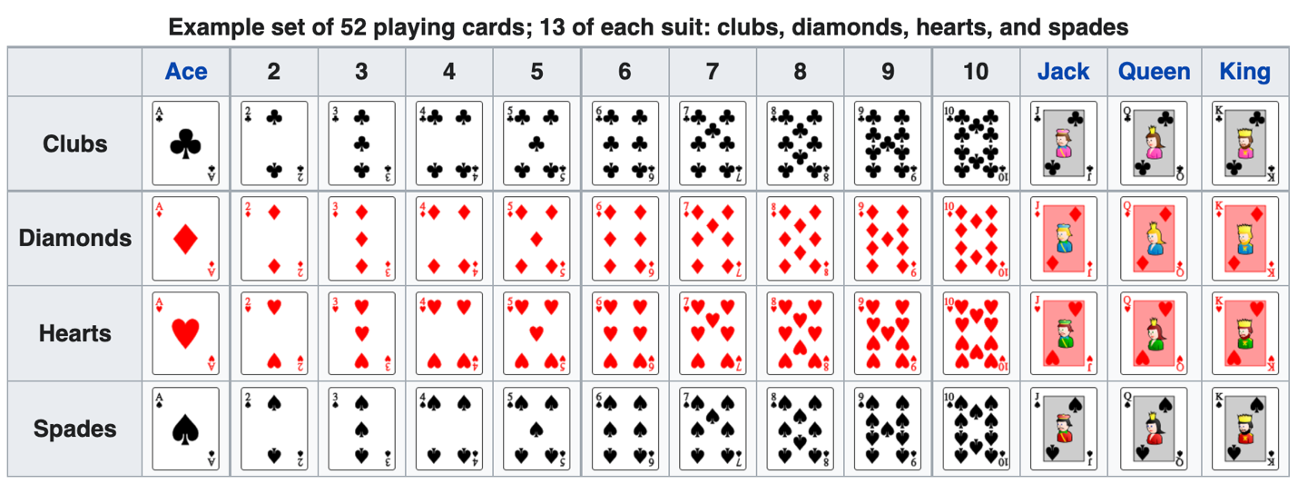

Computing the Probability of Mutually Exclusive Events

Key Takeaway: Probability of the Union of Mutually Exclusive Events
The probability of the union of two mutually exclusive events E and F is given by:
$$P(E∪F) = P(E) + P(F)$$

Question Help
Given a set of events, compute the probability of the union of mutually exclusive events.
- Determine the total number of outcomes for the first event.
- Find the probability of the first event.
- Determine the total number of outcomes for the second event.
- Find the probability of the second event.
- Add the probabilities.

Example
A card is drawn from a standard deck. Find the probability of drawing a heart or a spade.
The events "drawing a heart" and "drawing a spade" are mutually exclusive because they cannot occur at the same time.
- The probability of drawing a heart is 13/52.
- The probability of drawing a spade is also 13/52.
P(Heart or Spade) =

Try It
Consider the experiment consisting of selecting a random integer between 1 and 100.
- 𝐴 is the event that the number is between 67 and 76
- 𝑌 is the event that the number is between 60 and 68
- 𝐵 is the event that the number is between 73 and 89
Which events are mutually exclusive?

Try It
Consider drawing ONE card from a standard deck of 52 playing cards.
For the events "drawing a heart" and "drawing a 4":
- Are the events mutually exclusive?
- P(heart) =
- P(4) =
- P(heart or 4) =
For the events “drawing a Jack” and “drawing a Queen”:
- Are the events mutually exclusive?
- P(Jack) =
- P(Queen) =
- P(Jack or Queen) =

Find the Probability That an Event Will Not Happen
The complement of an event E, denoted E', is the set of outcomes in the sample space that are not in E.

Key Takeaway: The Complement Rule
The complement of an event E, denoted E', is the set of outcomes in the sample space that are not in E. The probability that the complement of an event will occur is given by:
$$P(E') = 1 - P(E)$$

Example
Suppose we are interested in the probability that a horse will lose a race. If event W is the horse winning the race, then the complement of event W is the horse losing the race. If the probability of the horse winning the race is 1/9, the probability of the horse losing the race is:

Example
Two six-sided number cubes are rolled.
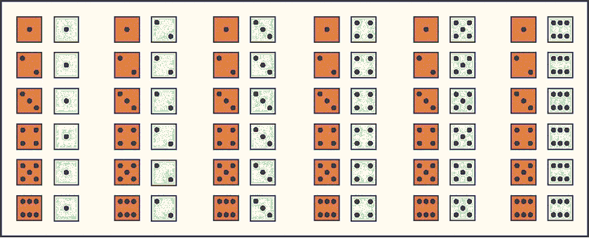
- Find the probability that the sum of the numbers rolled is less than or equal to 3.

- Find the probability that the sum of the numbers rolled is greater than 3.

Try It

Suppose that according to a poll, 27.1% of Americans believe that there is another planet in the center of the Earth. If you randomly select an American, what is the probability (as a percentage) that they do NOT believe that there is another planet in the center of the Earth?

Try It
The table below shows the probability model for blood types in the United States population:
Blood type | O | A | B | AB
Probability | 0.43 | 0.2 | 0.09 | 0.28
If you randomly select an American, what is the probability that they do NOT have type O blood?

Computing Probability Using Counting Theory
Many interesting probability problems involve counting principles, permutations, and combinations. In these problems, we will use permutations and combinations to find the number of elements in events and sample spaces.

Example
A store has 8 cellular phones and 3 of those are defective. Find the probability that a couple purchasing 2 phones receives 2 phones that are not defective.

Example
A child randomly selects 5 toys from a bin containing 3 bunnies, 5 dogs, and 6 bears.
- Find the probability that only bears are chosen.

- Find the probability that 2 bears and 3 dogs are chosen.

- Find the probability that at least 2 dogs are chosen.

Try It
You are taking a multiple-choice test with 7 questions. Each question has 4 possible answers to choose from. If you guess randomly on every question, what is the probability of getting at least one question wrong?

Try It
You have a collection of 11 books. You randomly select 8 of these books and arrange them on a bookshelf. What is the probability that these 8 books end up in alphabetical order by title?

